Members
Kittiwin Chankitivuth 6204640046
Pongpanot Chaloemvisetphon 6204641267
Narin Tantangtrong 6204641515
Intuch Nopparat 6204641523

Impact of Asian Flu on poverty in the United States of America

Abstract: From 1957 to 1958, there was a spread of Asian Flu pandemic. During the spread, there was a slight increase in poverty. We found that one significant factor that caused poverty to increase during that time was higher unemployment rate according to consumer attitudes toward the economy. From the analysis, we divided factors of higher unemployment rate into 1) Consumption declined due to consumer confidence fell from the recession 2) Export-Import decreased because of contractionary policy of foreign countries. This illustrates that Asian Flu did not have any contribution to an increase in unemployment. We make a conclusion that a pandemic was not the factor that increased poverty during the pandemic period.

In 1957, a pandemic named “Asian flu or Asian Influenza” occurred and the death cases causes by this pandemic is estimated to be around 1.5 million worldwide. With the large number of loss in human population, this paper focuses on the socioeconomics impact of the pandemic with the focus in the poverty in United States from the impact of Asian flu.
After COVID-19 has spread across the world, the impact of the spread has been analyzed in many aspects more than just on the health perspective. One obvious aspect that receive an impact from the virus is poverty. The government measure such as lockdown and quarantine have caused a decrease in economic activity, the decrease in such activity causes the loss of jobs to many people which causes some group of people to fall into poverty.
From this, we want to evaluate Asian Influenza on the effect it had on society during that period and whether the impact is large enough to cause some people to fall into poverty or not. Following that point, this paper chooses the United States of America as the country that we choose to analyze as the United States one of the most powerful and most economically advanced country during that time. Analyzing the United States, we believe that we would see the best government mitigation method to limit the impact of the pandemic and also limit any other unobservable factors that could cause the worsen in impact of the pandemic such as corruption in government.
First, the paper will give a brief summarize about the Asian Flu along with the government measure and other topics about the pandemic. This section of the paper will help the readers to understand the analysis in the causality of this pandemic better in the later section. Second, the paper evaluates the factors that causes the change in the poverty and then a deep dive into the analysis of these factors during the spread of the Asian Flu. Third, the paper is going to evaluate the factors that caused an increase in poverty during the period of the spread of the Asian Flu and determine whether the causes of that fluctuation are the disease or not. Lastly, the paper gives an example case of COVID-19 as a disease that has an impact on poverty to show the mechanism of the disease that causes an increase in poverty along with giving suggestions for the future research.

About Asian flu

Asian flu is a virus that mutated the reassortant strain or mixed species between avian influenza and human influenza virus which was similar to H1N1 in 1918. It is influenza subtype A H2N2 but it had a dramatic shift in the strain and type of protein and became new types of the virus with the same origin. With shifts in protein of this gene, most of the people did not have any immunity to prevent them from the virus except people who were born in 1880 -1890s and survive from Russian flu. It transmitted from one person to another person by close contact and respiratory secretion such as saliva and bronchial secretion from the throat. The number of the people infected and deaths by Asian flu were 1.5 million and 4 million for the death toll and the infected people all over the world respectively.
Symptom
The symptoms of the Asian flu were divided into two categories which are minor and life-threatening conditions. Most of the minor conditions consisted of cough, fever, body aches, and loss of appetite while the life-threatening condition was Pneumonia or inflammation in air sacs. The incubation time for the virus to grow was around one to three days and the duration of the symptoms to be recovered was two to seven days based on symptom conditions and a help of antipyretic or fever drugs.
China to USA
The first case of Asian flu originated from Guizhou, China. In February 1957, it spread to the surrounding regions of East Asia via trading ships and one of them was Hong Kong. The number of the infected in Hong Kong was ten percent of Hong Kong's population. In late April 1957, the Asian flu reached Singapore, but it did not end at Asia continent. In June 1957, the US sent the navy to investigate Hong Kong about the unknown pandemic that had occurred. In a week, a medical officer from the navy had identified a new strain. They imported the strain of the virus from US specimens to the coastal base in the US and some soldiers from naval vessels were infected without being known by anyone in summer. It spread to the surrounding coastal state without noticing it. In winter, the outbreak got the US a big hit as most of the schools open new semesters and the climate was suitable for the virus to transmit to other people. Asian flu spread around the northern hemisphere in November and the European continent. Most of the infections were at eastern part of the US.
Government intervention
However, there was no measure by the US government to counter Asian flu such as quarantine, close schools, or close borders to limit the infection of the virus. The reasons were the mild and inapparent cases of this particular influenza and the increase in travelers. It was to maintain the economy as recession occurred. On the other hand, there was an association that was to encourage and measure for people to stay away and be healthy in order to lower the infection which was Association of state and Territorial Health Officials or “ASTHO” and some of measures were about stay home, rest, and drink plenty of water. The purposes of ASTHO were to reduce the burden from the hospital admission and limit the admission to hold the worst-condition patients with the belief that prevention or quarantine was not effective for the body to build the immunity for the virus.
Vaccination
It started from a man named “Maurice Hilleman” who noticed the situation from Hong Kong and assumed the possibility of emergence of the new influenza due to the large number of people having flu symptoms such as cough and fever. He later sent the messages to the government to inspect Hong Kong having a new influenza and September would be the time that the US got an outbreak. After the government approval and collection of the example of this influenza, He and researchers found this new strain of Asian flu on 22 May 1957. In late June, the vaccine was invented, and the sample product sent to the big six pharmaceutical companies to accommodate the number of the infected. In September, the outbreak occurred, the 40 million doses were given for the next three months to each state with the amount according to each state population. (Timeline) They first inoculated to the military and later to doctors and healthcare workers. In August 15 of 1957, Surgeon General announced the allocation and distribution of the vaccine to each state according to its population size through customary commercial networks. However, 60% of the vaccine was effective during the outbreaks. Although the 40 million doses of the vaccine were made, there were 7 million people were only received.
Mortality and transmissibility of the Asian flu in the US
There were 25 percent of the whole US population or 44,437,871 people in the US infected from the Asian flu. However, since most of the symptoms were mild, the life-threatening conditions consisted of pneumonia. The rise of the respiratory issued cases involved by Asian flu, consisting of pneumonia and influenza, were 200 and 1,200 cases in September and December of 1957.
The minimum and maximum of the infection fatality rate (ifr) were 0.16 percent and 0.26 percent or equal to 60,000 to 117,000 deaths out of 44,437,871. In addition, 60,000 deaths were curated from September 1957 to March 1958 over 108 cities in the US when the US was badly hit by Asian flu. Since Asian flu was a respiratory type virus, the number of the death tolls due to pneumonia and influenza was 300 people in September which was the start of the Asian flu affecting the US. In October, the number of the cases reached the peak at 900 deaths in a week which was higher than the number of the expected deaths by 3 folds. In mid-December 1957, the mortality number due to Asian flu-associated subsequently decreased to the level of the expected death toll (400). The number of deaths from Asian flu rose from 300 in January 1958 to 800 in March 1958. After the research the number of the expected death rate per 100,000 over eight different age groups, which consisted of under 1, 1-4, 5-14, 15-19, 20-44, 45-64, 65-76, 75 and above, the group which was affected the most was teenagers, then young adults. On the other hand, the group with the most excess death ratio was elderly with the highest number of the deaths due to pneumonia in 1958, 1959, and 1960. The relationship between the rise of the influenza and the number of the mortality rate over the 10,000 population every year from 1957 to 1960 was, since the pandemic hit, the mortality rate increased dramatically which was almost 2 folds above from the baseline mortality per 10,000 population from Arizona

Impact of Asian flu on poverty

To be able to evaluate the impact of Asian flu on poverty, we must know the factors that can cause the change in the trend of the poverty in America first. Hoynes, Page, and Stevens (2006) discuss and evaluate four determinants that can causes a change in poverty rate in America. First, the impact of labor market opportunities. Second, the role of changes in family structure. Third, the role played by government antipoverty program, and lastly, the role immigration. However, from the finding of the study, the last two factors: the role of government antipoverty program and the role of immigrant, do not play an important role in changing the rate of poverty in the United States.
For the government transfer and government tax program, it is obvious that these programs are helping the poor by providing cash and other benefits directly for the poor, and they also benefit the poor by having an indirect effect of changing individuals’ behavior of the poor as well, nevertheless, these programs will not be taken into account when the poverty rate is measured. First, some government transfers only focus on the people who are on the level that is significantly below the poverty line. Second, the federal tax credit that targeted the low-income families do not affect the official poverty rate because the official definition of the poverty is based on pretax income. Lastly, government in-kind transfer will not have an effect as they do not count as income.
For the immigration, the immigrations are known to be less educated and have fewer skill than the natives resulting in higher fraction of the immigrants are below the poverty line compare to the natives. Nevertheless, the fraction of immigrant to the population is simply too small to affect the overall poverty rate by much.
From this, the two factors remained that are significant to the change in trend of poverty are labor market opportunity and family structure. The opportunity in the labor market can be capture by these measurements: unemployment rates and real median wages. As these measurements represent sources of income which play an important in the measurement of the official poverty rate. For the family structure, the persons who are living in a single parent’s family are more likely to be in poverty as they only have one source of income compare to married families. Moreover, the cost of not be able to share the resource in the household causes the poverty rate in this group to be higher as well. However, the prediction of poverty from family structure is not as extreme as predicted because of the increase in women education and income provide them to be able to support the family on their own.

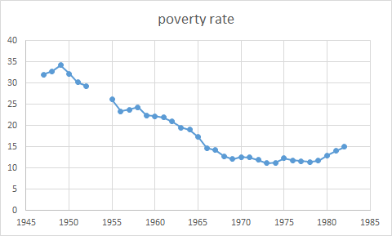
U.S. Poverty Rate

Source: Plotnick, R. D., Smolensky, E., Evenhouse, E., & Reilly, S. (1998)

The overall trend of poverty since the late 1940s has been on a declining trend. However, in 1958 there is a slight bump in the declining trend, the poverty rate increase from 23.8 in 1957 to 24.3 percent. This was the year that the Asian Flu occurred. To know whether the increase in the poverty rate come from the impact of the flu or not, we evaluate the factors that causes the change in the poverty trend from the section above. If those factors were impact by the influence of the flu, then we can conclude that the flu cause the poverty to increase.

Family Structure
In family structures, it can be divided into two factors to be considered which are the change in family members and the change in people’s behavior on family structure during epidemic. When one of the family members is gone due to an epidemic, they have less income with a little decrease in consumption, which leads to poverty. However, the symptoms of the Asian Flu were mild and hardly killed people. It can be concluded that it had no significant effect on Poverty. On the aspect of people’s behavior, this pandemic did not cause any change to the behaviors of the people that leads to the change in family structure towards a single parent family, therefore, an increase in poverty did not come from the change in family structure.

Real Median Wage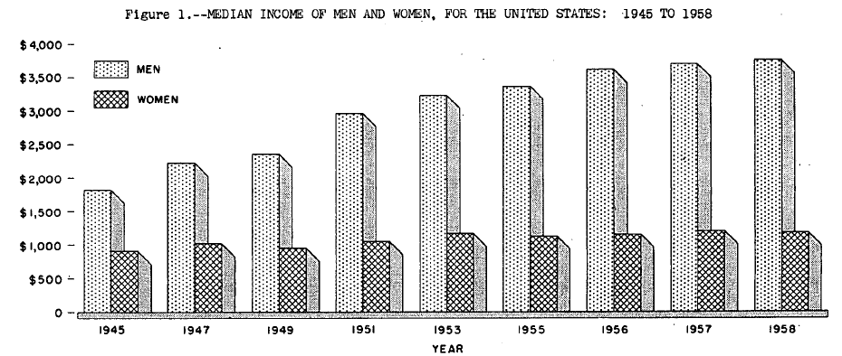
Source: U. S. Department of Commerce, (1960)

In 1958, the average income of men remained at the same level ($3700) as in 1957, despite the decline in economic activity that extended over much of the year. This was partly from continuing advances in the earnings of workers under long-term agreements before 1958. Another factor is from the result of wage contracts negotiated during the year, therefore, the increase in the poverty rate during the year of 1958 was not the result from a decrease in real median wage.

Unemployment Rate
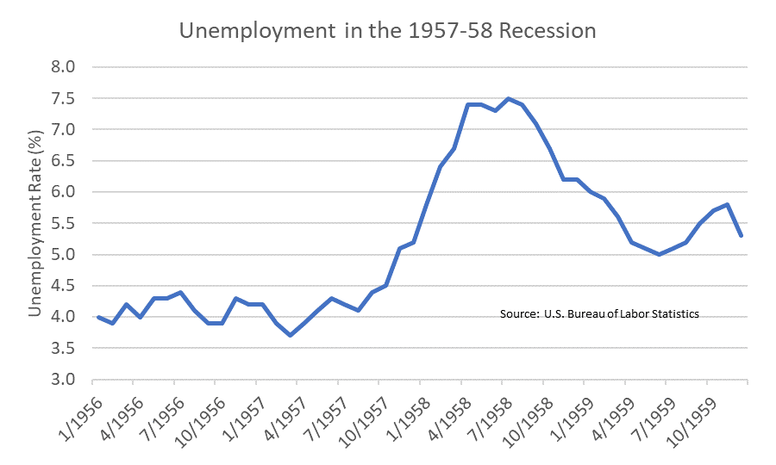
Unemployment rate is one of the indexes that we can observe a significant change over the year 1958. The recession of 1958 forced over 5 million people out of work that is 7.5 percent of the labor force in April and reached a low point for general economic activity. Unemployment rate at 7.5 percent which is a peak unemployment rate since 1950. The industries that received the hardest hit are the durable goods manufacture and the lumber, mining, and textile industries were the industries because of major decreases in consumer consumption.
During the 1957-1958 there was a slight increase in the unemployment rate in the USA from 5.2(1957) percent to 6.2(1958) percent while the unemployment rate from the past 2 year (1955 to 1956) was 4.2 percent. Unemployment was highest in industrial areas in Northeast and Midwest and in mining areas. For instance, Michigan is one of the states with a high unemployment rate of 11 percent, and Detroit also set a record for unemployment rate at 20 percent.
One factor that caused unemployment was consumer confidence. Consumer confidence directly affects higher unemployment because of less spending. During an economic decline, employees believe that their real income will decrease then they will cut down on spending for non-essential goods. From 1957-1958, consumer optimism declined because of the attitude toward economic condition. For example, the index of consumers’ expectations in long term and short-term regarding Business conditions between 1956-1958 sharply decreased from 100 percent in 1956(assume 1956 to be 100 percent) to 72 percent in May 1958 which is a large drop in economic expectation due to recession in 1957.
The reason why we mainly focus on consumer spending is that consumer spending has a negative relationship with unemployment rate which means increasing in consumer spending will lead to decreasing unemployment. So, we divided consumer spending into 1) not in a labor force + self-employed and 2) employee. In this part we evaluate each spending unit into which group of wage earners is affected the most.
Total spending units in 1958 consisted of 1) self-employed or not in a labor force of approximately one-third of a total spending 2) employee spending units was a large proportion of 69 out of 100. Comparing with the previous year, self-employed or not in a labor force slightly increased by 2 percent while employee spending insignificantly dropped by 2 percent. In addition, employed with a full year job was less interesting compared with employees who work less than a full year, so people interested in less than a full year job this causes people, who worked 26 weeks or less, was higher in 1958 than in 1957.
In both years (1957-1958), the large proportion of unemployment were unskilled and semiskilled workers, nonwhite persons, and less educated. Unemployment was high in both years due to spending units per head. In 1957, the most affected group of people in unemployment were young and inexperienced workers that they just entered the labor force. However, the most affected group in 1958 was a group that had more skill, older, and average education compared with 1957. It depends on occupations such as semi-skilled workers who work in durable goods that are affected the most by the recession. Semi-skilled also represented a larger proportion of workers who worked less than a full year in 1958 than in 1957. The main reason for the increasing unemployment rate between 1957 to 1958 were age and educated groups. In both years, under 25 were affected, but the highest rise took place in the middle age ranges (35-44) and (45-54).
In conclusion, higher unemployment rate affected a group that works in durable goods and the lumber, mining, and textile industries. It forced over 5 million people out of work which reached a peak unemployment rate since 1950. Total spending of employees dropped by 2 percent compared to last year while total spending of not in a labor force increased by 2 percent which means overall spending will drop because employees will have larger effect than unemployment. People tend to work at part time jobs instead of working full year job due to a recession and working contracts. At the beginning of 1957, it affected a group of people that just entered into a labor force because they lack experience and lack of skill. The most affected group of workers in 1958 were higher-skilled and semi-skilled worker with average education and non-white person.

Cause of unemployment

From the section above, an increase in poverty rate can be implied from the increase in unemployment rate, however, we still cannot conclude whether the Asian flu cause an increase in poverty or not. To find the answer, we evaluate the root cause of an increase in unemployment by looking at the factors that causes a decrease in economics activities. If the decline in economic activities is originated from the spread of the Asian Flu, then we can conclude that the disease causes poverty.
Consumption and Production
Starting with the data we have found. Auto sales fell 31% over 1957, making 1958 the worst auto year since World War II. In just three years, car sales fell from almost 8 million purchases in 1955 to 4.3 million purchases in 1958. Motor vehicle production is running at 101,266 units a week, compared with 161,865 vehicles in the comparable week 1957. One of the major reductions of consumption and production is the automobile industry (Turley, 1976).

People consume less goods, especially durable goods. Durable goods manufacturers and the lumber, mining, and textile industries were three of the industries that were hit the hardest due to a severe drop in unfulfilled orders for durable goods and a decreasing demand for commodities and other materials. From the data we have found, New car sales took a sharp dive as middle-class consumers decided to keep their cars for longer instead of upgrading after a few years. The sale of the car drops rapidly which leads to many problems.
The reason why the drop in car sale is important is the revenue generated from automotive-related purchases represents a crucial source of funds for government operations. For instance, in 1974 the Federal Government collected $6.1 billion in excise taxes on such purchases as motor fuel, tires, trucks, buses, and trailers. State revenues from motor use taxes amounted to 16 percent of total funds collected by the states in fiscal 1974. That is a large amount that can change many things.
In this case, the reduction in consumption and production. In an effort to overcome declining auto sales, one of the hardest hit sectors of the slump, the Beyer DeSoto dealership of St. Louis put its salesmen on duty for 64 hours straight, as part of a sell-a-thon that raised sales 73%. The falling car sales make the large firms in the automobile industry such as Ford Motor company to collapse. The collapse of Ford Motor triggered panic in the industry. The collapse is also one of the major factors contributing to the decline in business sentiment which led to recession.
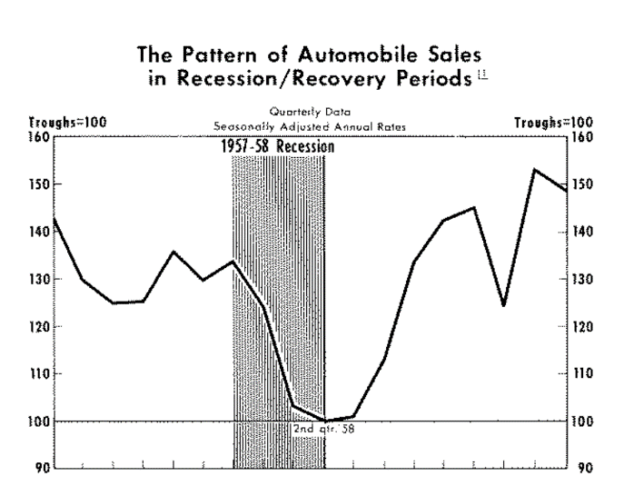
Other factors that contributed to the falling car sell is the tight monetary policy. The tight monetary policy also weakened the car sale, this makes the car sale to reduce by 30 percent. Other businesses such as Housing construction, by 1957, new houses had fallen to about 1.2 million units. The tight monetary policy with a higher interest rate had slowed housing construction activity, this slower housing construction caused housing supply to decline and hence shifted the housing prices upward.
Source: (Richards, 2020)
Another thing we should be concerned about is the consumer confidence. The impact from consumer confidence is crucial. The downward of the economic trend made the confidence of the consumer reduced. Consumer confidence had declined gradually since the onset of the recession and reached its lowest confidence at 78.5 in the first quarter of 1958, which was a 32% decline from the level before the recession. Likewise, business confidence also declined gradually since the onset of the recession, which was at its lowest growth at 33, fell by 40% from the level before the crisis occurred. This pessimism was then transmitted into high unemployment.
This was apparently in Personal Consumption Expenditures, or PCE. While the quarterly drop in PCE may seem mild, it is one of only four declining quarters from 1955 until today, with another being in the recession of 1960 and the final two being Q1 and Q2 of 2009 (with these latter two admittedly being much worse).
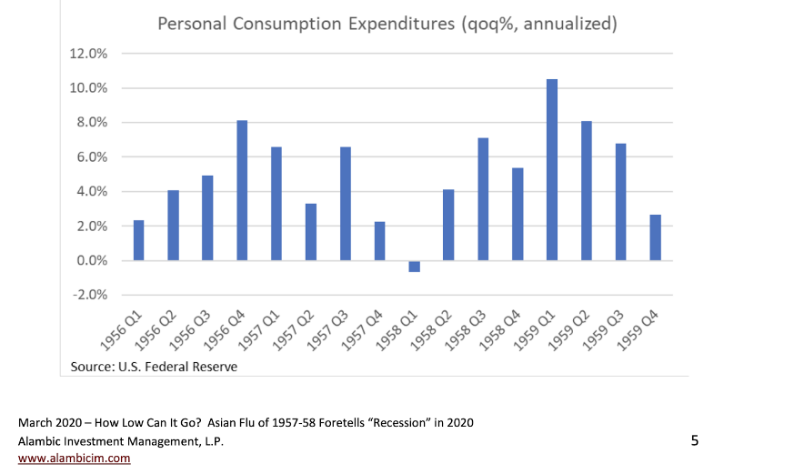
To sum up from the data and the graph shown above, one of the main factors that contributes to the rise in the unemployment rate is the drop in consumption. It consisted of two main factors that lead to the drop in consumption: the car sales dropped, and the fall of consumer confidence. Perhaps, using the data to conclude, the outcome is likely to be that the drop in consumption is occurring due to the car sales dropped and the consumer confidence fell which implies that Asian influenza has no significant effect on the consumption.
Source: (Richards, 2020)

Export and import
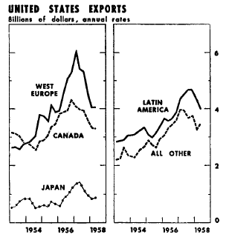
Source: Board of Governors of the Federal Reserve System (U.S.). (1958)
One of the main factors that caused the reduction in GDP in the year 1957-1958 was the fluctuation in import and export. For us to be able to link the causality between Asian flu and the fluctuation in import and export, further analysis of the cause of the fluctuation is required. For the reasons mentioned prior, this section of the paper would start by the analysis of the data and information gathered.
From the mid-1957 to early 1958, the United States export dropped significantly. The decline in foreign purchases declined by $4 billion annually. This “was one of the major factors in eight-month decline in United States economic activity after August 1957” (Federal Reserve Bulletin, 1958, p.1153). To better understand the decline in export, we must understand the reasons behind the rise in export before this period. A significant growth in United State exports from 1954 to 1957 was largely concentrated in capital goods and industrial materials, this reflects a strong demand abroad associated with the expansion of productive capacity throughout the world.
After the period of expansion, the government in industrial countries start to impose fiscal and monetary policy to restrain the economic boom, this causes the investment expenditures to begin to level off. Supply of industrial materials in America starts to increase according to the drop in demand in other countries, this causes a decline in raw material price on the world market at varying dates in 1957 and early 1958. The decline in prices causes the value of the export in the non-industrial countries to decrease, many of these countries were already running on a trade deficit, this generates a draining in their reserves which later cause them to reduce their import to slow their reserve drains.
Moreover, the decline in United States merchandise exports, from $20 billion annual rate in the first half of 1957 to $16 billion in early 1958, was concentrated in export to industrial countries. Exports to Canada, West Europe, and Japan were 30 per cent lower in the first of 1958 than a year earlier. Total shipment to nonindustrial countries began to decline at the end of 1957.
Over half the decline in total exports affected industrial materials. Export of steel, steel scrap, and other metals in the spring of 1958 were 40 per cent lower in value than in 1957, the decline in value partially comes from the decline in price. In addition to the industrial material the decline in export of raw cotton and coal were also large.
On the import side, the decline in imports consist of a decline in imports of metals, crude, semi-finished materials, and other materials. Imports of goods and services also dropped sharply at the end of 1957, however in the first half of 1958, the import only dropped by 3 per cent from a year earlier. Yet, the total imports during 1957-1958 was buoyed by further advances in imports of manufactures form West Europe and Japan, and by a larger import of meat mostly from Canada. The impressive growth in imports of automobiles continued to grow into 1958, making the value of automobiles import nine times as large as four years earlier. Despite the drop in import, the drop is so slight that it is not an important part that causes the fluctuation in United States economic activity.
By evaluating the total amount of import and export, the first conclusion can be drawn from the data that the major factor that causes a slowdown in economic activity in the United States is the decline in export. From the data, the drop in export is much greater than import, and as the demand in export drop, it can cause the demand of production in the country to drop and lead to a decrease in demand of labor. The second conclusion is that the major element that causes the drop in export is rooted from the contractionary fiscal and monetary policy in the oversee countries. As the growth in export during 1954-1957 majorly comes from capital goods and industrial material, this can be explained by the demand for expansion in productive capacity. Later, when the government attempts to reduce the pace of the growth by imposing a contractionary policy, the investment expenditure starts to drop and therefore causing the drop in demand of capital goods and industrial materials, this causes the export to decline significantly as the contractionary policy happens throughout the world.
From this, it can be seen that Asian Flu did not contribute any types of activities that causes the exporting activities to slow down, most of events that causes the slow down in export and import has come from other factors.

COVID-19

COVID-19 has created both a public health crisis and an economic crisis in the United States. It leads to dramatic swings in household spending. The pandemics have disrupted people’s lives and pushed the hospital system to its limit. Hence, created the economic slowdown. SMEs’ revenue fell by 20 percent.
In November 2020, the COVID 19 has the number of infected people in the USA of 11.6 million and the number of deaths is 250,000 people. The world infected case is 55.6 million and the number of deaths is 1.34 million. Thus, people have found ways to stop the disease by cleaning themselves more such as washing their hands more often, wearing a mask, and social distancing. However, the government has to come and fix the problem as well. Lockdown has been mainly occurring during the COVID19 to curb the spreading of the pandemics.
Lockdown or shutdown has an impact of slowing the spread of the COVID19, however, it also has a negative impact. Lockdown reduced the economy's capacity to produce goods and services. The total number of hours worked fell by about 60 percent. in March. Interestingly, the fall of the number of works is mostly by reduced employment and temporary furloughs but not by reducing work hours. Due to the lower goods produced, many firms began to reduce their employees by laying off them. Between March and April, a firm that has employment with 20 employees reduces their employment by 16 percent; for a bigger size of firm with the employee ranging from 20 to 49 employees was declined for 22 percent (Wilmoth 2020). Labor market has been hit quickest and most severe.
Many households encountered the rental fee problems. They are forced out of work, so having less than two month’s income in liquid assets and having high debt-to-income ratios is a problem for them (Kolomatsky, 2020). Although the government had increased the federal payment, it was inadequate for the households to pay the rental fee in most parts of the US. The data in late July illustrated 26 states more than one-fifth of renting households had not yet paid their rent for June, and that in five of those states (including New York) one-third of households had not yet paid their rent. Therefore, many workers are forced to be out of work during the pandemics. The unemployment rose more than 14 million, from 6.2 million in February to 20.5 million in May 2020. Therefore, many workers are also forced to be in poverty.
Comparing to Asian Flu, COVID-19 causes the economic activities to decrease significantly due to the measure implemented by the government. The decrease in economic activities has a major impact in an increase in unemployment which is one of the main factors that cause the poverty to increase. However, for Asian Flu, the government measure to handle the disease did not have as much impact on the economic activities, therefore, the impact of unemployment from the disease was not significant.

Conclusion

From our findings, the poverty rate that increase during the year of the spread of the disease did not come from the disease. By examining the factors that causes the poverty to increase during the year of 1958, we find that a significant factor that cause the poverty to increase is unemployment rate. The unemployment rate increase from 5.2 to 6.2 percent over the year 1957-1958. This unemployment is originated from a decline in consumption, production, and total amount of export. The decline in these areas cause the economic activities to slow down, therefore, an increase in unemployment. However, these causes of these decline are unrelated to Asian Flu, therefore, Asian Flu did not cause an increase in poverty during that period.
From our conclusion that Asian Flu did not cause poverty, we exemplify COVID-19 as the disease that causes the poverty to increase. We find that the way COVID-19 has caused poverty is through the channel of unemployment caused by government measures of lock down and work from home. From this study and the case of COVID-19, the focus for the future research for pandemics and poverty can possibly be a research that find the disease that causes poverty through other aspects beside unemployment, such as poverty from the pandemic that are caused by the change in family structure or change in immigration.

References
1957-1958 Pandemic (H2N2 virus). (2019, January 02). Retrieved November 06, 2020, from https://www.cdc.gov/flu/pandemic-resources/1957-1958-pandemic.html
Alambic Investment Management,L.P. (2020). How Low Can It Go? Asian Flu of 1957-58 Foretells “Recession” in 2020. Retrieved November 1, 2020, from https://www.alambicim.com/post/how-low-can-it-go-asian-flu-of-1957-58-foretells-recession-in-2020
Board of Governors of the Federal Reserve System (U.S.), 1935-. (1958). Federal Reserve bulletin: The 1957-1958 Recession in World Trade. Retrieve from https://fraser.stlouisfed.org/files/docs/publications/FRB/pages/1955-1959/14330_1955-1959.pdf
Brown, D. (2009, August 26). Lessons to be learned from 1957 pandemic. Retrieved November 06, 2020, from https://www.seattletimes.com/seattle-news/health/lessons-to-be-learned-from-1957-pandemic/

Cobos AJ, Nelson CG, Jehn M, Viboud C, Chowell G. Mortality and transmissibility patterns of the 1957 influenza pandemic in Maricopa County, Arizona. BMC Infect Dis. 2016 Aug 11;16(1):405. doi: 10.1186/s12879-016-1716-7. PMID: 27516082; PMCID: PMC4982429.
Federal Reserve bulletin. (1959). 1959 Survey of Consumer Finances. Retrieved from https://isr.umich.edu/wp-content/uploads/historicPublications/1959SURVEYOFCONSUMERFINANCES_1502_.PDF
Hoynes, Hilary, W., Marianne E. Page, and Ann Huff Stevens. 2006. "Poverty in America: Trends and Explanations." Journal of Economic Perspectives, 20 (1): 47-68.DOI: 10.1257/089533006776526102

Lauren B, Kristen E, Broady, Wendy Edelberg, Jimmy O’Donnell. Ten facts about COVID-19 and the U.S. Economy. Retrieved September 17, 2020 from https://www.brookings.edu/research/ten-facts-about-covid-19-and-the-u-s-economy/.
LANGMUIR, ALEXANDER Duncan. “EPIDEMIOLOGY OF ASIAN INFLUENZA.” American Review of Respiratory Disease, www.atsjournals.org/doi/pdf/10.1164/arrd.1961.83.2P2.2.
Little, B. (2020, March 18). How the 1957 Flu Pandemic Was Stopped Early in Its Path. Retrieved November 06, 2020, from https://www.history.com/news/1957-flu-pandemic-vaccine-hilleman

Moon, E. (2020, June 01). How the U.S. Fought the 1957 Flu Pandemic. Retrieved November 06, 2020, from https://www.smithsonianmag.com/smithsonian-institution/united-states-vaccine-1957-flu-pandemic-180974906/

Mueller, E. (1966). The Impact of Unemployment on Consumer Confidence. Public Opinion Quarterly, 30(1), 19. doi:10.1086/267379

Plotnick, R. D., Smolensky, E., Evenhouse, E., & Reilly, S. (1998). Inequality, Poverty, and the Fisc in Twentieth-Century America. Journal of Post Keynesian Economics, 21(1), 51-75. doi:10.1080/01603477.1998.11490179

Recession Tips. 2020. The Recession Of 1957-1958 (Eisenhower Recession) - Recession Tips. [online] Available at: <https://recession.tips/eisenhower-recession-1957-1958/> [Accessed 6 November 2020].

Rogers, K. (2020, March 26). 1957 flu pandemic. Retrieved November 06, 2020, from https://www.britannica.com/event/1957-flu-pandemic

Simpson, J. (2020, April 19). The Man Who Beat the 1957 Flu Pandemic. Retrieved November 06, 2020, from https://blogs.scientificamerican.com/observations/the-man-who-beat-the-1957-flu-pandemic/

Turley, J., 1976. Automobile Sales in Perspective. Review, 58.

U. S. Department of Commerce, (1960), Current Population Reports: Consumer Income, Washington 25, D. C. Retrieved from https://www2.census.gov/prod2/popscan/p60-033.pdf

Viboud, Cécile & Simonsen, Lone & Fuentes, Rodrigo & Flores, Jose & Miller, Mark & Chowell, Gerardo. (2016). Global Mortality Impact of the 1957–1959 Influenza Pandemic. Journal of Infectious Diseases. 213. 738-745. 10.1093/infdis/jiv534.

Viboud C, Simonsen L, Fuentes R, Flores J, Miller MA, Chowell G. Global Mortality Impact of the 1957-1959 Influenza Pandemic. J Infect Dis. 2016 Mar 1;213(5):738-45. doi: 10.1093/infdis/jiv534. PMID: 26908781; PMCID: PMC4747626.

William C. Shiel Jr., M. (2017, January 25). Definition of Asian flu. Retrieved November 06, 2020, from https://www.medicinenet.com/script/main/art.asp?articlekey=26428

Yoneyama T., Mukkai S., Influence of the Cold War upon Influenza Pandemic of 1957-1958 Multidisciplinary Science, Computer Science 1-6 https://arxiv.org/ftp/arxiv/papers/1006/1006.0020.pdf

