EE325: Mini Research Report Template
Member 1 _____________________________________________ i.d.________________
Member 2 _____________________________________________ i.d.________________
Member 3 _____________________________________________ i.d.________________
Member 4 _____________________________________________ i.d.________________
- Topic (or research question) ___________________________________________
- Motivation (1 paragraph)
- Discuss why is this topic interesting.
- Population of Interest (1-5 sentences)
- What is the population of interest?
- Data (0.5 – 1 page)
- How did you obtain your data? (If you obtain a complete dataset from a website, explain how the data-collector(s) collected their data.)
- Do you think your data can be a representative of the population of interest?
- Use a table to summarize variables’ name and definition. See some examples in Appendix A.
- Make a descriptive statistics table (using the “summary” command on STATA.)
- Results (as appropriate)
- Show your results in the standard format (use the “outreg2” command to help you save time).
- Discuss your results, e.g. compare adj-R² from different specifications. Justify the specification which you think is the best.
- Discuss the impacts of each variable on the Y variable (based on your best regression).
- Discuss whether you your estimation (of your best regression) has violated any of the 5 MLR assumption. If so, how?
- Limitations and Discussion (0.5 – 1 page)
- What could be done to improve this research?
- Reference (Consult the guideline in Appendix B)
- If you obtained a complete dataset from a website, give reference to this dataset.
- Give reference to any source of information that you use for the writing of this report.

Appendix A
Example 1:
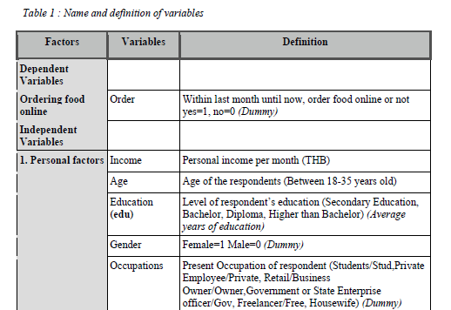

Example 2:
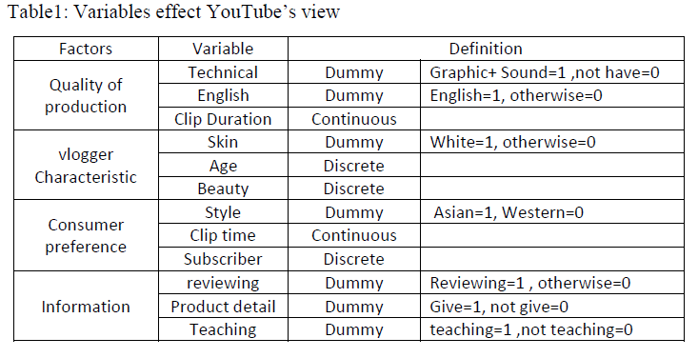

Example 3:
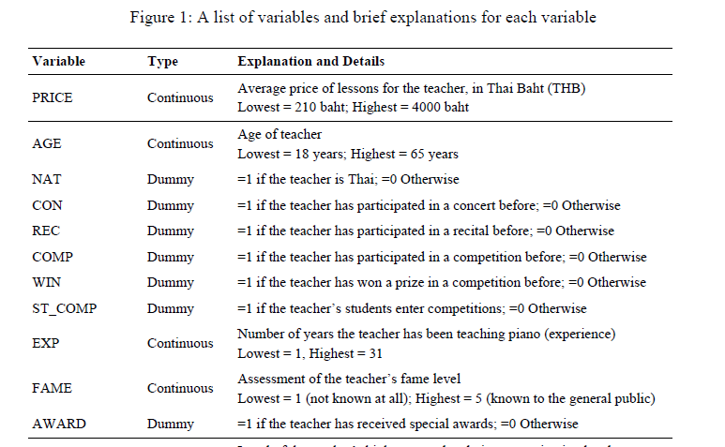

Appendix B
(APA format – the references should be arranged in alphabetical order.)
Bernstein, M. (2002). 10 tips on writing the living Web. A List Apart: For People Who Make Websites, 149. Retrieved from http://www.alistapart.com/articles/writeliving
Biswas, S. (2008). Dopamine D3 receptor: A neuroprotective treatment target in Parkinson's disease. Retrieved from ProQuest Digital Dissertations. (AAT 3295214)
Frook, B. D. (1999, July 23). New inventions in the cyberworld of toylandia [Msg 25]. Message posted to http://groups.earthlink.com/forum/messages/00025.html
Parker-Pope, T. (2008, May 6). Psychiatry handbook linked to drug industry. The New York Times. Retrieved from http://well.blogs.nytimes.com/2008/05/06/psychiatry-handbook-linked-to-drug-industry/?_r=0
United States Department of Housing and Urban Development. (2008). Indiana income limits [Data file]. Retrieved from http://www.huduser.org/Datasets/IL/IL08/in_fy2008.pdf
Wegener, D. T., Kerr, N. L., Fleming, M. A., & Petty, R. E. (2000). Flexible corrections of juror judgments: Implications for jury instructions. Psychology, Public Policy, and Law, 6, 629-654.
Wegener, D. T., & Petty, R. E. (1994). Mood management across affective states: The hedonic contingency hypothesis. Journal of Personality and Social Psychology, 66, 1034-1048.

*** For the Rules on making the APA citation format, please go to the Purdue Online writing lab website https://owl.english.purdue.edu/owl/resource/560/05/
- The reference for different types of sources should be constructed differently. For example, the reference format for books would be different from the reference format for online website, etc.
- Click on the link listed on the left-hand side panel to see how you should construct the citation list for each type of sources.
- It is important that you use the correct reference format. Papers without correct reference format will not be graded.
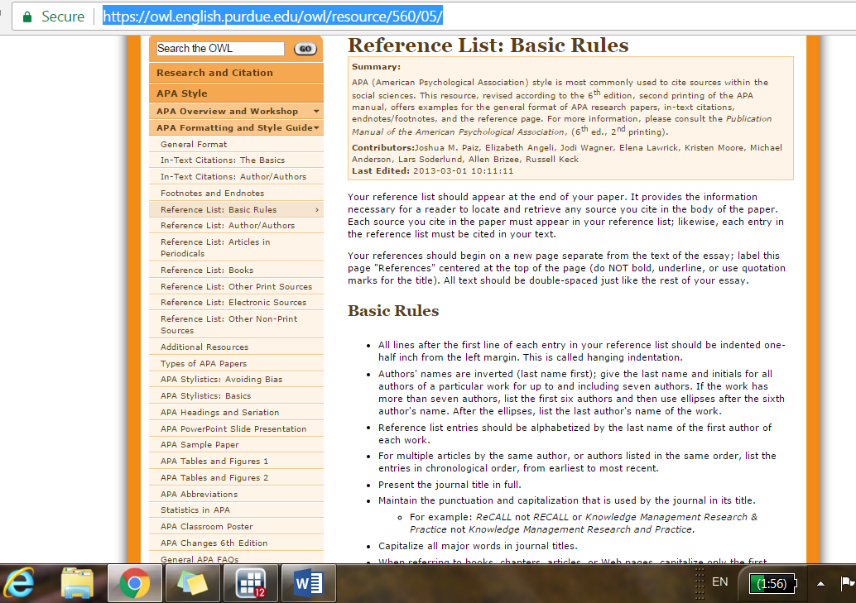

(MLA format – the references should be arranged in alphabetical order.)
"Athlete's Foot - Topic Overview." WebMD, 25 Sept. 2014, www.webmd.com/skin-problems-and-treatments/tc/athletes-foot-topic-overview.
Bagchi, Alaknanda. "Conflicting Nationalisms: The Voice of the Subaltern in Mahasweta Devi's BashaiTudu." Tulsa Studies in Women's Literature, vol. 15, no. 1, 1996, pp. 41-50.
Buchman, Dana. "A Special Education." Good Housekeeping, Mar. 2006, pp. 143-48.
Duvall, John N. "The (Super)Marketplace of Images: Television as Unmediated Mediation in DeLillo's White Noise." Arizona Quarterly, vol. 50, no. 3, 1994, pp. 127-53.
Lundman, Susan. "How to Make Vegetarian Chili." eHow, www.ehow.com/how_10727_make-vegetarian-chili.html. Accessed 6 July 2015.
Poniewozik, James. "TV Makes a Too-Close Call." Time, 20 Nov. 2000, pp. 70-71.

*** For the Rules on making the MLA citation format, please go to the Purdue Online writing lab website https://owl.english.purdue.edu/owl/resource/747/08/
- Click on the link listed on the left-hand side panel to see how you should construct the citation list for each type of sources.


