Assignment 6

What needs to be done is to clarify an order of ARIMA(p,d,q). It is recommended for us to identify the value of d by doing unit root to find values of p,d, and q in which the series are integrated. The answer from the table shows that p-value is <0.0001 lower than 0.05 rejecting the null hypothesis of unit root which means the return on spot is stationary.

The answer from the table shows that p-value is <0.0001 lower than 0.05 rejecting the null hypothesis of unit root which means the return on spot is stationary.
What we must do next is to implement ARIMA. As maximum lag equals to 5, we have to perform (1,0,1) (1,0,2) (1,0,3) (1,0,4) (1,0,5) (2,0,1) (2,0,2) (2,0,3) (2,0,4) (2,0,5) (3,0,1) (3,0,2) (3,0,3) (3,0,4) (3,0,5) (4,0,1) (4,0,2) (4,0,3) (4,0,4) (4,0,5) (5,0,1) (5,0,2) (5,0,3) (5,0,4) (5,0,5)

rspot
. qui arima rspot, arima(1,0,1) nolog
. est store arima101
. qui arima rspot, arima(1,0,2) nolog
. est store arima102
. qui arima rspot, arima(1,0,3) nolog
. est store arima103
. qui arima rspot, arima(1,0,4) nolog
. est store arima104
. qui arima rspot, arima(1,0,5) nolog
. est store arima105
. qui arima rspot, arima(2,0,1) nolog
. est store arima201
. qui arima rspot, arima(2,0,2) nolog
. est store arima202
. qui arima rspot, arima(2,0,3) nolog
. est store arima203
. qui arima rspot, arima(2,0,4) nolog
. est store arima204
. qui arima rspot, arima(2,0,5) nolog
. est store arima205
. qui arima rspot, arima(3,0,1) nolog
. est store arima301
. qui arima rspot, arima(3,0,2) nolog
. est store arima302
. qui arima rspot, arima(3,0,3) nolog
. est store arima303
. qui arima rspot, arima(3,0,4) nolog
. est store arima304
. qui arima rspot, arima(3,0,5) nolog
. est store arima305
. qui arima rspot, arima(4,0,1) nolog
. est store arima401
. qui arima rspot, arima(4,0,2) nolog
. est store arima402
. qui arima rspot, arima(4,0,3) nolog
. est store arima403
. qui arima rspot, arima(4,0,4) nolog
. est store arima404
. qui arima rspot, arima(4,0,5) nolog
. est store arima405
. qui arima rspot, arima(5,0,1) nolog
. est store arima501
. qui arima rspot, arima(5,0,2) nolog
. est store arima502
. qui arima rspot, arima(5,0,3) nolog
. est store arima503
. qui arima rspot, arima(5,0,4) nolog
. est store arima504
. qui arima rspot, arima(5,0,5) nolog
. est store arima505

Out of all the outputs, ARIMA(1,0,2) represents the lowest value; therefore, ARIMA(1,0,2) is the most suitable.
rfuture
. qui arima rfuture, arima(1,0,1) nolog
. est store arima101
. qui arima rfuture, arima(1,0,2) nolog
. est store arima102
. qui arima rfuture, arima(1,0,3) nolog
. est store arima103
. qui arima rfuture, arima(1,0,4) nolog
. est store arima104
. qui arima rfuture, arima(1,0,5) nolog
. est store arima105
. qui arima rfuture, arima(2,0,1) nolog
. est store arima201
. qui arima rfuture, arima(2,0,2) nolog
. est store arima202
. qui arima rfuture, arima(2,0,3) nolog
. est store arima203
. qui arima rfuture, arima(2,0,4) nolog
. est store arima204
. qui arima rfuture, arima(2,0,5) nolog
flat log likelihood encountered cannot find uphill direction
r(430);
. est store arima205
. qui arima rfuture, arima(3,0,1) nolog
. est store arima301
. qui arima rfuture, arima(3,0,2) nolog
. est store arima302
. qui arima rfuture, arima(3,0,3) nolog
. est store arima303
. qui arima rfuture, arima(3,0,4) nolog
. est store arima304
. qui arima rfuture, arima(3,0,5) nolog
flat log likelihood encountered cannot find uphill direction
r(430);
. est store arima305
. qui arima rfuture, arima(4,0,1) nolog
. est store arima401
. qui arima rfuture, arima(4,0,2) nolog
. est store arima402
. qui arima rfuture, arima(4,0,3) nolog
flat log likelihood encountered cannot find uphill direction
r(430);
. est store arima403
. qui arima rfuture, arima(4,0,4) nolog
. est store arima404
. qui arima rfuture, arima(4,0,5) nolog
. est store arima405
. qui arima rfuture, arima(5,0,1) nolog
. est store arima501
. qui arima rfuture, arima(5,0,2) nolog
flat log likelihood encountered cannot find uphill direction
r(430);
. est store arima502
. qui arima rfuture, arima(5,0,3) nolog
flat log likelihood encountered cannot find uphill direction
r(430);
. est store arima503
. qui arima rfuture, arima(5,0,4) nolog
. est store arima504
. qui arima rfuture, arima(5,0,5) nolog
. est store arima505

Out of all the outputs, ARIMA(1,0,1) represents the lowest value; therefore, ARIMA(1,0,1) is the most suitable.

. g fe_spot=rspot-rspothat_s
(1 missing value generated)

. g sfe=fe^2
(1 missing value generated)
. sum sfe if t>=2
Variable | Obs Mean Std. Dev. Min Max
-------------+---------------------------------------------------------
sfe | 7,683 3.19e-06 .0000348 1.61e-15 .0020963

rspot
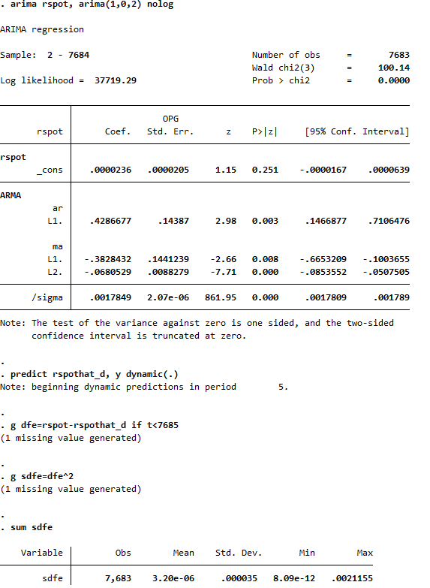

predict rspothat, y dynamic(7864)
twoway (line rspot t, sort) (scatter rspothat t,sort)

rfuture
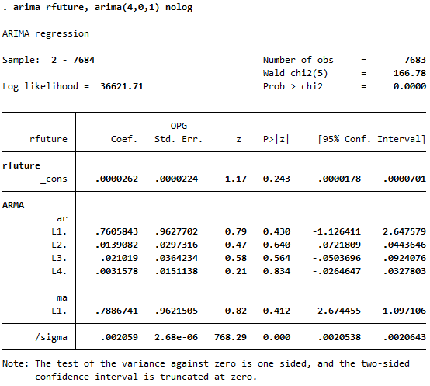
\

predict rfuturehat_s, xb
twoway (line rfuturehat_s t, sort) (scatter rfuture t,sort)

. g fe_future=rfuture-rfuturehat_s
(1 missing value generated)
. g sfe_future=fe_future^2
(1 missing value generated)

. sum sfe_future if t>=2
Variable | Obs Mean Std. Dev. Min Max
-------------+---------------------------------------------------------
sfe_future | 7,683 4.24e-06 .0000388 1.56e-15 .0018415

predict rfuturehat_d, y dynamic(.)
Note: beginning dynamic predictions in period 7.
. g dfe_future=rfuture-rfuturehat_d
(1 missing value generated)
. g sdfe_future=dfe_future^2
(1 missing value generated)

sum sdfe_future if t<7685
Variable | Obs Mean Std. Dev. Min Max
-------------+---------------------------------------------------------
sdfe_future | 7,683 4.25e-06 .0000388 6.46e-10 .0018373

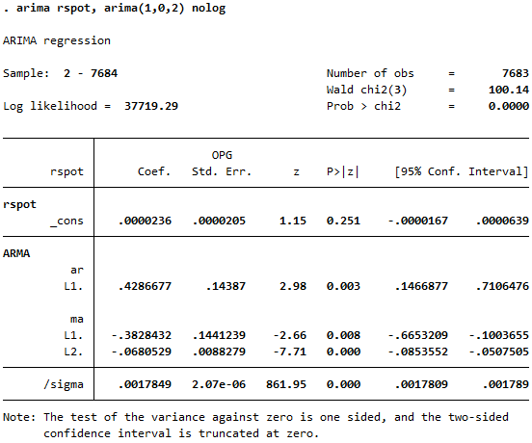

. predict rspothat, y dynamic(7864)
. twoway (line rspot t, sort) (scatter rspothat t,sort)

