1.
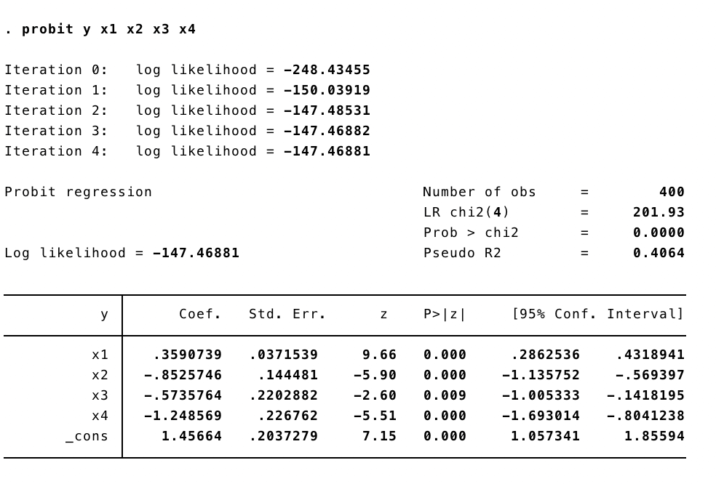
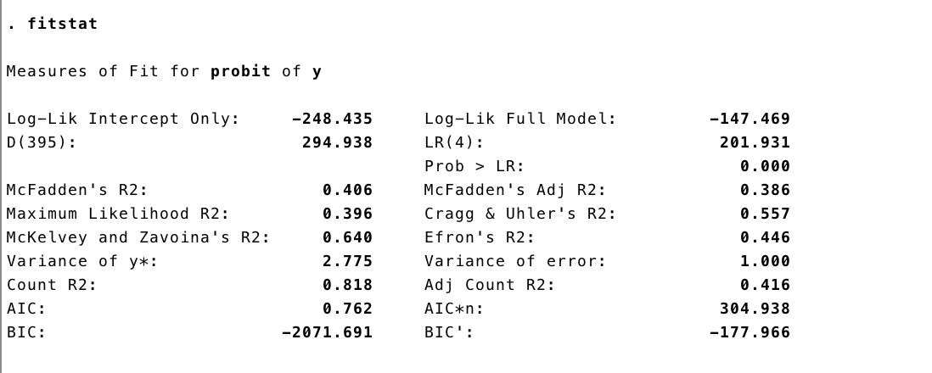

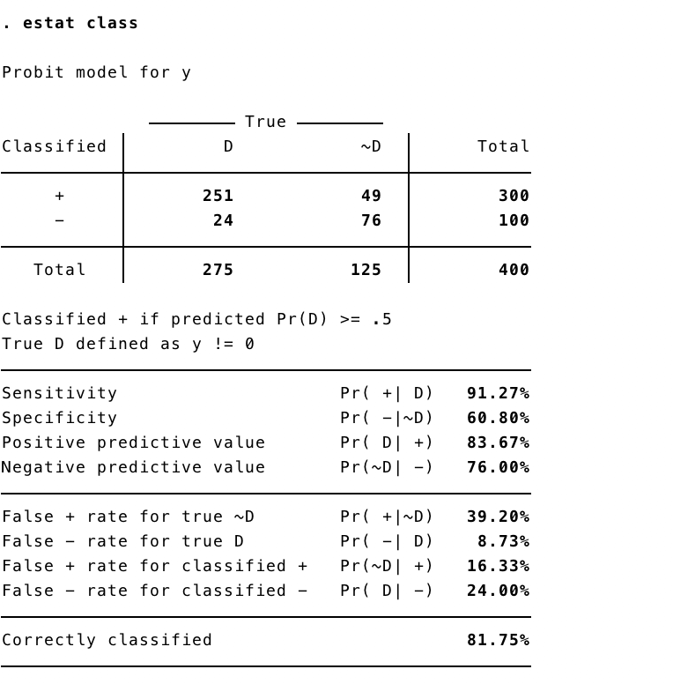
From the estimation using the Probit model

Overall Test
As we get the LR chi-square test of 201.93 with the p-value of 0.001, we can conclude that at least one of the regression coefficients in the model is not equal to zero. Therefore, all explanatory variables can be used in explaining the dependent variable.

Individual Test
All of explanatories variables get p-value lower than 0.05, this can be implied that each of them can be used to explain the dependent variable.

Pseudo R-square
From the Probit model we get the pseudo R-square of 0.4064. This can be used to compare when running another probit model whether which one can explain better.

Counted R-square
From the Probit mode, we get the counted R-square equal to 81.75%, this implies the number of correct predictions over total observation.

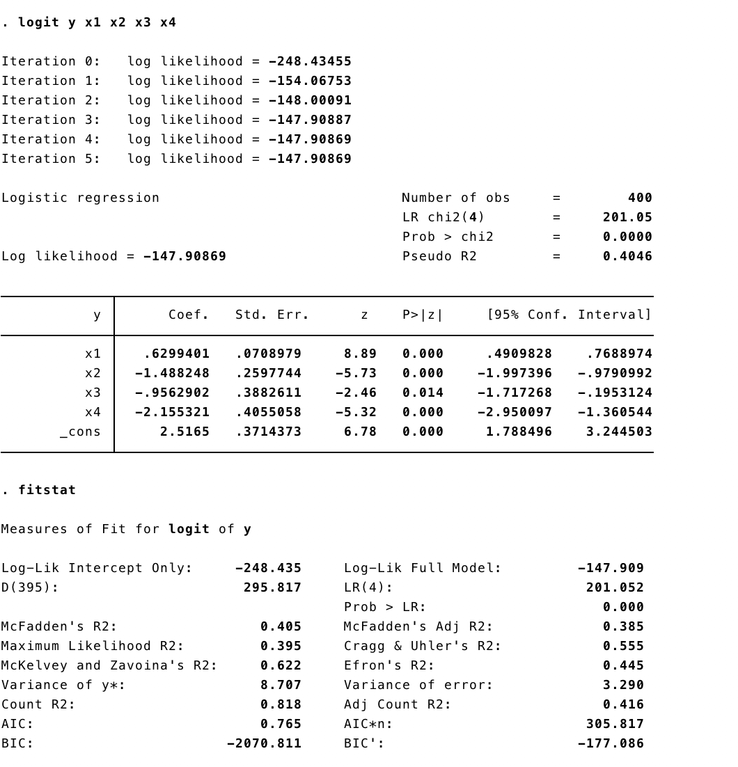

Overall Test
As we get the LR chi-square test of 201.05 with the p-value of 0.000, we can conclude that at least one of the regression coefficients in the model is not equal to zero. Therefore, all explanatory variables can be used in explaining the dependent variable.

Individual Test
All of explanatories variables get p-value lower than 0.05, this can be implied that each of them can be used to explain the dependent variable.

Pseudo R-square
From the logit model, we get the pseudo R-square of 0.405. This can be used to compare when running another logit model whether which one can explain better.

Counted R-square
From the Logit model, we get the counted R-square equal to 81.8%, this implies the number of correct predictions over total observation.

2.
Comparing Pseudo R-square between two models, Probit model can explain the data better since 0.4064 is greater than 0.405. So, it is more appropriate to use Probit model.

3.
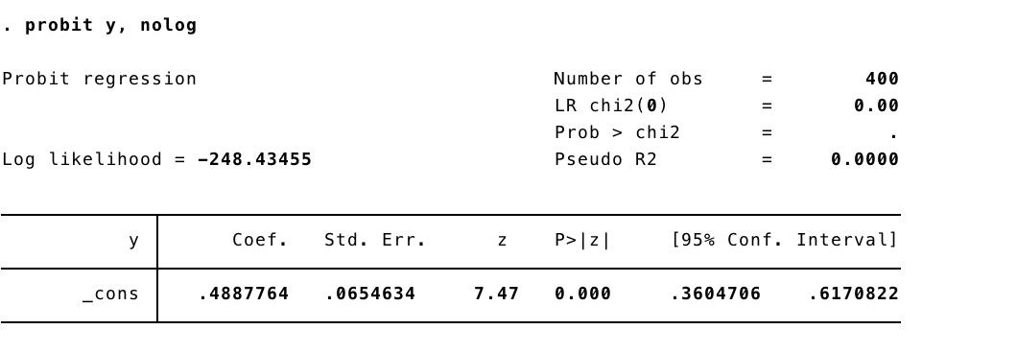

We get the overall LR-test statistic of 201.93 with the p-value of 0.000

4.
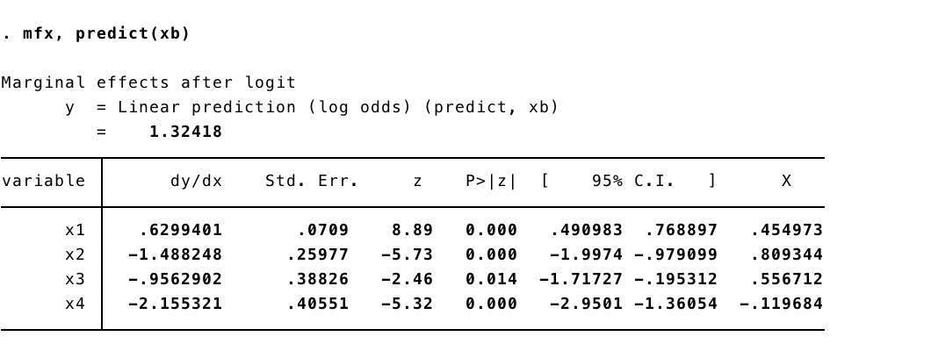
I hat = 2.52+0.62(0.45)-1.49(0.81)-0.96(0.56)+2.16(0.12)=1.32
5. 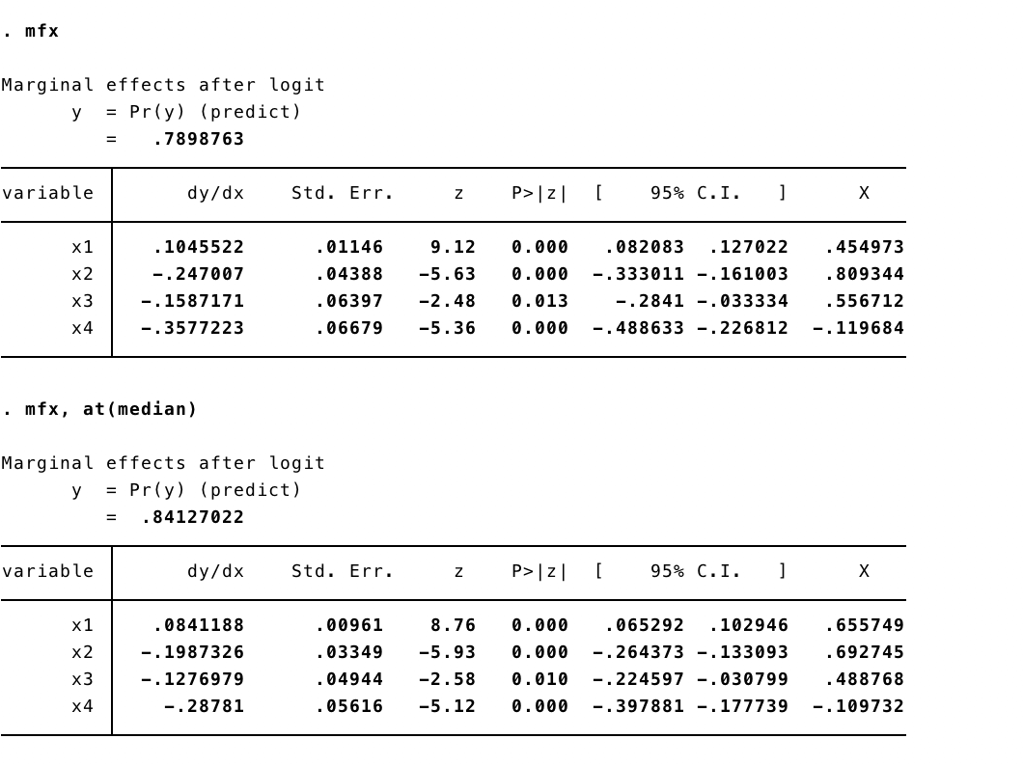
6.
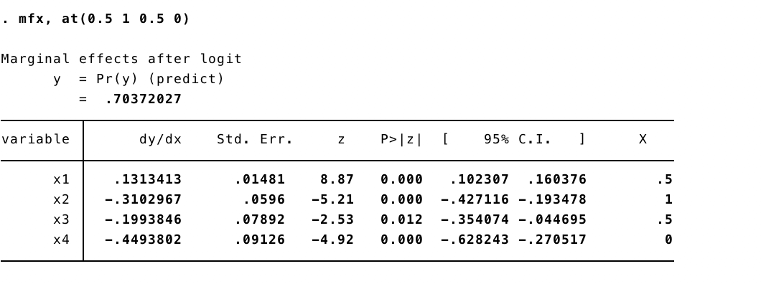

7.
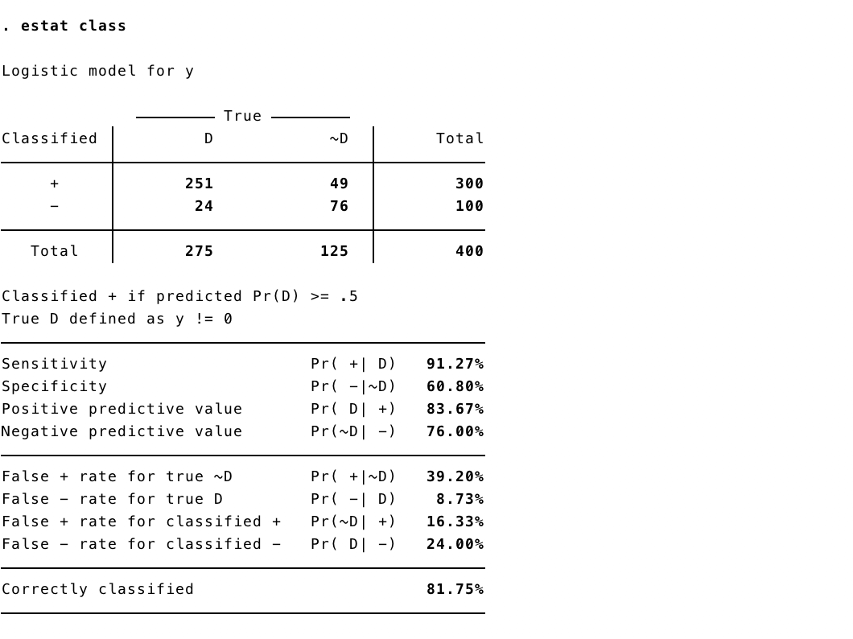

8.


