The S&P 500 breaks another record
Do soaring shares reflect irrational exuberance or declining competition?
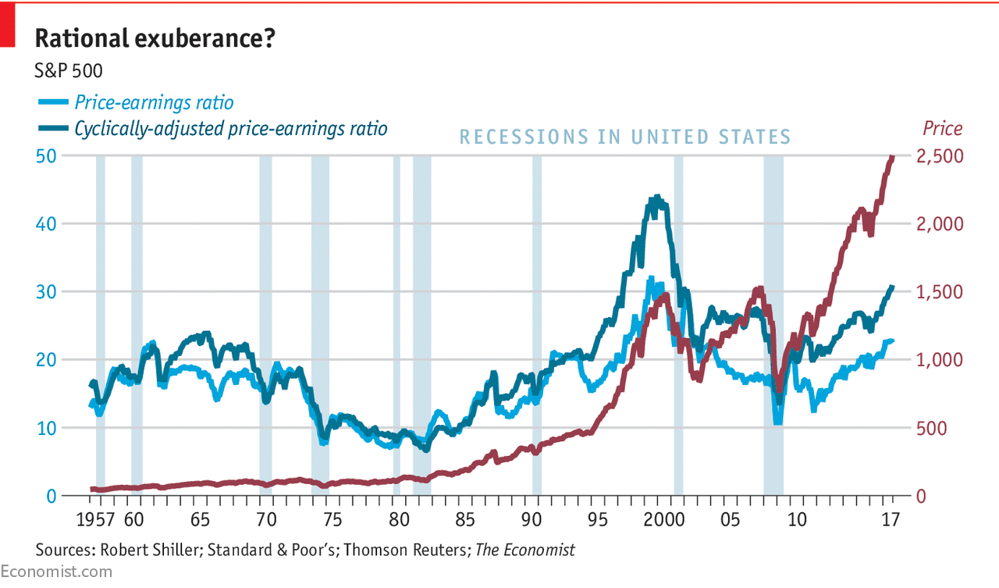

Graphic detail
Sep 18th 2017
by THE DATA TEAM

WHO would bet against the Sage of Omaha? In 2007 Warren Buffett, America’s most accomplished investor, predicted that during the next ten years the S&P 500, the country’s leading index of large-capitalisation shares, would outperform a portfolio of hedge funds. He offered a $1m bet to anyone who disagreed. Only Ted Seides, a hedge-fund manager, dared to take up Mr Buffett on the wager. Sure enough, he lost spectacularly. With eight months left before the decade was up, Mr Seides conceded defeat. His five hedge funds had produced a combined annual return of just 2.2%, against 7.1% for the S&P 500.
Launched on March 4th 1957, the Standard & Poor's 500—which, owing to multiple share classes and other oddities, currently consists of 505 stocks—is the most watched equity index in the United States. Over the past 60 years, the value of the shares in the index has grown by an average of 6.9% a year, to $21.2trn. Fully $3trn is invested in index funds that track its daily gyrations. Even by its own lofty standards, the S&P has been on a roll since it hit rock bottom during the global financial crisis: on September 15th it broke the 2,500 mark for the first time. An investor in Vanguard’s flagship S&P 500 index fund who bought shares on March 9th 2009 would have enjoyed a subsequent annualised return of 18.9%.
How long will the current expansion last? As a measure of animal spirits, Robert Shiller, a Nobel prize-winning economist, adjusts the S&P 500’s price-earnings ratio by comparing the current price to the 10-year average of earnings. If this cyclically-adjusted price-earnings ratio (CAPE) is higher than its long-run mark, that suggests that either prices must fall or earnings must rise for the index’s valuation to return to normal levels. The current ratio of 31 suggests that stocks are about 50% over-valued—a figure that has only been exceeded in the past 60 years during the dot-com bubble.
Bulls argue that the S&P 500’s constituents can justify this heady valuation. Big American companies are wielding increased market power, enabling them to earn outsized profits at the expense of America’s customers. Two-thirds of America’s top 900 industries have become more concentrated since 1997, and the top-four firms’ weighted-average share of revenues in each of America’s industries has risen from 26% to 32% in that time. If incumbent firms enjoy sufficient barriers to entry to retain their dominant positions, the S&P’s price-to-earnings ratio will be unlikely to revert to a long-run average that reflects a time when America’s economy enjoyed healthier competition. That might enable Wall Street’s long bull market to continue—but at what cost to Main Street?

