AC 201 Fundamental Accounting
Chapter 4 Adjustments, Financial Statements, and the Quality of Earnings

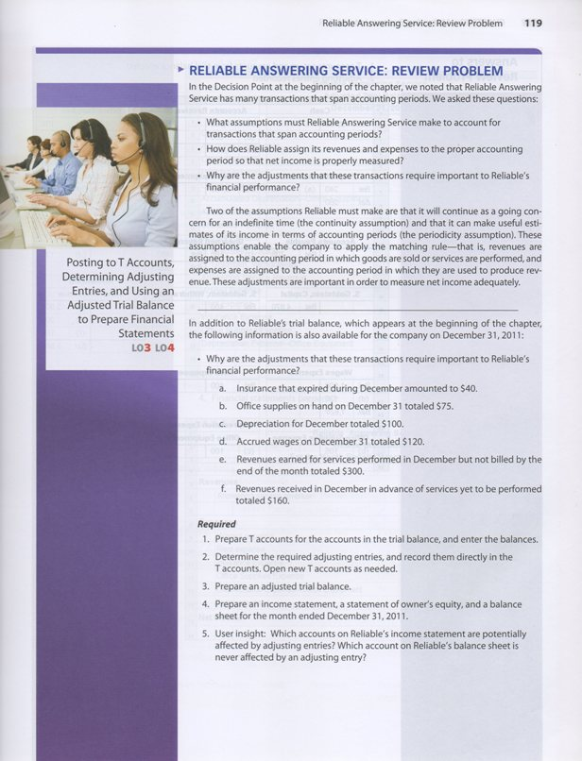

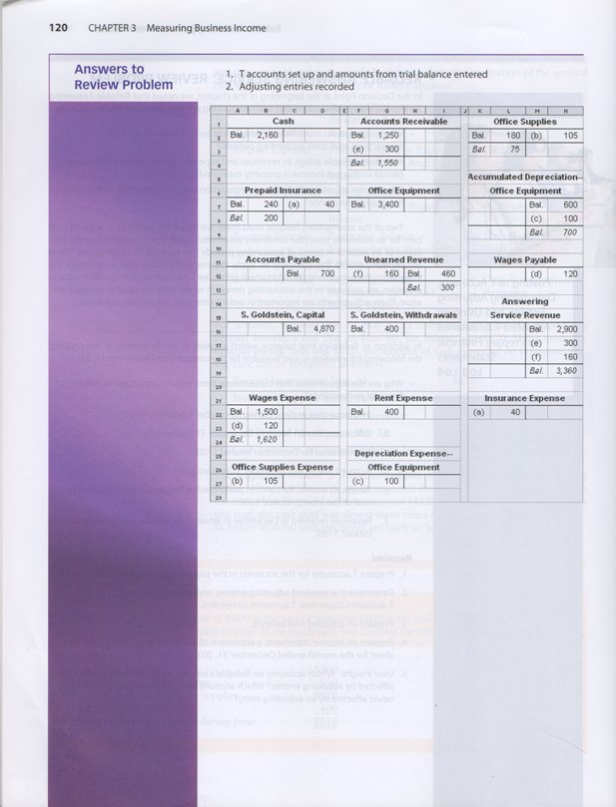

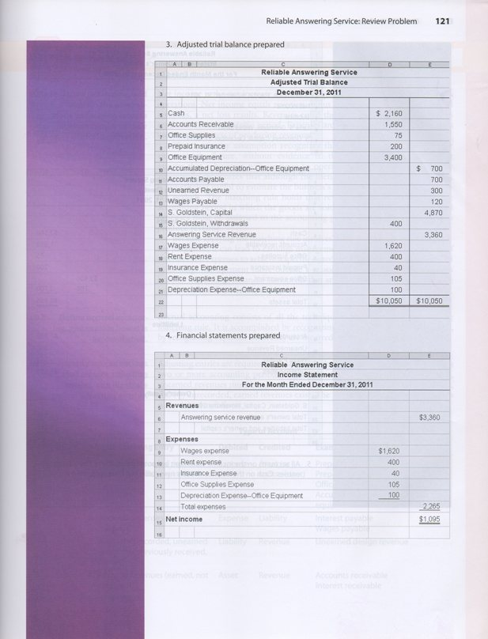

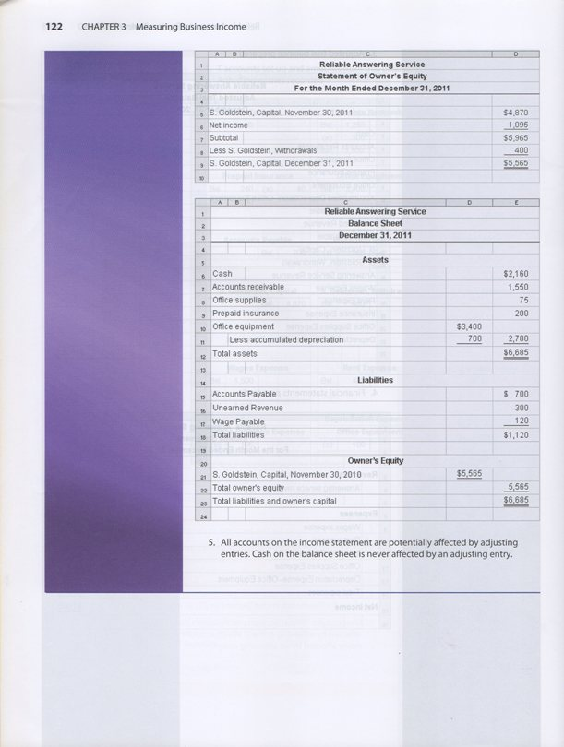

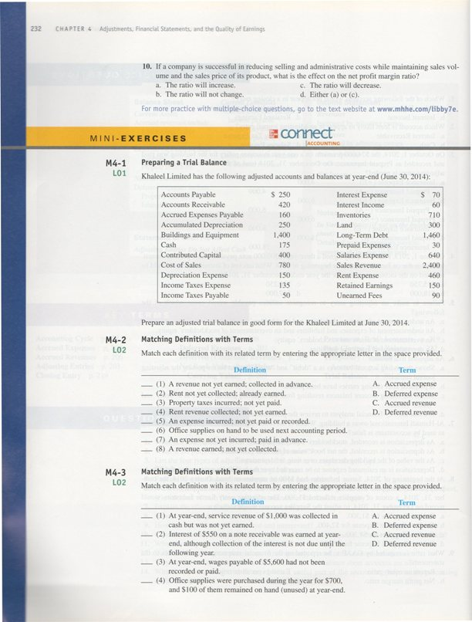

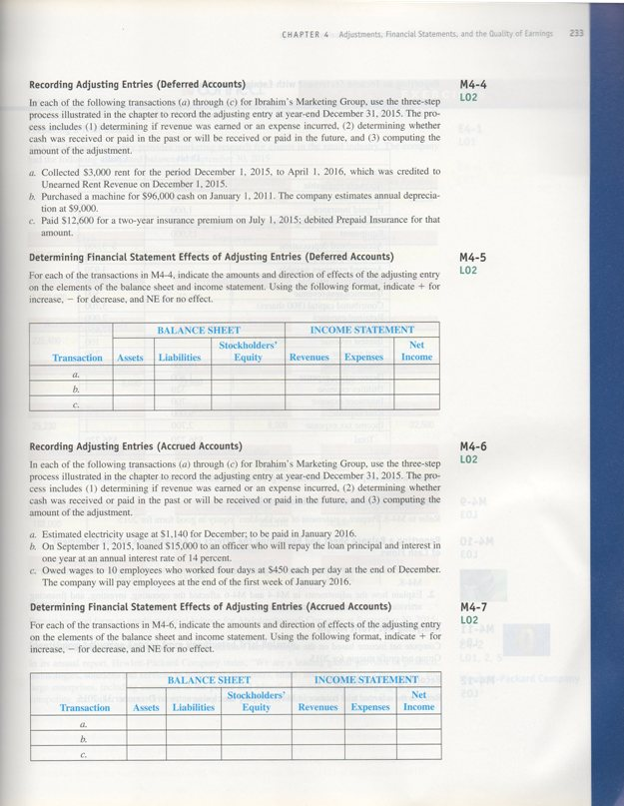

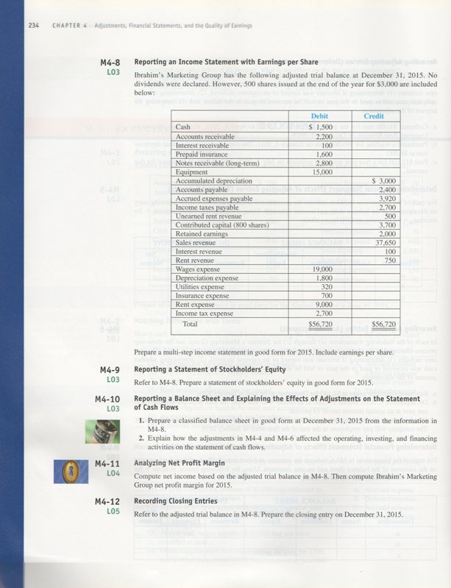

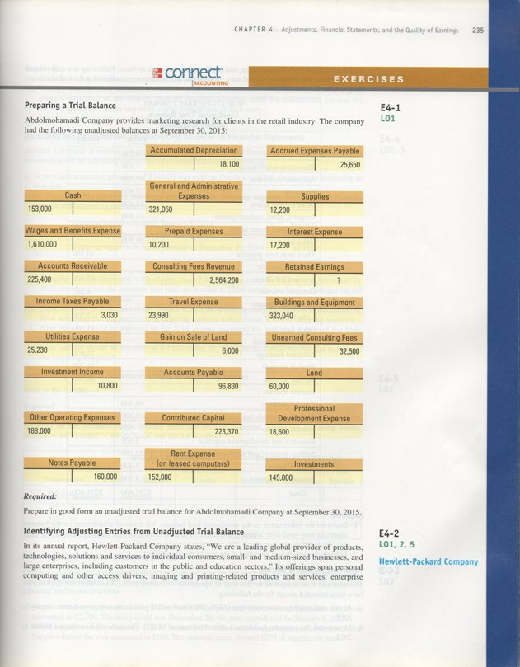

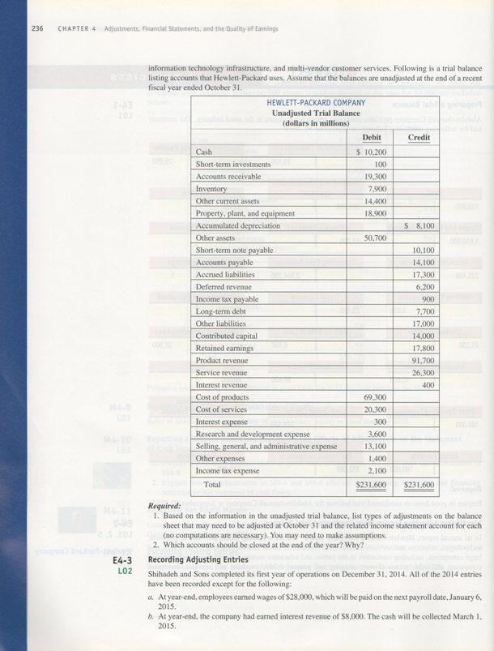

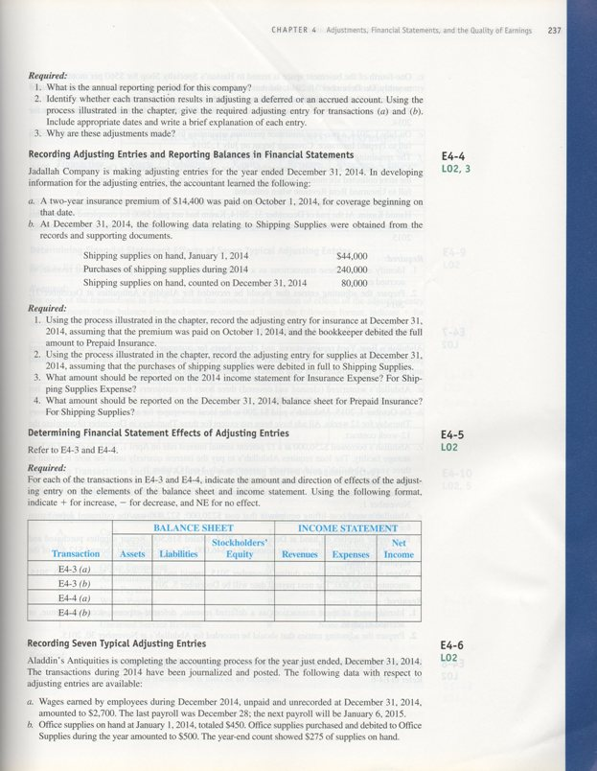

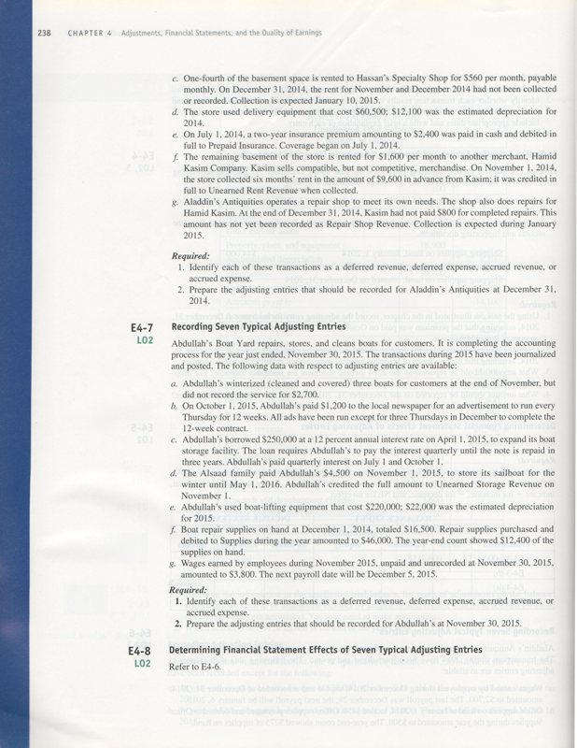

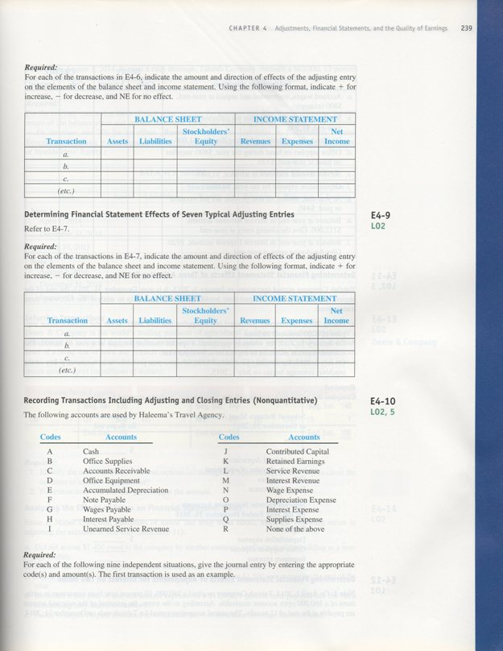

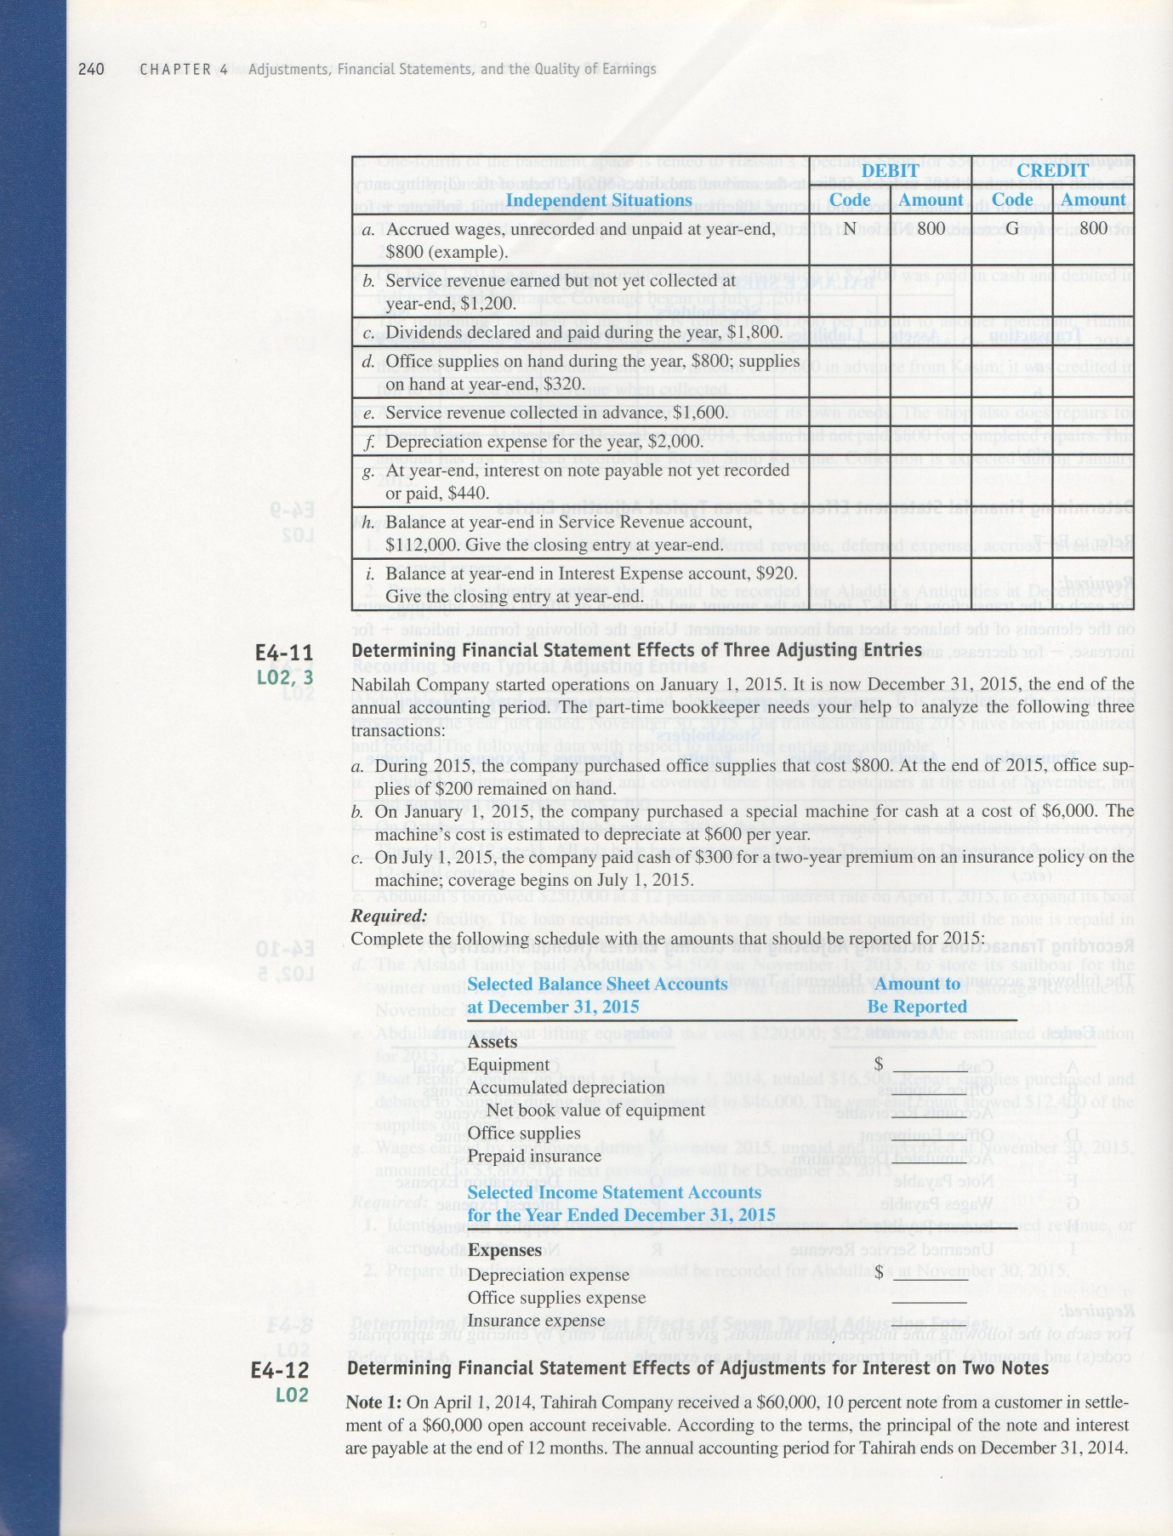

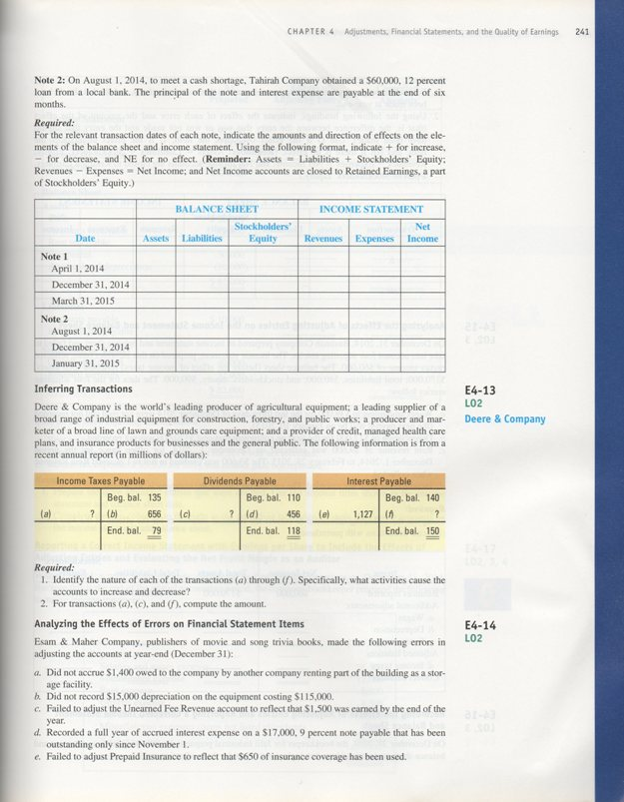

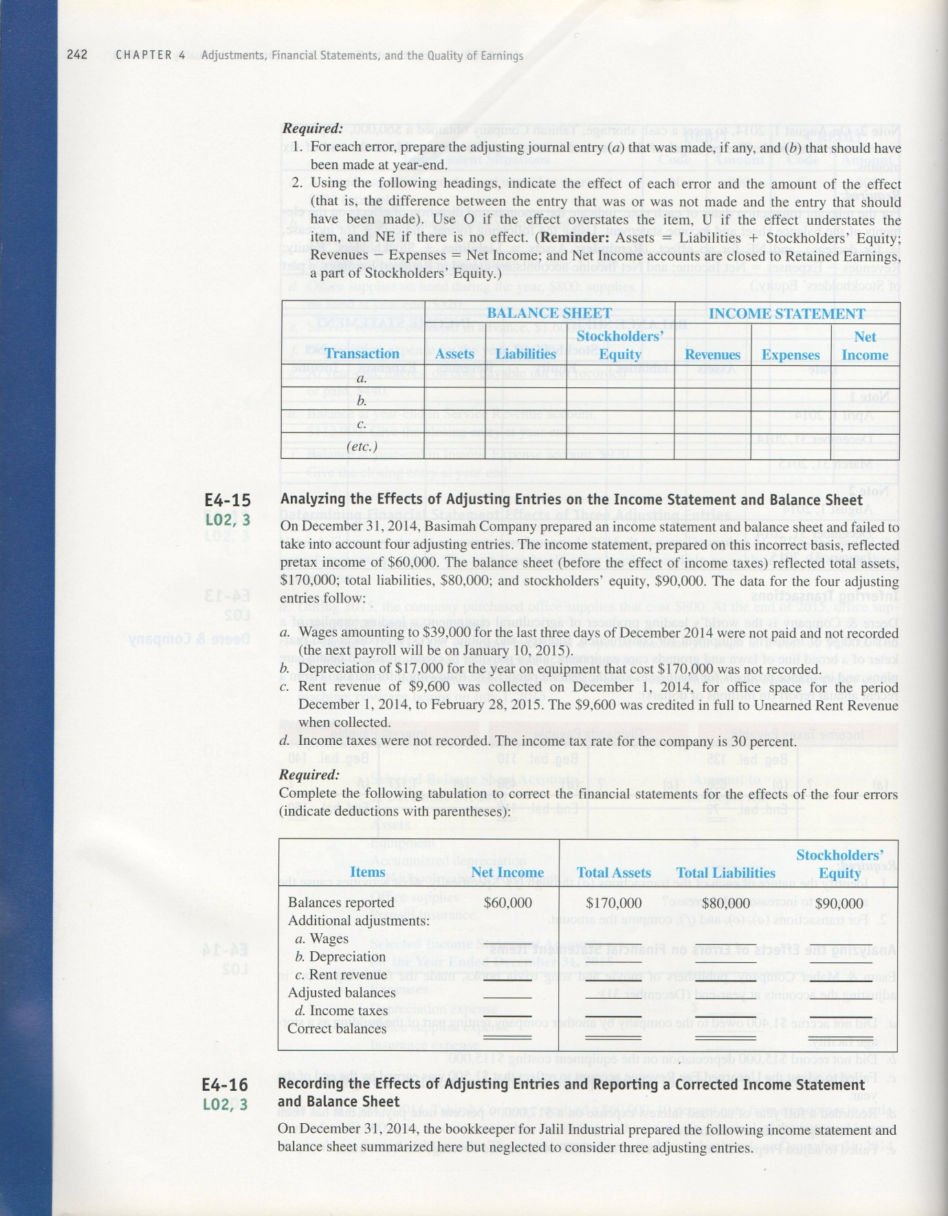

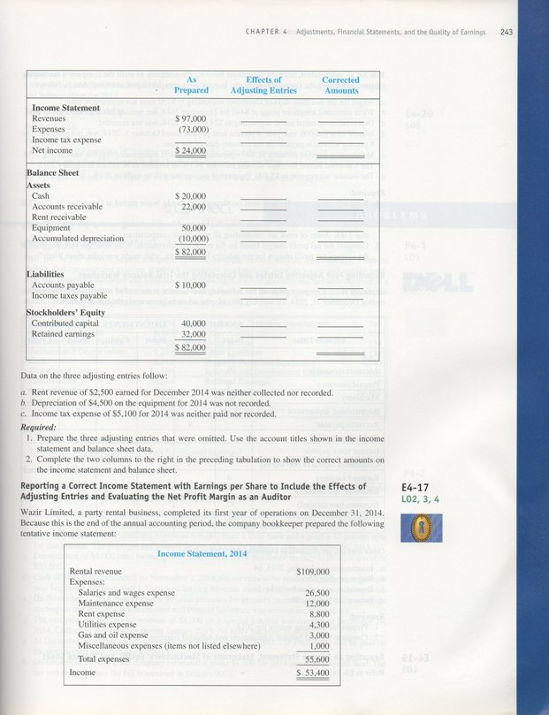

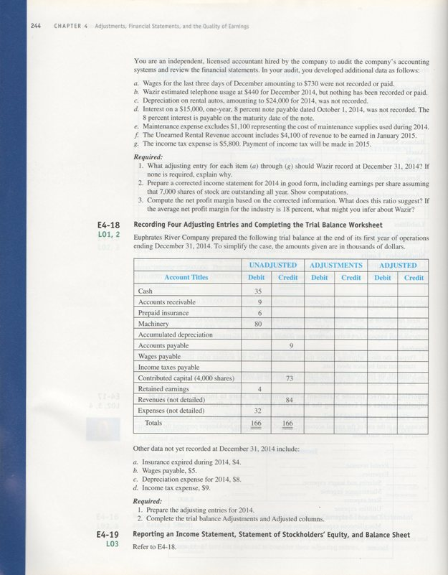

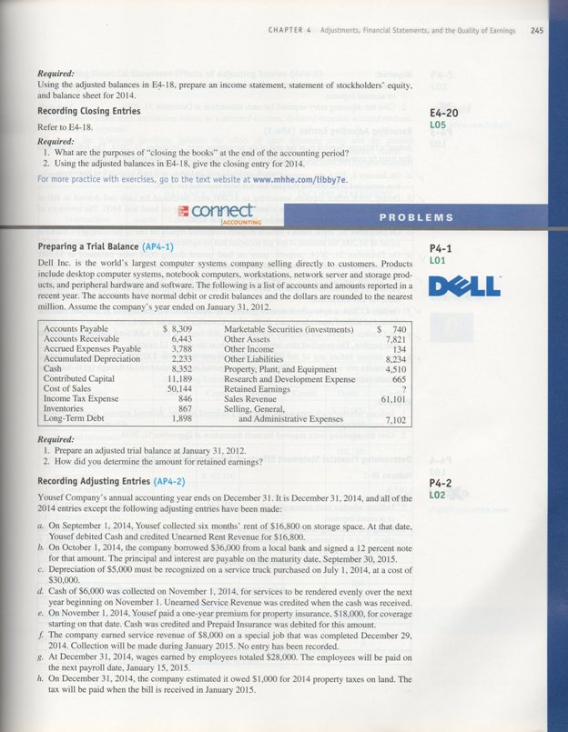

MINI-EXERCISES

M4–1.
Khaleel Limited
Adjusted Trial Balance
At June 30, 2014

 | Debit | Credit
Cash | $ 175
Accounts receivable | 420
Inventories | 710
Prepaid expenses | 30
Buildings and equipment | 1,400
Accumulated depreciation |  | $ 250
Land | 300
Accounts payable |  | 250
Accrued expenses payable |  | 160
Income taxes payable |  | 50
Unearned fees |  | 90
Long-term debt |  | 1,460
Contributed capital |  | 400
Retained earnings |  | 150
Sales revenue |  | 2,400
Interest income |  | 60
Cost of sales | 780
Salaries expense | 640
Rent expense | 460
Depreciation expense | 150
Interest expense | 70
Income taxes expense | 135
Totals | $ 5,270 | $ 5,270

M4–2.
(1) D
(2) C
(3) A
(4) D
(5) A
(6) B
(7) B
(8) C

M4–3. (1) D
(2) C
(3) A
(4) B

M4–4.

(a) | 1. Rent revenue is now earned.
 | 2. Cash was received in the past – a deferred revenue was recorded.
3. Amount: $3,000 ÷ 4 months = $750 earned

Adjusting entry –
 | Unearned rent revenue (−L) | 750
 | Rent revenue (+R, +SE) |  | 750

(b) |  | 1. Depreciation Expense on the equipment is now incurred.
 |  | 2. Cash was paid in the past when the equipment was purchased – a deferred expense was recorded. The net book value of the equipment is overstated. Accumulated Depreciation (the contra-account) needs to be increased for the amount used during the period.
3. Amount: $9,000 given

Adjusting entry –
 |  |  | Depreciation expense (+E, −SE) | 9,000
 |  |  | Accumulated depreciation (+XA, −A) |  |  |  | 9,000
(c) |  | 1. Insurance expense was incurred in the period.
 |  | 2. Cash was paid for the insurance in the past – a deferred expense was recorded.
3. Amount: $12,600 x 6/24 = $3,150

Adjusting entry –
 |  |  | Insurance expense (+E, −SE) |  | 3,150
 |  |  | Prepaid insurance (−A) |  |  |  |  | 3,150

M4–5.
 | Balance Sheet |  |  | Income Statement
Transaction | Assets | Liabilities | Stockholders’ Equity | Revenues | Expenses | Net  Income
a. | NE | –750 | +750 | +750 | NE | +750
b. | –9,000 | NE | –9,000 | NE | +9,000 | –9,000
c. | –3,150 | NE | –3,150 | NE | +3,150 | –3,150
M4–6.

(a) |  | 1. Utilities Expense is incurred.
 |  | 2. Cash will be paid in the future for utilities used in the current period – an accrued expense needs to be recorded.
3. Amount: $1,140 given

Adjusting entry –
 |  |  | Utilities expense (+E, −SE) | 1,140
 |  |  | Utilities payable (+L) |  | 1,140

(b) |  | 1. Interest revenue is now earned on the note receivable.
 |  | 2. Cash for the interest will be received in the future – an accrued revenue needs to be recorded.
3. Amount: $15,000 principal x .14 annual rate x 4/12 of a year = $700

Adjusting entry –
 |  |  | Interest receivable (+A) |  | 700
 |  |  | Interest revenue (+R, +SE) |  |  |  | 700
(c) |  | 1. Wages expense was incurred in the period.
 |  | 2. Cash will be paid in the future to the employees who worked in the current period – an accrued expense needs to be recorded.
3. Amount: 10 employees x 4 days x $450 per day = $18,000

Adjusting entry –
 |  |  | Wages expense (+E, −SE) |  | 18,000
 |  |  | Wages payable (+L) |  |  |  | 18,000

M4–7.
 | Balance Sheet |  |  | Income Statement
Transaction | Assets | Liabilities | Stockholders’ Equity | Revenues | Expenses | Net  Income
a. | NE | +1,140 | –1,140 | NE | +1,140 | –1,140
b. | +700 | NE | +700 | +700 | NE | +700
c. | NE | +18,000 | –18,000 | NE | +18,000 | –18,000

M4–8.
IBRAHIM’S MARKETING GROUP
Income Statement
For the Year Ended December 31, 2015

Operating Revenues:  Sales revenue  Total operating revenues  Operating Expenses:  Wages expense  Depreciation expense  Utilities expense  Insurance expense  Rent expense  Total operating expenses  Operating Income  Other Items:  Interest revenue  Rent revenue  Pretax Income  Income tax expense | $ 37,650  37,650  19,000  1,800  320  700  9,000  30,820  6,830  100  750  7,680  2,700
Net Income | $ 4,980
Earnings per share* | $9.05

* calculated as $4,980 ÷ [(300 + 800) ÷ 2] = $4,980 ÷ 550 = $9.05

Average number of shares

M4–9.
IBRAHIM’S MARKETING GROUP
Statement of Stockholders’ Equity
For the Year Ended December 31, 2015
 |  | Contributed Capital |  | Retained Earnings |  |  |  | Total  Stockholders’ Equity
Balance, January 1, 2015 |  | $ 700 |  | $ 2,000* |  |  |  | $ 2,700
Share issuance |  | 3,000 |  |  |  |  |  | 3,000
Net income |  |  |  | 4,980 |  |  |  | 4,980
Dividends declared |  |  |  | (0) |  |  | (0)
Balance, December 31, 2015 |  | $ 3,700 |  | $ 6,980 |  |  |  | $ 10,680
* From the trial balance.
Work backwards
M4–10.

Req. 1
IBRAHIM’S MARKETING GROUP
Balance Sheet
At December 31, 2014

Assets  Current Assets:  Cash  Accounts receivable  Interest receivable  Prepaid insurance  Total current assets  Notes receivable  Equipment (net of accumulated depreciation, $3,000)  Total Assets  Liabilities  Current Liabilities:  Accounts payable  Accrued expenses payable  Income taxes payable  Unearned rent revenue  Total current liabilities  Stockholders’ Equity  Contributed capital  Retained earnings  Total Stockholders’ Equity  Total Liabilities and Stockholders’ Equity | $ 1,500  2,200  100  1,600  5,400  2,800  12,000  $ 20,200  $ 2,400  3,920  2,700  500  9,520  3,700  6,980  10,680  $ 20,200

Req. 2

The adjustments in M4–4 and M4–6 have no effect on the operating, investing, and financing activities on the statement of cash flows because no cash is paid or received at the time of the adjusting entries.

M4–11.

Revenues:  Sales revenue  Interest revenue (not operating)  Rent revenue (not operating)  Total revenues  Costs and expenses:  Wages expense  Depreciation expense  Utilities expense  Insurance expense  Rent expense  Income tax expense  Total costs and expenses  Net Income | $ 37,650  100  750  38,500  19,000  1,800  320  700  9,000  2,700  33,520  $ 4,980

Net profit margin = Net income ÷ Operating revenues = $4,980 ÷ $37,650 = 13.23%

The operating revenue source for this company is from sales. Interest revenue and rent revenue are not included in the denominator because they are other (non-operating) revenue sources.

M4–12.

Sales revenue (−R)  Interest revenue (−R)  Rent revenue (−R)  Retained earnings (+SE)  Wages expense (−E)  Depreciation expense (−E)  Utilities expense (−E)  Insurance expense (−E)  Rent expense (−E)  Income tax expense (−E) | 37,650  100  750 | 4,980  19,000  1,800  320  700  9,000  2,700

EXERCISES

E4–1.

Abdolmohamadi Company
Unadjusted Trial Balance
At September 30, 2015

 | Debit | Credit
Cash | $ 153,000
Accounts receivable | 225,400
Supplies | 12,200
Prepaid expenses | 10,200
Investments | 145,000
Buildings and equipment | 323,040
Accumulated depreciation |  | $ 18,100
Land | 60,000
Accounts payable |  | 96,830
Accrued expenses payable |  | 25,650
Unearned consulting fees |  | 32,500
Income taxes payable |  | 3,030
Notes payable |  | 160,000
Contributed capital |  | 223,370
Retained earnings * |  | 144,510
Consulting fees revenue |  | 2,564,200
Investment income |  | 10,800
Gain on sale of land |  | 6,000
Wages and benefits expense | 1,610,000
Utilities expense | 25,230
Travel expense | 23,990
Rent expense | 152,080
Professional development expense | 18,600
Other operating expenses | 188,000
General and administrative expenses | 321,050
Interest expense | 17,200
Totals | $3,284,990 | $3,284,990

* Since debits are supposed to equal credits in a trial balance, the balance in Retained Earnings is determined as the amount in the credit column necessary to make debits equal credits (a “plugged” figure).
E4–2.

Req. 1
Types | Accounts to be Adjusted
Deferred Revenues:  Deferred Revenue may need to be adjusted for any revenue earned during the period | Deferred Revenue (L) and Product Revenue and/or Service Revenue (R)
Accrued Revenues:  Interest may be earned on Short-term Investments  Any unrecorded sales or services provided will need to be recorded | Interest Receivable (A) and Interest Revenue (R)  Accounts Receivable (A) and Product Revenue and/or Service Revenue (R)
Deferred Expenses:  Other Current Assets may include supplies, prepaid rent, prepaid insurance, or prepaid advertising  Any additional use of Property, Plant, and Equipment during the period will need to be recorded | Other Current Assets (A) and Selling, General, and Administrative Expense (E)  Accumulated Depreciation (XA) and Cost of Products and/or Cost of Services (E)
Accrued Expenses:  Interest incurred on Short-term Note Payable and Long-term Debt will need to be recorded  There are likely many other accrued expenses to be recorded, including wages, warranties, and utilities  Income taxes must be computed for the period and accrued | Accrued Liabilities (L) and Interest Expense (E)  Accrued Liabilities (L) and Selling, General, and Administrative Expenses (among other expenses) (E)  Income Tax Payable (L) and Income Tax Expense (E)

Req. 2

Temporary accounts that accumulate during the period are closed at the end of the year to the permanent account Retained Earnings. These include: Product revenue, service revenue, interest revenue, cost of products, cost of services, interest expense, research and development expense, selling, general, and administrative expense, other expenses, and income tax expense.
E4–3.

Req. 1

The annual reporting period for this company is January 1 through December 31, 2014.

Req. 2 (Adjusting entries)

Both transactions are accruals because revenue has been earned and expenses incurred but no cash has yet been received or paid.

(a) | 1. Wages expense is incurred.
 | 2. Cash will be paid in the next period to employees who worked in the current period – an accrued expense needs to be recorded.
3. Amount: $28,000 given

Adjusting entry –
 | Wages expense (+E, −SE) | 28,000
 | Wages payable (+L) |  | 28,000

(b) |  | 1. Interest revenue is now earned.
 |  | 2. Cash will be received in the future – an accrued revenue needs to be recorded.
3. Amount: $8,000 given

Adjusting entry –
 |  |  | Interest receivable (+A) | 8,000
 |  |  | Interest revenue (+R, +SE) |  |  | 8,000

Req. 3

Adjusting entries are necessary at the end of the accounting period to ensure that all revenues earned and expenses incurred and the related assets and liabilities are measured properly. The entries above are accruals; entry (a) is an accrued expense (incurred but not yet recorded) and entry (b) is an accrued revenue (earned but not yet recorded). In applying the accrual basis of accounting, revenues should be recognized when earned and measurable and expenses should be recognized when incurred in generating revenues.

E4–4.

Req. 1
Prepaid Insurance is a deferred expense that needs to be adjusted each period for the amount used during the period.

The amount of expense is computed as follows: $14,400 x 3/24 = $1,800 used

Adjusting entry –
Insurance expense (+E, −SE) 1,800
Prepaid insurance (−A) 1,800

Req. 2
Shipping Supplies is a deferred expense that needs to be adjusted at the end of the period for the amount of supplies used during the period.

The amount is computed as follows: Beginning balance $ 44,000
Supplies purchased 240,000
Supplies on hand at end (80,000)
Supplies used $204,000

Adjusting entry –
Shipping supplies expense (+E, −SE) 204,000
Shipping supplies (−A) 204,000

Req. 3
Prepaid Insurance |  |  | Insurance Expense
10/1 14,400
 | AJE 1,800 |  | AJE 1,800
End. 12,600 |  |  | End. 1,800

Shipping Supplies |  |  | Shipping Supplies Expense
Beg. 44,000
Purch. 240,000 | AJE 204,000 |  | AJE 204,000
End. 80,000 |  |  | End. 204,000

2014 Income statement:
Insurance expense $ 1,800
Shipping supplies expense $ 204,000

Req. 4
2014 Balance sheet:
Prepaid insurance $ 12,600
Shipping supplies $ 80,000

E4–5.
 | Balance Sheet |  |  | Income Statement
Transaction | Assets | Liabilities | Stockholders’ Equity | Revenues | Expenses | Net  Income
E4–3 (a) | NE | +28,000 | –28,000 | NE | +28,000 | –28,000
E4–3 (b) | +8,000 | NE | +8,000 | +8,000 | NE | +8,000
E4–4 (a) | –1,800 | NE | –1,800 | NE | +1,800 | –1,800
E4–4 (b) | –204,000 | NE | –204,000 | NE | +204,000 | –204,000

E4–6.

Req. 1
a. | Accrued expense
b. | Deferred expense
c. | Accrued revenue
d. | Deferred expense
e. | Deferred expense
f. | Deferred revenue
g. | Accrued revenue

Req. 2 Computations
a. | Wages expense (+E, −SE) | 2,700 |  |  | Given
 | Wages payable (+L) |  | 2,700
b. | Office supplies expense (+E, −SE) | 675 |  |  | $450 + $500
 | Office supplies (−A) |  | 675 |  | - $275 = $675 used
c. | Rent receivable (+A) | 1,120 |  |  | $560 x 2 months
 | Rent revenue (+R, +SE) |  | 1,120 |  | = $1,120 earned
d. | Depreciation expense (+E, −SE) | 12,100 |  |  | Given
 | Accumulated depreciation (+XA, −A) |  | 12,100
e. | Insurance expense (+E, −SE) | 600 |  |  | $2,400 x 6/24 =
 | Prepaid insurance (−A) |  | 600 |  | $600 used
f. | Unearned rent revenue (−L) | 3,200 |  |  | $9,600 x 2/6 =
 | Rent revenue (+R, +SE) |  | 3,200 |  | $3,200 earned
g. | Repair accounts receivable (+A) | 800 |  |  | Given
 | Repair shop revenue (+R, +SE) |  | 800

E4–7.

Req. 1
a. | Accrued revenue
b. | Deferred expense
c. | Accrued expense
d. | Deferred revenue
e. | Deferred expense
f. | Deferred expense
g. | Accrued expense
Req. 2 Computations
a. | Accounts receivable (+A) | 2,700 |  |  | Given
 | Service revenue (+R, +SE) |  | 2,700
b. | Advertising expense (+E, −SE) | 900 |  |  | $1,200 x 9/12 =
 | Prepaid advertising (−A) |  | 900 |  | $900 used
c. | Interest expense (+E, −SE) | 5,000 |  |  | $250,000 x .12
 | Interest payable (+L) |  | 5,000 |  | x 2/12 (since last payment) = $5,000 incurred
d. | Unearned storage revenue (−L) | 750 |  |  | $4,500 x 1/6 =
 | Storage revenue (+R, +SE) |  | 750 |  | $750 earned
e. | Depreciation expense (+E, −SE) | 22,000 |  |  | Given
 | Accumulated depreciation (+XA, −A) |  | 22,000
f. | Supplies expense (+E, −SE) | 50,100 |  |  | $16,500 +
 | Supplies (−A) |  | 50,100 |  | $46,000 – $12,400
 |  |  |  |  | = $50,100 used
g. | Wages expense (+E, −SE) | 3,800 |  |  | Given
 | Wages payable (+L) |  | 3,800

E4–8.
 | Balance Sheet |  |  | Income Statement
Transaction | Assets | Liabilities | Stockholders’ Equity | Revenues | Expenses | Net  Income
(a) | NE | +2,700 | –2,700 | NE | +2,700 | –2,700
(b) | –675 | NE | –675 | NE | +675 | –675
(c) | +1,120 | NE | +1,120 | +1,120 | NE | +1,120
(d) | –12,100 | NE | –12,100 | NE | +12,100 | –12,100
(e) | –600 | NE | –600 | NE | +600 | –600
(f) | NE | –3,200 | +3,200 | +3,200 | NE | +3,200
(g) | +800 | NE | +800 | +800 | NE | +800

E4–9.
 | Balance Sheet |  |  | Income Statement
Transaction | Assets | Liabilities | Stockholders’ Equity | Revenues | Expenses | Net  Income
(a) | +2,700 | NE | +2,700 | +2,700 | NE | +2,700
(b) | –900 | NE | –900 | NE | +900 | –900
(c) | NE | +5,000 | –5,000 | NE | +5,000 | –5,000
(d) | NE | –750 | +750 | +750 | NE | +750
(e) | –22,000 | NE | –22,000 | NE | +22,000 | –22,000
(f) | –50,100 | NE | –50,100 | NE | +50,100 | –50,100
(g) | NE | +3,800 | –3,800 | NE | +3,800 | –3,800

E4–10.

 |  | Debit |  | Credit
 | Independent Situations | Code | Amount | Code | Amount
a. | Accrued wages, unrecorded and unpaid at year-end, $800 (example). | N | 800 | G | 800
b. | Service revenue earned but not yet collected at year-end, $1,200. | C | 1,200 | L | 1,200
c. | Dividends declared and paid during the year, $1,800. | K | 1,800 | A | 1,800
d. | Office Supplies on hand during the year, $800; supplies on hand at year-end, $320. | Q | 480 | B | 480
e. | Service revenue collected in advance, $1,600. | A | 1,600 | I | 1,600
f. | Depreciation expense for the year, $2,000. | O | 2,000 | E | 2,000
g. | At year-end, interest on note payable not yet recorded or paid, $440. | P | 440 | H | 440
h. | Balance at year-end in Service Revenue account, $112,000. Give the closing entry at year-end. | L | 112,000 | K | 112,000
i. | Balance at year-end in Interest Expense account, $920. Give the closing entry at year-end. | K | 920 | P | 92

E4–11.

Selected Balance Sheet Amounts at December 31, 2015
Assets:
Equipment (recorded at cost per cost principle) | $6,000
Accumulated depreciation (for one year, as given) | (600)
Net book value of equipment (difference) | 5,400
Office supplies (on hand, as given) | 200
Prepaid insurance (remaining coverage, $300 x 18/24 months) | 225

Selected Income Statement Amounts for the Year Ended December 31, 2015
Expenses:
Depreciation expense (for one year, as given) | $ 600
Office supplies expense (used, $800 - $200 on hand) | 600
Insurance expense (for 6 months, $300 x 6/24 months) | 75

E4–12.
 | Balance Sheet |  |  | Income Statement
Date | Assets | Liabilities | Stockholders’ Equity | Revenues | Expenses | Net  Income
Note 1:  April 1, 2014 | +60,000/  –60,000 | NE | NE | NE | NE | NE
December 31, 2014ª | + 4,500 | NE | + 4,500 | + 4,500 | NE | + 4,500
March 31, 2015^{b} | +66,000/  –64,500 | NE | + 1,500 | +1,500 | NE | + 1,500
Note 2:  August 1, 2014 | + 60,000 | + 60,000 | NE | NE | NE | NE
December 31, 2014^{c} | NE | + 3,000 | - 3,000 | NE | + 3,000 | - 3,000
January 31, 2015^{d} | - 63,600 | - 63,000 | - 600 | NE | + 600 | - 600

- $60,000 principal x .10 annual interest rate x 9/12 of a year = $4,500
- Additional interest revenue in 2015: $60,000 x .10 x 3/12 = $1,500. Cash received was $66,000 ($60,000 principal + $6,000 interest for 12 months); receivables decreased by the $60,000 note receivable and $4,500 interest receivable accrued in 2014.
- $60,000 principal x .12 annual interest rate x 5/12 of a year = $3,000
- Additional interest expense in 2015: $60,000 x .12 x 1/12 = $600. Cash paid was $63,600 ($60,000 principal + $3,600 interest for 6 months); payables decreased by the $60,000 note payable and $3,000 interest payable accrued in 2014.

E4–13.

Req. 1 (a) Cash paid on accrued income taxes payable.
(b) Accrual of additional income tax expense.
(c) Cash paid on dividends payable.
(d) Amount of dividends declared for the period.
(e) Cash paid on accrued interest payable.
(f) Accrual of additional interest expense.

Req. 2 Computations:
(a)
Beg. Bal. | + | accrued income taxes | - | cash paid | = | End. bal.
$135 | + | 656 | - | ? | = | $79
 |  |  |  | ? | = | $712 paid
(c)
Beg. Bal. | + | dividends declared | - | cash paid | = | End. bal.
$110 | + | 456 | - | ? | = | $118
 |  |  |  | ? | = | $448 paid
(f)
Beg. Bal. | + | accrued interest expense | - | cash paid | = | End. bal.
$140 | + | ? | - | 1,127 | = | $150
 |  | ? |  |  | = | $1,137 accrued

E4–14.

Req. 1 Adjusting entries that were or should have been made at December 31:

(a) No entry was made. Entry that should have been made:
Rent receivable (+A) 1,400
Rent revenue (+R, +SE) 1,400

(b) No entry was made. Entry that should have been made:
Depreciation expense (+E, −SE) 15,000
Accumulated depreciation (+XA, −A) ………… 15,000

(c) No entry was made. Entry that should have been made:
Unearned fee revenue (−L) 1,500
Fee revenue (+R, +SE) 1,500

(d) Entry that was already made:
Interest expense (+E, −SE) 1,530
Interest payable (+L) 1,530
($17,000 x .09 x 12/12 months)

Entry that should have been made:
Interest expense (+E, −SE) 255
Interest payable (+L) 255
($17,000 x .09 x 2/12 months)

(e) No entry was made. Entry that should have been made:
Insurance expense (+E, −SE) 650
Prepaid insurance (−A) 650

Req. 2
 | Balance Sheet |  |  | Income Statement
Transaction | Assets | Liabilities | Stockholders’ Equity | Revenues | Expenses | Net  Income
(a) | U 1,400 | NE | U 1,400 | U 1,400 | NE | U 1,400
(b) | O 15,000 | NE | O 15,000 | NE | U 15,000 | O 15,000
(c) | NE | O 1,500 | U 1,500 | U 1,500 | NE | U 1,500
(d) | NE | O 1,275 | U 1,275 | NE | O 1,275 | U 1,275
(e) | O 650 | NE | O 650 | NE | U 650 | O 650
E4–15.

Items | Net Income |  |  | Total Assets |  | Total Liabilities |  | Stockholders’ Equity
Balances reported | $60,000 |  |  | $170,000 |  | $80,000 |  | $90,000
Additional adjustments:  a. Wages | (39,000) |  |  |  |  | 39,000 |  | (39,000)
b. Depreciation | (17,000) |  |  | (17,000) |  |  |  | (17,000)
c. Rent revenue | 3,200 |  |  |  |  | (3,200) |  | 3,200
Adjusted balances | 7,200 |  |  | 153,000 |  | 115,800 |  | 37,200
d. Income taxes | (2,160) |  |  |  |  | 2,160 |  | (2,160)
Correct balances | $ 5,040 |  |  | $153,000 |  | $117,960 |  | $35,040

Computations:
a. Given, $39,000 accrued and unpaid.
b. Given, $17,000 depreciation expense.
c. $9,600 x 1/3 = $3,200 rent revenue earned. The remaining $6,400 in unearned revenue is a liability for two months of occupancy "owed'' to the renter.
d. $7,200 income before taxes x 30% = $2,160.

E4–16.

Req. 1

a. | Rent receivable (+A) | 2,500
 | Revenues (rent) (+R, +SE) |  | 2,500
b. | Expenses (depreciation) (+E, −SE) | 4,500
 | Accumulated depreciation (+XA, −A) |  | 4,500
c. | Income tax expense (+E, −SE) | 5,100
 | Income taxes payable (+L) |  | 5,100

Req. 2
 | As Prepared |  |  | Effects of Adjusting Entries |  | Corrected Amounts
Income statement:
Revenues | $97,000 |  | a | $2,500 |  | $99,500
Expenses | (73,000) |  | b | (4,500) |  | (77,500)
Income tax expense |  |  | c | (5,100) |  | (5,100)
Net income | $24,000 |  |  | (7,100) |  | $16,900
Balance Sheet:
Assets
Cash | $20,000 |  |  |  |  | $20,000
Accounts receivable | 22,000 |  |  |  |  | 22,000
Rent receivable |  |  | a | 2,500 |  | 2,500
Equipment | 50,000 |  |  |  |  | 50,000
Accumulated depreciation | (10,000) |  | b | (4,500) |  | (14,500)
 | $82,000 |  |  | (2,000) |  | $80,000
Liabilities
Accounts payable | $10,000 |  |  |  |  | $10,000
Income taxes payable |  |  | c | 5,100 |  | 5,100
Stockholders' Equity
Contributed capital | 40,000 |  |  |  |  | 40,000
Retained earnings | 32,000 |  |  | (7,100) |  | 24,900
 | $82,000 |  |  | (2,000) |  | $80,000

E4–17.

Req. 1

a. | Salaries and wages expense (+E, −SE) | 730
 | Salaries and wages payable (+L) |  | 730
b. | Utilities expense (+E, −SE) | 440
 | Utilities payable (+L) |  | 440
c. | Depreciation expense (+E, −SE) | 24,000
 | Accumulated depreciation (+XA, −A) |  | 24,000
d. | Interest expense (+E, −SE) | 300
 | Interest payable (+L) |  | 300
 | ($15,000 x .08 x 3/12)
e. | Maintenance expense (+E, −SE) | 1,100
 | Maintenance supplies (−A) |  | 1,100
f. | No adjustment is needed because the revenue will not be earned until January (next year).
g. | Income tax expense (+E, −SE) | 5,800
 | Income tax payable (+L) |  | 5,800
E4–17. (continued)

Req. 2
WAZIR LIMITED
Income Statement
For the Year Ended December 31, 2014

Operating Revenue:
Rental revenue | $109,000
Operating Expenses:
Salaries and wages ($26,500 + $730) | $27,230
Maintenance expense ($12,000 + $1,100) | 13,100
Rent expense | 8,800
Utilities expense ($4,300 + $440) | 4,740
Gas and oil expense | 3,000
Depreciation expense | 24,000
Miscellaneous expenses | 1,000
Total expenses | 81,870
Operating Income | 27,130
Other Item:
Interest expense ($15,000 x .08 x 3/12) | 300
Pretax income | 26,830
Income tax expense | 5,800
Net income | $ 21,030
Earnings per share: $21,030 ÷ 7,000 shares | $3.00

Req. 3

Net profit margin = Net Income ÷ Net Sales (or Operating Revenue)
= $21,030 ÷ $109,000 = 19.3%

The net profit margin indicates that, for every $1 of rental revenues, Wazir earns $0.193 (19.3%) in net income. This ratio is higher than the industry average net profit margin of 18%, implying that Wazir is more profitable and better able to manage its business (in terms of sales price or costs) than the average company in the industry.
E4–18.

Req. 1

(a) Insurance expense (+E, −SE) 4
Prepaid insurance (−A) 4

(b) Wages expense (+E, −SE) 5
Wages payable (+L) 5

(c) Depreciation expense (+E, −SE) 8
Accumulated depreciation (+XA, −A) 8

(d) Income tax expense (+E, −SE) 9
Income tax payable (+L) 9

Req. 2
euphrates RIVER Company
Trial Balance
December 31, 2014
(in thousands of dollars)

 | Unadjusted |  | Adjustments |  | Adjusted
Account Titles | Debit | Credit | Debit | Credit | Debit | Credit
Cash | 35 |  |  |  | 35
Accounts receivable | 9 |  |  |  | 9
Prepaid insurance | 6 |  |  | a 4 | 2
Machinery | 80 |  |  |  | 80
Accumulated depreciation |  |  |  | c 8 |  | 8
Accounts payable |  | 9 |  |  |  | 9
Wages payable |  |  |  | b 5 |  | 5
Income taxes payable |  |  |  | d 9 |  | 9
Contributed capital |  | 73 |  |  |  | 73
Retained earnings | 4 |  |  |  | 4
Revenues (not detailed) |  | 84 |  |  |  | 84
Expenses (not detailed) | 32 |  | a 4  c 8  b 5  d 9 |  | 58
Totals | 166 | 166 | 26 | 26 | 188 | 188

E4–19.
EUPHRATES RIVER COMPANY
Income Statement
For the Year Ended December 31, 2014
(in thousands of dollars)

Revenues (not detailed) | $84
Expenses ($32 + $4 + $8 + $5) | 49
Pretax income | 35
Income tax expense | 9
Net income | $26
EPS ($26,000 ÷ 4,000 shares) | $6.50

EUPHRATES RIVER COMPANY
Statement of Stockholders' Equity
For the Year Ended December 31, 2014
(in thousands of dollars)
 | Contributed Capital |  | Retained Earnings |  | Total Stockholders' Equity
Beginning balances, 1/1/2014 | $ 0 |  | $ 0 |  | $ 0
Stock issuance | 73 |  |  |  | 73
Net income |  |  | 26 |  | 26
Dividends declared |  |  | (4) * |  | (4)
Ending balances, 12/31/2014 | $ 73 |  | $ 22 |  | $ 95

* The amount of dividends declared can be inferred because the unadjusted trial balance amount for retained earnings is a negative $4. Since this is the first year of operations, we can assume the entire amount is due to a dividend declaration.

EUPHRATES RIVER COMPANY
Balance Sheet
At December 31, 2014
(in thousands of dollars)

Assets |  |  | Liabilities and Stockholders’ Equity
Current Assets: |  |  | Current Liabilities:
Cash | $ 35 |  | Accounts payable | $ 9
Accounts receivable | 9 |  | Wages payable | 5
Prepaid insurance ($6 - $4) | 2 |  | Income taxes payable | 9
Total current assets | 46 |  | Total current liabilities | 23
Machinery | 80 |  | Stockholders' Equity:
Accumulated depreciation | (8) |  | Contributed capital | 73
 |  |  | Retained earnings | 22
Total assets | $118 |  | Total liabilities and  stockholders' equity | $118
E4–20.

Req. 1

The purposes of “closing the books” at the end of the accounting period are to:
- Transfer the balance in the temporary accounts to a permanent account (Retained Earnings).
- Create a zero balance in each of the temporary accounts for accumulation of activities in the next accounting period.

Req. 2

Revenues (−R) 84
Expenses ($32 + $4 + $8 + $5 + $9) (−E) 58
Retained earnings (+SE) 26

