Create forms and reports according to the pictures.
Use BNK.accdb and rename it to your student id.

- Form for recording theatre event and members who perform in each event
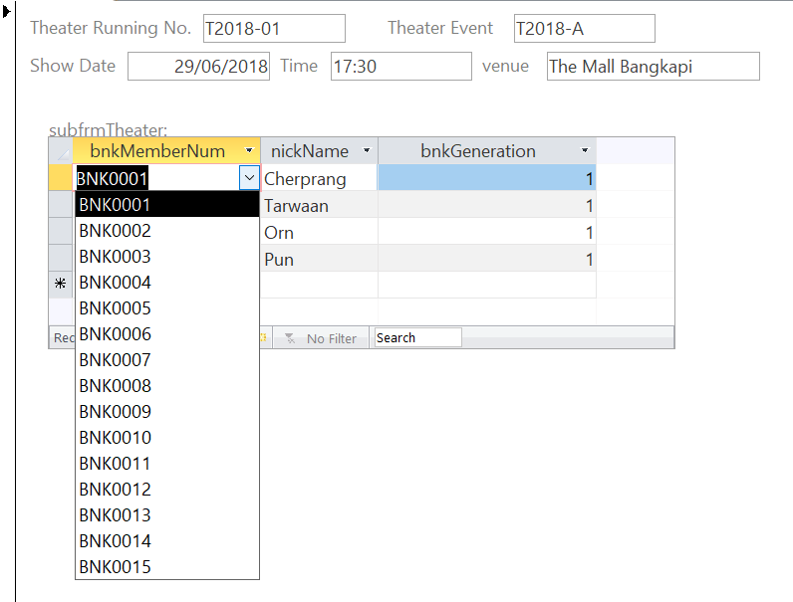
- Form for recording BNK members and their portfolio
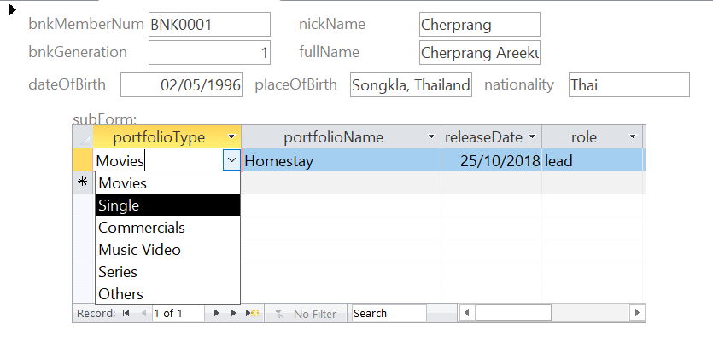

- Report: members’ portfolio
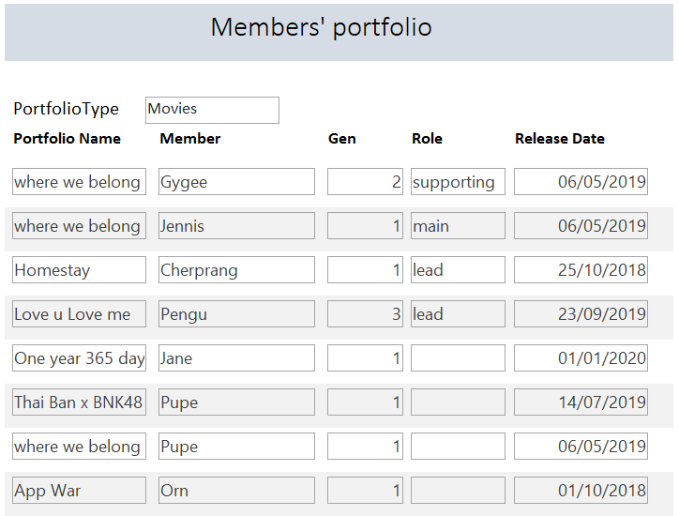

- Report: Members by generation
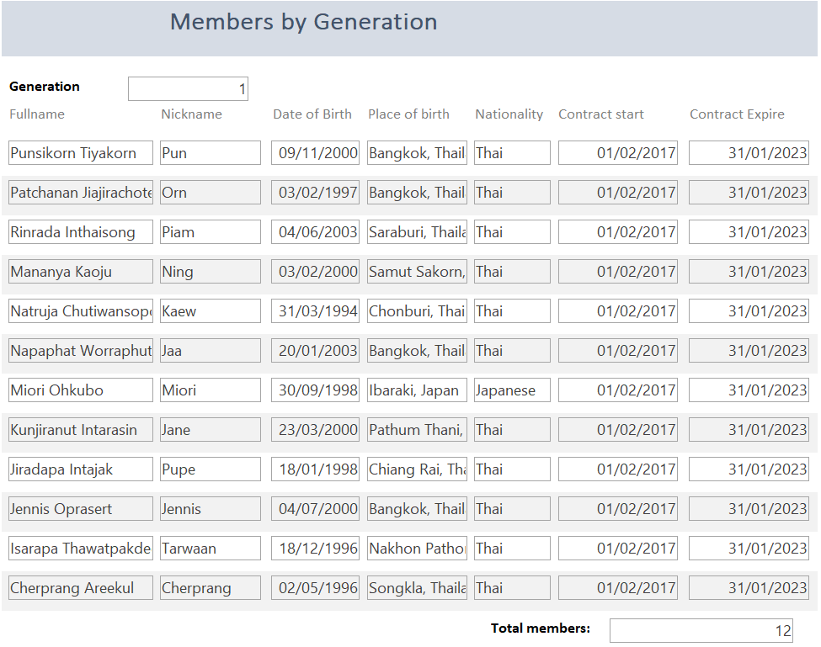
- Report: Members by Talents


