Exercise 8 International Economics
1. What is the difference between “absolute” and “comparative” advantages? What are the main implications of these two theories? (i.e. what do they suggest?)
= The Absolute advantage or AA is the advantage in using less resources to produce goods. In other words, the country will have low cost. The comparative advantage is the advantage that it produces a good at a lower opportunity cost. The implications of the theories are that the country should focus on the specialization or doing what you are good at for the most profit, and with each country’s different comparative cost, we will look at the opportunity cost (lower opportunity cost in a country= better) to let both countries benefit from the trade.
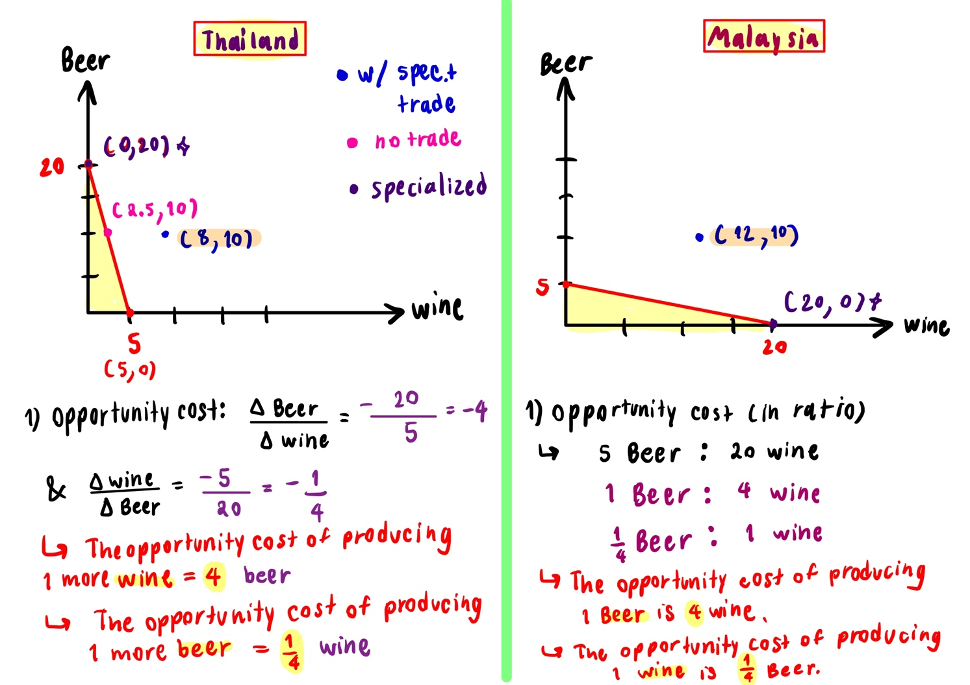
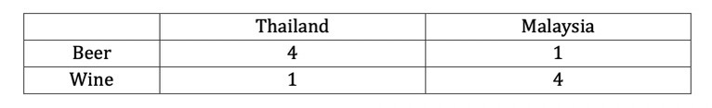
2. The table below shows the amount of production that one worker in each country can produce. Assume that each country has 5 workers. Draw a PPF and show that both countries will benefit from trade.
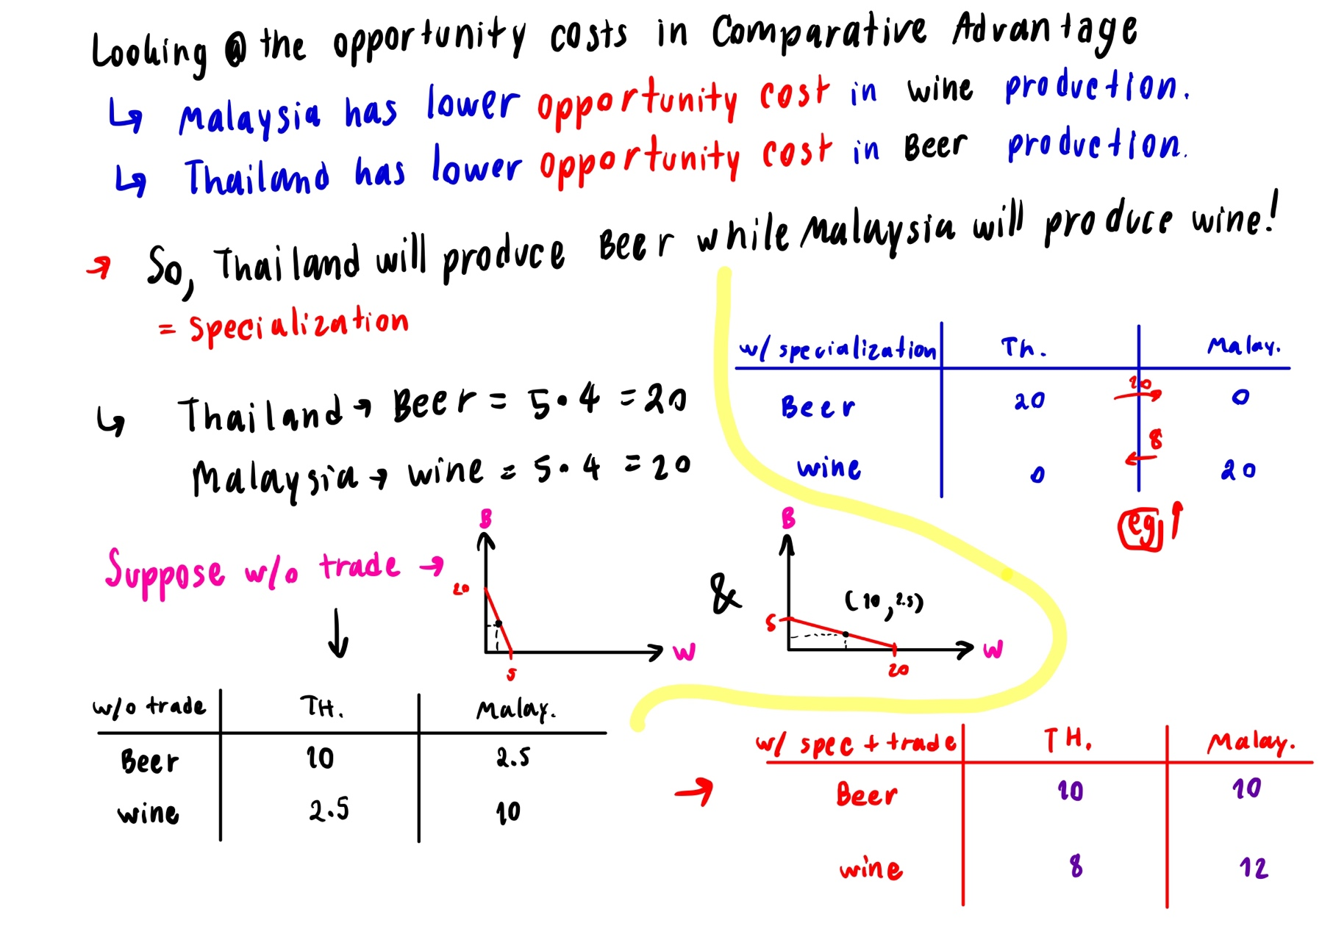
= In conclusion, the trade between Thailand and Malaysia allows the countries to achieve the point outside Production Possibility Frontier (PPF).
= Both countries are better off with trade as shown that Thailand got 5.5 more wine and Malaysia got 2 more wine and 5.5 more beer.

3. What do “current account surplus” and “capital account deficit” represent? What is the “Balance of Payment Identity”?
= “Current account surplus” represents the inflows in the country for the three factors include X-M, primary income, and secondary income. This happens when inflows < outflows.
= “Capital account deficit” (KA) represents the money flows out of the country and it also suggests that the nation is increasing its ownership of foreign assets. (FOP) This happens when inflows < outflows.
= “Balance of Payment Identity” is the theory that the BOP = CA+KA. In other words, the sum of current account and capital account will be zero which tells that both should be the same or roughly the same.

4. Suppose the current market exchange rate is $0.3 / 1 Baht. Use the foreign exchange market diagram to explain how the Central Bank of Thailand can “devalue” Thai baht to $0.2 / 1 Baht under the fixed exchange rate regime.
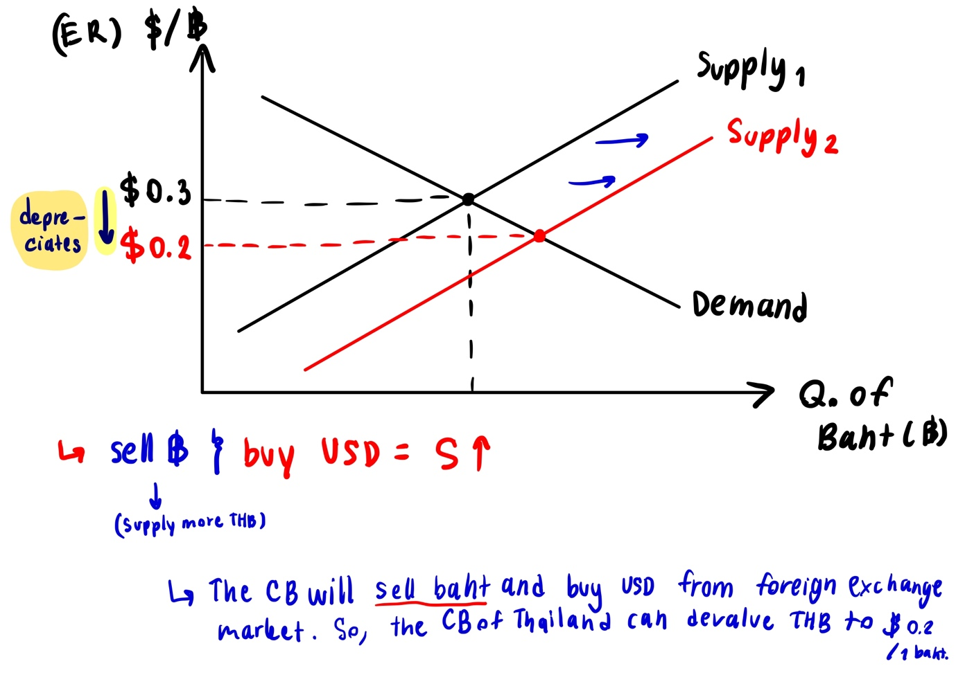
5. How does the floating exchange rate regime work? Under such regime, how does each of the following events affect Thai Baht (assumed to be a domestic currency)?
- The rest of the world imports more from Thailand.
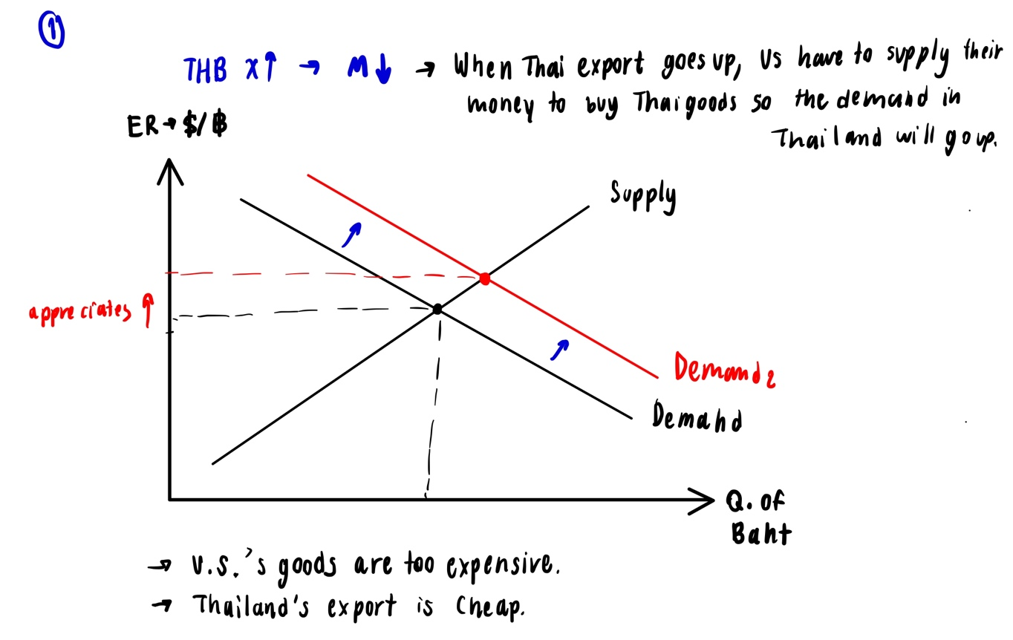
= When the rest of the world imports more from Thailand >> Thai X goes up, demand of THB will rise or shift up
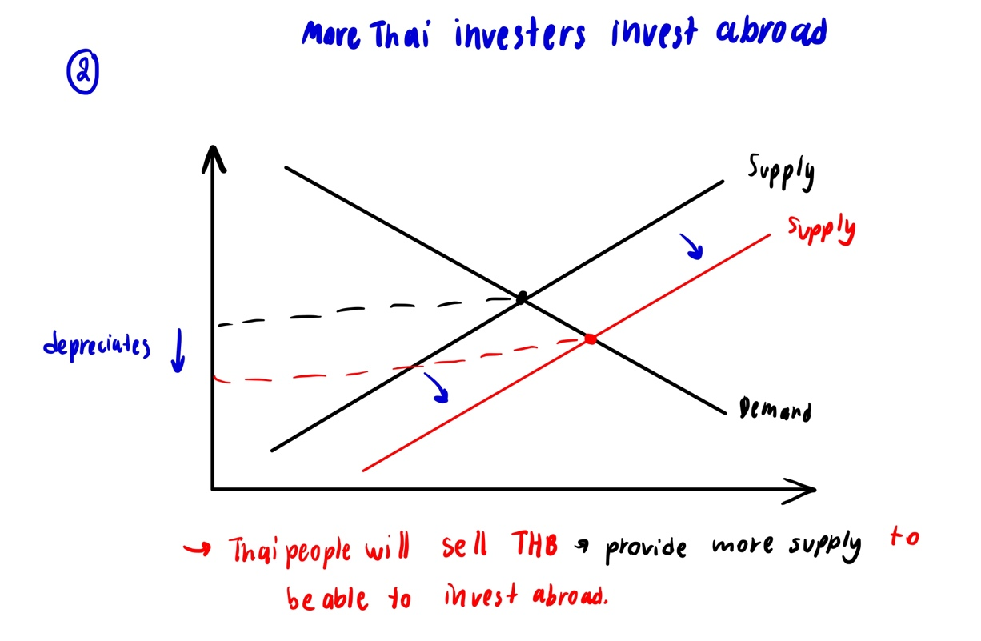
- More Thai investors invest abroad.

- Thailand will leave ASEAN (similar to the UK leaving the EU).
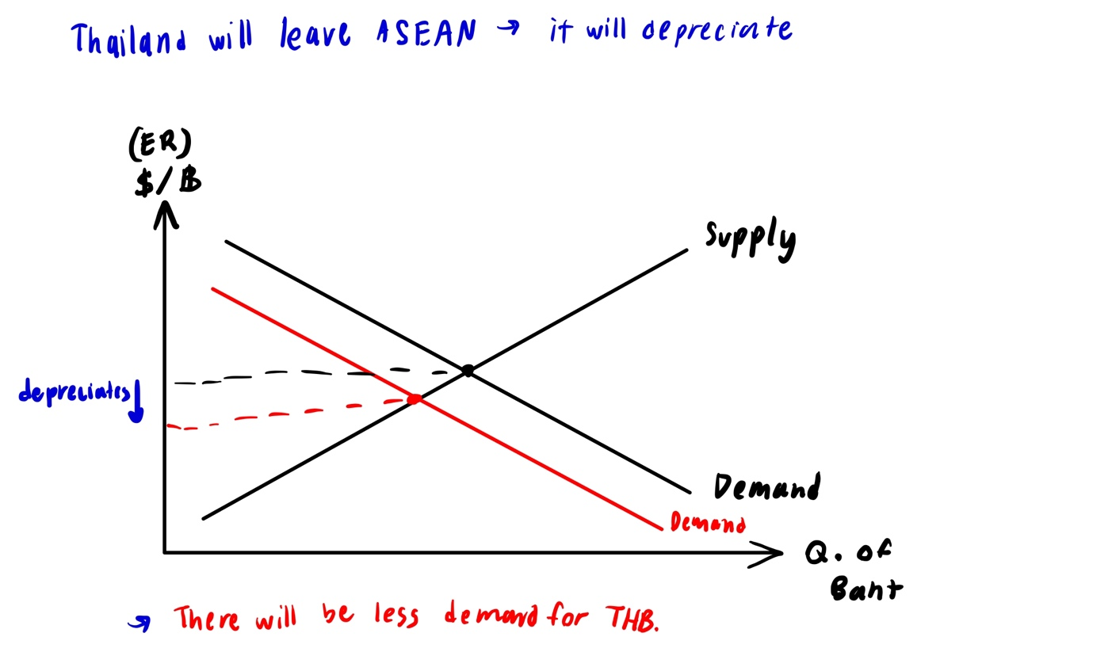
6. In the floating exchange rate regime, why might inflation cause a currency to appreciate and depreciate?
= EG in Thailand:
In floating rate regime, the inflation can cause the currency to appreciate and depreciate. Firstly, because of the high inflation, interest rates which are the return of savings will increase due to the fisher’s equation, making the foreigners attracted to the currency. So, THB will appreciate.
Secondly, as inflation increases, it means that the domestic goods will be more expensive, leading to depreciation as the export decreases and import increases. So, THB will depreciate.
Lastly, the purchasing power of the currency becomes less valuable, making the demand to hold money decrease so THB will depreciate.

7. Suppose an iPhoneX is priced at 400 USD in the US and 300 GBP in the UK. Calculate the PPP exchange rate between USD and GBP.
$400 : 200 GBP
$2 : 1 GBP
S (Exchange rate of currency 1 to currency 2) = 2/1
= 2
8. Suppose the nominal exchange rate is 40 THB / 1 GBP. One apple costs 20 THB in Thailand, but costs 1 GBP in the UK. Calculate the real exchange rate.
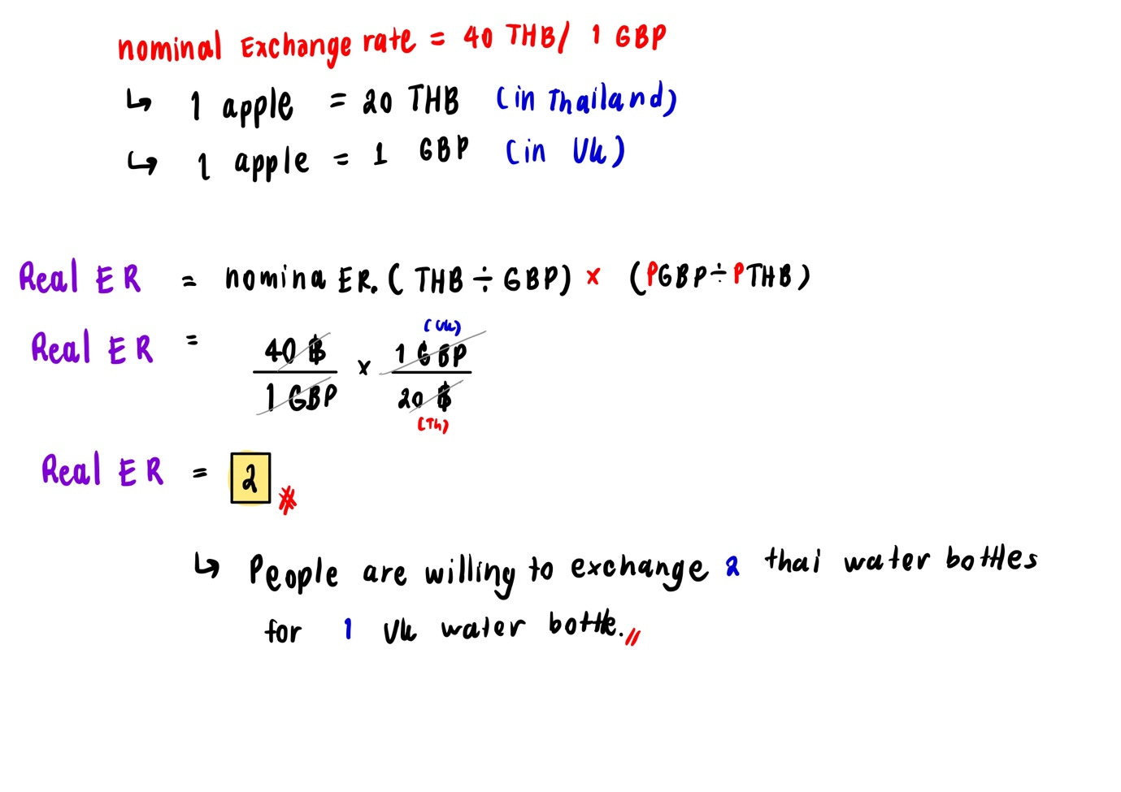
9. What assumptions are required for the Law of One Price to hold?
The assumptions required for the law of One Price to hold are that the price of the same goods should be roughly the same if there is no transportation cost. This is due to the arbitrage as people will try to make free money by buying at a cheaper rate and sell at higher rate in different country. However, this arbitrage will eventually lead to having the same price in the end.

