Govt sops to poor raise questions of propriety
politics November 21, 2018 01:00
By KAS CHANWANPEN
THE NATION
AddThis Sharing Buttons
Share to FacebookShare to TwitterShare to LINEShare to Google+Share to More

Bt38-bn subsidy from populist scheme used to woo welfare cardholders.

WITH THE general election fast approaching, the military-backed government yesterday announced an assistance package for the poor worth Bt38.73 billion under the Pracharat Welfare for Grassroots Economy Fund to subsidise 14.5 million holders of the state welfare card, starting from December until September next year.
The move coming just months ahead of the elections raised questions on whether the junta was exploiting the state budget to boost its popularity. The doubts were only magnified as some Cabinet members have joined the Palang Pracharat Party, whose name coincides with the junta’s major populist scheme.
Junta chief Prime Minister Prayut Chan-o-cha yesterday rejected the accusation, saying the government just does its job and deals with different issues on a day-to-day basis.
“I don’t want the media to say that this government just gives people money for political purposes,” Prayut said yesterday, after the Cabinet meeting gave the green light for the subsidy package. “Everything has been done according to the laws. It’s just a coincidence that it has been finalised now. Just don’t make everything about politics.”
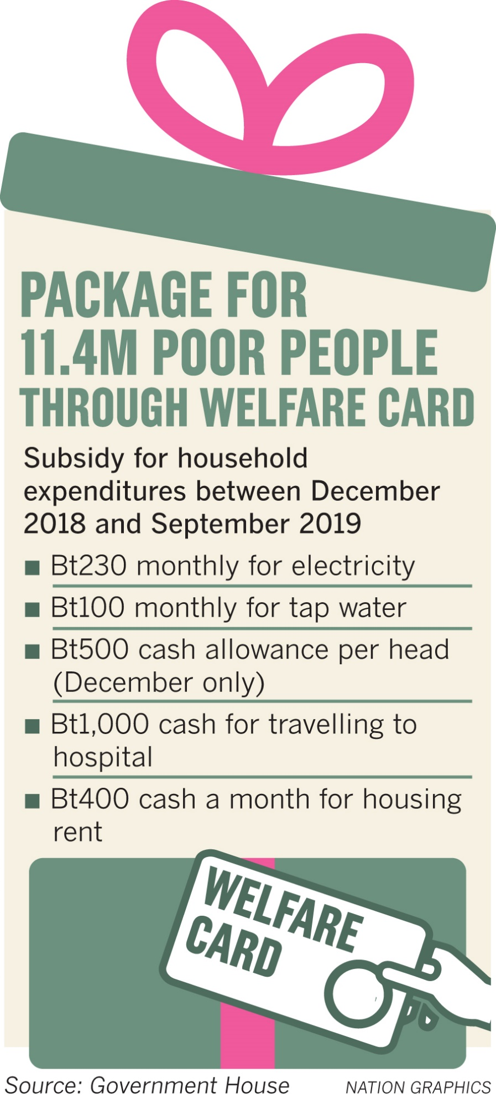

Responding to questions from the media, Government Spokesman Puttipong Punnakanta yesterday said the projects had not materalised overnight.
He explained that they had undergone a long process of scrutiny and come to fruition yesterday, reiterating it had nothing to do with the upcoming election or attempts to boost the junta’s popularity.
The junta government yesterday agreed to inject money into the grassroots economy through the Pracharat scheme. All holders of the state welfare card will receive a one-time extra amount of Bt500 in cash obtained via the card to spend on anything next month, estimated to cost Bt7.25 billion. The government spokesman said that it could be regarded as a New Year’s gift to the people.
Amid questions on why the government had embarked on a spending spree, handing out Bt7.25 billion for almost nothing, Puttipong said it was partly aimed at relieving the people’s burden. The government viewed that this Bt500 could help state welfare cardholders to some extent during the new-year season when they might have more expenses than normal, he said.
In addition, from next month until September next year, the cardholders would also get a utility bill subsidy.
Those who spend less than Bt230 and Bt100 on electricity and water respectively would be eligible for the subsidy.
The amount they pay towards the utility bills would be returned to them as credit in the card. The amount could be used for purchases in Pracharat stores.
For the elderly, the government next month plans to hand out one-time extra cash of Bt1,000 to cardholders aged above 65. The amount is supposedly aimed at helping with commuting expenses of senior citizens who often need to visit hospitals, according to the spokesman. Cardholders aged above 60 and paying rent for their houses will be reimbursed Bt400 from next month until September next year.
All these measures to boost the grassroots economy would cost Bt38.73 billion for the Pracharat Welfare for Grassroots Economy Fund. The fund currently has a reserve of Bt55 billion, according to the government.
Of the country’s nearly 70-million population, more than 14 million people have signed up as low-income earners and are getting a subsidy from this fund. The new package for the poor would enhance the country’s economic growth rate to 0.07 percent, according to the National Economic and Social Development Board.
Deputy Prime Minister Somkid Jatusripitak said that more measures to stimulate the economy were underway. The Finance Ministry was currently working on a tax scheme to offer incentives to consumers to shop more during the New Year season, he said.
Other measures include debt restructuring by the Government Savings Bank to help working people as well as a special taxi installment scheme for taxi drivers by SME Bank, he said. Taxi drivers can pay an installment of Bt300 a day for seven years. A similar measure for motorcycle taxi drivers is also a possibility, the deputy PM said.


