Group A -
1 Chavika Chotivittayayanin 5104640197
2 Salisa Orutsahakij 5104641104
3 Arina Thongjua 5204640055
4 Jakrapong Chongpermsup 5204640246
5 kantaratch Singhto 5204640352
6 Ornwanya Pengpring 5204640642
7 Somrudee nurenim 5204641038''
8 kidjung chongpermsup – (group leader)

Group B
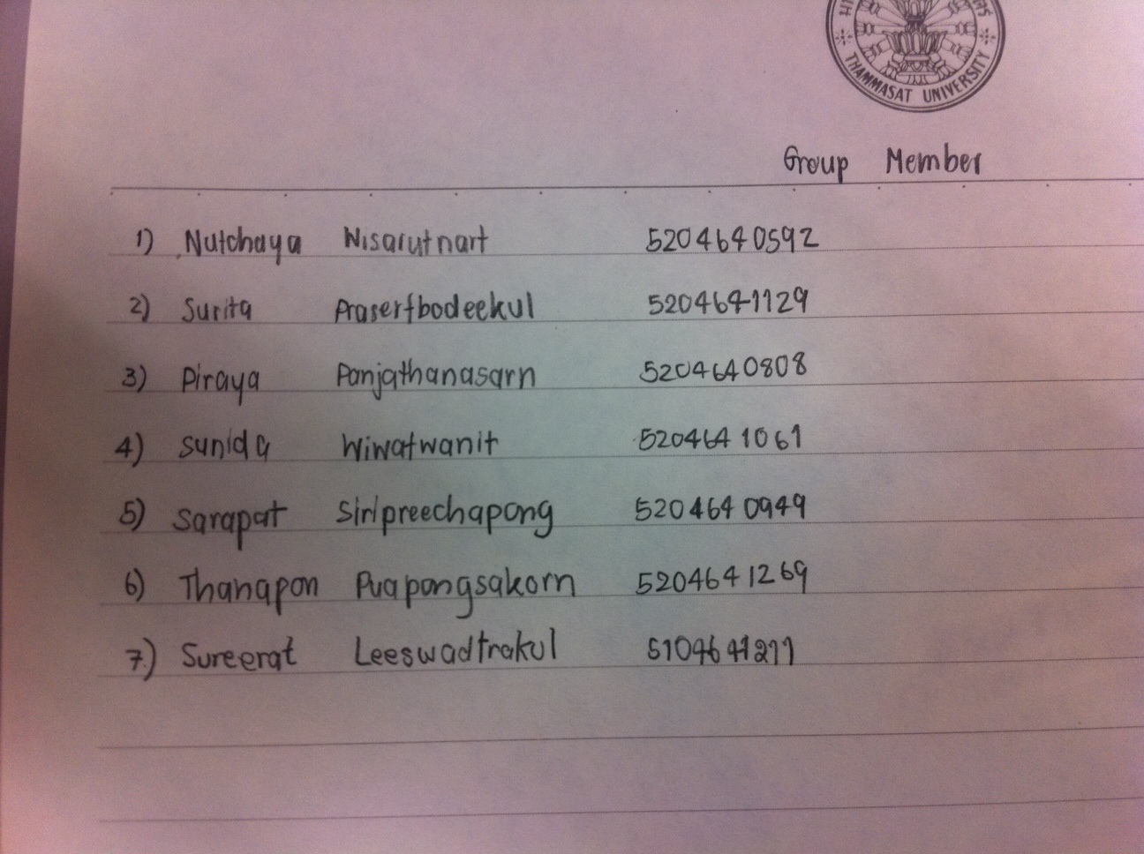

Group C -
1. Atchara Aramcharoen 5104640056
2. Jiramon Sutheerachart 5104640296
3. Kiratha Kasemnavakarn 5104640353
4. Neungrutai Horakul 5104640593
5. Paksiree Bupadham 5104640726
6. Sarunjade Prasertsuwan 5104641120
7. Supajika Charnchaiwanitphong 5104641195

Group D -
1. 5204640105 Benjaporn P.
2. 5204640386 Kittisak D.
3. 5204640816 Pisith C.
4. 5204640824 Piyaporn L.
5. 5204641178 Tamonwan P.
6. 5204641483 Chaiwat K.

Group E -
1. Veeranan 5102641445
2. Tanya 5102641221
3. Noppawan 5102640645
4. Pimhatai 5204640782
5. Sapol 5204640915
6. Warothai 5204641400
7. Josefin 5404930165
8. Andrea 5204930272

Group F -
1) Neknatee Pipatveeravat(Ken) 5204640519
2) Jarasthep Chawengsri (Jay) 5204640279
3) Natakorn Vesapa (Prince) 5204640576
4) Thajchapong Pujaraprapa (Earth) 5204641251
5) Paniti Surangkanarom (Ken) 5204640675
6) Ploypailin Sripan (Ploy) 5204640857

Group G –
- Pimnuch Panma 5104640999
- Pavee Preechajarn 5104640841
- Kleddao Boonyingyongstit 5104641419
- Nattawut Jenmana 5104640551
- Nathapong Wongyaprom 5104640528
- Nisa Tangsilwattanakul
- Patareeya Kongsupopsiri

