Corn Laws
“After the war, the soldiers and sailors won the war against Napoleon, but the government handed the victory to the landlords. They had profited from the high prices of grain during the war blockade, and so the government passed the Corn Law to forbid the import of wheat. The Corn Laws enriched the landed gentry at the expense of everyone else. The rich get richer.” (Hobson, 2016).
In 1813 when the Napoleonic war ended, grain and wheat (corn) prices fell. The British Government passed the Corn Laws in order to restrict the import of cheap foreign grains by introducing import tariffs on grains from overseas, so that the grain prices could be high to favour domestic wheat producers. The law was passed between 1815 to 1846.
The high prices caused the cost of food to increase and consequently depressed the domestic market for manufactured goods because the working class had to pay at high prices to get food.
During that time, the right to vote came from the property requirement. Only 1/12 of adult males. As a result, those who dominated the Parliament in 1815 were landowners, the rich, who were able to represent themselves and pass such laws to enrich themselves like the Corn Laws. (Marjie, 2016).
According to Salvadori, N and Signorino, R. (2013), David Ricardo was against the Law because it restricted the concept of free trade. In his book “Principles of Political Economy and Taxation, 1817.”, he illustrated using an example of Poor and Rich countries. If both countries make a trade, export and import wine and cloth with each other, they would be better off than producing the goods that they do not specialise. The idea of comparative advantage strengthens his conclusion about the Corn Laws. Ricardo used the comparative advantage concept to show the loss of having tariff that drives up the prices. He showed that countries are better off with free trade. He emphasised that the Corn Laws’ repeal is desirable because the return on capital and the rate of accumulation would be higher at any point of time in an open than a closed economy. Ricardo’s idea became the fundamental of the political moves towards free trade after the Corn Laws were repealed in 1846.

 | Cloth | Wine | Autarky
England | 60 | 6 | 1 wine : 10 cloth
Portugal | 72 | 36 | 1 wine : 2 cloth
Figure 1: Comparative advantage (Ricardo, 1817, p.90-91)
In this example, Portugal has an absolute advantage in both goods and a comparative advantage in Wine. England has a comparative advantage in cloth. So, England should produce and export only cloth, in exchange for imports of wine from Portugal.
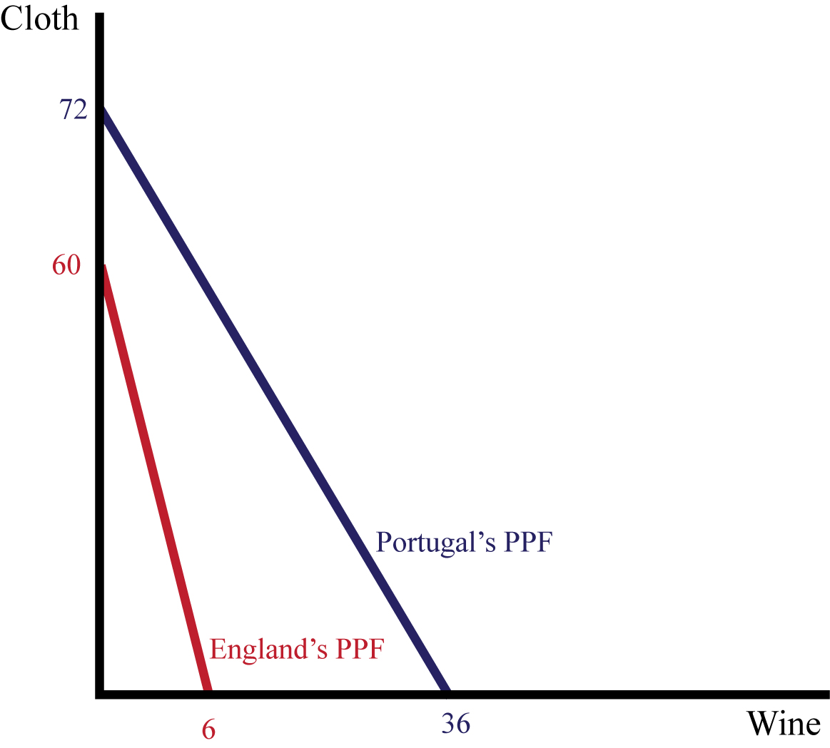
Figure 2: Comparative advantage (Ricardo, 1817, p.90-91)

On the other side, Malthus was in favour of the Laws because the Laws could guarantee the country’s self-sufficiency in food. Malthus thought that it would be dangerous for Great Britain to rely on others for the food supply. The wages would be higher when the wheat prices become higher, while the lower prices of wheat would reduce the wages. He thought that if Corn Laws were to be properly applied, the price would be stable and both consumers and producers would become better off. Malthus emphasised that it is safer for Great Britain to keep on growing its own wheat supply to match its food requirements. Because, according to him, the population increases at a higher rate than food supply.

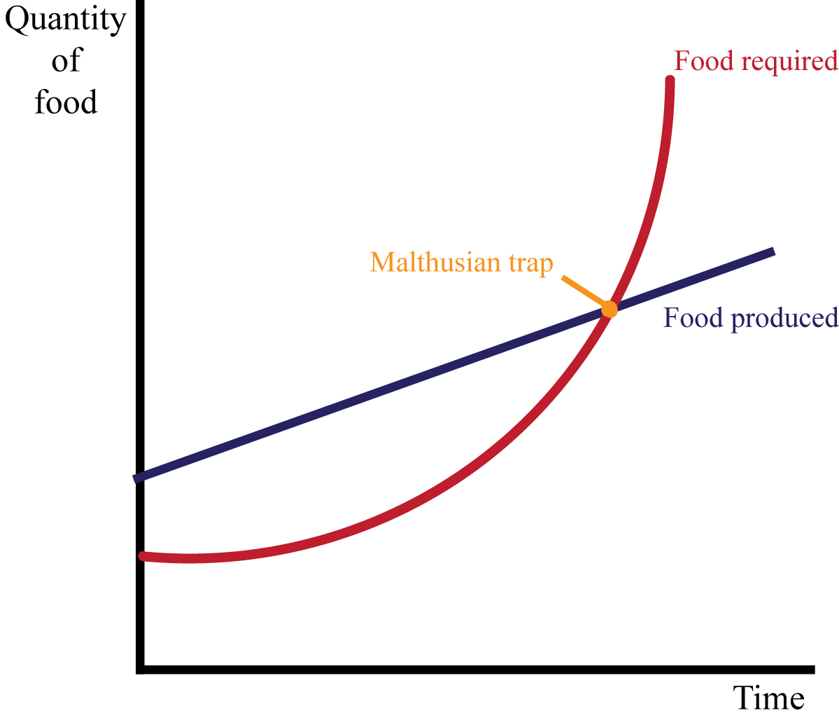
Figure 3: Malthusian trap (Malthus, 1914, p.10-11)
There were challenges from many different groups of agitators including the Chartists, the Anti-Poor Law movement, the Ten-Hour Movement, and the Anti-Corn-Law League (Douglas, 1989).
The Anti-Corn-Law League (1836-1839), led by Richard Cobden and John Bright, was the alliance from both liberals and radicals who opposed the Corn Laws. The Radical opposition wanted a cheaper food. While the Liberal opposition wanted to pay lower wages. Both wanted the same thing, which is the wheat prices to be lowered i.e. the Corn Laws to be repealed. They headed a campaign which ended in success in 1846 when the Prime Minister, Sir Robert Peel repealed the legislation (Phillips, 2007).
Another factor that supported Sir Peel’s repeal was the Irish Potato Famine in 1845. It was the failure of the Irish potato crops that caused the population to fall drastically. Because at that time, the Irish had become dependent on the potato as a staple part of the diet. Those who survived immigrated to England. People were starving from the shortage of food supply, and the Parliament faced tension to keep the food prices high.

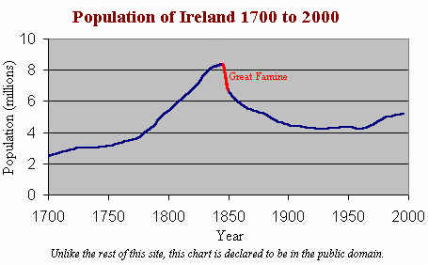
Figure 4: Ireland’s population during 1700 - 2000 (Connell, 1975)

After the Corn Laws were repealed, Sir Peel lost the support of his party and had to resign as Prime Minister. Throughout the 19th century, grain prices in Great Britain fell. Grain imports rose from having more efficient rail roads and water transportation. More barriers were also removed. The trade became freer. For example, the Navigation Laws that was repealed in 1849. It was considered to be when the mercantilism was officially ended (Douglas, I., 1989).
The repeal of the Corn Laws was the beginning of the triumph of free trade in Britain and is a good example of the ideology and interests in determining economic policy.

Sources
Connell, K. (1975). The Population of Ireland 1750-1845. Retrieved from http://www.wesleyjohnston.com/users/ireland/past/famine/demographics_pre.html

Douglas, I. (1989). Political Economy and Peel’s Repeal of the Corn Laws. Retrieved from https://www.dartmouth.edu/~dirwin/docs/Peel.pdf

Hobson, J. (2016). Who shot Edward Vyse in the head? The Corn Law Riots, 1815. Retrieved from https://about1816.wordpress.com/2016/08/05/who-shot-edward-vyse-in-the- head-the-corn-law-riots-1815/

Marjie, B. (2016). The Corn Laws. Retrieved from http://www.victorianweb.org/history/cornlaws1.html

Malthus, T. 1914. An Essay on the Principle of Population. Retrieved from https://archive.org/details/essayonpopulatio00malt

Phillips, E. (2007). What Crushed the Corn Laws?. Retrieved from https://mises.org/library/what-crushed-corn-laws

Ricardo, D. (1815). An Essay on the Influence of a low Price of Corn on the Profits of Stock; shewing the Inexpediency of Restrictions on Importation. Retrieved from http://la.utexas.edu/users/hcleaver/368/368RicardoCornLawstable.pdf

Ricardo, D. (1817). On the Principles of Political Economy and Taxation. Retrieved from https://socialsciences.mcmaster.ca/econ/ugcm/3ll3/ricardo/Principles.pdf

Salvadori, N and Signorino, R. (2013). The Malthus versus Ricardo 1815 Corn Laws Controversy: An appraisal. Retrieved from https://mpra.ub.uni-muenchen.de/50534/

Steelman, A. (2008). Anti-Corn Law League. Retrieved from http://sk.sagepub.com/reference/libertarianism/n9.xml

