EE461 Assignment 1 : Learning about indicators
• Graph #1 : using cross-sectional data
I chose the variables GNI per capita-ppp and trained teachers in primary education in percent of total amount of teachers.
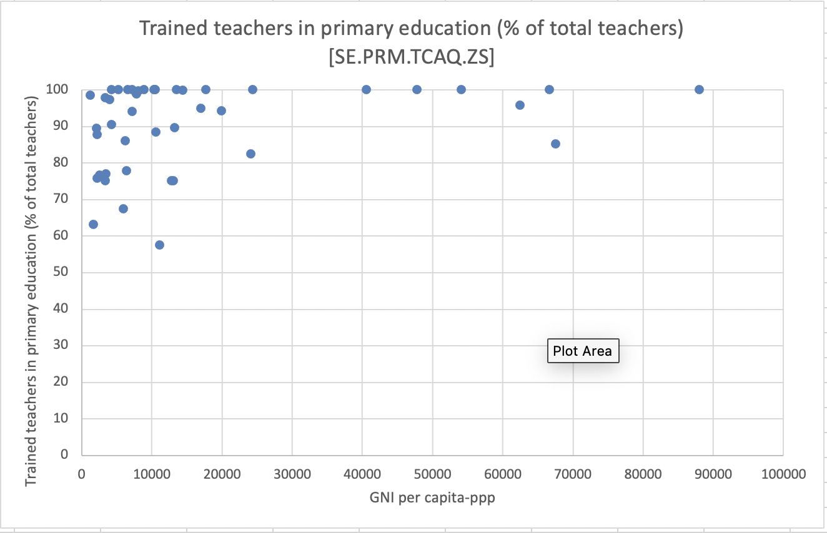

From the scatterplot we can see that when there is a low GNI, which means that the countries income divided by the population is low, there is a lower percentage of the teachers in primary education that are trained.
- which year of this cross-country data?

• Graph #2 : using time-series data + 3 countries (Panel)
I chose to look at intentional homicides per 100 000 inhabitant for the last 25 years, and compared countries from different continents, Norway, Mexico and Thailand.
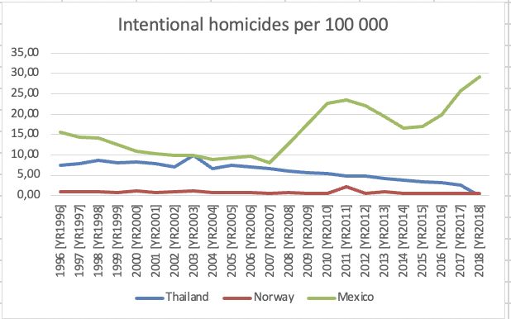
We can see from the diagram that Mexico has always had the highest rate of intentional homicides, while Norway has had the lowest rate. Meanwhile Thailand had a peak in 2003 with 10 intentional homicides per 100 000 inhabitant, and Norway had a peak in 2001 with around 2 or 3. The rate of Mexico was sinking until 2007 where they had around 8 homicides per 100 000 inhabitant, and in 2018 they had a rate of 18.

- Quite interesting that before 2007, Mexico has a decreasing trend, but starting to increase after 2007. If we can look into Mexico’s economic situation, we may get to know more.
Score: 8.5

