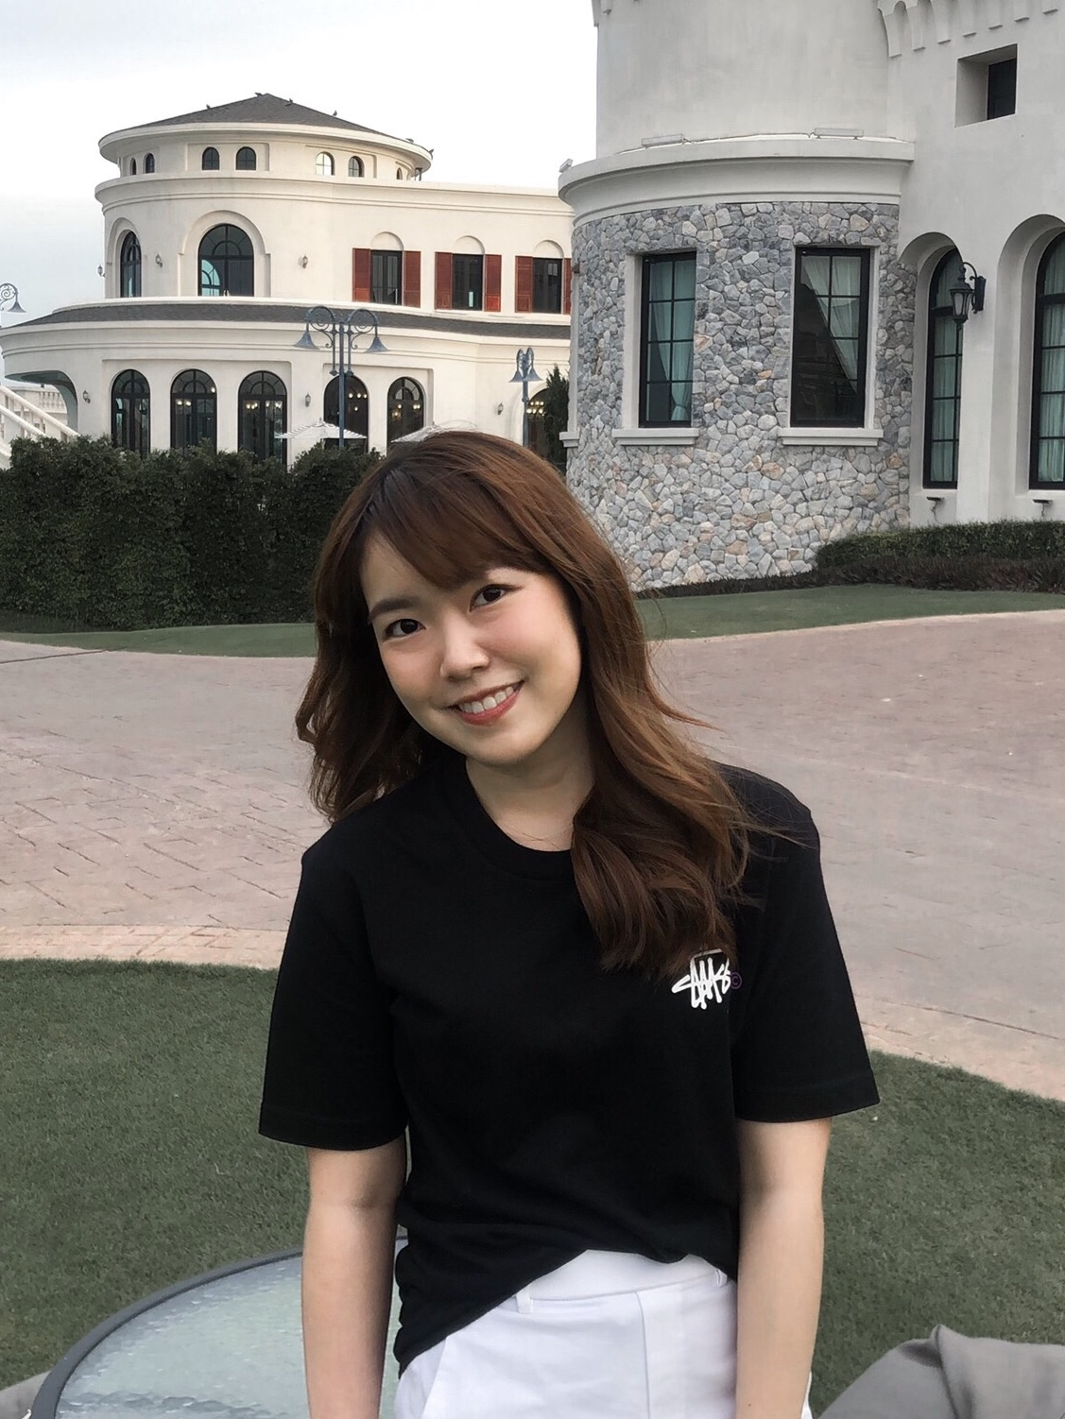
Student Information
EE211 Microeconomics
Semester 1/2020
- Name __Laksika Bijayendrayodhin__
- Nickname___Vé (เว)___
- Email __laksika.bij@st.econ.tu.ac.th___ Phone Number __0899221056___
- Year of program: [ / ] 1st year [] 2nd year [] 3rd year [] 4th year
- Major area (if any)___Economics___
- Minor area (if any) ________________________________________
- Classes that you have already taken
______-_____________________________________________________________
___________________________________________________________________
___________________________________________________________________
- Classes that you are currently taking
________I took a Microeconomics, Statistics, ASEAN, Social Life Skill, Communication English, and Civic Engagement.__________________________________________
___________________________________________________________________
- Classes that you plan to take in the next semester(s) or next academic year(s)
_____I plans to take a macroeconomics and calculus together. Also, I want to study about law economics. When, I have to chose a minor area. I will prefer a Finance.___________________
- What is/are your favorite subject(s)?
______I really like mathematics class._______________________________________
- What do you expect to learn from this class?
______I expect the knowledge which is more than in economics class when in high school. Moreover, I will use all information from this class in the future._________
- What is your concern, if any, about being in this class?
_______I think my English skills are not completely perfect. So, I may not understand in some time._______________________________________________________________
- What would you suggest to enhance your learning experience while taking this class? Is there any teaching technique that other instructors use and you particularly like? If so, please suggest.
_______Maybe we can use some group work or playing game about economic, such as Kahoot.________________________________________________________________
- Briefly describe your career aspiration(s). List the top two choices if there are many.
_________I want to do in my family business and also a new owner business. I think I want to do both at the same time.___________________________________________
- Other comments and/or suggestions.
_______-____________________________________________________________
___________________________________________________________________

(Note: All information is to be used for teaching purpose only, and will be kept confidential.)

