Group Assignment 1

1) Research current economic conditions (interest rates, inflation) using The Wall Street Journal, other library resources, or the World Wide Web. Based on current economic conditions, what actions would you recommend to people who are saving and borrowing money?

Considering certain economic conditions, inflation rate and interest rate, which are the most important to explain cost of borrowing and lending and the price of exchanging money today for money received in the future for people to consider before taking any actions. There are such many factors that affect these two main economic conditions.

Factors that affect Thailand inflation now

- Oil price and cost of production (cost push inflation) – Dramatically drop in oil price due to World oil supply rise higher than actual demand since the end of 2014 and seem likely to stay at the low level through the first quarter of 2015. From this factor, it also causes lower cost of production

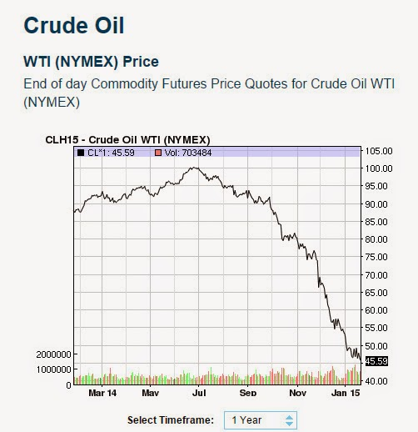

- Thai baht appreciate – In Euro Zone, there are some economics problems and ECB decided to undertake QE, combing with lower interest rate in US than in Thailand. Foreigner investors found that investing in Thai give them higher returns so there are high capital inflows to Thailand, which cause Thai baht to appreciate. This factor affects Thailand export and also leads to slowly growth of an economy.
- Instability in Thailand political – Since now Thailand is governed by Military Coup, many other countries might afraid and reluctant to invest in Thailand. This also affects Thailand’s economic growth and inflation as well.
- Interest rate – government lower interest rate to boost the stagnant economy, make cheaper cost of borrowing, people borrow more to invest and spend as demand increase with the same supply function, overall price level goes up and inflation goes up, vice versa.
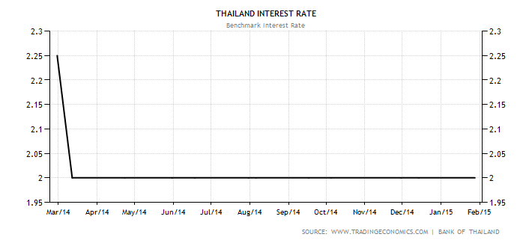
Government set the policy interest rate equal to 2% from the graph

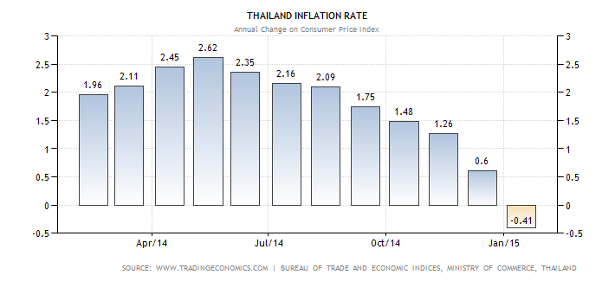

From the graph above the last month we got the negative inflation, which caused by the plumped drop in oil price. The rate will go up to positive again after market adjust itself which correspond to the ministry of finance’s prediction that this year inflation is2.2% or within bound of 1.7-2.7%.
According to increasing in expected inflation and higher interest rate, we came up with recommendations to both lender and borrower. Lender in favors of low inflation because those will decrease their purchasing power and lower the initial return from that particular saving plan. Inflation is the variable that lender or saver can’t control so we have to learn to deal with it. First, we have to keep ahead of inflation by looking at saving plan that return exceed inflation rate such as the short-term (up to 6 months) fix deposit or cooperate bonds. Second, we should deposit money in the financial products that allow us to early withdraw the principal in case that inflation increase to prevent lower rate of return received because the real interest rate is falling. Third, trying to increase the fraction of your saving to keep up with inflation rate and interest rate to maintain the certain level of return that you prefer. Borrower should borrow in long-term contract to prevent higher cost of borrowing and take currently advantage from low interest rate.

2) Collect advertisements and promotional information from several financial institutions, or locate the Web sites of financial institutions. Create a list of factors that a person might consider when comparing costs and benefits of various savings plans.

If you have a chunk of money and want to give up some of partial money today in order to save and gain some return in the future without taking any risk. Then getting one of the fix deposit accounts is one way.

TBANK Promotion: Fixed Deposit Account
(http://www.checkraka.com/price/fixed-account-2-739/ธนาคารธนชาต-Thanachart-บัญชีเงินฝากดับเบิ้ลเฮง-1443597/)

Restriction in order to invest money in Double Hang, the specific conditions required, Double Hang only provides for the regular clients. Clients have to purchase ‘Perfect Coverage 15/7’ insurance before open the fixed saving account which the minimum amount of insurance premium is 25,000 bath per year. Moreover, Bank requires the minimum money deposit at the day saver open the fixed deposit account. It also has the maximum amount of money deposit that is not to exceed the insurance premium. Furthermore, at the end of maturities, which are 88-day, 188-day and 388-day, the rate of return will reconsider by the financial institution again. The bank might reduce the rate of return as equal to the normal rate of return.

For the liquidity, the benefit is that if clients open the fixed deposit account for 388-day and have deposited for over 90 days, clients will be able to withdraw the money deposit before maturity date with principle plus with partial return, which equals to the current market rate of return in saving account. The current market saving account is equal to 0.50% at this moment. But there is a cost if clients have deposited less than 90 days, every single plan allows client to withdraw only the principle and none of return. This becomes less liquidity to clients.

For the rate of return, the benefit of 388-day promotion, if client select 388-day plan of fixed deposit account, Bank pays the return rate to clients twice a year; at 6-month and at the maturity date which is date of 388th which benefits the depositors. The cost of this fixed deposit account promotion does not pay the compound interest rate. It pays the fixed rate of return which means that as long as the client deposit the money with the bank, the amount of interest rate does not accumulate as you deposit longer period of time.

SCB Promotion: Fixed Deposit Account
(http://www.scb.co.th/th/news/2015-02-18/pro-deposit-lucky)

Siam Commercial Bank offers a fixed deposit saving plan called ‘Rub-Sub, Rub-Chok.’ Firstly, the rates of return SCB offering on this fixed deposit savings plan are 1.68% on 88-day fixed deposit account and 2.09% on 188-day fixed deposit account. With the normal fact, this type of saving plan does offer higher interest than saving account one. Then, the interest rate will be paid at the end of each plan chosen, 88th date or 188th date.

Next, taxes, on this promotion offered, there is no tax reduction that could benefit the saver meaning that the interest rate earned will be normally taxed at 15% by the bank.

Lastly, the restrictions and fees, joining this promotional fixed deposit account by Siam Commercial Bank requires savers minimum amount on opening account of more than 50,000 Baht and the minimum next deposit of more than 1,000 Baht. This means that the savers have save some large amount of money before entered this saving plan. Moreover, there is time constraint on this promotion, between 1st and 28th February 2015, or only one month, which is considered a short period of time available. One more restriction on this promotion, if the savers do not keep the money in the account until its maturity, the bank will not pay interest, on the 88-day case. On the 188-day case, however, if the savers deposit money up to 3 months but not to maturity, the bank will only pay interest at the lowest rate of saving account one respectively to the real deposit’s period of time.

KBANK Promotion: Fixed (special) Deposit Account
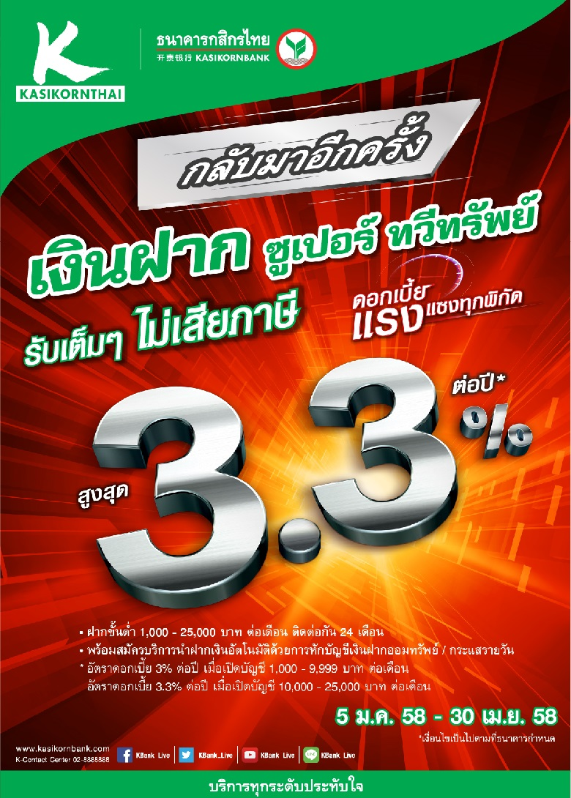
Kasikorn bank offers a promotion for a saving account with a great deal of rate of return and many advantages. This promotion is called ‘Super Ta-Wee-Sub.’ However, making a decision to invest or save your money is a piece of cake. There are several factor that investor needs to consider. First is rate of return, this program offer a very high rate of return up to 3.3 percent per year, but there are many conditions and restrictions.

Saving amount per month | Rate of return
1,000-9,999 Baht | 3 %
10,000-25,000 Baht | 3.3%

The minimum amount to deposit is from 1,000 to 25,000 baht per month and investor needs to deposit 24 months continually. If investor cannot regularly deposit until 3 months, bank will not pay the interests. In the case that investor cannot deposit 24 month constantly, bank will give the interest rate on the date that investor open the account with tax 15 percent. In the case of unstable deposit, if investor cannot make it once or twice, the rate of return will change to be the rate on the date opening account with the tax deduction. If investor cannot make it in the third time, the bank has to charge for the tax at 15 percent. For the tax deduction, the investor who has a duty to pay tax will get benefit from this interest and cannot miss the deposits more than twice.

All in all (TBANK, SCB and KBANK)

For Disadvantage of most fixed deposit accounts, less liquidity, depositors cannot withdraw the deposited money before the maturity date. If they withdraw some of deposited money, bank will pay them back only the principle and none of rate of return. For example, a saver deposit his money into the fixed deposit account for 3 year up to 20,000 Baht with rate of return of 2.5% each year, if he wants to withdraw the money at the end of the second year, which is before the maturity date. Bank will return him only the principle with the amount of money equal to 20,000 Baht and none of the interest return.

Furthermore, safety, it might not be profitable as more risky investments, but it offers a guaranteed a sum of money at the end of period which depositors will receive. This includes all of the money from the principle and interest that they have accrued. Also guaranteed that the rate of return will not fluctuate from the external factor, for example, during the economic crisis or political uncertain, the rate of return usually drop in the market, the depositor can eliminate these worries.

Even though this kind of savings plans guarantee the rate of return during the economy crisis, if the market turn out to be positive sign that there is a rise in the interest rate in the market, higher than the interest rate in the agreement of fixed deposit account at the day you agree. It is obviously not going to advantage them because the relative rate of return that is higher but they still get the return that is lower. This mean that the depositors cannot withdraw your money in order to reinvest on other saving plans. For this reason, it shows that fixed deposit account has a constraint even though it provides the higher rate of return.

Finally, inflation factor, the saver need to make sure before joining these savings plans that the inflation rate at that time does not exceed or eat up the real interest they are going to get. If the inflation increases and become more than the interest rate bank offering, this will result in negative real interest rate making the savers worse off. Thus, it is significant to include this as one of the factors on making decision putting the money in these savings plans.

Member:
Ichaya Yongvanichakorn 5504640292
Jatuporn Jittapirom 5504640326
Preenapa Detchsri 5504641365
Sahawut Aunanant 5504641514
Itsayaporn Tanyaset 5604640341
Mingsumon Chotjinda 5604640622

