AC 201 Fundamental Accounting
Chapter 3 Operating Decisions and the Statement of Comprehensive Income

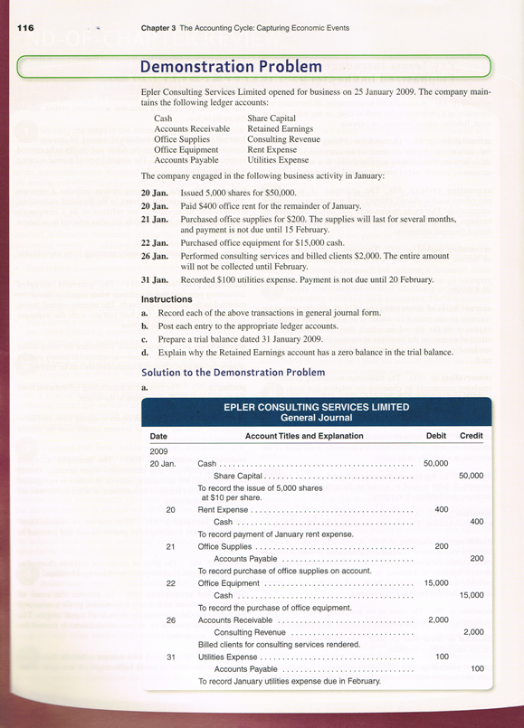
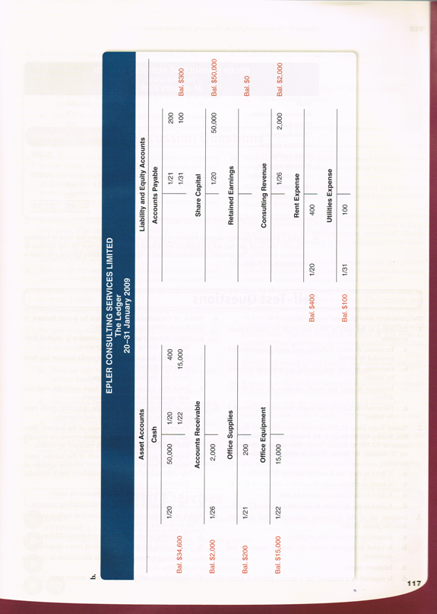
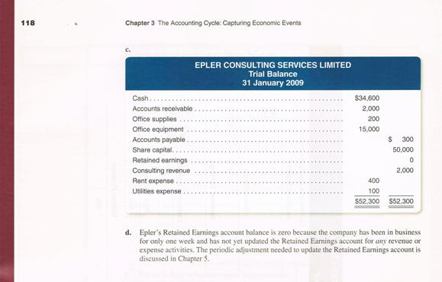

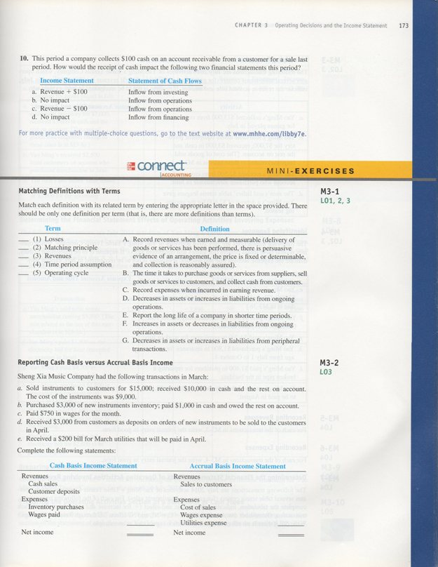

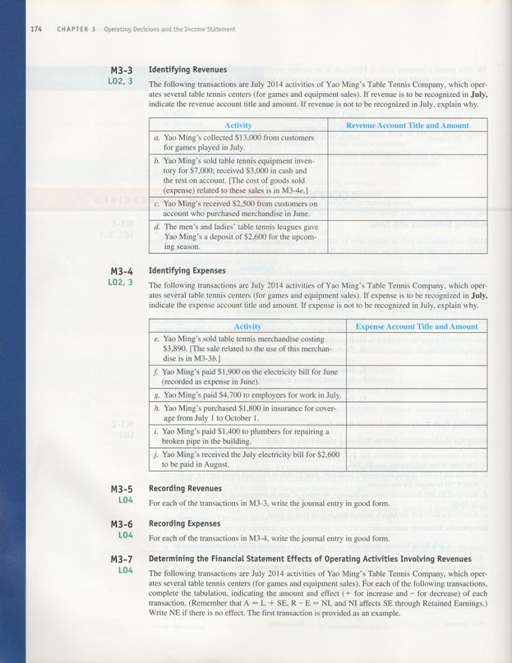

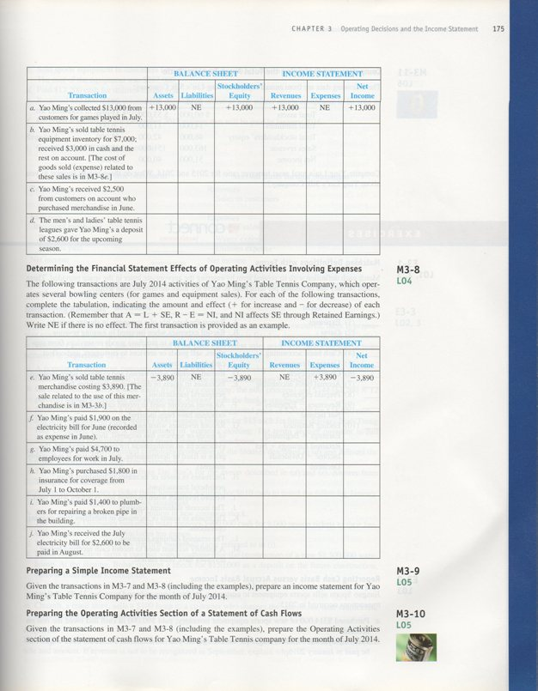

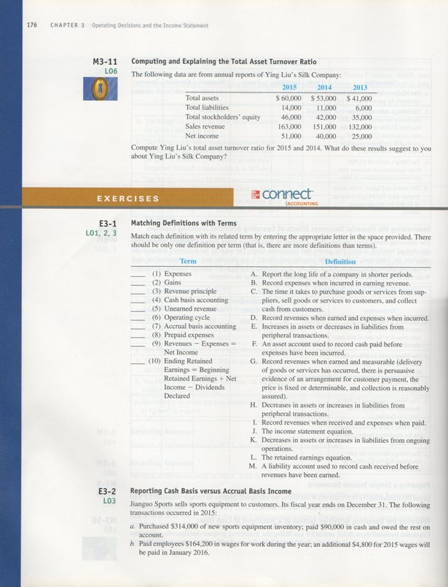

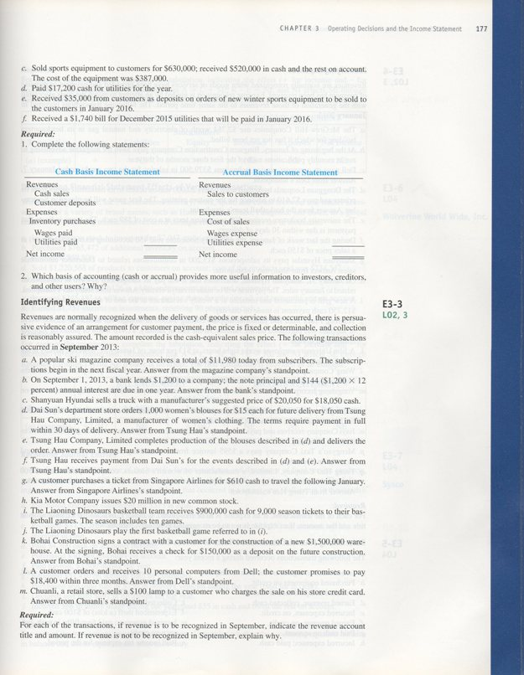

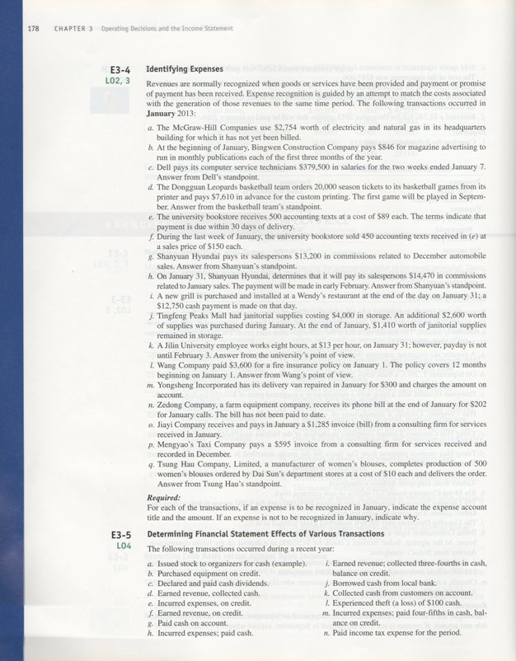

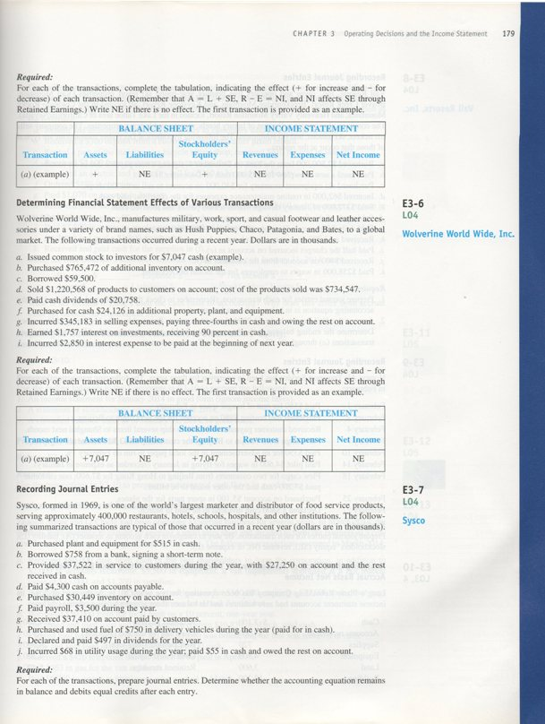

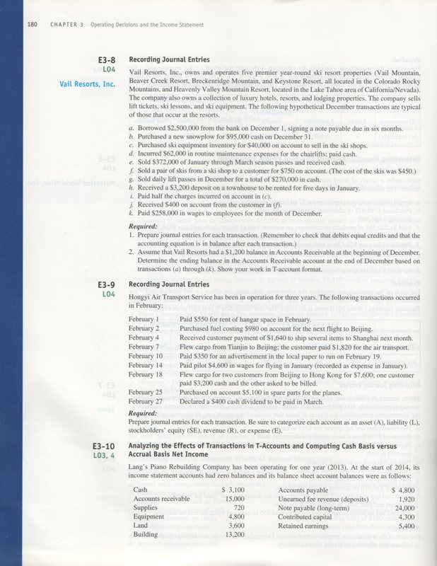
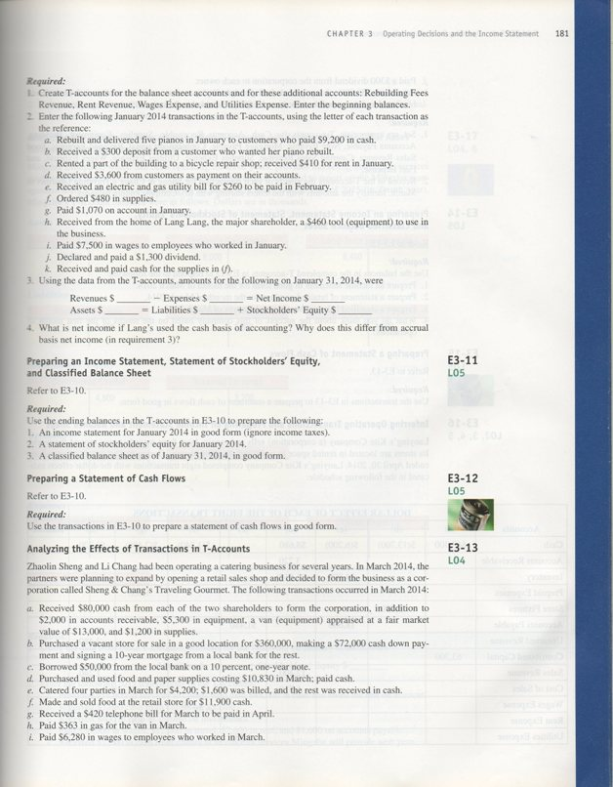

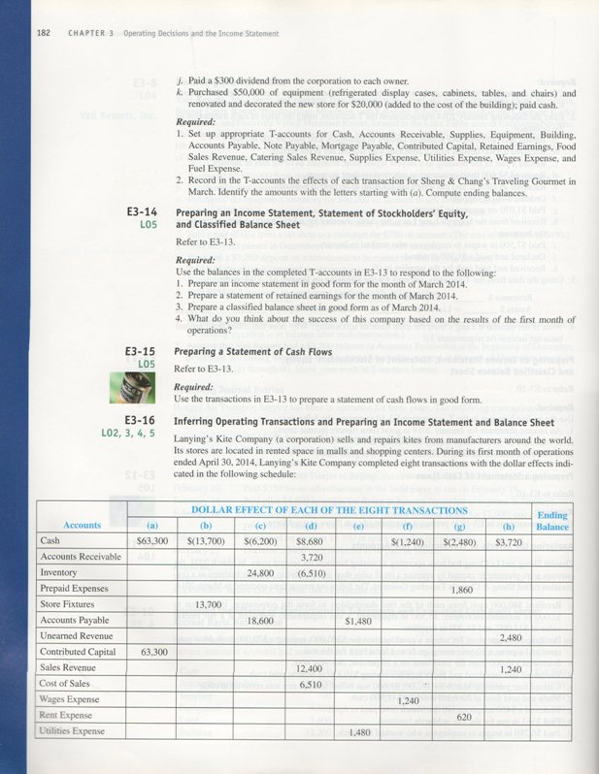

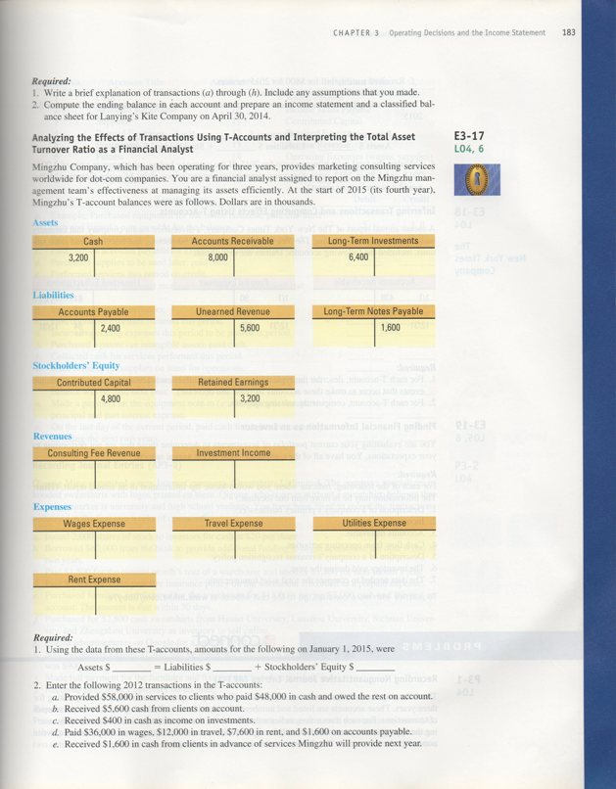

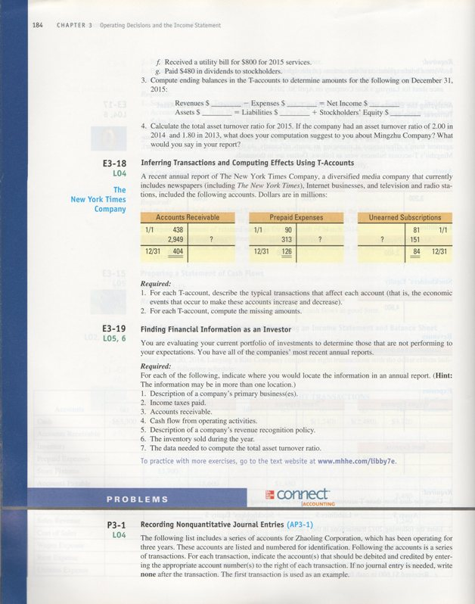

MINI-EXERCISES

M3–1.
 | TERM
G | - Losses
C | - Matching principle
F | - Revenues
E | - Time period assumption
B | - Operating cycle

M3–2.
Cash Basis  Income Statement |  | Accrual Basis  Income Statement
Revenues:  Cash sales  Customer deposits | $10,000  3,000 | Revenues:  Sales to customers | $15,000
Expenses:  Inventory purchases  Wages paid | 1,000  750 | Expenses:  Cost of sales  Wages expense  Utilities expense | 9,000  750  200
Net Income | $11,250 | Net Income | $5,050

M3–3.
 | Revenue Account Affected | Amount of Revenue Earned in July
a. | Games Revenue | $13,000
b. | Sales Revenue | $7,000
c. | None | No revenue earned in July; cash collections in July related to earnings in June.
d. | None | No revenue earned in July; earnings process is not yet complete – Unearned Revenue is recorded upon receipt of cash.

M3–4.

 | Expense Account Affected | Amount of Expense Incurred in July
e. | Cost of Goods Sold | $3,890
f. | None | No expense is incurred in July; payment related to June electricity usage.
g. | Wages Expense | $4,700
h. | Insurance Expense | $600 incurred and expensed in July and $1,200 not incurred until future months (recorded as Prepaid Expense (A)).
i. | Repairs Expense | $1,400
j. | Utilities Expense | $2,600 incurred in July

M3–5.

a. | Cash (+A) | 13,000
 | Games Revenue (+R, +SE) |  | 13,000

b. | Cash (+A) | 3,000
 | Accounts Receivable (+A) | 4,000
 | Sales Revenue (+R, +SE) |  | 7,000

c. | Cash (+A) | 2,500
 | Accounts Receivable (−A) |  | 2,500

d. | Cash (+A) | 2,600
 | Unearned Revenue (+L) |  | 2,600

M3–6.

e. | Cost of Goods Sold (+E, −SE) | 3,890
 | Inventory (−A) |  | 3,890

f. | Accounts Payable (–L) | 1,900
 | Cash (−A) |  | 1,900

g. | Wages Expense (+E, −SE) | 4,700
 | Cash (−A) |  | 4,700

h. | Insurance Expense (+E, −SE) | 600
 | Prepaid Expenses (+A) | 1,200
 | Cash (−A) |  | 1,800

i. | Repairs Expense (+E, −SE) | 1,400
 | Cash (−A) |  | 1,400

j. | Utilities Expense (+E, −SE) | 2,600
 | Accounts Payable (+L) |  | 2,600

M3–7.
 | Balance Sheet |  |  | Income Statement
 | Assets | Liabilities | Stockholders’ Equity | Revenues | Expenses | Net  Income
a. | +13,000 | NE | +13,000 | +13,000 | NE | +13,000
b. | +7,000 | NE | +7,000 | +7,000 | NE | +7,000
c. | +2,500  –2,500 | NE | NE | NE | NE | NE
d. | +2,600 | +2,600 | NE | NE | NE | NE

Transaction (c) results in an increase in an asset (cash) and a decrease in an asset (accounts receivable). Therefore, there is no net effect on assets.

M3–8.

 | Balance Sheet |  |  | Income Statement
 | Assets | Liabilities | Stockholders’ Equity | Revenues | Expenses | Net  Income
e. | –3,890 | NE | –3,890 | NE | +3,890 | –3,890
f. | –1,900 | –1,900 | NE | NE | NE | NE
g. | –4,700 | NE | –4,700 | NE | +4,700 | –4,700
h. | –1,800/  +1,200 | NE | –600 | NE | +600 | –600
i. | –1,400 | NE | –1,400 | NE | +1,400 | –1,400
j. | NE | +2,600 | –2,600 | NE | +2,600 | –2,600

Transaction (h) results in an increase in an asset (prepaid expenses) and a decrease in an asset (cash). Therefore, the net effect on assets is − 600.

M3–9.

Yao Ming’s Table Tennis Company

Income Statement
For the Month of July 2014
Revenues:
Games revenue | $13,000
Sales revenue | 7,000
Total revenues | 20,000
Expenses:
Cost of goods sold | 3,890
Utilities expense | 2,600
Wages expense | 4,700
Insurance expense | 600
Repairs expense | 1,400
Total expenses | 13,190
Net income | $ 6,810

M3–10.

Yao Ming’s Table Tennis Company
Partial Statement of Cash Flows
For the Month of July 2014
Cash Flows from Operating Activities:
Cash received from customers  (=$13,000+$3,000+$2,500+$2,600) | $21,100
Cash paid to suppliers (=$1,900+$1,800+$1,400) | (5,100)
Cash paid to employees | (4,700)
Cash from operating activities | $11,300

M3–11.

 |  |  |  | 2012 |  |  |  |  | 2011
Total Asset | = | Sales |  |  | $163,000 | = | 2.89 |  |  | $151,000 | = | 3.21
Turnover |  | Average Total Assets |  |  | $56,500* |  |  |  |  | $47,000**

* ($53,000 + $60,000) ÷ 2
** ($41,000 + $53,000) ÷ 2

The decrease in the asset turnover ratio suggests that the company is managing its assets less efficiently, generating fewer sales per dollar of assets in 2015 than in 2014.

EXERCISES

E3–1.
 | TERM
K | (1) Expenses
E | (2) Gains
G | (3) Revenue principle
I | (4) Cash basis accounting
M | (5) Unearned revenue
C | (6) Operating cycle
D | (7) Accrual basis accounting
F | (8) Prepaid expenses
J | (9) Revenues − Expenses = Net Income
L | (10) Ending Retained Earnings =
 | Beginning Retained Earnings + Net Income − Dividends Declared

E3–2.

Req. 1
Cash Basis  Income Statement |  | Accrual Basis  Income Statement
Revenues:  Cash sales  Customer deposits | $520,000  35,000 | Revenues:  Sales to customers | $630,000
Expenses:  Inventory purchases  Wages paid  Utilities paid | 90,000  164,200  17,200 | Expenses:  Cost of sales  Wages expense  Utilities expense | 387,000  169,000  18,940
Net Income | $283,600 | Net Income | $55,060

Req. 2

Accrual basis financial statements provide more useful information to external users. Financial statements created under cash basis accounting normally postpone (e.g., $110,000 credit sales) or accelerate (e.g., $35,000 customer deposits) recognition of revenues and expenses long before or after goods and services are produced and delivered (until cash is received or paid). They also do not necessarily reflect all assets or liabilities of a company on a particular date.

E3–3.

Activity | Revenue Account Affected | Amount of Revenue Earned in September
a. | None | No revenue earned in September; earnings process is not yet complete.
b. | Interest revenue | $12 (= $1,200 x 12% x 1month/12 months)
c. | Sales revenue | $18,050
d. | None | No transaction has occurred; exchange of promises only.
e. | Sales revenue | $15,000 (= 1,000 blouses x $15 per blouse); revenue earned when goods are delivered.
f. | None | Payment related to revenue recorded previously in (e) above.
g. | None | No revenue earned in September; earnings process is not yet complete.
h. | None | No revenue is earned; the issuance of stock is a financing activity.
i. | None | No revenue earned in September; earnings process is not yet complete.
j. | Ticket sales revenue | $90,000 (= $900,000 ÷ 10 games)
k. | None | No revenue earned in September; earnings process is not yet complete.
l. | Sales revenue | $18,400
m. | Sales revenue | $100

E3–4.
Activity | Expense Account Affected | Amount of Expense Incurred in  January
a. | Utilities expense | $2,754
b. | Advertising expense | $282(= $846 x 1 month/3 months) incurred in January. The remainder is a prepaid expense (A) that is not incurred until February and March.
c. | Salary expense | $189,750 incurred in January.  The remaining half was incurred in December.
d. | None | Expense will be recorded when the related revenue has been earned.
e. | None | Expense will be recorded in the future when the related revenue has been earned.
f. | Cost of goods sold | $40,050 (= 450 books x $89 per book)
g. | None | December expense paid in January.
h. | Commission expense | $14,470
i. | None | Expense will be recorded as depreciation over the equipment’s useful life.
j. | Supplies expense | $5,190 (= $4,000 + $2,600 - $1,410)
k. | Wages expense | $104 (= 8 hours x $13 per hour)
l. | Insurance expense | $300 (= $3,600 ÷ 12 months)
m. | Repairs expense | $300
n. | Utilities Expense | $202
o. | Consulting Expense | $1,285
p. | None | December expense paid in January.
q. | Cost of goods sold | $5,000 (= 500 blouses x $10 per blouse)

E3–5.
 | Balance Sheet |  |  | Income Statement
 | Assets | Liabilities | Stockholders’ Equity | Revenues | Expenses | Net  Income
a. | + | NE | + | NE | NE | NE
b. | + | + | NE | NE | NE | NE
c. | - | NE | - | NE | NE | NE
d. | + | NE | + | + | NE | +
e. | NE | + | – | NE | + | –
f. | + | NE | + | + | NE | +
g. | – | – | NE | NE | NE | NE
h. | – | NE | – | NE | + | –
i. | + | NE | + | + | NE | +
j. | + | + | NE | NE | NE | NE
k. | + / – | NE | NE | NE | NE | NE
l. | – | NE | – | NE | + * | –
m. | – | + | – | NE | + | –
n. | – | NE | – | NE | + | –

Transaction (k) results in an increase in an asset (cash) and a decrease in an asset (accounts receivable). Therefore, there is no net effect on assets.

* A loss affects net income negatively, as do expenses.

E3–6.

 | Balance Sheet |  |  | Income Statement
 | Assets | Liabilities | Stockholders’ Equity | Revenues | Expenses | Net  Income
a. | +7,047 | NE | +7,047 | NE | NE | NE
b. | +765,472 | +765,472 | NE | NE | NE | NE
c. | +59,500 | +59,500 | NE | NE | NE | NE
d. | +1,220,568  –734,547 | NE NE | +1,220,568 –734,547 | +1,220,568 NE | NE  +734,547 | +1,220,568 –734,547
e. | –20,758 | NE | –20,758 | NE | NE | NE
f. | +/–24,126 | NE | NE | NE | NE | NE
g. | –258,887 | +86,296 | –345,183 | NE | +345,183 | –345,183
h. | +1,757 | NE | +1,757 | +1,757 | NE | +1,757
i. | NE | +2,850 | –2,850 | NE | +2,850 | –2,850

Transaction (f) results in an increase in an asset (property, plant, and equipment) and a decrease in an asset (cash). Therefore, there is no net effect on assets.

E3–7.

(in thousands)
a. | Plant and equipment (+A) | 515
 | Cash (−A) |  | 515
 | Debits equal credits. Assets increase and decrease by the same amount.
b. | Cash (+A) | 758
 | Short-term notes payable (+L) |  | 758
 | Debits equal credits. Assets and liabilities increase by the same amount.
c. | Cash (+A)  Accounts receivable (+A) | 10,272  27,250
 | Service revenue (+R, +SE) |  | 37,522
 | Debits equal credits. Revenue increases retained earnings (part of stockholders' equity). Stockholders' equity and assets increase by the same amount.

E3–7. (continued)

d. | Accounts payable (−L) | 4,300
 | Cash (−A) |  | 4,300
 | Debits equal credits. Assets and liabilities decrease by the same amount.
e. | Inventory (+A) | 30,449
 | Accounts payable (+L) |  | 30,449
 | Debits equal credits. Assets and liabilities increase by the same amount.
f. | Wages expense (+E, −SE) | 3,500
 | Cash (−A) |  | 3,500
 | Debits equal credits. Expenses decrease retained earnings (part of stockholders' equity). Stockholders' equity and assets decrease by the same amount.
g. | Cash (+A) | 37,410
 | Accounts receivable (−A) |  | 37,410
 | Debits equal credits. Assets increase and decrease by the same amount.
h. | Fuel expense (+E, −SE) | 750
 | Cash (−A) |  | 750
 | Debits equal credits. Expenses decrease retained earnings (part of stockholders' equity). Stockholders' equity and assets decrease by the same amount.
i. | Retained earnings (−SE) | 497
 | Cash (−A) |  | 497
 | Debits equal credits. Assets and stockholders’ equity decrease by the same amount.
j. | Utilities expense (+E, −SE) | 68
 | Cash (−A)  Accounts payable (+L) |  | 55  13
 | Debits equal credits. Expenses decrease retained earnings (part of stockholders' equity). Together, stockholders' equity and liabilities decrease by the same amount as assets.

E3–8.

Req. 1

a. Cash (+A) 2,500,000
Short-term note payable (+L) 2,500,000
Debits equal credits. Assets and liabilities increase by the same amount.

b. Equipment (+A) 95,000
Cash (−A) 95,000
Debits equal credits. Assets increase and decrease by the same amount.

c. Merchandise inventory (+A) 40,000
Accounts payable (+L) 40,000
Debits equal credits. Assets and liabilities increase by the same amount.

d. Repair and maintenance expense (+E, −SE) 62,000
Cash (−A) 62,000
Debits equal credits. Expenses decrease retained earnings (part of stockholders' equity). Stockholders' equity and assets decrease by the same amount.

e. Cash (+A) 372,000
Unearned pass revenue (+L) 372,000
Debits equal credits. Since the season passes are sold before Vail Resorts provides service, revenue is deferred until it is earned. Assets and liabilities increase by the same amount.

f. Two transactions occur:
(1) Accounts receivable (+A) 750
Ski shop sales revenue (+R, +SE) 750
Debits equal credits. Revenue increases retained earnings (a part of stockholders' equity). Stockholders' equity and assets increase by the same amount.

(2) Cost of goods sold (+E, −SE) 450
Merchandise inventory (−A) 450
Debits equal credits. Expenses decrease retained earnings (a part of stockholders' equity). Stockholders' equity and assets decrease by the same amount.

g. Cash (+A) 270,000
Lift revenue (+R, +SE) 270,000
Debits equal credits. Revenue increases retained earnings (a part of stockholders' equity). Stockholders' equity and assets increase by the same amount.

h. Cash (+A) 3,200
Unearned rent revenue (+L) 3,200
Debits equal credits. Since the rent is received before the townhouse is used, revenue is deferred until it is earned. Assets and liabilities increase by the same amount.

i. Accounts payable (−L) 20,000
Cash (−A) 20,000
Debits equal credits. Assets and liabilities decrease by the same amount.

E3–8. (continued)

j. Cash (+A) 400
Accounts receivable (−A) 400
Debits equal credits. Assets increase and decrease by the same amount.

k. Wages expense (+E, −SE) 258,000
Cash (−A) 258,000
Debits equal credits. Expenses decrease retained earnings (a part of stockholders' equity). Stockholders' equity and assets decrease by the same amount.

Req. 2
Accounts Receivable
Beg. bal. 1,200  (f) 750 | 400 (j)
End. bal. 1,550

E3–9.

2/1 | Rent expense (+E, −SE) | 550
 | Cash (−A) |  | 550
2/2 | Fuel expense (+E, −SE) | 980
 | Accounts payable (+L) |  | 980
2/4 | Cash (+A) | 1,620
 | Unearned revenue (+L) |  | 1,620
2/7 | Cash (+A) | 1,820
 | Transport revenue (+R, +SE) |  | 1,820
2/10 | Advertising expense (+E, −SE) | 350
 | Cash (−A) |  | 350
2/14 | Wages payable (−L) | 4,600
 | Cash (−A) |  | 4,600
2/18 | Cash (+A)  Accounts receivable (+A) | 3,200  4,400
 | Transport revenue (+R, +SE) |  | 7,600
2/25 | Parts supplies (+A) | 5,100
 | Accounts payable (+L) |  | 5,100
2/27 | Retained earnings (−SE) | 400
 | Dividends payable (+L) |  | 400

E3–10.

Req. 1 and 2

Cash |  |  | Accounts Receivable |  |  | Supplies
Beg. 3,100  (a) 9,200  (b) 300  (c) 410  (d) 3,600 | 1,070 (g)  7,500 (i)  1,300 (j)  480 (k) |  | Beg.15,000 | 3,600 (d) |  | Beg. 720  (k) 480
6,260 |  |  | 11,400 |  |  | 1,200

Equipment |  |  | Land |  |  | Building
Beg. 4,800  (h) 460 |  |  | Beg. 3,600 |  |  | Beg. 13,200
5,260 |  |  | 3,600 |  |  | 13,200

Accounts  Payable |  |  | Unearned Fee Revenue |  |  | Note  Payable
(g) 1,070 | 4,800 Beg.  260 (e) |  |  | 1,920 Beg.  300 (b) |  |  | 24,000 Beg.
 | 3,990 |  |  | 2,220 |  |  | 24,000

Contributed Capital |  |  | Retained Earnings |  |  | Rebuilding Fees Revenue
 | 4,300 Beg.  460 (h) |  | (j) 1,300 | 5,400 Beg. |  |  | 0 Beg.  9,200 (a)
 | 4,760 |  |  | 4,100 |  |  | 9,200

Rent Revenue |  |  | Wages Expense |  |  | Utilities Expense
 | 0 Beg.  410 (c) |  | Beg. 0  (i) 7,500 |  |  | Beg. 0  (e) 260
 | 410 |  | 7,500 |  |  | 260

Item (f) is not a transaction; there has been no exchange.

Req. 3

Net income using the accrual basis of accounting:
Revenues | $9,610 | ($9,200 + $410)
– Expenses | 7,760 | ($7,500 + $260)
Net Income  (accrual basis) | $ 1,850

Assets | = | Liabilities | + | Stockholders’ Equity
$6,260 |  | $ 3,990 |  | $ 4,760
11,400 |  | 2,220 |  | 4,100
1,200 |  | 24,000 |  | 1,850 net income
5,260
3,600
13,200
$40,920 |  | $30,210 |  | $10,710

E3–10. (continued)

Req. 4

Net income using the cash basis of accounting:

Cash receipts | $13,510 | (transactions a through d)
– Cash disbursements | 9,050 | (transactions g, i, and k)
Net Income  (cash basis) | $ 4,460

Cash basis net income ($4,460) is higher than accrual basis net income ($1,850) because of the differences in the timing of recording revenues versus receipts and expenses versus disbursements between the two methods. The $3,900 higher amount in cash receipts over revenues includes cash received prior to being earned (from (b), $300) and cash received after being earned (in (d), $3,600). The $1,290 higher amount in cash disbursements over expenses includes cash paid after being incurred in the prior period (in (g), $1,070), plus cash paid for supplies to be used and expensed in the future (in (k), $480), less an expense incurred in January to be paid in February (in (e), $260).

E3–11.

Req. 1

LANG’S PIANO REBUILDING COMPANY
Income Statement (unadjusted)
For the Month Ended January 31, 2014

Operating Revenues:
Rebuilding fees revenue | $ 9,200
Total operating revenues | 9,200
Operating Expenses:
Wages expense | 7,500
Utilities expense | 260
Total operating expenses | 7,760
Operating Income | 1,440
Other Item:
Rent revenue | 410
Net Income | $ 1,850

E3–11. (continued)

Req. 2

LANG’S PIANO REBUILDING COMPANY
Statement of Stockholders’ Equity (unadjusted)
For the Month Ended January 31, 2014

 | Contributed Capital |  | Retained Earnings |  | Total Stockholders’ Equity
Balance, December 31, 2013 | $ 4,300 |  | $ 5,400 |  | $9,700
Additional contributions | 460 |  |  |  | 460
Net income |  |  | 1,850 |  | 1,850
Dividends |  |  | (1,300) |  | (1,300)
Balance, January 31, 2014 | $ 4,760 |  | $5,950 |  | $10,710

Req. 3

LANG’S PIANO REBUILDING COMPANY
Balance Sheet (unadjusted)
At January 31, 2014

Assets  Current assets:  Cash  Accounts receivable  Supplies  Total current assets  Equipment  Land  Building  Total Assets  Liabilities and Stockholders’ Equity  Current liabilities:  Accounts payable  Unearned fee revenue  Total current liabilities  Note payable  Total Liabilities  Stockholders’ Equity:  Contributed Capital  Retained Earnings  Total Stockholders’ Equity  Total Liabilities and Stockholders’ Equity | $ 6,260  11,400  1,200  18,860  5,260  3,600  13,200  $ 40,920  $ 3,990  2,220  6,210  24,000  30,210  4,760  5,950  10,710  $ 40,920

E3–12.

LANG’S PIANO REBUILDING COMPANY
Statement of Cash Flows
For the Month Ended January 31, 2014
Operating Activities
Cash received from customers  (=$9,200+$300+$410+$3,600) | $13,510
Cash paid to employees | (7,500)
Cash paid to suppliers (=$1,070+$480) | (1,550)
Total cash from operating activities | 4,460
Investing Activities
None | 0
Total cash provided by investing activities | 0
Financing Activities
Dividends paid | (1,300)
Total cash used in financing activities | (1,300)
Increase in cash | 3,160
Beginning cash balance | 3,100
Ending cash balance | $6,260

Transaction (h) is omitted from the statement of cash flows because the transaction did not involve a cash payment. However, as discussed in future chapters, this type of transaction is a noncash investing and financing activity that requires supplemental disclosure.

E3–13.

Req. 1 and 2

Cash |  |  | Accounts Receivable |  |  | Supplies
Beg. 0  (a)160,000  (c) 50,000  (e) 2,600  (f) 11,900 | 72,000 (b)  10,830 (d)  363 (h)  6,280 (i)  600 (j)  70,000 (k) |  | Beg. 0  (a) 2,000  (e) 1,600 |  |  | Beg. 0  (a) 1,200
64,427 |  |  | 3,600 |  |  | 1,200

Equipment |  |  | Building |  |  | Accounts Payable
Beg. 0  (a) 18,300  (k) 50,000 |  |  | Beg. 0  (b)360,000  (k) 20,000 |  |  |  | 0 Beg.  420 (g)
68,300 |  |  | 380,000 |  |  |  | 420

Note Payable |  |  | Mortgage Payable |  |  | Contributed Capital
 | 0 Beg.  50,000 (c) |  |  | 0 Beg.  288,000(b) |  |  | 0 Beg.  181,500 (a)
 | 50,000 |  |  | 288,000 |  |  | 181,500

Retained  Earnings |  |  | Food Sales Revenue |  |  | Catering Sales Revenue
(j) 600 | 0 Beg. |  |  | 0 Beg.  11,900 (f) |  |  | 0 Beg.  4,200 (e)
600 |  |  |  | 11,900 |  |  | 4,200

Supplies Expense |  |  | Utilities Expense |  |  | Wages Expense
Beg. 0  (d) 10,830 |  |  | Beg. 0  (g) 420 |  |  | Beg. 0  (i) 6,280
10,830 |  |  | 420 |  |  | 6,280

Fuel Expense
Beg. 0
(h) 363
363

E3–14.

Req. 1

SHENG & CHANG’S TRAVELING GOURMET
Income Statement (unadjusted)
For the Month Ended March 31, 2014

Revenues:  Food sales revenue  Catering sales revenue  Total revenues  Expenses:  Supplies expense  Utilities expense  Wages expense  Fuel expense  Total costs and expenses | $ 11,900  4,200  16,100  10,830  420  6,280  363  17,893
Net Loss | $ (1,793)

Req. 2

SHENG & CHANG’S TRAVELING GOURMET
Statement of Stockholders’ Equity (unadjusted)
For the Month Ended March 31, 2014

 | Contributed Capital |  | Retained Earnings |  | Total Stockholders’ Equity
Beginning, March 1, 2011 | $ 0 |  | $ 0 |  | $ 0
Additional contributions | 181,500 |  |  |  | 181,500
Net loss |  |  | (1,793) |  | (1,793)
Dividends |  |  | (600) |  | (600)
Ending, March 31, 2011 | $ 181,500 |  | $ (2,393) |  | $179,107

Note: In many states, dividends could not have been declared legally due to the insufficient amount in retained earnings.

E3–14. (continued)

Req. 3

SHENG & CHANG’S TRAVELING GOURMET
Balance Sheet (unadjusted)
At March 31, 2014

Assets  Current assets:  Cash  Accounts receivable  Supplies  Total current assets  Equipment  Building  Total Assets  Liabilities  Current liabilities:  Accounts payable  Note payable  Total current liabilities  Mortgage payable  Total Liabilities  Stockholders’ Equity  Contributed capital  Retained earnings  Total Stockholders’ Equity  Total Liabilities and Stockholders’ Equity | $ 64,427  3,600  1,200  69,227  68,300  380,000  $517,527  $ 420  50,000  50,420  288,000  338,420  181,500  (2,393)  179,107  $517,527

Req. 4

The company generated a small loss during its first month of operations, before making any adjusting entries. The adjusting entries for depreciation and interest expense will increase the loss. So far the company does not appear to be successful, but it is only in its first month of operating a retail store. If sales can be increased without inflating fixed costs (particularly salaries expense), the company may soon turn a profit. It is not unusual for small businesses to lose money as they start up operations.

E3–15.

SHENG & CHANG’S TRAVELING GOURMET
Statement of Cash Flows
For the Month Ended March 31, 2014

Operating Activities
Cash received from customers  (=$2,600+$11,900) | $ 14,500
Cash paid to employees | (6,280)
Cash paid to suppliers (=$10,830+$363) | (11,193)
Total cash used in operating activities | (2,973)
Investing Activities
Purchased building (=$72,000+$20,000) | (92,000)
Purchased equipment | (50,000)
Total cash used in investing activities | (142,000)
Financing Activities
Borrowed on a note payable | 50,000
Issued stock | 160,000
Paid dividends | (600)
Total cash from financing activities | 209,400
Increase in cash | 64,427
Beginning cash balance | 0
Ending cash balance | $ 64,427

Note that portions of transactions (a) and (b) are omitted from the statement of cash flows. However, as discussed in future chapters, these types of transactions are noncash investing and financing activities that require supplemental disclosure.

E3–16.

Req. 1

Transaction | Brief Explanation
a | Issued capital stock to shareholders for $63,300 cash.
b | Purchased store fixtures for $13,700 cash.
c | Purchased $24,800 of inventory, paying $6,200 cash and the balance on account.
d | Sold $12,400 of goods or services to customers, receiving $8,680 cash and the balance on account. The cost of the goods sold was $6,510.
e | Used $1,480 of utilities during the month, not yet paid.
f | Paid $1,240 in wages to employees.
g | Paid $2,480 in cash for rent, $620 related to the current month and $1,860 related to future months.
h | Received $3,720 cash from customers, $1,240 related to current sales and $2,480 related to goods or services to be provided in the future.

Req. 2

Lanying’s Kite Company
Income Statement
For the Month Ended April 30, 2014

Sales Revenue  Expenses:  Cost of sales  Wages expense  Rent expense  Utilities expense  Total expenses | $ 13,640  6,510  1,240  620  1,480  9,850
Net Income | $ 3,790

E3–16. (continued)

Lanying’s Kite Company
Balance Sheet
At April 30, 2014

Assets |  |  | Liabilities and Shareholders’ Equity
Current Assets: |  |  | Current Liabilities:
Cash | $52,080 |  | Accounts payable | $20,080
Accounts receivable | 3,720 |  | Unearned revenue | 2,480
Inventory | 18,290 |  | Total current liabilities | 22,560
Prepaid expenses | 1,860 |  | Shareholders’ Equity:
Total current assets | 75,950 |  | Contributed capital | 63,300
Store fixtures | 13,700 |  | Retained earnings | 3,790
 |  |  | Total shareholders’ equity | 67,090
Total Assets | $89,650 |  | Total Liabilities & Shareholders’ Equity | $89,650

E3–17.

Req. 1

Assets | = | Liabilities | + | Stockholders’ Equity
$ 3,200 |  | $ 2,400 |  | $ 4,800
8,000 |  | 5,600 |  | 3,200
6,400 |  | 1,600
$17,600 |  | $9,600 |  | $ 8,000

Req. 2

Cash |  |  | Accounts  Receivable |  |  | Long-Term Investments
Beg. 3,200  (a) 48,000  (b) 5,600  (c) 400  (e) 1,600 | 57,200 (d)  480 (g) |  | Beg. 8,000  (a) 10,000 | 5,600 (b) |  | Beg. 6,400
1,120 |  |  | 12,400 |  |  | 6,400

Accounts  Payable |  |  | Unearned  Revenue |  |  | Long-Term  Notes Payable
(d) 1,600 | 2,400 Beg.  800 (f) |  |  | 5,600 Beg.  1,600 (e) |  |  | 1,600 Beg.
 | 1,600 |  |  | 7,200 |  |  | 1,600

Contributed Capital |  |  | Retained Earnings
 | 4,800 Beg. |  | (g) 480 | 3,200 Beg.
 | 4,800 |  |  | 2,720

Consulting Fee Revenue |  |  | Investment  Income
 | 0 Beg. |  |  | 0 Beg.
 | 58,000 (a) |  |  | 400 (c)
 | 58,000 |  |  | 400

Wages Expense |  |  | Travel Expense |  |  | Utilities Expense
Beg. 0  (d) 36,000 |  |  | Beg. 0  (d) 12,000 |  |  | Beg. 0  (f) 800
36,000 |  |  | 12,000 |  |  | 800

Rent Expense
Beg. 0
(d) 7,600
7,600

E3–17. (continued)

Req. 3

Revenues | $58,400 | ($58,000 + $400)
– Expenses | 56,400 | ($36,000 + $12,000 + $800 + $7,600)
Net Income | $ 2,000

Assets | = | Liabilities | + | Stockholders’ Equity
$ 1,120 |  | $ 1,600 |  | $ 4,800
12,400 |  | 7,200 |  | 2,720
6,400 |  | 1,600 |  | 2,000 net income
$19,920 |  | $10,400 |  | $ 9,520

Req. 4

Total Asset Turnover | = | Sales (Operating) Revenues | = | $58,000* | = | 3.09
 |  | Average Total Assets |  | $18,760**

* The $400 of investment income is not an operating revenue and is not included in the computation.
** ($17,600 beginning total assets + $19,920 ending total assets) ÷ 2

The increasing trend in the total asset turnover ratio from 1.80 in 2010 and 2.00 in 2011 to 3.09 in 2012 suggests that the company is managing its assets more efficiently over time.

E3–18.

Req. 1

Accounts receivable increases with customer sales on account and decreases with cash payments received from customers.
Prepaid expenses increase with cash payments of expenses related to future periods and decrease as these expenses are incurred over time.
Unearned subscriptions increases with cash payments received from customers for goods or services to be provided in the future and decreases when those goods and services are provided.

Req. 2

Accounts Receivable |  |  | Prepaid Expenses |  |  | Unearned Subscriptions
1/1 438 |  |  | 1/1 90 |  |  |  | 81 1/1
2,949 | 2,983 |  | 313 | 277 |  | 148 | 151
12/31 404 |  |  | 12/31 126 |  |  |  | 84 12/31

Computations:
 | Beginning | + | “+” | − | “−” | = | Ending
Accounts receivable | 438 | + | 2,949 | − | ?  ? | =  = | 404  2,983
Prepaid expenses | 90 | + | 313 | − | ?  ? | == | 126  277
Unearned subscriptions | 81 | + | 151 | − | ?  ? | =  = | 84  148

E3–19.

ITEM | LOCATION
- Description of a company’s primary business(es). | Letter to shareholders;  Management’s Discussion and Analysis;  Summary of significant accounting policies note
- Income taxes paid. | Notes; Statement of cash flows
- Accounts receivable. | Balance sheet
- Cash flow from operating activities. | Statement of cash flows
- Description of a company’s revenue recognition policy. | Summary of significant accounting policies note
- The inventory sold during the year. | Income statement (Cost of Goods Sold)
- The data needed to compute the total asset turnover ratio. | Balance sheet and income statement

