1.1
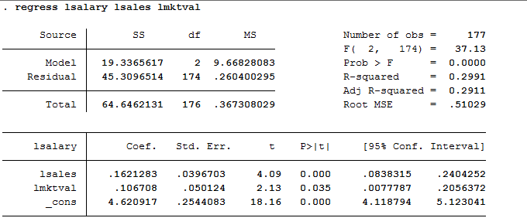

Ans: The model of the constant elasticity: log(salary) = β0 + β1log(sales) + β2log(mktval) + u
The estimated model would be: log(salary) = 4.6209 + 0.1621log(sales) + 0.1067log(mktval)

1.2
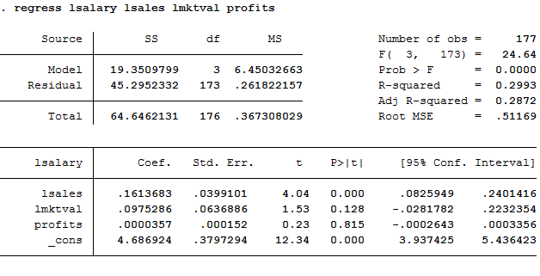

Ans: (i) Because profits could be negative in some years and since we cannot take log on negative value
(ii) Since R-square is equal to 0.2993, it doesn’t show that these firm performance variables explain most of the variation in the CEO salary very well.

1.3
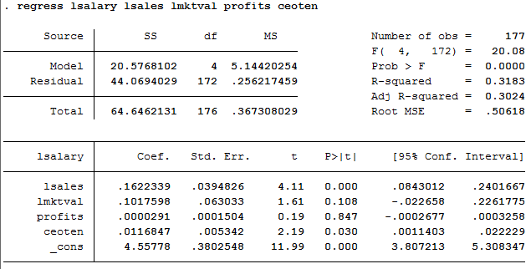
Ans: The estimated model is:
log(salary) = 4.56 + 0.16log(sales) + 0.10log(mktval) + 0.00prof its + 0.01ceoten
This means that if CEO tenure increases by 1 year, salary would increase by 1%.
1.4
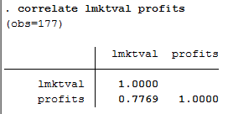
Ans: The sample correlation coefficient is 0.7769 log(mktval) and profits are highly correlated. Profits
and the log of market value move together in the positive direction.

2 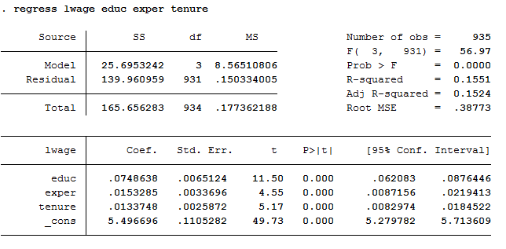
2.1 Ans : Ho : β2 - β3 = 0
Ha : β2 – β3 ≠ 0
2.2
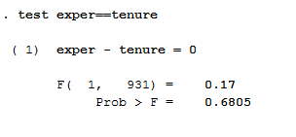
Ans : Assuming that using 0.05 level of significant, we accept Ho because p-value is greater than 0.05. So we can conclude that β2 = β3

3.
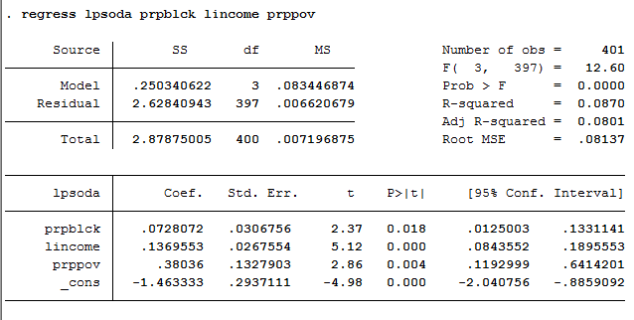
3.1. Ans : log(psoda) = -1.4633 + 0.728(prpblck) + 0.1369(income) + 0.3803(prpprov)
At 0.05 level of significant: Since P-value(0.018) of the estimated β1 is less than 0.05, we will reject Ho which means that the estimated β1 is different from 0 at 0.05 level of significant.
At 0.01 level of significant: Since P-value(0.018) of the estimated β1 is greater than 0.01, we will accept Ho which means that the estimated β1 is not different from 0 at 0.01 level of significant.
3.2
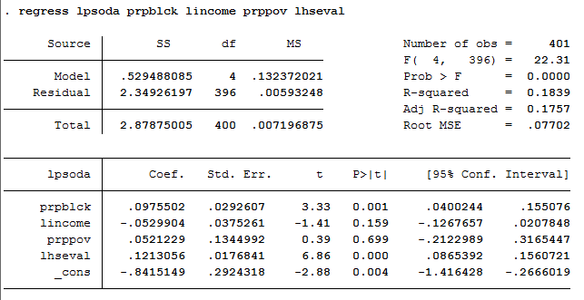
Ans : The coefficient of β4 is equal to 0.1213, which means that when the median housing value increases by 1 percent, the price of median soda will increase by 0.1213 percent.
The p-value for Ho: βlog(hseval) = 0 is equal to 0.000

3.3 (i) Ans : P-value of B2 increases from 0.00 to 0.159 which is higher than 0.05. So we accept Ho and log(income) is not statistically significant.
P-value of B2 increases from 0.004 to 0.699 which is higher than 0.05. So we accept Ho and prppov is not statistically significant.
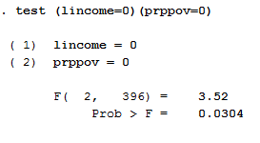
(ii) Ans : The p-value is equal to 0.0304, which is less than 0.05. So we reject Ho at 0.05 level of significant. We can conclude that the two are jointly significant.

3.4 Ans : R-adjusted of the previous regression is less than the one from the later regression after adding log(hseval). (0.0801<0.1757)
We can conclude that this model is more reliable than the previous one without (hseval)
log(psoda) = -0.8415 + 0.0975(prpblck) – 0.529(income) + 0.0521(prpprov) + 0.1213(hseval).

