Thakdanai Sinprasong 5604641802
1.)Discuss one Insurance product and comment on its benefits.
The insurance product that I choose is “AIA 15pay30” offered by AIA. The customers are required to make payment of 15 years and the life time of insurance will cover to 30 years. This product provide payback period of 1% from sum assured for 2-29 periods. The customers can accumulate money from payback period with the company and the company will going to pay interest rate that greater than or equal to 2% every year. This insurance product will compensate up to 150% of sum assured for any loss of customer’s life. The minimum sum assured is 100000 baht. The customers are entitled to a tax privilege of up to 100000 baht/year. Then the most obvious benefit that the customers will get is the payback period and the amount of money that customer will get at maturity because the company will pay instead if some accident about physical occur to consumer that make loss of ability to pay insurance premium. This insurance product ensures that the customer will get the goal in financial at maturity date. The tax benefit is satisfied since the customers can save up to 100000 baht/year as the tax privilege. The customers will gain higher benefit as the sum assured is higher. They will get higher premium discount rate as the amount of sum assured is higher, which means that they will have less burden on the premium that they have to pay.

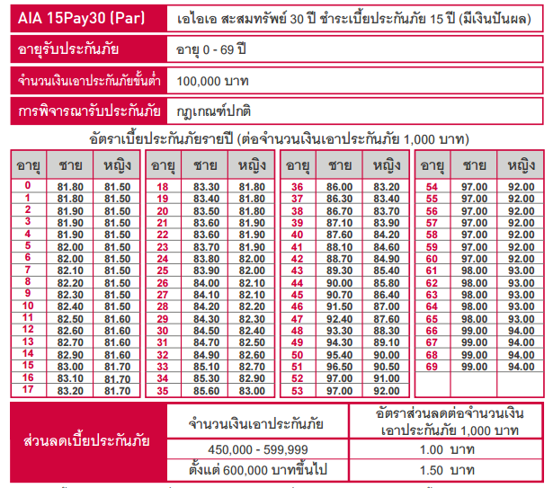

2.) Which mortgage would result in higher total payment?
Mortgage A : $970 a month for 30 years
Total payment = $970*12 months*30years = $349200
Mortgage B : $760 a month for 5 years and $1005 for 25 years
Total payment = ($760*12months*5years)+($1005*12months*25years)=$347100
Therefore, mortgage A would result in higher total payments.
3.) What are the two main types of consumer credit.
A closed-end credit is a loan or extension of credit in which the proceeds are dispersed in full when the loan closes and must be repaid, including any interest and finance charges, by a specified date. The loan may require periodic principal and interest payments, or may require the entire payment of principal at maturity. In this type of loan or credit arrangement, the full amount owed must be paid back by the borrower by a set point in time. Most real estate and auto loans are closed-end credit, while credit cards and home-equity lines of credit are open-end or revolving lines of credit.
Open-end credit is a pre-approved loan between a financial institution and borrower that may be used repeatedly up to a certain limit and can subsequently be paid back prior to payments coming due. The pre-approved amount will be set out in the agreement between the lender and the borrower. Open-end credit agreements are advantageous to borrowers, as they exert more control over how much they borrow and when. In addition, interest is not usually charged on the part of the line of credit that is not used, which can lead to interest savings for the borrower.
4.) What are the general rules of measuring credit capacity?
A debt-to-income ratio (DTI) is one way lenders (including mortgage lenders) measure an individual’s ability to manage monthly payment and repay debts. DTI is calculated by dividing total recurring monthly debt by gross monthly income, and it is expressed as a percentage. The low percentage meaning a good balance between debt and income, conversely, the high percentage is the signal of too much debt for a certain amount of income an individual has. The recommendation is that the ratio should not be exceed 20%.
Debt/Equity Ratio is a debt ratio used to measure a company's financial leverage, calculated by dividing a company’s total liabilities by its stockholders' equity which is the difference between the total value of an individual’s assets and liabilities. The D/E ratio indicates how much debt a company is using to finance its assets relative to the amount of value represented in shareholders’ equity. With a high personal debt to equity ratio, it means the low ability to repay loan. On the other hand, with a low personal debt to equity ratio, it create a high ability to repay the loan. The recommendation is that the ratio should not be exceeded 0.5.
The general rules of measuring credit capacity are the debt payment to income ratio should not be exceeded 20% and the debt to equity ratio should not be exceeded 0.5.
5.) A few years ago, Michael Tucker purchased a home for $100000. Today, the home is worth $150000. His remaining mortgage balance is $50000. Assuming that Michael can borrow up to 80 percent of the market value, what is the maximum amount he can borrow?
The market value of Michael’s home=$150000. Michael can borrow up to 80 percent of the market value, or $120000. Michael still owe %50000 mortgage on his home. Therefore, he can borrow a maximum of $120000-$50000 = $70000.

