FN281 - Personal Finance

Group Assignment

Teeratat Nopsuwanwong 5702641373
Veetima Boonthum 5804640125
Natcha Petcherdsak 5804640497
Onicha Bannawat 5804640901
Theerasit Ongthongkham 5804641297
Kittitat Chunjitsavakon 5804641438
Orn-in Pattanapaisal 5804641693

Bachelor of Economics, Thammasat University
Semester 2/2017

Introduction
The truth is everyone’s final goal is to gain happiness. No matter what you do or plan to do, in the end of the day, everyone expects to earn happiness by satisfying their need and want. However, human’s needs and wants are unlimited but the resources we have are limited. So, we have to manage the resource we have wisely to achieve the goal as many as possible, which also mean to satisfy ourselves as much as possible too. To do so, there are many things to concern including how to obtain the resources, how to protect the resources, and how we should use the resources. And, If you do all of these right, you not only satisfy yourself by achieving the thing you need and want but you will also gain “certainty in life”. Because uncertainty always cause us problems, certainty in life is another ultimate source of happiness. Therefore, we will show you the sample of how to obtain, protect, and use the resources wisely by introducing you Mr.A’s personal financial planning.
First of all, let’s learn more about Mr.A’s persona. Mr.A, a 22-year-old man who is single. He came from a merchant family. His family owns a business in northeast of Thailand. Nowadays, he is a 4th year student who is studying BBA program at Thammasat University. He has only one semester left before he graduates. Currently, he has no job yet and his only income is provided by his parents for his living cost. He receives 34,000 per month. To be more classified, he use this amount of money to pay condominium rental fee of 9,000 every month to live near university. He also has to pay electrical bill and water bill for it at 1,400 per month. He has approximately expense on meal of 12,000 baht per month. Lastly, he owns a car but he still need to use public transportation since there is no parking space where he studies, so there will be a cost on both public transportation and fuel for his car which will cost approximately 5,000 baht per month. For his current financial position, he currently own 500,000 of cash in saving account.

Identification of financial goals
- Short-term goal: Working at PTT company in financial department..
- Intermediate-term goal: Studying for master’s degree at University of Washington.
- Long-term goal: Marriage, having one-child, buying car and house for family.

Career planning and development
There are a thousand ways for us to contribute to a career development and at the same time meet the organizational needs. The outcomes desired by organizations include achieving the best match between people and jobs. To find the match one, we have to identify ourselves what we have been studied, and it is suitable for which kind of jobs. Since Mr.A currently studies in Business School, Thammasat University, as a senior student. In order to achieve the career development, he needs to find the short run, long run, and ultimate goals.
For the short run goals, Mr.A needs to find some jobs to gain experiences before pursuing a master degree. As we all know that most of the well-known university often require participants to have work experience before enrolment. Especially those who studied in Financial and Economics fields. The distinction is necessary because there are specialized programs that require knowledge and skills that can only be acquired when spending time in the field as a professional. This is often the case with Masters studies that have a very strong quantitative emphasis. Mr.A decided to apply for a job at PTT Global Chemical Public Company Limited, since as we can see that PTT was considered as one of the biggest company in Thailand. PTT has a competitive remuneration package, comparing to other leading companies. By providing a highly connected workplace, an inclusive and diverse environment, comprehensive health and wellness programs, robust professional development opportunities, and competitive compensation and benefits, and in their personal lives (PTT, 2017). PTT also focuses on the growth of our diverse workforce with equal opportunities and development opportunity. At present, PTT group is seeking the new talent, who are searching for their career advancement for long-term growth and sustainability of our organization. Therefore, working at PTT not only benefit he in short-run but also help his life to be stable in long-run.
Before Mr.A decided to enter in PTT, he used to work at Boon Rawd Brewery Co., Ltd. as an internship student. Therefore, he is quite confident that he can get into PTT. After Mr.A can enter to PTT in Financial Analyst and Financial Risk Management position, he is going to work there about 2 years or according to the contract that he has made with PTT. Then he is going to apply for master's degree at the University of Washington. The reason of enrolling in master degree is to get noticed in today’s job market and to improve his financial prospect. However, after Mr.A finished master’s degree, he will come back to Thailand and find new jobs with the higher rate of income that he used to get in the past.
In short, we can sum up Mr.A’s life into three major parts. Firstly, after graduating he is going to work at PTT for 2 years. Second, Mr.A planned to pursue master’s degree at the University of Washington. Lastly, after he finished master’s degree, he is going to find new jobs that give him higher income.

Spending plan/cash flow analysis
In order to construct spending plan, knowing how much Mr.A’s earning is as important as knowing how much Mr.A’s spending. This is because we will know how the money should work for him.
Mr.A has applied his first job and he gets a salary of 30,000 baht/month. He will get this rate of salary for 2 years before he goes to study for master degree. During the time, there is only one expense Mr.A has to bear, which is daily expenses. This is because he moved out of condominium after applying a first job and live at home instead where his parent bears the utility cost. He could spend on daily expenses not exceed 20,000 baht/month. His daily expense budget includes 5,000 baht of transportation expense, 12,000 baht of meal expense, and the rest of 3,000 baht will be flexible expense.
When Mr.A is studying at Washington University for master degree, he will be fully funded by his parent. Moreovers, it is harder to make an assumption when you never live there before and the different in currency also make it more difficult. Therefore, we decide to skip the financial planning while he is living in abroad.
After 2 years past, Mr.A will acquire master degree and come back to Thailand. The first goal after coming back is that he want to start having family. So, he will start buying a car and a house and then save money for future-child tuition. In order to do so, he will apply for the new job at KPMG with the higher salary at 70,000 baht/month because of the higher degree he has gotten. Right after he got his new job, he decides to buy a car first since he still have not enough saving money yet to purchase on huge obligation like mortgage plus his old car has been fully depreciated. Therefore, he will buy a SUV car(family car), which priced at 1,699,000 baht, by paying the down payment, which is 25% of the price or 424,750 baht, and then start to pay by installment each upcoming year for another 4 years. Moreover, his daily expenses budget will also increase to 30,000 baht/month. However, Mr.A’s salary will also increase from 70,000 baht/month to 100,000 baht/month within 2 years after he has been working at KPMG. And, he also usually get 3-month-bonus all the time. At the age of 30, a child will born and he will become a father. Surely, his expenses will be increased to 35,000/month for supporting 3 lifes and will be increased more as the time pass by due inflation of 6% per year. At the age of 32, he will have enough saving money to start purchasing mortgage. The house will be priced at 9,470,000 baht and required the down payment of 22% or 2,083,400 baht. Then, he will need to pay down the mortgage in 20 years or 240 months at the interest rate of 6.4% per year or 70,200 baht per month. At the age of 41 and 51, his salary will be increased to 120,000 baht/month with 3-month-bonus and 150,000 baht/month with 3-month-bonus respectively.

Tax planning
After graduate the bachelor degree, Mr. A prefers get a job for two years before going to study master. He will works for the PTT Public Company Limited with starting salary of 30,000 baht a month. So he has income of 360,000 baht a year and since he stay with his family which not incur a lot of expenses except costs of living so he decide to put 50,000 baht of his income into Long term Equity Fund (LTF) per year for 2 years before leaving which not only save some amount of money from income but also generate returns for him. Furthermore, he decides to buy life insurance from AIA with premium of 2,000 baht per month which is an insurance premium at the beginning phrase so per year is 24,000 baht. Therefore, he use all of his expenses and advantages provided by government to take into account deductions and allowances to make calculation of taxable income.

- Assessable Income is 360,000 baht
- Deduction of income from employment is 100,000 baht (50% of income but not exceeding 100,000 baht)
- Allowance consist of Single taxpayer 60,000 baht, long term equity fund 50,000 baht, and Life Insurance 24,000 baht which totally is 134,000 baht.
- Taxable income is Assessable Income minus deduction minus allowance equal to 126,000.
Since his taxable income is less than 150,000 baht, he is being excluded from paying taxes.
Therefore, total personal income tax that he has to pay is 0 baht

Two years after Mr.A comes back from studying master (27 years old), he will find a job that provide him salary of 70,000 baht a month so he has income of 840,000 baht a year. Since he receive more salary accounting for 40,000 baht while his expenditures still low, he decide to put more 30,000 baht into Long term Equity Fund (LTF) every year which is 80,000 baht in total. Moreover, he will invest in Retirement Mutual Fund (RMF) in order to save for his retirement every year which cost him 15,000 baht per year until the year he retire. Lastly, he still has to pay the same amount of 2,000 baht for life insurance premium every month since the contact is not end yet.

- Assessable Income is 840,000 baht
- Deduction of income from employment is 100,000 baht (50% of income but not exceeding 100,000 baht)
- Allowance consist of Single taxpayer 60,000 baht, long term equity fund 80,000 baht, Life Insurance 24,000 baht and retirement mutual fund 15,000 baht which totally is 179,000 baht
- Taxable income is Assessable Income minus deduction minus allowance equal to 561,000 baht.
Since his taxable income is more than 150,000 baht, he obligate to pay taxes.
Net taxable income (THB) | Tax rate (%) | Tax paid (THB)
0 - 150,000 | 0 | 0
150,001 - 300,000 | 5 | 7500
300,001 - 500,000 | 10 | 20000
500,001 - 750,000 | 15 | 9,150
Therefore, total personal income tax that he has to pay is 36,650 baht

When he worked for his new company for two years (29 years old), he get a promotion which receive a new higher level of income at 100,000 baht a month so he has income of 1,200,000 baht a year. At this age, he plan to get marriage with his girlfriend and having a child within next year which causes him to save some amount of money out of his income every month so he decide to put same amount of money into Long term Equity Fund (LTF) which is 80,000 baht in total and that same Retirement Mutual Fund (RMF) which is 15,000 baht per year for every year until the year he retire. Lastly, he still has to pay the same amount of 24,000 baht life insurance premium per year until the end of the contract.

- Assessable Income is 1,200,000 baht
- Deduction of income from employment is 100,000 baht (50% of income but not exceeding 100,000 baht)
- Allowance consist of Single taxpayer 60,000 baht, long term equity fund 80,000 baht, Life Insurance 24,000 baht and retirement mutual fund 15,000 baht which totally is 179,000 baht
- Taxable income is Assessable Income minus deduction minus allowance equal to 921,000 baht.
Since his taxable income is more than 150,000 baht, he obligate to pay taxes.

Net taxable income (THB) | Tax rate (%) | Tax paid (THB)
0 - 150,000 | 0 | 0
150,001 - 300,000 | 5 | 7,500
300,001 - 500,000 | 10 | 20,000
500,001 - 750,000 | 15 | 37,500
750,001 - 1,000,000 | 20 | 34,200
Therefore, total personal income tax that he has to pay is 99,200 baht

Use of Credit
When his age is 27, he plans to buy a SUV car in order to use as a family car, then he looks for a car which costs between 1,400,000-1,900,000 baht. So he decides to choose Honda CR-V which costs 1,699,000 baht. He will apply for a loan with commercial bank and also use the car that he is purchasing as collateral for the loan.

Car: Honda CR-V
Price | Down 25% | Principal | 48 months  (2.5% / year) | 60 months  (2.8% / year) | 72 months  (3% / year)
฿1,699,000 | ฿424,750 | ฿1,274,250 | ฿29,200 | ฿24,212 | ฿20,884

He calculates by add-on interest loan:
For 48 months: ฿1,274,250 * 0.025 * 4 = ฿127,425
฿1,274,250 + ฿127,425 / 48 = ฿29,200 per month
For 60 months: ฿1,274,250 * 0.028 * 5 = ฿178,395
฿1,274,250 + ฿178,395 / 60 = ฿24,212 per month
For 72 months: ฿1,274,250 * 0.03 * 6 = ฿229,365
฿1,274,250 + ฿229,365 / 72 = ฿20,884 per month

He uses debt payment to income ratio to help him decide how many years he should borrow.
For 48 months: 29,200 / 125,000 = 23.36%
For 60 months: 24,212 / 125,000 = 19.37%
For 72 months: 20,884 / 125,000 = 16.7%

He will put 424,750 baht(down payment 25%) in cash towards the purchase, so he will has only loan left 1,274,250 baht. Since he doesn’t want to pay much interest rate, so he decides to borrow for 48 months which is the shortest period for payment. Then he will pay 29,200 baht per month. Even the ratio is 23.36%, but it's just a bit higher than 20% which mean that the monthly debt payment is in the rate that he can pay, compared to his monthly income.

He plans to buy a house when he becomes 32. He looks for a single house that has a price below 12 millions baht, and also located near sathorn road.

Home:
Price | Down 22% | Principal | 168 months (6.4% / year) | 240 months (6.4% / year) | 360 months (6.4% / year)
฿9,470,000 | ฿2,083,400 | ฿7,386,600 | ฿83,360 | ฿70,200 | ฿60,000
We calculates by add-on interest loan:
For 168 months: ฿7,386,600 * 0.064 * 14 = ฿6,618,400
฿7,386,600 + ฿6,618,400 / 168 = ฿83,360 per month

For 240 months: ฿7,386,600 * 0.064 * 20 = ฿9,455,000
฿7,386,600 + ฿9,455,000 / 240 = ฿70,200 per month

For 360 months: ฿7,386,600 * 0.064 * 30 = ฿14,190,000
฿7,386,600 + ฿14,190,000 / 360 = ฿60,000 per month

After he consider with his income, he decides to borrow a bank as a home loan for 20 years. So he will have to pay 70,200 per month for 240 months.

Savings and investment program
For LTF (Long Term Equity Fund), he assumes to use 8.07% as the rate of return. He plans to invest 50,000฿ (each year) at age 23-24 since he think that in that period, he still lives with his family so the expense will still be low. And he sees it as opportunity to invest some money in LTF. After finishing his master degree, he plans to invest 80,000฿ (each year) from age 27-53. The reason is that it not only reduces the tax that he has to pay each year, but also generates a lot of return when he retire in the future. The result is that he will receive money about 14,000,000฿ at age 60.
For RMF (Retirement Mutual Fund), he assumes to use 5.00% as the rate of return. He plans to start investing after finishing his master degree (From age 27-59) and the amount of money that he plans to invest is 15,000฿ (each year) because this amount of money is not too high or too low to invest and moreover it can reduce the tax that he has to pay each year too (Similar to LTF). The result is that he will receive money about 1,000,000฿ at age 60.
*** (Note : Seeing the Real Calculation in Appendix) ***

Changes in housing situation
After Mr. A gets marry with his girlfriend when he is 29, he plans to buy a house for him and his girlfriend in order to facilitate themselves after having a child. Mr. A and his wife needs to save their money to purchase their house in the future. So he plans to buy it and moves out when he becomes 32.

Major consumer purchases
Purchasing decisions are constanting changing over lifetime. Being at the young adult stage, without much living expenses such as utility bills and mortgage payments to concern about, Mr. A may consume more products that provide him with short-run entertainment. Whereas growing older and becoming more financially independent, he has to bear more expenses, thus, each purchase made has to be considered more thoroughly.
The first major purchase will be made on his first car when he is at 27 years old. He decides on Honda CR-V because its price range is at satisfactory with his income, and its functionality suits his usages. He plans to get married at the age of 29, the age in which his annual income reaches 1,500,000 baht, because he thinks that he will be financially ready to start a family of his own. Marriage incurs a lot of expenses, including a wedding venue, wedding rings, catering, and entertainment, so he decides a budget of 500,000 baht for the entire event, and the money will come from his savings.
The next major purchases will be on the decision to have a child at the age of 30 and a house at 32. Both decisions incur long-term expenses. Mr.A will pay for all his child’s expenses which include all living expenses and tuition fees up until Bachelor’s degree, or a total of 22 years. The kindergarten, primary, secondary schools, and a university that he chooses for his child will cost him around 80,000 - 120,000 baht per year. With 3% inflation, the total worth of money that he needs to have is 6,356,730 baht. For him to have a family of his own, Mr. A plans to take a mortgage loan purchase a house, in which the price is 9,470,000 baht and it will be repaid within 20 years or when he reaches the age of 52, the same age that his one child graduates.
(See Child’s Expenditure in Appendix)

Insurance needs
Insurance is one of the most crucial investment acting as a safeguard against any unpredictable risk in the futures. From the fact that life is uncertain and unfortunate events are impossible to be foreseen. According to Mr. A’s career path at PTT, the company already provide him a welfare protection which attend his hospital fee, gift & bequests in case of his death etc. Nevertheless, in case of his death or permanent injured, those welfare protection offered by PTT is not sufficient. Therefore, in order to stabilize Mr.A family’s livelihood and fulfill his family financial requirements, insurance is one of the most important investments. According to achieve his financial goals, there are two insurance products required; unit-linked and car’s insurance.
Unit-linked
Unit-linked is one type of insurance which provides both risk cover and investment program. Mr.A prefers unit-linked products since it is linked to Mutual funds and enables me to diversify my portfolio align with risk protection. From available products offering in the market, I preferred AIA unit-linked product.

MMF | Short-term  debt | Mixed | Thai  equity | Foreign equity
TMBTM  SCBTMFPlus-1 | KFMTFI  TMBGF | KF-CINCOME | SCBSET,ABG  ABSL,ABSM  JUMBO25 | ABWOOF

As can be seen, purchasing unit-linked product not only benefit risk protecting but also diversifying and investing purpose. From Mr.A’s plan, he would deduct 6.67% of his salary to pay unit-linked premium. For example, his expected salary 30,000 THB at the beginning, he would pay 2,000 THB per month (minimum required premium) an insurance premium at the beginning phrase. Therefore, his investment in insurance can be considered as step-up investment directly proportional with my salary at a constant rate of 6.67%
In addition, according to Mr.A plan to purchase a vehicle, car insurance is essential financial products required since it covers any expense for damaging occurred to not only his vehicle but also the passenger’s hospital fee. Car insurance products offering in the market are 1st class, 2nd class and 3rd class ranging from highest to least insured benefits. Mr.A decides to purchase first class insurance for his future vehicle. Here is the premium and insured benefit of Bangkok insurance. The insurance information shows in figure below.


Insurance  premium | Damage to life | Damage to assets | Damage to the car | Lost car /Fire | Medical fee | Personal Accident | Driver Insurance
16,301 | 10,000,000 | 5,000,000 | 490,000 | 490,000 | 100,000 | 150,000 | 250,000

Retirement and Estate-Planning
Overall, Mr.A will still live in his own house after retirement which he estimates that he will retire at 60 year-old. He will live normally and quietly with his families and may travel sometimes but not too often, also he expects that he can live up to 80 year-old before he pass-away. So Mr.A has to plan his saving to meet the expected expense after retirement.
For expected expense side, he uses “Return on Investment” as 3% and “Inflation Rate on Expenditure” as 8%, the reason is that after retirement, he has to be careful about his money and minimize the risk as much as possible, so he will save in low-return investment which yield a lower rate than other average investments and it is better to keep as a spare especially on expense side, so he use quite high inflation rate on expenditure. We assume the expense at age 60 to be 1,560,000฿ per year and use Inflation Rate on Expenditure to estimate the expense up to age 80, then he discounts all of expense back to period of age 60 by using Return on Investment as a discount rate. The result is that he need money about 55,000,000฿ to cover all of his expense.
For saving side, he use “Average Reinvestment Rate” as 5% and “Inflation Rate on Expenditure” as 6%. He gain 5% from averaging the reinvestment rate from many investments that he expect to invest in. He records the income that he expects to gain which he separates it into 4-interval which is 840,000฿ , 1,500,000฿ , 1,800,000฿ and 2,250,000฿ (per year). And for expense, he starts with 360,000฿ in the first 4-year of working and increases it to be 420,000฿ then after that he uses Inflation Rate on Expenditure to calculate the expense in the future. Next he has saving from income minus by expense and discount it to age 60 by using Average Reinvestment Rate. Moreover, he gains more money from the investment in LTF and RMF with give about 14,000,000฿ and 1,250,000฿ at the retirement or at age 60. The result is that he will have about 85,000,000฿ in his saving when he retire at age 60.
When comparing the expense and saving, we can see that his saving can cover all of his expense and also have about 30,000,000฿ as a spare money in case of any emergency that go out of his calculation. We can conclude that he has a very good money security in his retirement.
*** (Note : Seeing the Real Calculation in Appendix) ***

Summary
The topic of finance has become increasingly important as people grow older. Knowing that one day we would have to be financially independent, the money we spend daily now has to be monitored more discreetly as savings and investments are major subjects for our long-term goals. Laying all the short-term, intermediate-term, and long-term goals allow us to keep tracks of what we are doing in each stage of life, and whether we stick to the goal. If deviations were to happen, we could then alter our spending behavior so that we could remain intact with our goals.
Not only we have to consider about our spending, but we also have to think about our career path and development, and how our income could be increased from each major decision we take. As education has become a necessity, having only a Bachelor’s degree may not be sufficient in the higher level of workforce. Cost analysis has to be done to consider whether it is worth it for us to take another major step by losing 2 years or more of our lives by gaining not much or not at all while pursuing a Master’s degree in the hope to have an increased income afterwards. In each stage of our lives, major purchasing decisions are also needed to be contemplated carefully as they will incur long-term effects on our financial balance. These include an automobile, a house, a decision to get married, and have a child, for instance. Saving, investments, and insurance are beneficial not only in case of an emergency, but they will also provide you income in your retirement.

Appendix

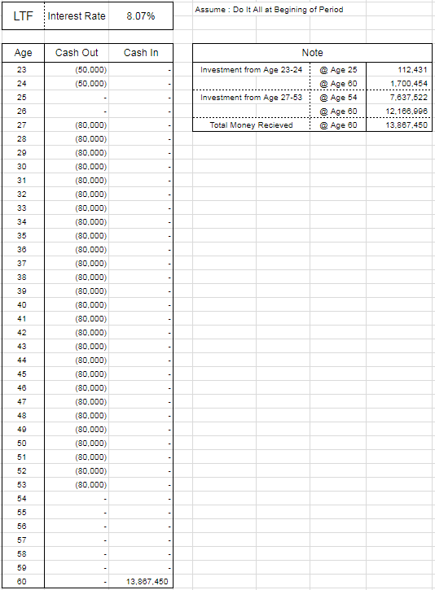
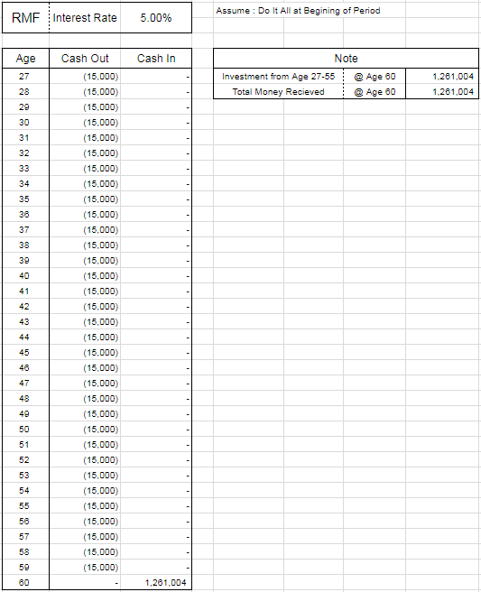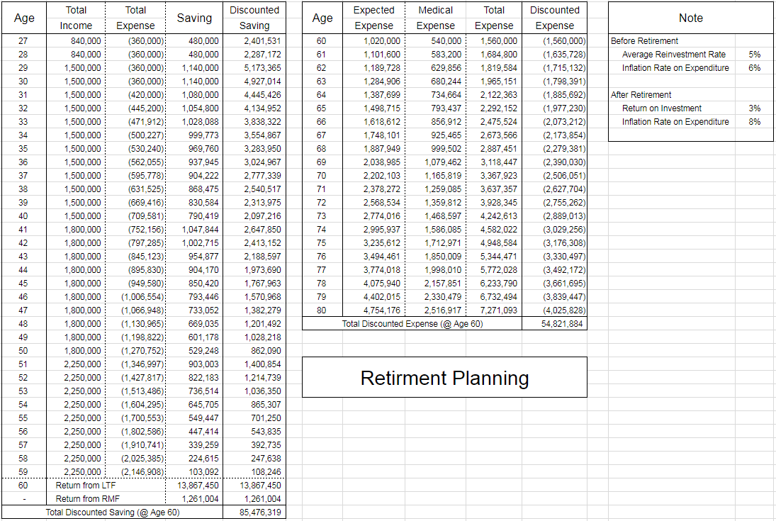
A Child’s Expenditure
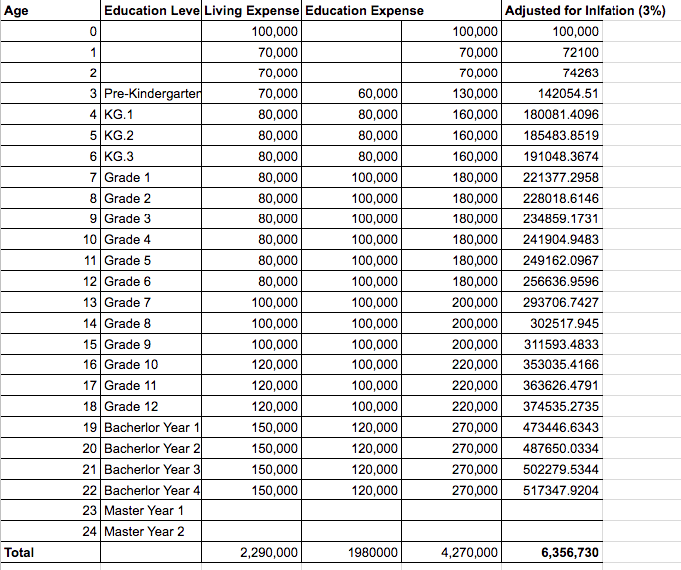

Reference

