BA 291 Class Review
Topics discussed:
1. Business model is the way company generates income. From the definition, it could be any form and any things. Examples of business model we discuss in class are differs from each other by the type of customer, by the way they collect money, by the cost structure and by the way it sells its product.
Business model starts with defining target segment und value proposition you about to offer to your customer.
- Business Model Canvas & its element
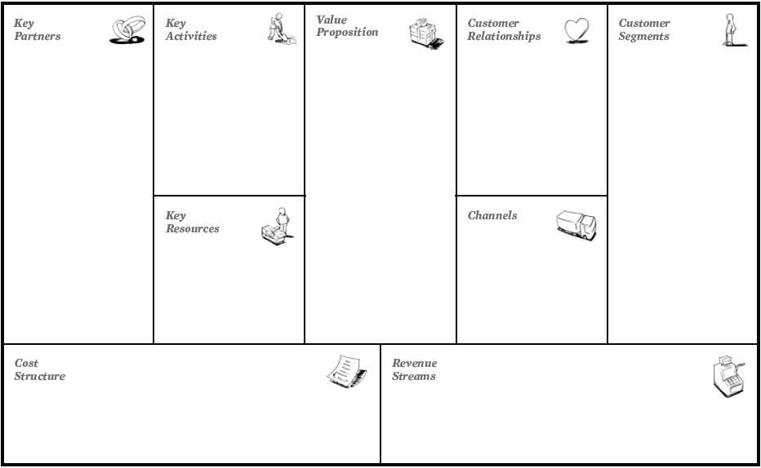

Example of Business Model
– Subscription – generate recurring revenues
- Bait and Hook / Razor and Blade
- Long tail – make money from niche market (lulu.com)
- Multi-sided – google, M2F magazine
- Freemium – Antivirus, Skype
- Low cost – reduce cost in order to sell it at low price
- Online Auction – Ebay
Etc.
- Economies of Scale : are the cost advantages that enterprises obtain due to size, output, or scale of operation, with cost per unit of output generally decreasing with increasing scale as fixed costs are spread out over more units of output.
- Economies of Scope: a proportionate saving gained by producing two or more distinct goods, when the cost of doing so is less than that of producing each separately

2. Business plan as a guideline of business.
Purpose of business plan:
- For external use: acquire credit, attract investor, venture capitalist, gain fund
- For internal use: guide direction, define activities need to be done, how resource is allocated.
Elements of business plan
- Executive summary: summarize all the detail of the business plan in 2-3 pages. Must carefully write it, otherwise, people may not continue reading the other parts.
- Company description: “Story telling” Show the past, present and future of business. Motivation of business. Company background.
- Management and organization: how the company is organized and what each individual’s duties and responsibility are. Who are the management team, what are the HR policies?
- Industry and market analysis: Analyze the trend of industry in which the business is operated. The market characteristic, market size, potential of the market.
- Competitor analysis: Who are the competitors, what are they strength and weakness. How would we beat them?
- Product and services (operational issues): What is the product, how would we sell it?
- Marketing strategy: Describe sales and marketing strategies. The 4’Ps.
- Financial plan: Cost calculation, budget needed, sales projection.

3. Business ethics and social responsibility as a new trend of doing business and the requirement from customers.
- Basic assumption: why people act unethically? – because they are differ by their education (awareness and knowledge), self-interest, co-workers and social environment and the availability of “opportunities”. People also differ in term of level of moral development.
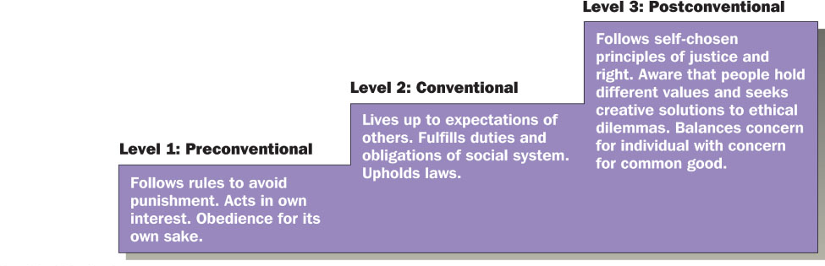

CSR - the triple bottom line "social, economic and environmental" factors.. A concept whereby companies integrate social and environment concern in their business operations and in their interaction with their stakeholders on a voluntary basis.
Corporate philanthropy: widespread business practice of donating money, goods, and services to charitable causes.
Strategic CSR: By taking a strategic approach, companies can determine what activities they have the resources to devote to being socially responsible and can choose that which will strengthen their competitive advantage.
Responsive CSR: acting as a good corporate citizen and mitigating adverse or anticipated adverse effects from the business activity, essentially from company operations.
Social Enterprise: First priority is solving environmental or social problem and not profit making.

4. Business Law
- Law as a framework of business
- Law in everyday life: contract law (e.g. buying contract), tax law (we pay VAT and also income tax), rental & leasing law (if you live a dorm or rent a condo), claim on remedy or in case of neglect or tort, or since we were born, law grant as a legal status as “natural person” which allows us for some specific right e.g. to vote, to get married, to hold assets, to enter contract.
- Law related to business: business registration, selling and buying contract, cartel & competition law, intellectual property right, environmental law, labor law.
- Legal forms of business organization
1. Sole proprietorship: easiest form to establish. No separate entity.
2. Partnership (starts up from 2 person)
- unregistered ordinary partnership: no separate entity. Owners handle in their own name as natural person, therefore, personal income tax. Unlimited liability, liable with partnership and private assets.
Severaly and jointly liable for others partners.
- registered ordinary partnership: Separate entities from partners. Able to own asset, to sue or be sued in the court under partnership. Still unlimited liability and jointly. Pay corporate income tax. 2.Obligor, claim partnership first, then partner.
- limited partnership: one partner is limited partner and the other call general partner. Limited partner provide money and liable with the sum of his initial investment (limited liability) but general partner liability is unlimited. Pay corporate income tax.
- private company: the most common form of business organization in Thailand. Establish by at least 3 promoters. Separate entity. Liability is cap by unpaid capital. Pay corporate income tax.
Dividend paid to shareholder will tax again (10% withholding tax).
- public company: 15 promoters. More process required when setting up this form. Can raise fund in stock exchange market.
- See the comparison table!!!!!!

5. Business environment
Analyzing macro environment of business - PESTEL Analysis – Opportunity and Threats
Analyzing industry environment – 5 Forces, or SCP model - Intensity of Competition within industry
Analyzing internal environment – resource, capability, competitive advantage – Strengths and Weakness

6. Entrepreneurship is the process of starting a business, typically a startup company offering an innovative product, process or service. The entrepreneur perceives an opportunity and often exhibits biases in taking the decision to exploit the opportunity.

7. Management Process “POLC”
Planning, organizing, leading and controlling (POLC) are the four basic processes or functions of management that constitute the entire work of management. All these four processes are essential parts of management.
Planning - Establishing a set of organizational goals. Developing strategies and plans to achieve the stated goals
Organizing - Organizing is the function of management that involves identification of activities/ roles , developing an organizational structure (grouping activities into department), and allocating human resources to ensure the accomplishment of objectives (job delegation – authority, responsibility and accountability).
The structure of organization is usually represented by an organization chart, which provides a graphic representation of the chain of command within an organization.
- Typical structure – functional, divisional, matrix, mixed (see pro and con of each form)

Leading - involves the social and informal sources of influence that you use to inspire action taken
by others. If managers are effective leaders, their subordinates will be enthusiastic about exerting
effort to attain organizational objectives.
Leadership style – How to lead? , what are the incentives or things that can be used to motivate employee.

Controlling - is measurement of accomplishment against the standards and correction of deviation if any to ensure achievement of organizational goals.
Performance standards are often stated in monetary terms such as revenue, costs, or profits but
may also be stated in other terms, such as units produced, number of defective products, or levels
of quality or customer service (it can be measured quantitative/ direct measure or qualitative/ indirect measure).
Controlling process (see graphic)
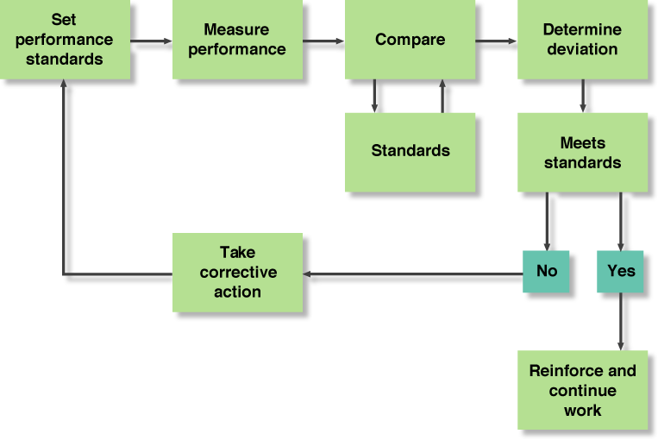
Feedforward, Feedback and Concurrent control
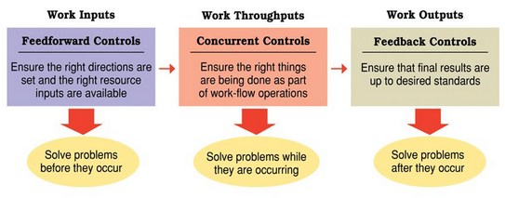

More references about POLC:
- http://www.saylor.org/site/wp-content/uploads/2013/03/BUS208-Carpenter-CH1.pdf
- http://study.com/academy/lesson/four-functions-of-management-planning-organizing-leading-controlling.html

