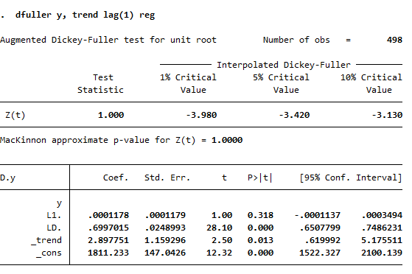
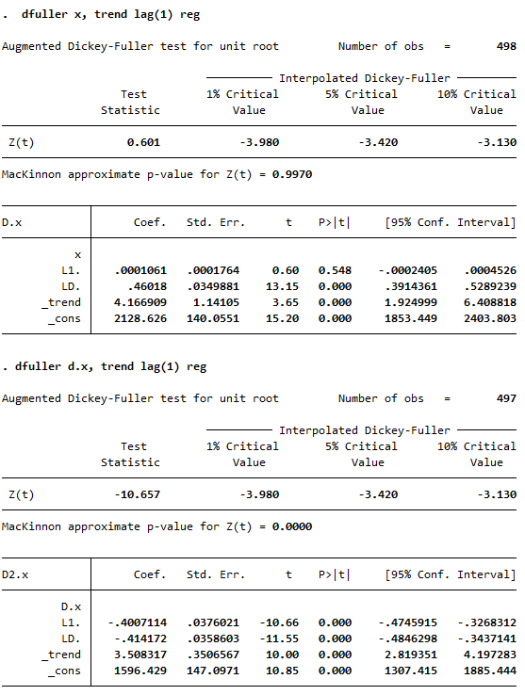
1,

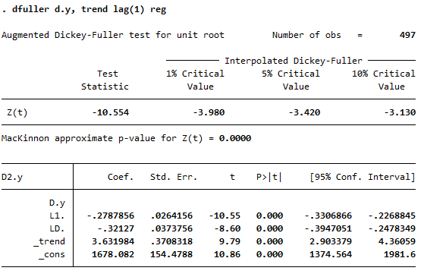

From the result, both x and y are I(1)
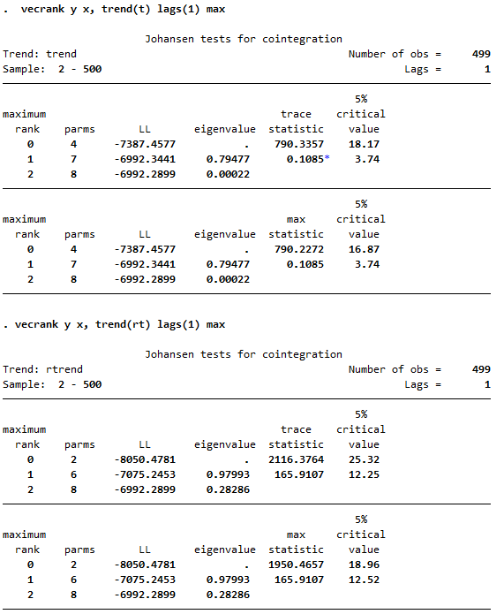
2. i)

ii)

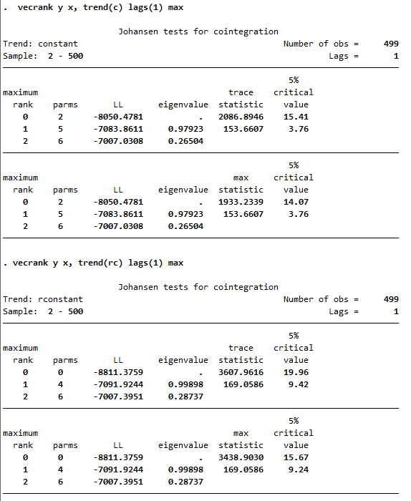
iii)

iv)

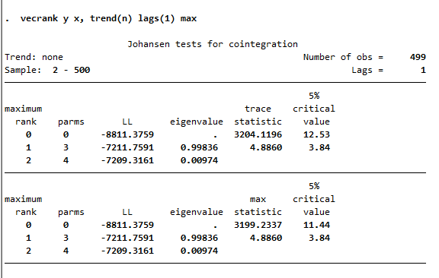
v)

From the model i), rank equals to 1. According to ii), iii), iv), v), rank equals to 2. Cointegrating equation exists between x and y.
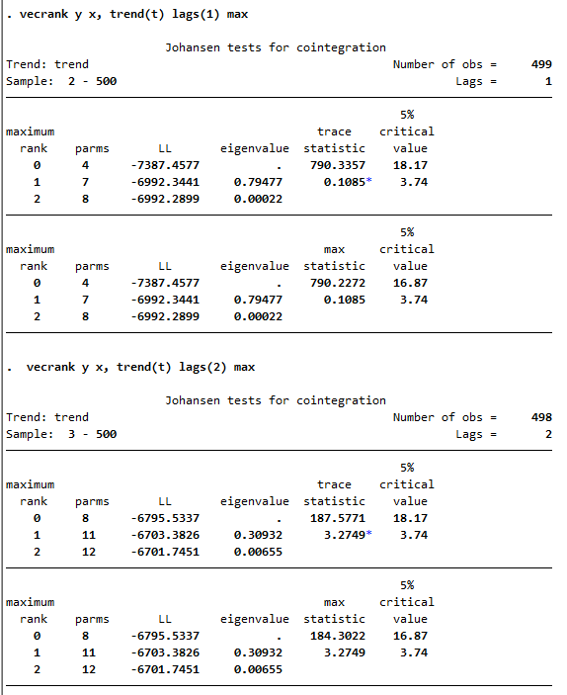
3)

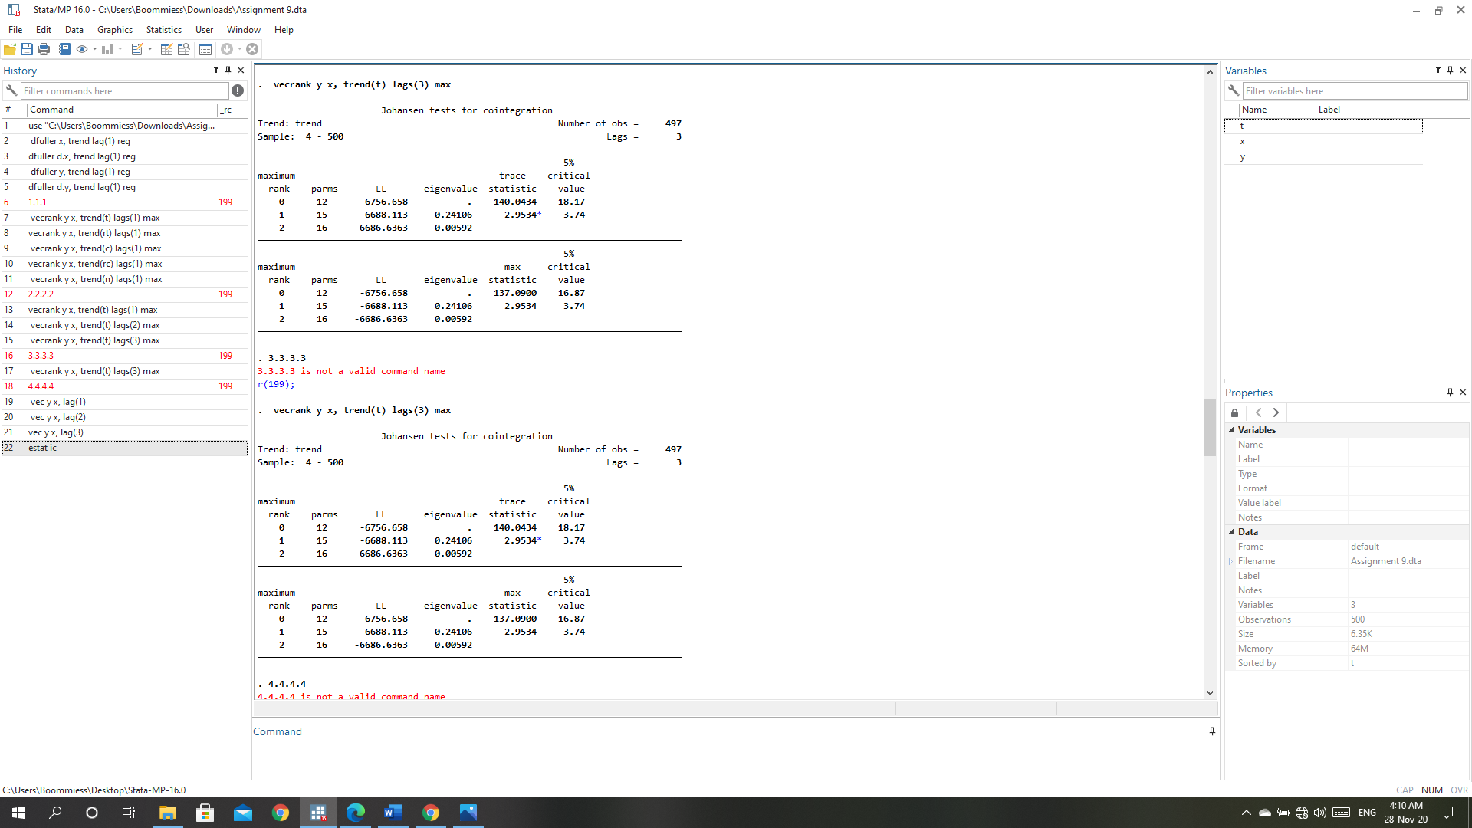

From all three models, rank=1. Cointegrating equation exists between x and y.

4)

With the highest LL, linear trend with three lag terms is the most appropriated and rank = 1. There is one cointegrating equation between x and y.
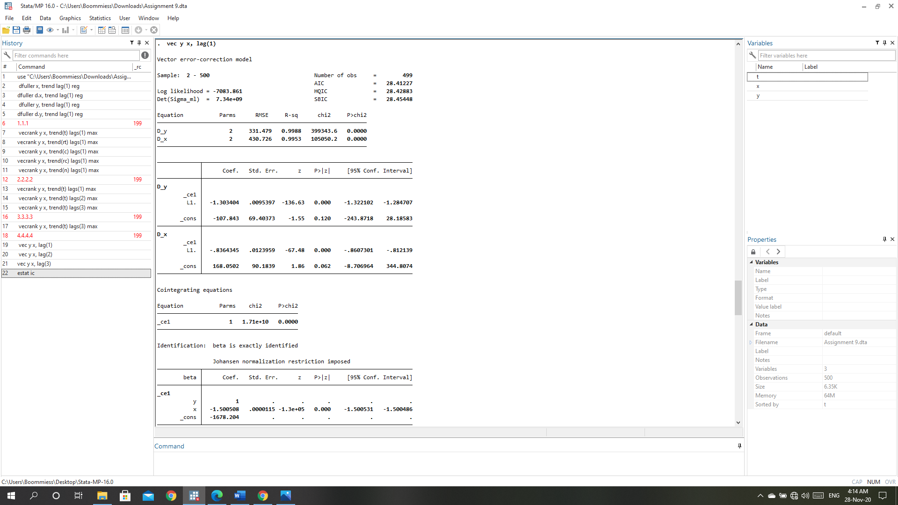
5)

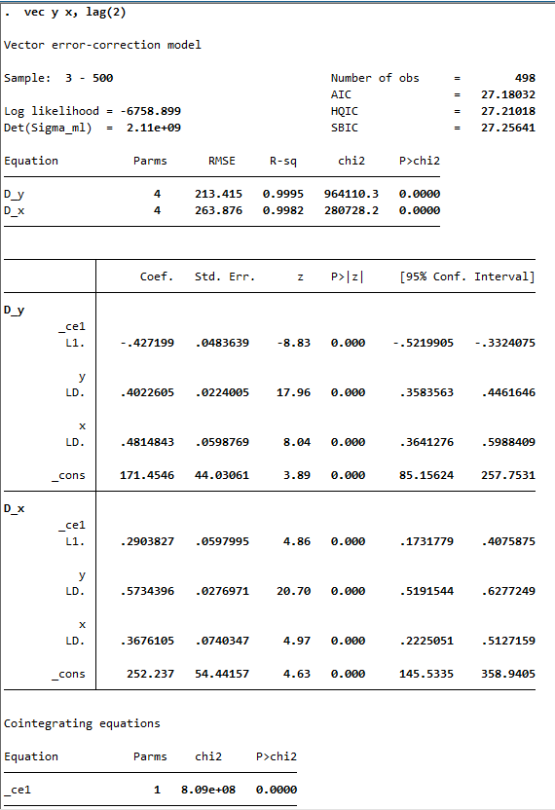

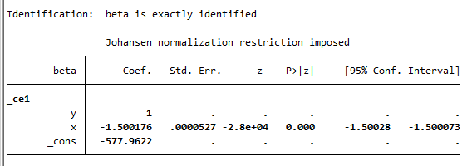

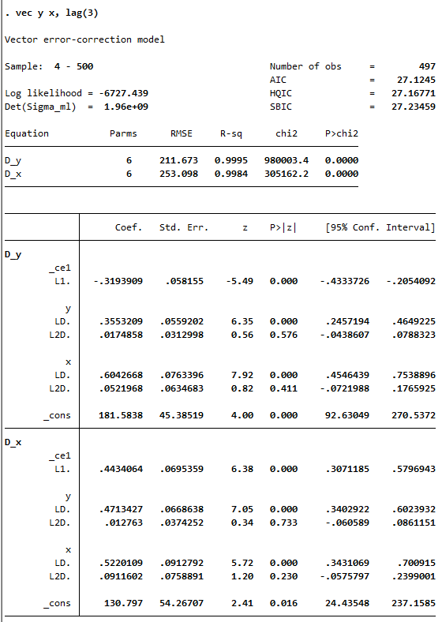

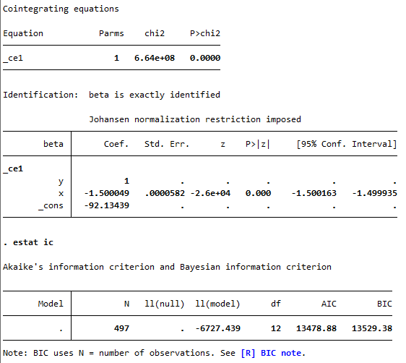

- With the lowest BIC, three lag is the most optimal.
- Cointegrating equation y x 1.5 92.13 0 or y x 92.13 1.5
- Speed of adjustment parameter = -0.3194

