Import Substitution, Export Promotion, and Industrial Policy
Overview Idea::
This article starts with Myint ‘s observation talking about Vicious of poverty and how to overcome it. With Import Substitution, Exporting primary products, Promotion of manufactured exports, NAIC, NIC, countries have been going through the path leading to industrialization.
This paper explains situations and cases in East Asian countries when their governments attempted to achieve economic growth.
- Those governments had launched policies in order to move through three stages of economic development. Which are
- Exporting primary products
- Import Substitution
- Promotion of manufactured exports
This paper also response to broad policies which made countries transitioning in above stages.
- There are two:
- NAIC (Newly Agro-Industrializing Country) Industrialization
- Industrial Upgrading policy
And in the end, how Asian countries adjusted when 1997 crisis came.

Part 1: Myint’s Analysis
This part is followed Myint’s ideas on intro part. Myint showed how to overcome “vicious cycle of poverty”. The cycle refers to low growth in per capita income due to individual’s low rates of savings and investments which is a result of low productivity in agricultural sector. Growth in population cannot be absorbed from only agricultural sector. If it is, it will result in low income. Improved medical will result in worst situations such as lower income per capita.
Myint mentioned two observations on vicious cycle issue. First was low growth rates in developing countries which always caused by low saving and low investment. Myint also argued that growth is also depended on how to use resources productively. In developing countries, there are abundant of unused human and natural resources capital. If these capitals and resources were used skillfully, there would have chance that countries can grow without sacrifice production for domestic consumption.
Another observation is the opinion for developing countries., he distinguished between peasant export countries and mine- and plantation based economies in originally colonized countries and between population-scarce national economies and big population national economies.
Myint suggested that population scarce countries can develop by excess labor and resources to boost export. But if import-oriented businesses were controlled by foreign capital or by single domestic class, foreign currency would be squandered on imports of luxury goods, and currency would consequently drift out of the country.
Second observation is at least one from three conditions must following peasant export economies.
- Economic incentives, a balance-growth relationship between the agricultural sector and consumer goods manufacturing sector
- Balance-growth relationship between agriculture and the capital goods sector
- Export substitution of processed goods for primary one. This one was “NAIC pattern of industrialization” adopted in Thailand.
Part 2: Primary Product Exports, Import Substitution, and Export Promotion
When a developing country attempts industrialization, they would adopt three strategies as we mentioned.
- Primary product export has linked to colonial domination, Myint said, when a colony exports agricultural or mining products, it generally imports the necessary investment capital and technology- “dependent monetary system’” Myint called, and sometimes part of labor force too. The expansion of export-oriented industries has no developmental effect on industries oriented to the domestic market.
Therefore, some people argued that primary export does not have much effect on industrialization. Law of diminishing marginal return quite adapts well in the agricultural sector since productivity quite rise rather sluggish like the industrial sector. But primary export is better off only in short run, not in medium and long.
- Another theory is export pessimism by Ragnar Nurke. He argued that developing countries should promote import substation rather than exports of primary products. The tools to promote IS included foreign exchange controls, import tariff hikes, quantitative import controls, investment supports for enterprises pursuing import substitution (tax holiday and tax exemption on machine or raw material), and fiscal finance or policy money with lower interest rates.
However, these policies came up with against problems
- The imposition of differing tariff rates on imports according to the importer’s objectives leads to distortions in the domestic price mechanism and has the overall effect of reducing economic welfare and damage utility to consumers
- Import substitution policies also tend to have a negative impact on exports of agricultural products.
- Import substitution usually starts with low-end technology industries, or those that have already achieved technological maturity and thus does not necessary have the desired effect of promoting domestic technological development
- Plus , ISI could deteriorate the competitive advantage principle since the country could not be specialize for import substitution product but still hold on producing it .
And, also two identified problems in future,
- Industrialization is based on domestic market. Size of population will be an issue to absorb products.
- IS leads to an increase in imports of raw material, intermediate materials, and capital goods. Results could be trade deficit.
Therefore , even the country tried to produce domestic consumption goods with an aim to lower degree of imported consumption goods , the country will probably subject to imported raw material for ISI production anyway.
According to Flying Geese model of Akamatsu Kaname, the following chart will tell steps to shift countries from their current situation to further steps.
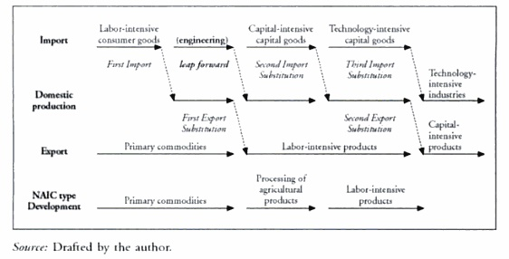
3.In export promotion, gov’t adopts policies to promote the process:
Maintaining favorable foreign exchange rate, reducing or rebating import tariffs levied on raw materials and equipment required by exporting industries , offering tax incentives, low interest financing, and cut price supplies of electricity, water, etc., for companies in those industries, establishment of export processing zones, establishment of gov’t –sponsored trade associations such as the Korea Trade Promotion Association. This is an example from Korea.
Once entails policy finance or fiscal finance-low interest loans from gov’t sponsored financial institutions to exporting enterprises—and other policies tend to distort domestic price mechanism
Part 3: An alternative approach to IS- NAIC industrialization
In Southeast Asians’ industrialization has two ways to escape primary exports. One is to promote ES and another one is to call in MNC to create bases for processing labor-intensive manufactured good to export. The extension of SE to substitute primary products is processed ore semi-processed material. Thailand and Philippines had started.
SE may be seen in Thailand policies in 70s such as promoting agro-business and increase planting in agriculture instead of exporting maize. The products were processed and later exports, “Export Substitution” called by Myint. The strategy required considerable effort and innovation by the Thai Industrialists. Processing tapioca for export entailed the installation of modern large-capacity silos and hard-pellet, technology. Other agro products required more technology in production. This kind of industrialization makes considerable demand on what Mint calls “the capacity to use existing resources productively”. This required gov’t supports in financial policy expanded by commercial bank, directed by Central Bank.
In Korea, SE was not shifted dramatically in the volume, but in qualitative way. From primary products to textiles/garments to electronic parts since 70s which quite same way to Taiwan. In Thailand, it was quite gentler and mostly focused on adding value to processing primary products. In both South Korea and Taiwan, there was drastic decline in proportion of the population working in agriculture, and in the primary sector. Conversely, population moved to work for manufacturing industries. For Thailand, it was a contradiction to those countries. In 70s, workers moved gradually to manufacturing. There was less immigration to city due to rise in agricultural and agro sectors allowed them to stay in their villages.
Therefore , the big difference of Thai and Korean SE is the focus of the policy. It seems like Thailand emphasized to increase
There are 4 ways to explain why expansion in agricultural and marine products NAIC helped Thailand’s industrialization.
- The increasing value of agricultural exports and the diversification of export products generated the foreign currency that enabled Thailand to pay for the imports of raw materials and machinery required to start the process of IS in textiles and other sectors
- Growth in new agricultural and agro products enhanced the incomes of provincial merchants and commercialized farmer, therby expanding the domestic market for IS industries.
- Agricutural exports made a contribution to central gov’t finances, through the rice premium and other duties.
- Exports of agricultural-related products brought into existence new breed of local entrepreneur in the form of agribusiness groups, i.e. CP
Thus Thailand has been driven by agri or associate products which contradict to hypothesis of primary products export theory. So Thailand should be called NAIC rather than NICs like South Korea and Taiwan
However, Thailand who had been big shrimp exports faced environmental issues
- Shrimp farming would involve with anti-biotic. It can pollute to nearby paddle fields, coastal water, and turning to land using to grow shrimps into sludge.
- It required not high technology formation, thereby easy to imitate and catch up.
- NAIC industrialization can support primary products but does not bring to the domestic economy the kind of needed to upgrade IS.
Conclusively, Thailand did benefit from NAIC during that period and could increase export volume significantly. However, NAIC could not be a good practice of industrialization in long run since it destroys and exploits resources and eventually, NAIC can ruin Thailand production process.
Part 4: Second-Phase Import Substitution and Industrial Policy
According to Traditional economic terms, government usually promote import substitution by industrial policy consisting of four main principles :
- Policies aiming to alter the industrial structure- The gov’t intervenes directly in the pricing of raw materials and manufactured products, using financial and tax incentives to protect and nurture infant and other specified industries
- Policies designed to promote technological development and supply better market information.
- Policies designed to improve economic utility by intervening in specific industrial organization by licensing anti-depression cartels to avoid excessive competition and to achieve economy of scale
- Specific policies to provincial companies often SME sized enterprises such as introduction of energy-saving systems
During that time , government set a high tax to impede imported goods , plus any foreign direct investment.
Gov’t also seeks to implement industrial policy some or all
- A new legislation to support specific industries for some specific period
- Admin guidance
- Maintenance of basic infras
- Special taxation to targeted industries
- Gov’t subsidies
- Gov’t financing, such that provided by Japan development bank
The first, forth, and sixth are particularly important. The weights of these policies were debatable and reflected in Japan.
Japanese industrial policy in 50s to 60s were not in direct term but rather as catalyst for longer-terms structural changes such as creation of sector organization and the exchange of information between gov’t officials and private sector. However, some researchers argued that main driver of Japanese industrial development was from private sector. The significance of gov’t leadership has often been overemphasized.
Part 5: East Asian Countries’ approached to Industrial Policy.
Any systematic study of industrial policy in East Asian countries will reveal the following five policies
- General promotion of exports, using incentive taxation and import tariff refunds not limited to any particular group of industries.
- Policies to protect and cultivate specified industries, in order to promote the development of heavy and chemical industries or upgrading industrial structure.
- Policies to promote tech changes and improve productivity.
- Policies to promote industries that would indirect support export drive.
- Policies to protect and cultivate SMEs and regional enterprises.
The creation of local enterprises capable of taking on foreign competitors, securing employment, transferring industry to the region strengthening export-supporting industries, and promoting venture businesses.
In east Asian, they shifted on outward from primary IS toward heavy and chemical industries. Taiwan and South Kore did in 70s. In southeast Asia, Philippines did in the late of 70s and Thailand started eastern seaboard to exploit natural gas. But later this kind of policy were revised. Korea needed to import raw material.
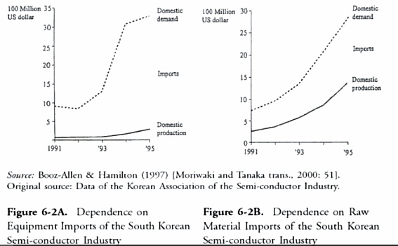
Part 6: Liberalization Policies and Industrial Structure Adjustment after the Crisis.
After the crisis , it seems like many Asian countries started adopting liberalization policies – by this , it refers to more free trade agreement , less tariffs and promote exportation.
If South Korea, Hong Kong and Taiwan represent pattern of policies, Thailand’s approach may be read as exactly halfway between those two patterns Thailand promoted exports without specifying particular export-oriented industries. As early as 1971 this committee was working to limit the number of types and models that could be manufactured in Thailand. What happened after was Japanese owed auto assembly intervened Thai auto part firms to provide tech support and quality control. It was apparent these interventions rather than gov’t protection itself.
However, 1997 financial crisis brought Asian countries faced radical situation. The urgent to revive economy and enhance competitiveness is spotlight once more. Thai policies initiated to promote SMEs.
In the world bank 2002 report, it recommended east Asian countries to achieve innovation to key of growth.. Another recommendation from Ysuf and Evenett is gov’t should be facilitator than conductors to help propagate institutional reforms, industrial restructuring, and regional economic cooperation

