Individual Assignment

- Discuss one Insurance product and its benefits.
AIA H&S Plus Gold is a health insurance product of AIA insurance company, which provides a maximum benefit up to 5 million baht for you(insured) and your family. H&S Plus Gold also provides 5 options of health insurance policy, with minimum benefit of 1 million baht. The insured can choose the most suitable policy for him/herslef. The coverage of insurance is covered from the basic illness up to the serious illness and also for accident. This insurance acts like a
saving account for the insured, which the insured will have to continously saving a certain amount of money per year for an unexpected medical payment. The saving can help alleviate the huge cost of medical payment. This is one of the options to allocate the riskiness of the insured’s spending.
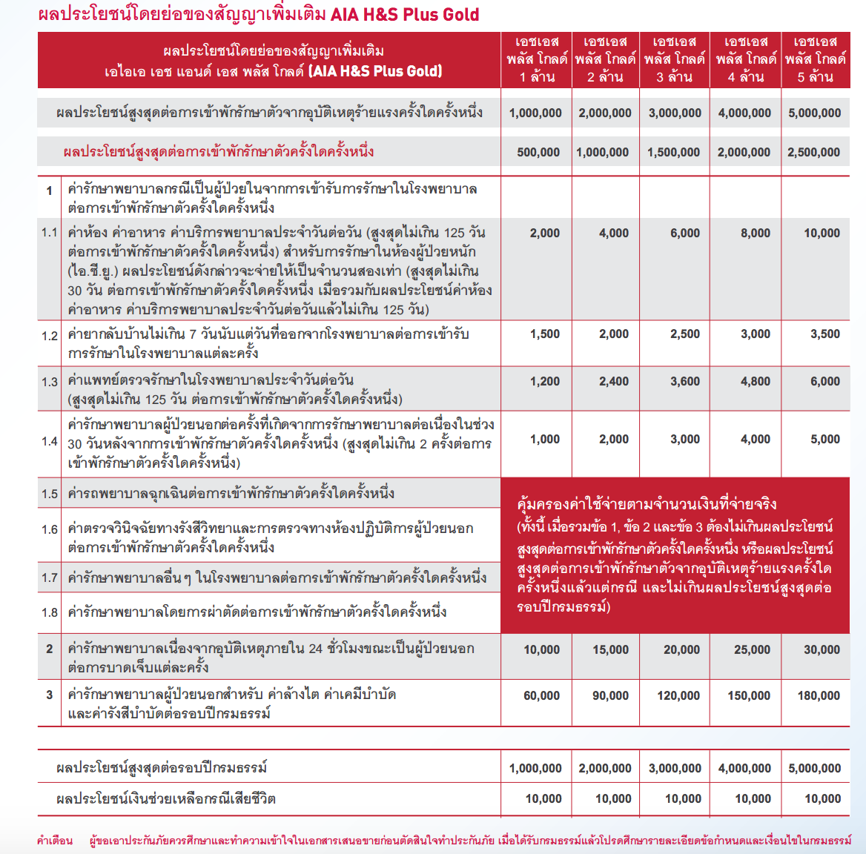

- Which mortgage result in a higher payment?
Mortgage A: $970 a month for 30 years
- Total Payment = $970 x 360 = $349,200
Mortgage B: $760 a month for 5 years and $1005 for 25 years
- Total Payment = ($760 x 60) + ($1005 x 300) = ($45,600 + $301,500) = $347,100
As a result from the calculation above, Mortgage A yields higher total payments, which is $349,200 compared to mortgage B, which is only $347,100.
- What are the two main types of consumer credit?
- Closed-end credit is used for specific purpose and specific amount. Since it is not considered as a revolving credit line, identification of purchase needs to be identified. Payment of this type are usually of equal amount over a period of time, which is the amount of principal plus interest. This type of consumer credit is usually the mortgage loans and automobile loans.
- Open-end credit is used in small purchases mostly found in credit cards. Consumers are usually given a limit amount of purchase on the credit line. Consumers cannot make a purchase beyond the maximum amount of credit, otherwise they will be charged on a higher rate. Also, the consumers must pay off the part of credit owed at the end of specific period.

- What are the major rules of measuring credit capacity?
- Debt payment to income ratio:$\frac{monthly debt payment}{monthly income}$
  - payment should not be more than 20% of your income.
- Debt to Equity ratio: $\frac{liablities}{net worth}$
  - Should not exceed 0.5

- A few years ago, Michael Tucker purchases a home for $100,000. Today the home is worth $150,000. His remaining mortgage balance is $50,000. Assuming that Michael can borrow up to 80 percent of the market value, What is the maximum amount he can borrow?

- Market value of home: $150,000
Maximum Home credit line based on market value (maximum 80%):​
= $120,000​
Less balance of remaining mortgage – $50,000​
Maximum credit limit on Home credit line: ​ $70,000

