Nitchanan Kwanlertchit
5604640812
FN281 Assignment
1) Discuss one Insurance product and comment on its benefits
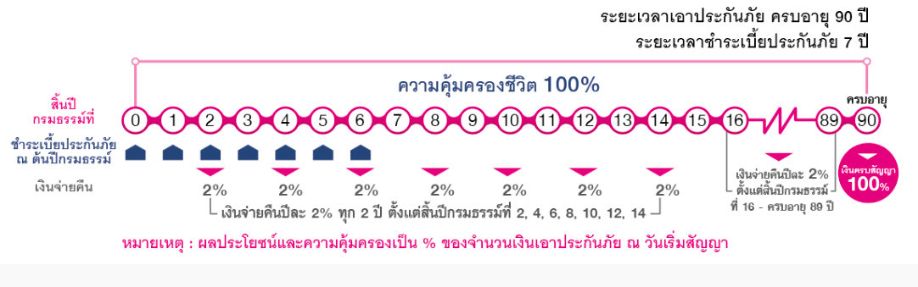
One of products of Muang Thai life insurance offering a product called “Muang Thai Rub Sub Talod Cheep”. This plan gets two benefits, which are the combination between whole life security and wealth. It requires paying short term premium but getting a long-term coverage. (Pay only 7 years cover until age of 90). Also, the return will receive continuously throughout the contract.

2) Which mortgage would result in higher total payments?

Mortgage A: $970 a month for 30 years
Mortgage B: $760 a month for 5 years and $1005 for 25 years

A= 970 x 12 x 30 = $349,299
B= (760 x 12 x 5) + (1005 x 12 x 25) = $347,100

Mortgage A would result in higher total payment.

3) What are the two main types of consumer credit?

Two main types of consumer credit are closed-end credit and open-end credit.
First, Closed-end credit is the form of credit that used for specific purpose in a specific amount of borrowing and for a specific period of time. During the contract, borrowers have to pay back the principal plus interest in the determined rate in contract.
- Installment sales credit, type of loan that borrow to buy specific goods
- Installment cash credit, type of loan that give cash to borrow to use
- Single lump-sum credit, loan that require borrower to pay principal plus interest in one big amount at the end of contract.

Second, Open-end credit is the types of credit that not specific amount of borrowing but it has the maximum line of credit which borrower could make a loan. During the contract, loan can be revolved or continuously take loans and borrow require to pay partial amount in the limited time otherwise it will charge in a higher rate of interest.
- Revolving credit
- Incidental credit

4) What are the general rules of measuring credit capacity?

- Debt to equity ratio = liabilities/net worth
This should not exceed 0.5. This formula does not take mortgage into account of liabilities.
- Debt payment to income ratio = monthly debt payment/monthly income.
This should not exceed 20% because it need to make sure that the expense should be covered with some money left to pay loan in monthly payment.

5) A few years ago, Michael Tucker purchased a home for $100,000. Today, the home is worth $150,000. His remaining mortgage balance is $50,000. Assuming that Michael can borrow up to 80 percent of the market value, what is the maximum amount he can borrow?

The maximum amount that Michael can borrow is 80% of current market price of his home. So, it is around $150,000. Therefore, the maximum loan is $120,000. The remaining mortgage balance is $50,000.
Then, 120,000-50,000 = $70,000 is the total maximum amount that he can borrow.

