Using Microsoft Access
Microsoft Access is a database manage software. It supports designing, creating and storing data in form of relational database, in which, each table or entity has relationships among them. The database file created by Microsoft Access has an extension name .accdb and database administrator can choose to save it on any drive or folder of computer.
In Microsoft Access database management, there are 5 main tasks:
- Creating Data Table
- Data Querying
- Creating Forms for viewing, editing and saving new data record
- Creating Report
- Creating a Macro or group of commands for automatic operation when a specified event or action occurs. For instance, creating a command button for opening or closing a form.
Figure 1 shows the CREATE menu of Microsoft Access, which is for creating objects or component of database as mentioned in above 5 main tasks.
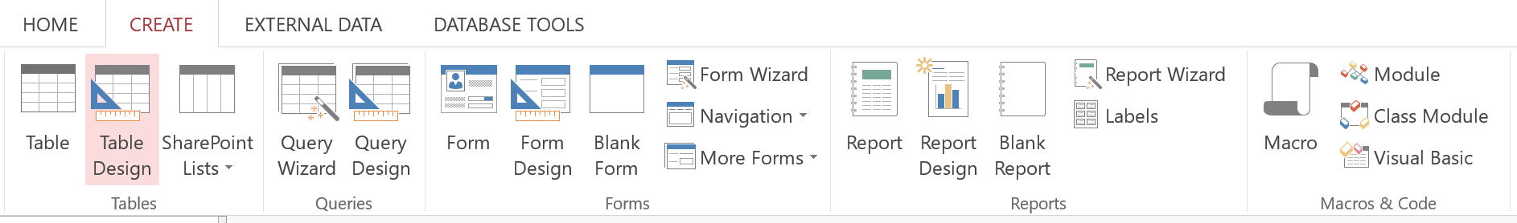
Figure 1: CREATE menu of Microsoft Access

Why and when to use Microsoft Access
The main usages of Microsoft Access are data storage and data querying. If we compare saving data into database software to saving data into other types of software, for instance, word processing or spreadsheet, you will find that the latter has limitations in data storing and data querying, especially when data keeps growing. Storing data in word processing software application which is like taking note sentence by sentence incrementally, makes it difficult for data processing. For example, recording customer orders of each table in a restaurant, as illustrated in Figure 2, makes it difficult to search and calculate total income of each day, or to figure out income of each day in the past. Furthermore, Word processing software itself does not provide tools to help search data and calculate in such a way.
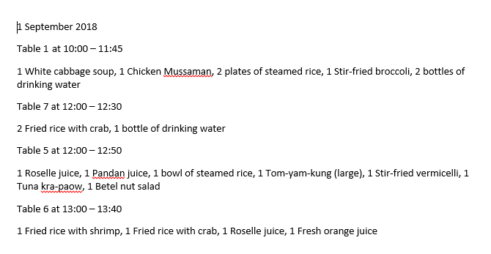
Figure 2: Saving data into word processing software
Since Microsoft Access provides tools to help with data querying and creating report, saving records as customer food orders on each table as shown in figure 2 into Microsoft Access database, allows user to search the data and generate reports such as Sales reports or Receipts very easily.

Creating Microsoft Access Table
- On tab CREATE, click Table Design to turn on table design mode
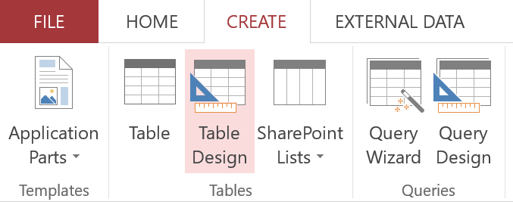
- Input data field name and choose data type for each field, and set primary key by clicking on the field name you want then click primary key button on DESIGN tab.
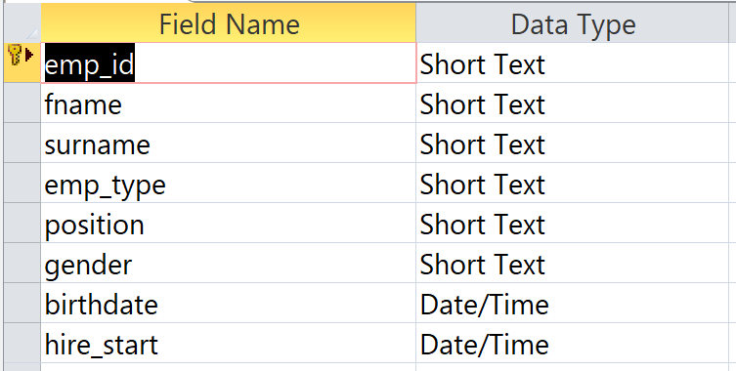
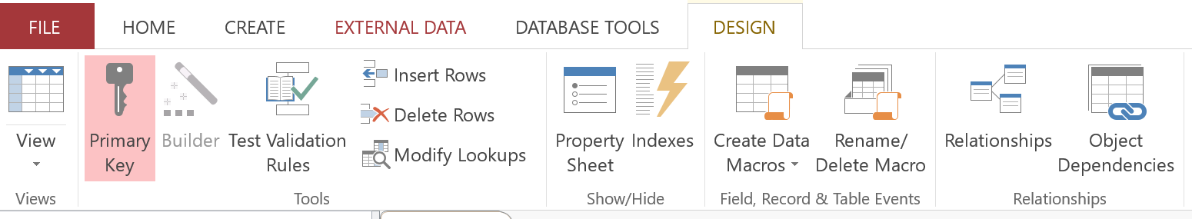
- Click Save button to save data table, input table name then click OK.
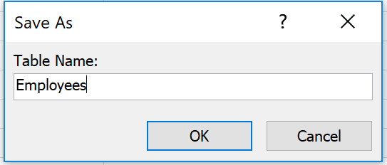

Importing data from Microsoft Excel into Microsoft Access
In case the data are already stored in Microsoft Excel, you can import them from Microsoft Excel to Microsoft Access database. Microsoft will see data on each sheet as one table and users will have to import data by sheet as follows.
- On EXTERNAL DATA tab, choose Import from Excel then click “Import the source data into a new table in the current database” to import data from Microsoft Excel sheet to create new table in current database file.
*Note: In the case that tables already exist in the current database file, choose “Append a copy of the records to the table”, then choose table name to append data to.
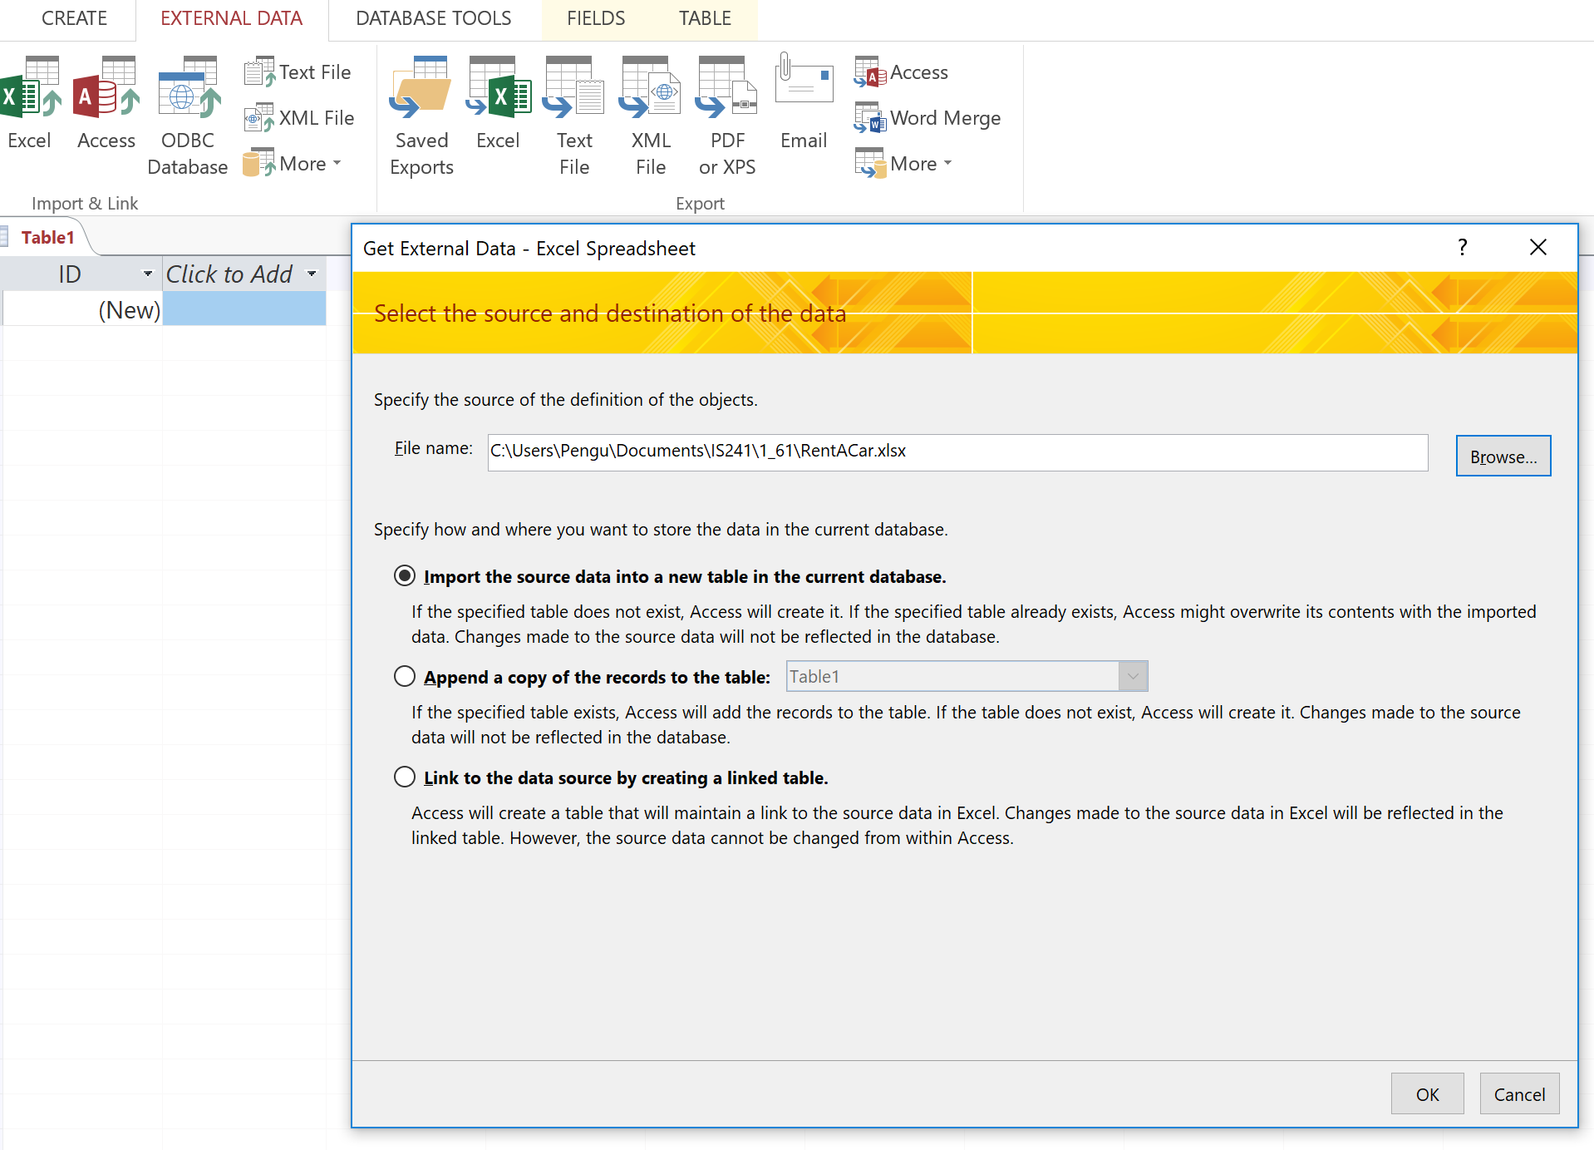
- Microsoft Access will show list of dataset names using the same names as Microsoft Excel sheet names. Select the data sheet that you want to import to Microsoft Access table.
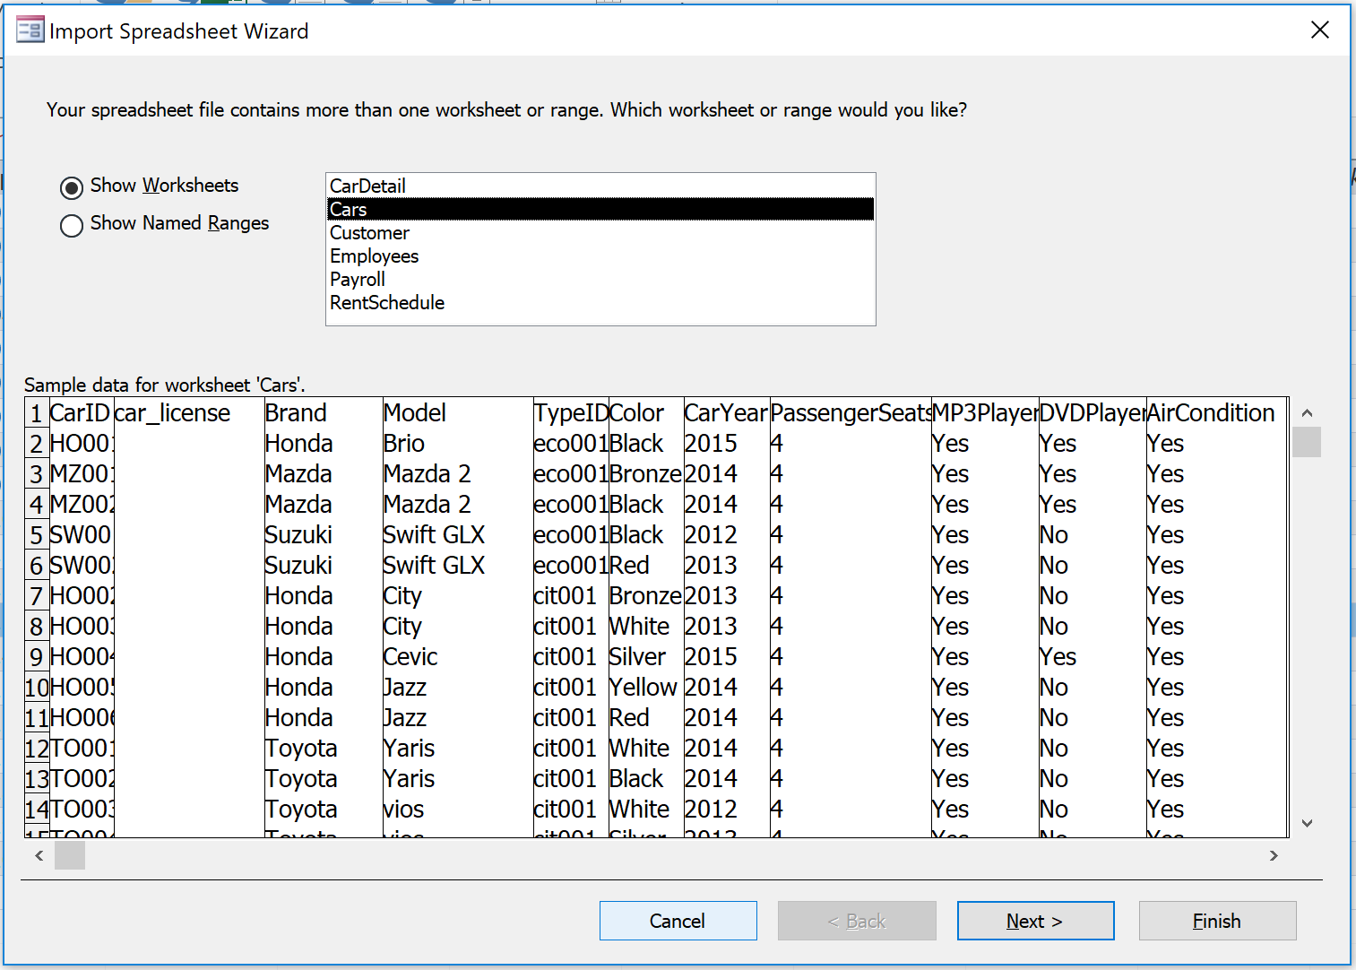
- If there is a header row in Microsoft Excel sheet, tick the box “First row contains column headings” to tell Microsoft Access not to import values on first row as data, but to use those values as field names of table.
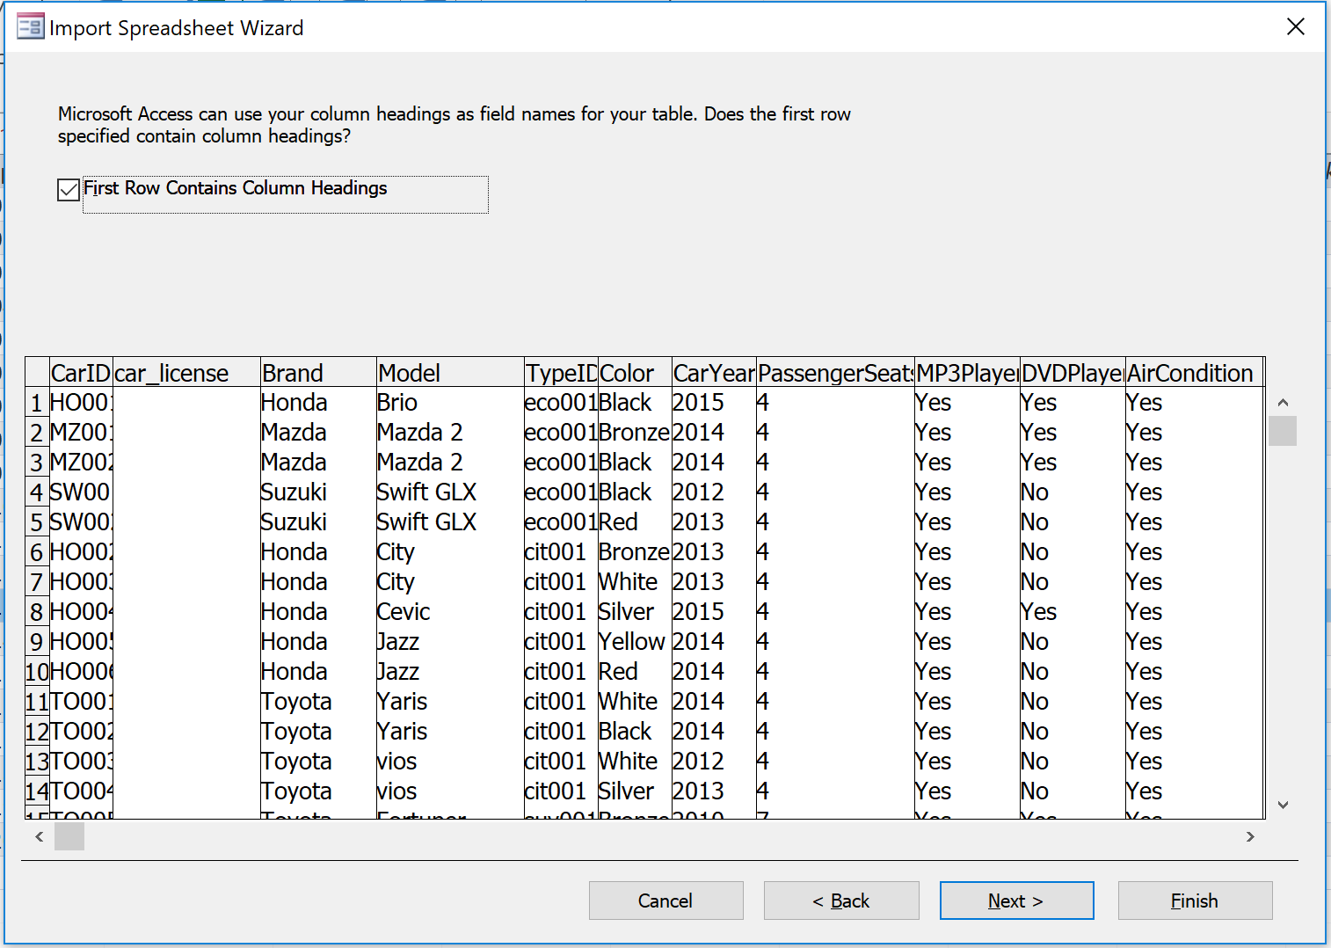

- Set details for data fields, field by field, by clicking on the field or column that you want to check and edit detail one by one until all are complete, then click Next and click Finish.
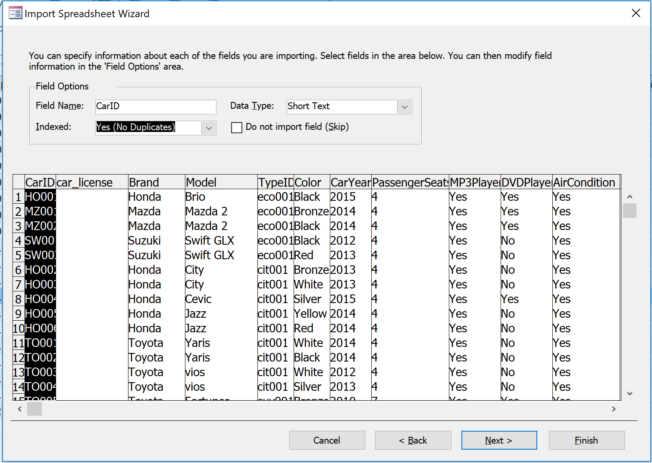

Creating a query for data searching
When there are a lot of data in several data tables, it is difficult to make understand and to make use of those data. Query is a tool to help search data according to conditions you want. Query can be created by following these steps.
- Click on CREATE tab then click Query Design
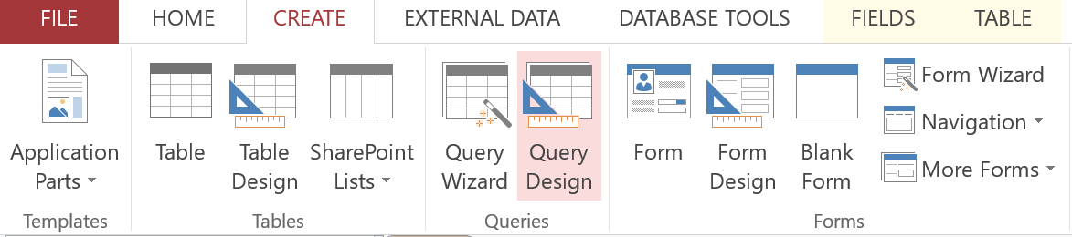

- Select data table that you want to query, click Add then click X to close Show Table window.
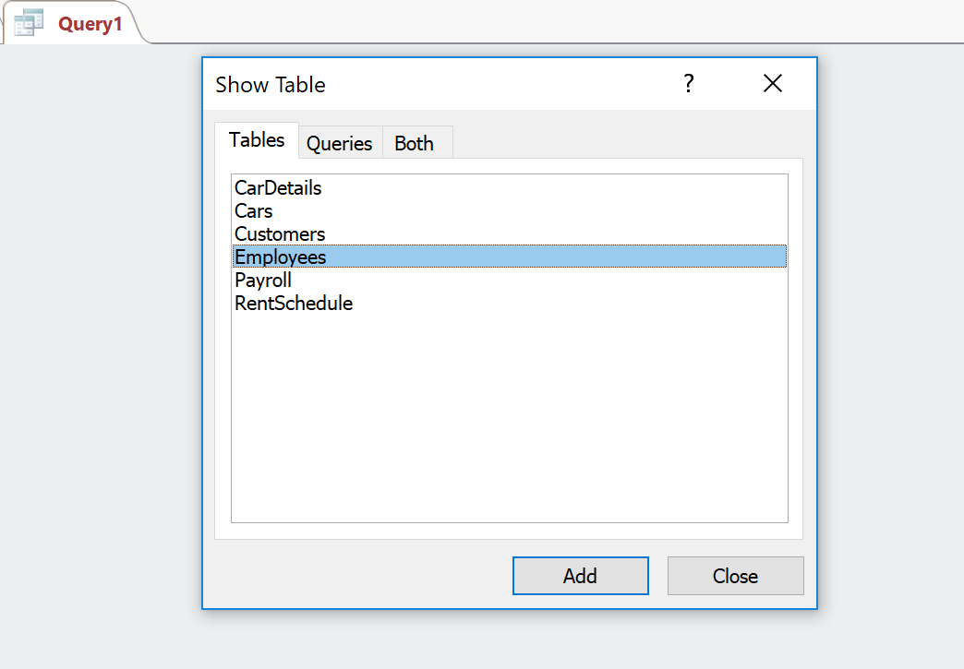
- In the Query Design section, users can specify
- Field – The field name of the data to be retrieved.
- Table – The table in which the selected field belongs to.
- Sort – select Ascending to sort search result in that field in ascending order or select Descending to sort search result in descending order.
- Show – check the box to display data of that field or leave it blank for checking condition only without showing in the result.
- Criteria – conditions to search for data such as > 5000, between 20000 and 25000
- Or – an OR condition operator. For example, suppose you want to retrieve employee information of employees in MIS department or employees with salary 20,000 or above. The selected field will be department, criteria box will be MIS and Or box will be > 20,000.

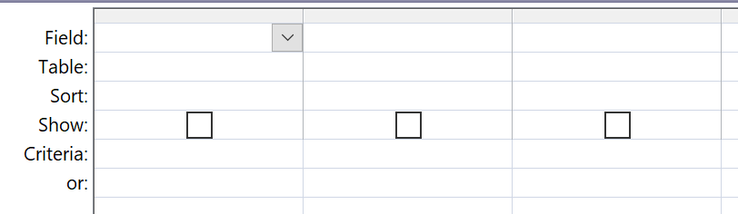
- Suppose you want to retrieve data from Employees table and display id, first name, position and gender of the employee by selecting only female employees (F), fields and conditions in Query Design should be specified as below.
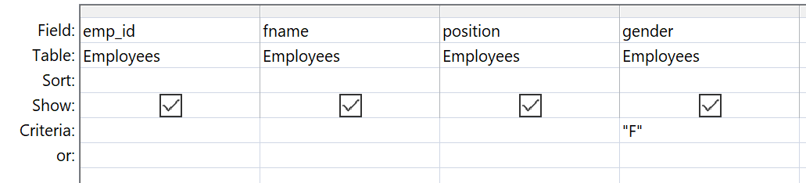

Query design Exercise
Specifying criteria to text fields.
- Display list of all black cars.
- Display list of all 2016 cars.
Specifying criteria to numeric fields.
- Display list of name and job position of employees with salary less than 20000.
- Display list of name and job position of employees who pays social security fee 450 baht or above.
Specifying criteria to date fields.
- Display list of name and job position of employees who started job on 15/6/2014.
- Display list of the cars that were rented on 16/8/2019.
Specifying criteria to Yes/No fields
- Display list of cars with DVD Player.
- Display list of cars without ABS.
Specifying criteria using AND
- Display list of cars with DVD Player and Navigator.
- Display list of all cars that are white and 2015 car.
Specifying criteria using OR
- Display list of cars with DVD Player or with Navigator.
- Display list of employees with positions as accountant or with salary 22000.
- Display list of Honda or Mazda or red cars.
- Display list of red Toyota or red Honda cars.
Specifying criteria for finding fields that have empty values
- Display list of customers without Landline phone number.
- Display list of cars that have not been returned.
Specifying criteria for finding fields with values ​​between A and B
- Display list of employees with salaries between 18000 and 22000.
- Display list of employees who started work between 1/1/2013 until 31/5/2013.
Specifying criteria for checking value in a list (IN)
- Display list of customers who live in New York or San Francisco or Bangkok
Specifying criteria using shorten text (Like)
? represents a single character or number.
* represents any characters or any numbers of any length.
# represents any one digit number (0-9).
[ ] represents any characters or number inside [ ].
- Display information of employees whose first name begins with letter A.
- Display customer information whose postcode begins with 2 and ends with 0.
Using Function in Query
Function that can be used and are frequently used in Query are Sum, Avg, Min, Max, Count and Group By. To use these Function, Go to DESIGN tab and click on ∑ Totals as shown below.
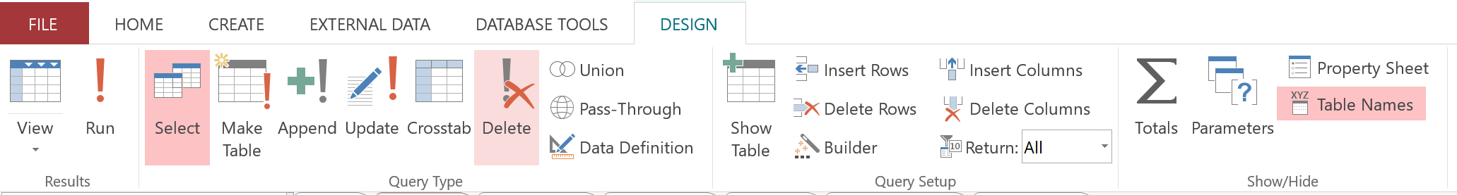
Once click on ∑, Total: row will appear in Query Design panel. Users can select desired functions from the list.
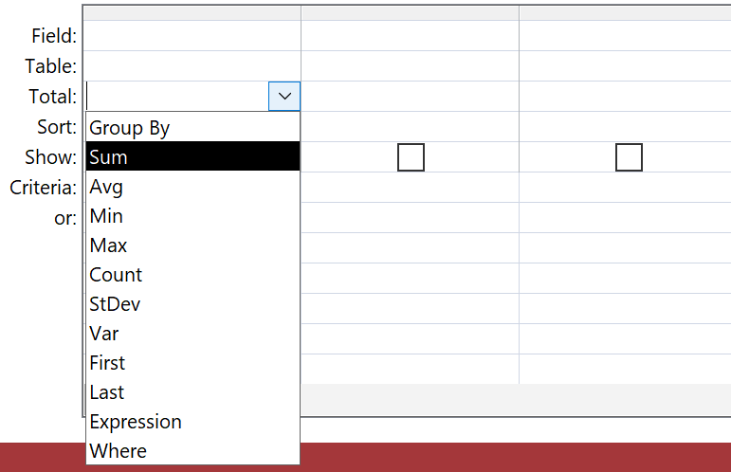

Example
- Display total salary and average salary of all employees.
- Display the total number of cars in the system.
- Display average of salary of employees with salary 20000 or above.
- What are the countries that the customers come from?
- Display total salary of each position.
- Calculate total salary of each position excluding salary lower than 18000.
- Calculate total salary of each position excluding salary lower than 18000 and display only departments which has total salary more than 50000.

Exercise
1. Query the information of all cars which has model name begins with letter E.
2. Query the information of all cars that is ‘March’ (car model) and is the car of 2015.
3. Query the information of all cars that were rented on August 2019
4. Display the number of times that the cars were picked up at Siam.
5. Display list of rented cars that were picked up and returned at Airport.
6. Display list of customer code and the number of times that the customer has rented cars.
7. Display the average of tax and allowance of employees with salary over 22000.
8. Query the information of employee who are female or employee with salary between 18000 and 20000.
9. Query the information of customers who have not given email address to the company.
10. Query the information of customers whose address zip code begins with 10 or 11.

