Natchalin Iwsakul 6104640153
Assignment 8
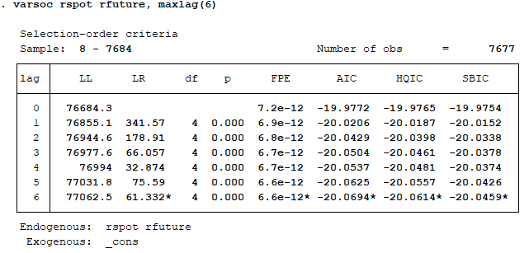
By setting rspot and rfuture as endogenous variables, and estimating the VARs model, we have found that the model with the most appropriated lag model using SBIC is lag 6.

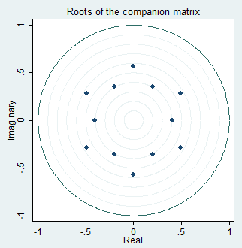
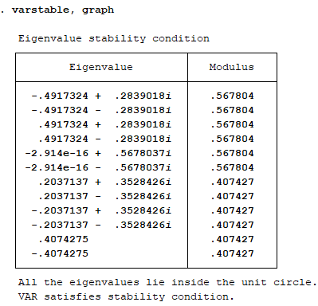
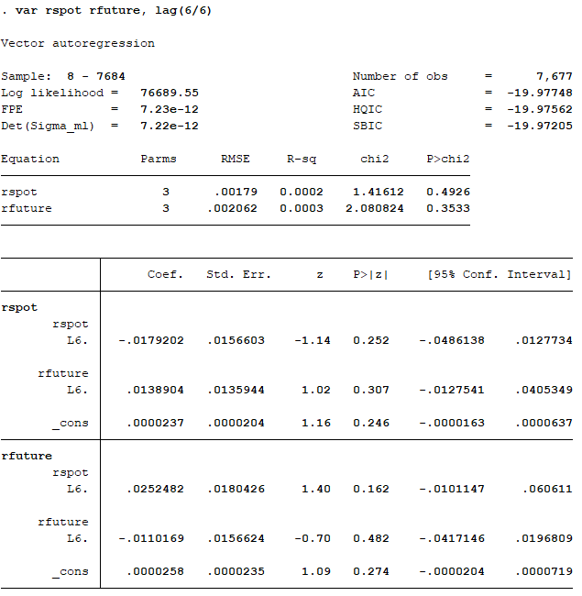

By estimating VARs from the lag 6 model, we can perform the stability test. Every eigen value is less than 1. Thus, it is a stable system.
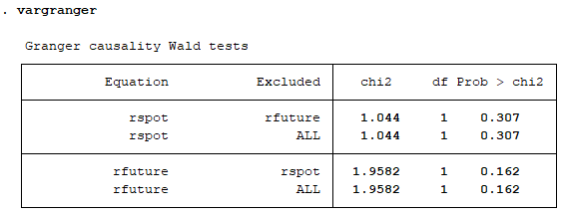
After that, we perform the Granger test to check if there is exogeneity problem.
The Prob > Chi2 of both rfuture affects rspot, and rspot affects rfuture are more than 0.05 significant level. Thus, we accept the null hypothesis; there is no interdependent relationship between rspot and rfuture.

3.
. irf create order1, order(rspot rfuture) step(6) set(irf01)
(file irf01.irf created)
(file irf01.irf now active)
(file irf01.irf updated)

. irf table irf, impulse(rspot rfuture) response(rspot rfuture)

Results from order1

+--------------------------------------------+
| | (1) (1) (1) |
| step | irf Lower Upper |
|--------+-----------------------------------|
|0 | 1 1 1 |
|1 | -.042989 -.074543 -.011434 |
|2 | -.101957 -.133505 -.070409 |
|3 | -.034997 -.066566 -.003428 |
|4 | -.02148 -.052956 .009995 |
|5 | -.033647 -.06485 -.002443 |
|6 | -.010717 -.041519 .020085 |
+--------------------------------------------+

+--------------------------------------------+
| | (2) (2) (2) |
| step | irf Lower Upper |
|--------+-----------------------------------|
|0 | 0 0 0 |
|1 | .211774 .175513 .248035 |
|2 | .030833 -.00561 .067276 |
|3 | .030738 -.005677 .067153 |
|4 | .002714 -.033596 .039023 |
|5 | .034962 -.001046 .070971 |
|6 | .017646 -.017933 .053226 |
+--------------------------------------------+

+--------------------------------------------+
| | (3) (3) (3) |
| step | irf Lower Upper |
|--------+-----------------------------------|
|0 | 0 0 0 |
|1 | .102511 .075055 .129966 |
|2 | .061675 .034224 .089126 |
|3 | .018216 -.009265 .045697 |
|4 | .026291 -.001106 .053688 |
|5 | .01553 -.011653 .042713 |
|6 | .006933 -.01982 .033686 |
+--------------------------------------------+

+--------------------------------------------+
| | (4) (4) (4) |
| step | irf Lower Upper |
|--------+-----------------------------------|
|0 | 1 1 1 |
|1 | -.162359 -.19391 -.130809 |
|2 | -.057352 -.089063 -.025641 |
|3 | -.025324 -.057023 .006376 |
|4 | -.004062 -.035665 .027541 |
|5 | -.029332 -.060699 .002035 |
|6 | -.003566 -.034475 .027344 |
+--------------------------------------------+
95% lower and upper bounds reported
(1) irfname = order1, impulse = rspot, and response = rspot
(2) irfname = order1, impulse = rspot, and response = rfuture
(3) irfname = order1, impulse = rfuture, and response = rspot
(4) irfname = order1, impulse = rfuture, and response = rfuture

4.
. irf table fevd, impulse(rspot rfuture) response(rspot)

Results from order1

+--------------------------------------------+
| | (1) (1) (1) |
| step | fevd Lower Upper |
|--------+-----------------------------------|
|0 | 0 0 0 |
|1 | 1 1 1 |
|2 | .993131 .989465 .996798 |
|3 | .990693 .98638 .995006 |
|4 | .990483 .986145 .994821 |
|5 | .990038 .98565 .994426 |
|6 | .989888 .985487 .994289 |
+--------------------------------------------+

+--------------------------------------------+
| | (2) (2) (2) |
| step | fevd Lower Upper |
|--------+-----------------------------------|
|0 | 0 0 0 |
|1 | 0 0 0 |
|2 | .006869 .003202 .010535 |
|3 | .009307 .004994 .01362 |
|4 | .009517 .005179 .013855 |
|5 | .009962 .005574 .01435 |
|6 | .010112 .005711 .014513 |
+--------------------------------------------+
95% lower and upper bounds reported
(1) irfname = order1, impulse = rspot, and response = rspot
(2) irfname = order1, impulse = rfuture, and response = rspot

. irf table fevd, impulse(rspot rfuture) response(rfuture)

Results from order1

+--------------------------------------------+
| | (1) (1) (1) |
| step | fevd Lower Upper |
|--------+-----------------------------------|
|0 | 0 0 0 |
|1 | .500791 .484986 .516596 |
|2 | .496679 .480799 .512558 |
|3 | .495972 .480066 .511879 |
|4 | .495855 .479951 .51176 |
|5 | .495851 .479947 .511756 |
|6 | .495689 .479783 .511594 |
+--------------------------------------------+

+--------------------------------------------+
| | (2) (2) (2) |
| step | fevd Lower Upper |
|--------+-----------------------------------|
|0 | 0 0 0 |
|1 | .499209 .483404 .515014 |
|2 | .503321 .487442 .519201 |
|3 | .504028 .488121 .519934 |
|4 | .504145 .48824 .520049 |
|5 | .504149 .488244 .520053 |
|6 | .504311 .488406 .520217 |
+--------------------------------------------+
95% lower and upper bounds reported
(1) irfname = order1, impulse = rspot, and response = rfuture
(2) irfname = order1, impulse = rfuture, and response = rfuture

