EE325 Computer Exercise I
1) This file CEOSAL2.DTA contains data on 177 chief executive officers and can be used to examine the effects of firm performance on CEO salary
(i) Estimate a model relating annual salary to firm values and market value. Make the model of the constant elasticity variety for both independent variables. Write the results out in equation form.

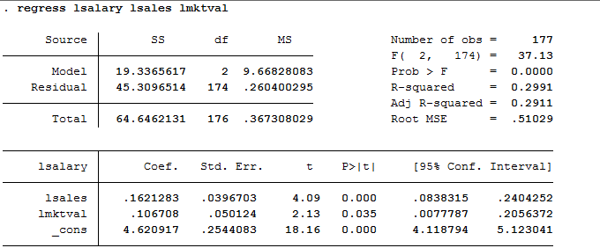
Ans:
The “constant elasticity variety” means a model that is linear in elasticities. Elasticities are percentage changes.
So a constant elasticity model would be: log(salary) = β0 + β1log(sales) + β2log(mktval) + u. The estimated model would be: log(salary) =4.62+ 0.1621log(sales)+0.1067log(mktval)
(ii) Add profits to the model from part (i). Why can this variable not be included in log form? Would you say that these firm performance variables explain most of the variation in CEO salaries?
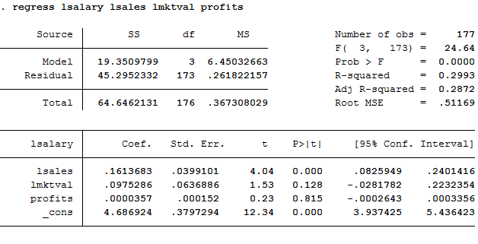

Ans:
Since profit could be negative in some years and we cannot run log on negative value. Therefore, we don’t use log on profit.
The R-square is equal to 0.2993, it means that these firm performance variable could poorly explain most of the variation in CEO salaries.
(iii) Add the variable cotton to the model in part (ii). What is the estimated percentage return for another year of CEO tenure, holding other factors constant?

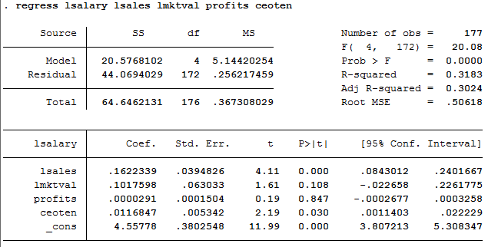
Ans:
The estimated model is
log(salary) = 4.56 + 0.16log(sales) + 0.10log(mktval) + 0.00prof its + 0.01ceoten
This means that if CEO tenure increases by 1 year, salary would increase by 1%. 1% is the estimated percentage return for another year of CEO tenure, holding other factors constant.
(iv) Find the sample correlation coefficient between the variables log(mktval) and profits.
Are these variables highly correlated? What does this say about the OLS estimators?
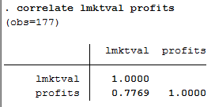
Ans:
Log(mktval) and profits variables are highly correlated with the value of 0.7769. The estimated dependent variable approaches to actual value. Profits and the log of market value move together in the positive direction.
2) Use the data in WAGE2.DTA for this exercise,
(i) Consider the standard wage equation;
State the null hypothesis that another year of general workforce experience has the same effect on log(wage) as another year of tenure with the current employer.
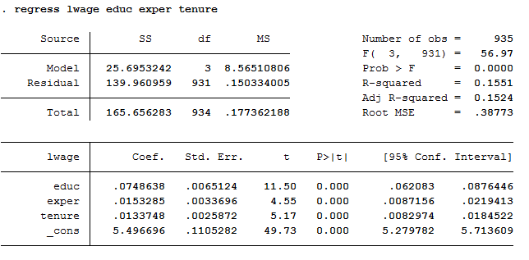
Ans:
Ho : β2 -β3 = 0
Ha :β2 – β3 ≠ 0
(ii) Test the null hypothesis in part (i) against a two-sided alternative, at the 5% significance level, by constructing a 95% confidence interval. What do you conclude?
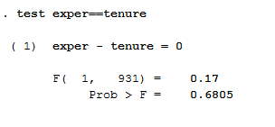
Ans:
Assuming that using 0.05 level of significant, we accept Ho because p-value is greater than 0.05. So we can conclude that β2 = β3.
3) Use the data in DISCRIM.DTA to answer this question.
(i) Use OLS to estimate the model
and report the results in the usual form. Is statistically different from zero at the 5% level against a two-sided alternative? What about at 1% level?

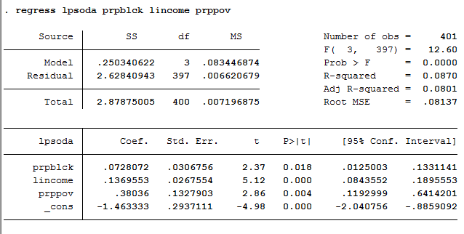
Ans:
Log(psoda) = -1.4633 + 0.728(prpblck) + 0.1369(income) + 0.3803(prpprov)
At 0.05 level of significant: Since P-value(0.018) of the estimated β1 is less than 0.05, we will reject Ho which means that the estimated β1 is different from 0 at 0.05 level of significant.
At 0.01 level of significant: Since P-value(0.018) of the estimated β1 is greater than 0.01, we will accept Ho which means that the estimated β1 is not different from 0 at 0.01 level of significant.
(ii) To the regression in part (i), add the variable log(hseval). Interpret its coefficient and
report the two-sided p-value for
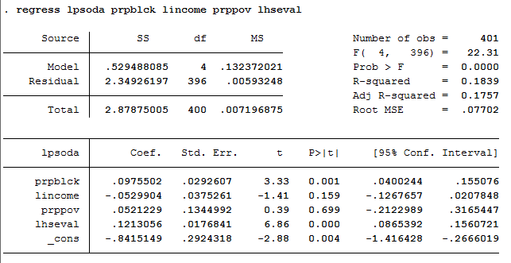
Ans:
The coefficient of β4 is equal to 0.1213, which means that when the median housing value increases by 1 percent, the price of median soda will increase by 0.1213percent.
The p-value for Ho: βlog(hseval) = 0 is equal to 0.000.
(iii) In the regression in part (iii), what happens to the individual statistical significance of
log(income) and prppov? Are these variables jointly significant? (compute a p-value.) What do you make of your answers?

(1)Ans:

P-value of B2 increases from 0.00 to 0.159 which is higher than 0.05. So we accept Ho and log(income) is not statistically significant.

P-value of B2 increases from 0.004 to 0.699 which is higher than 0.05. So we accept Ho and prppov is not statistically significant.
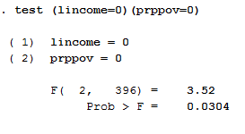

(2)Ans:
The p-value is equal to 0.0304, which is less than 0.05. So we reject Ho at 0.05 level of significant. We can conclude that the two are jointly significant.
(iv)Given the result of the previous regressions, which one would you report as most reliable in determining whether the racial makeup of a zip code influences local fast-food prices?
Ans:
R-adjusted of the previous regression is less than the one from the later regression after adding log(hseval). (0.0801<0.1757)
We can conclude that this model is more reliable than the previous one without (hseval) log(psoda) = -0.8415 + 0.0975(prpblck) – 0.529(income) + 0.0521(prpprov) + 0.1213(hseval).

