Partial Equilibrium (more information)
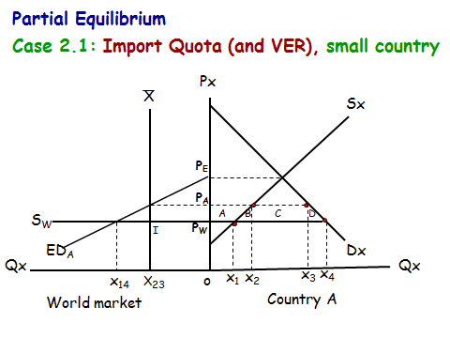
Case 2.1 (b): Voluntary Export Restraint (VER), small country
 | Free Trade | VER | Changes compared to free trade of VER
World price  Domestic price | P_{w}  P_{w} | P_{w}  P_{A} | Not change  = P_{w}P_{A}
Consumer  - Quantity consume  - Consumer Surplus | OX₄ | OX₃ | = X₃X₄  = area (A + B + C + D) = - (A + B + C + D)
Producer  - Quantity produce  - Producer Surplus | OX₁ | OX₂ | = X₁X₂  = area A = + A
Quantity import | X₁X₄ | X₂X₃ | = (X₁X₂ + X₃X₄)
Government revenue | 0 | 0 | Not change
Economic quota rent  (1) Domestic importer/retailer  (2) Foreign supplier  (3) Foreign government  (4) Home government | 0 | 0 | Not change
Country A’s overall welfare |  |  | = - (A + B + C + D) + A  = - (B + C + D)
Country B’s overall welfare |  |  | = + C
Welfare of the world |  |  | = - (B + C + D) + C  = - (B + D)

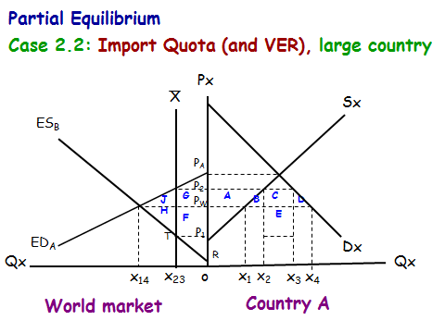

Case 2.2 (b): Voluntary Export Restraint (VER), large country
 | Free Trade | VER | Changes compared to free trade of VER
World price  Domestic price | P_{w}  P_{w} | P₂  P₂ | = P_{w}P₂  = P_{w}P₂
Consumer  - Quantity consume  - Consumer Surplus | OX₄ | OX₃ | = X₃X₄  = area (A + B + C + D) = - (A + B + C + D)
Producer  - Quantity produce  - Producer Surplus | OX₁ | OX₂ | = X₁X₂  = area A = + A
Quantity import | X₁X₄ | X₂X₃ | = (X₁X₂ + X₃X₄)
Government revenue | 0 | 0 | Not change
Economic quota rent  (1) Domestic importer/retailer  (2) Foreign supplier  (3) Foreign government  (4) Home government | 0 | 0 | Not change
Country A’s overall welfare |  |  | = - (A + B + C + D) + A  = - (B + C + D) = - (J + G)
Country B’s overall welfare |  |  | = G - H
Welfare of the world |  |  | = - (J + G) + (G – H)  = - J – G + G – H  = - J – H = - (J + H)

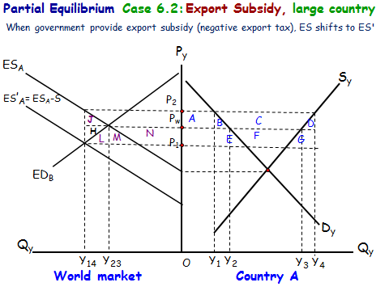

Partial Equilibrium
Case 6.2: Export subsidy, large country
 | Free Trade | Export subsidy | Changes compared to free trade of export subsidy
World price  Domestic price | P_{w}  P_{w} | P₁  P₂ | = P_{w}P₁  = P_{w}P₂
Consumer  - Quantity consume  - Consumer Surplus | OY₂ | OY₁ | = Y₁Y₂  = area (A + B) = - (A + B)
Producer  - Quantity produce  - Producer Surplus | OY₃ | OY₄ | = Y₃Y₄  = area (A + B + C) = + (A + B + C)
Quantity export | Y₂Y₃ | Y₁Y₄ | = (Y₁Y₂ + Y₃Y₄)
Government revenue | 0 | = Y₁Y₄ * T  = area (B+C+D+E+F+G) | = area (B+C+D+E+F+G) = - (B+C+D+E+F+G)
Country A’s overall welfare |  |  | = - (A + B) + (A + B + C) – (B + C + D + E + F + G)  = C – (B + C + D + E + F + G)  = - (B + D + E + F + G)  = - J – (H + L + M + N)
Country B’s overall welfare |  |  | = area (L + M +N) = + (L + M + N)
Welfare of the world |  |  | = - J – (H + L + M + N) + (L + M + N)  = - J – H = - (J + H)

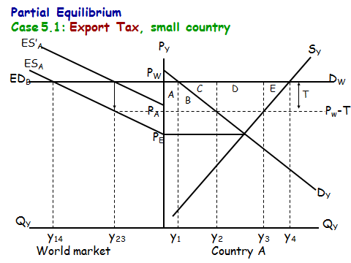

Case 5.1: Export tax, small country
 | Free Trade | Export tax | Changes compared to free trade of export tax
World price  Domestic price | P_{w}  P_{w} | P_{w}  P_{A} | Not change  = P_{w}P_{A}
Consumer  - Quantity consume  - Consumer Surplus | OY₁ | OY₂ | = Y₁Y₂  = area (A + B) = + (A + B)
Producer  - Quantity produce  - Consumer Surplus | OY₄ | OY₃ | = Y₃Y₄  = area (A+B+C+D+E) = - (A+B+C+D+E)
Quantity export | Y₁Y₄ | Y₂Y₃ | = (Y₁Y₂ + Y₃Y₄)
Government revenue | 0 | = Y₂Y₃ * T  = area D | = area D = + D
Country A’s overall welfare |  |  | = (A + B) – (A + B + C + D + E) + D  = - (C + E)

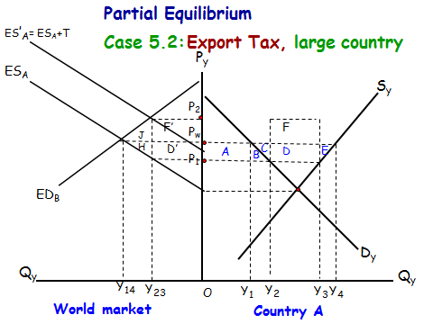
Case 5.2: Export tax, large country
 | Free Trade | Export tax | Changes compared to free trade of export tax
World price  Domestic price | P_{w}  P_{w} | P₂  P₁ | = P_{w}P₂  = P_{w}P₁
Consumer  - Quantity consume  - Consumer Surplus | OY₁ | OY₂ | = Y₁Y₂  = area (A + B) = + (A + B)
Producer  - Quantity produce  - Producer Surplus | OY₄ | OY₃ | = Y₃Y₄  = area (A+B+C+D+E) = - (A+B+C+D+E)
Quantity export | Y₁Y₄ | Y₂Y₃ | = (Y₁Y₂ + Y₃Y₄)
Government revenue | 0 | = Y₂Y₃ * T  = area D + F | = area D = + (D + F)
Country A’s overall welfare |  |  | = (A + B) – (A + B + C + D + E) + (D + F)  = F - (C + E)
Country B’s overall welfare |  |  | = - (J + F’)
Welfare of the world |  |  | = F – (C + E) – (J + F’)  = F’ – H – J + F’ = - (H + J)

