Thammasat University

H1N1 to 2008 and the lack of social responsibilities

Vittawin Saekow 6204640285
Chalida Akkapaiboon 6204640418
Nuttawat Sakulsantiporn 6204641390
Natthakul Burananitikul 6204640715

Contemporary Economic Issues
EE406
Ajarn Thanasak Jenmana

Executive summary

Since the world has faced the epidemic of the swine flu, the world system was paused and faced with numerous challenges stated from identifying the virus, imposing the regulation that will improve the standard of living in the health aspects as well as determining the cause of the problem. Enhancing the health professional will not only help the overall standard of living but also help to eradicate the virus as well. The consequences of this virus in the economic aspects are still not severe and the mortality rate still not yet spiking in some countries. Despite the city under the lockdown and closure regulation in Mexico City, the impact on the overall economy is still in a small margin in the gross domestic product. The regulation recommended by the health organisation stated to avoid human contact which affects the tourist industry since some countries are under lockdown situation thus this virus can be seen as the impediment of the tourist industry. Another ramification that is under-recognised is the mental effect that appears from human to human. The media process during that period portrays this virus as Spanish flu due to its origination of the virus. Under this media portraiture, it led to stigmatising among society. The previous stigmatisation level is not as severe as in this period which reflects segregation in the society. Besides, Vaccination is proven to be effective but the government policy only regulated the vaccination as voluntary rather than compulsory. Some of the groups that are unable to bear the cost of the vaccination are seen as the free-riders in the society who share the benefit from the vaccinated people. The free-rider problem is rooted in society since people tend to benefit themselves first then to another thus the society will worsen. Under the epidemic scenario, this type of behaviour will have large consequences for the whole society.

Table of contents

Introduction
________________________________________________________________

Aim and Objective ________________________________________________________________

Chapter 1
- History of the H1N1
- The prevention of the diseases
- The vaccination process
________________________________________________________________

Chapter 2
- Stigmatisation
- The disease Stigma (H1N1)
- Media Frame
- Free rider problem
________________________________________________________________

Conclusion ________________________________________________________________

Index / Preference ________________________________________________________________

Introduction

In 2008, the world was faced with the 19 months long infighting of swine flu which originated from Spain and it caused the death of a third of millions of the world population. The study showed how the world organisation contained these situations since it reflected the decreasing risk in serious illness was not more severe than seasonal flu. The states impose various regulations aimed to prevent and control the virus via travel restriction, Schools closure, workplace conditions, and Face masks. Despite the effectiveness of the regulations it yields a negative output response to a society in the lack of social responsibilities, This report looks into the factors that influence world health and economics. In the respect of society, we will look differently into the consequences that it yields. One of the most influential impacts that are the result of both of the crises can be permanent effects from all of the segments. The example that significantly damages the man and women in the society is the; stigmatisation which is caused by the misleading media output and the arises of free riders in which it affects society.

Aim and Objective

Swine flu since the subjects has a vigorous effect on humans. Since most of the research focuses on examining the effect of the virus in economic and health aspects but if we further analyse regards the intangible consequences caused by this incident. Therefore, this report will examine the mental ramification of swine flu regarding the lack of social responsibilities.

Chapter 1

Influenza H1N1 originated in 1918, an influenza pandemic is also known as the Spanish flu. The virus appeared around the end of the first world war in Spain during 1918-1919 causing the death of around 50 million people all over the world. This became the most infectious disease in that time since the Black Death in 1346 and this is the first wave among others two of H1N1 lethality diseases. During this period, there are no medical supplies to treat the infected properly thus most of the age of teenagers, elders, and made unwell people will be affected leading to an enormous number of deaths. As technological advances, scientists have found that when the virus enters the human body then it begins to generate an overly large number of antibodies causing death.
The scientist has used the new technology to prove from the frozen infected body that the virus made the effect over antibodies causing death. The influenza type A (H1N1) influenza can be found easily in the rainy season and can be less dangerous as the order of influenza type B, type C.
World health organisation has declared that the virus could always change its type according to nature itself or the combination of the species. Thailand also affected the Spanish flu since Thai soldiers transmitted the virus from France to Thailand during World war I. The virus was found later in Russian as known as Russian Flu in 1977-1978. Followed by the second H1N1 influenza appeared again in 2009, the swine flu. The cause of the flu was coming from the normal swine that obtained negative pathogens including in its genes which creates a possibility that the virus could be spread.
In 1988, the first record of infection was a pregnant woman who died from the virus.
Scientists are questioning whether it did not only come from human contact only but also can be found through animal contact due to advancement in the virus’s characteristic since the first H1N1 influenza in 1918 which was only transmitted via animals. As it developed the characteristic, now the virus can be transmitted from human interaction. A year later, scientists found evidence suggesting that the swine flu can develop from different carriers leading to the different types of the virus such as H3N2, H1N2, and H1N1.
The event that led to the skyrocketed number of infected cases to the pandemic in 2009 started in the previous year by the women who worked in the swine factory getting infected with the H1N1 virus showed mild symptoms such catching a cold, muscles sore, cough, and itchy eye. But the woman recovered by herself giving the sense that virus H1N1 is not severe to the public. As a consequence, the people underestimated the damages of the virus thus people have not yet implemented the proper prevention of the virus therefore creating the pandemic in 2009.

The pandemic 2009 can be separated into 3 different waves as followed :

The first wave; The virus has spread over the US with some particular outbreaks in some states, for example, Texas, New York, and California. The opening case was found in a group of students who have traveled to Mexico during the spring break carrying some virus around.
On the 4th May 2009, There was a confirmed number of 1 death with the 286 H1N1 flu-infected from 36 states, and 35 virus-infected people who went to the hospital. Then, the virus was spreading across every state sequentially. In one day, on the 5th of May, the number of infected ills had increased to 403 and found the second death in Texas. This caused the government to put more laboratory testing which found out that the virus was compound with many strange viruses related to the previous virus that they had found. However, in the first wave, people were not urged of the danger of the H1N1 epidemics yet since 2007-2008 there were pneumonia and influenza that has the large numbers of deaths also. This was the start point of the outbreak of the virus through human to human transmission. We use the based information from Denmark which experienced the 3 waves of the pandemic from July 2009 to February 2011. The working of admission to intensive care units (ICUs) has been placed since the first wave and got bigger in the second and third waves by order.

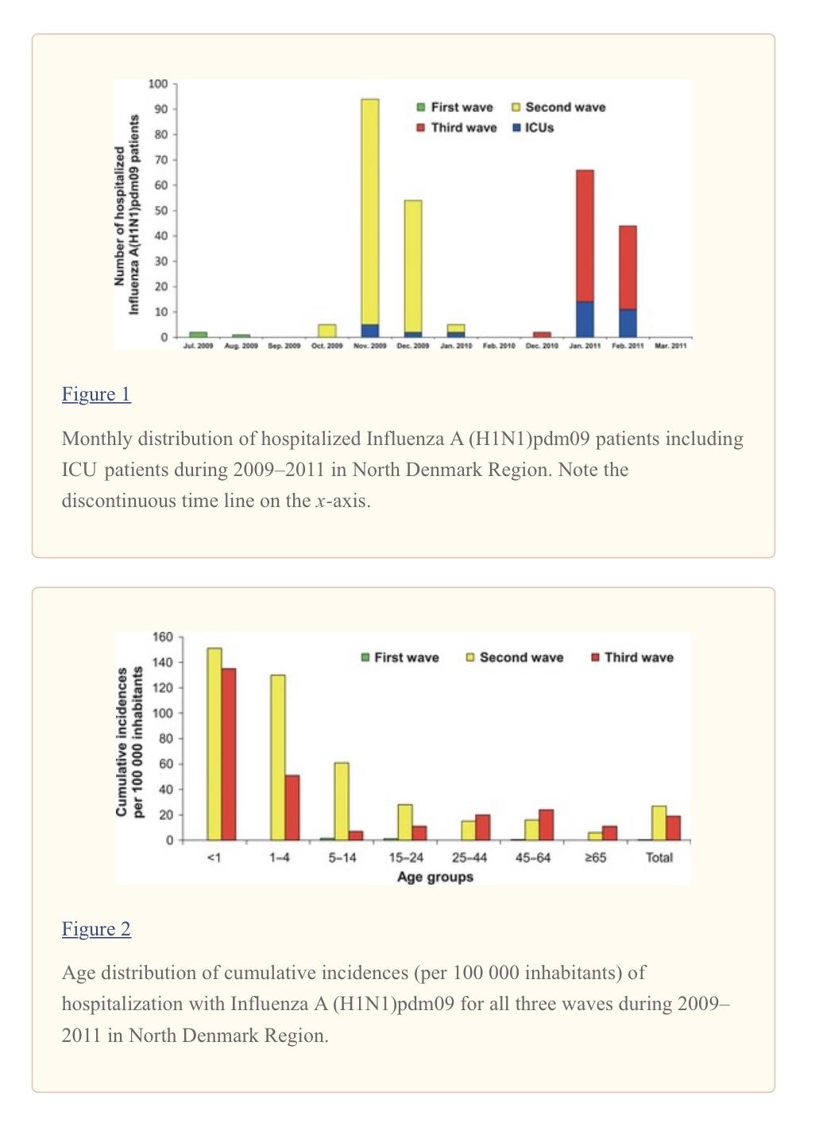

The second wave; Conversely, the second wave was much worse than the first one. The second wave made 4.8 times more patients than the prior wave patients in the hospital and 4.6 times more deaths compared to the first wave. This has been recorded as the post-peak of the infected people during the pandemic and held in late 2009 to the beginning of 2010. Even though there are a large number of infected people, hospitalised people also get easier. The second wave shows the larger impact even though the virus seems to be a normal seasonal flu, and seems to be more harmful to those who were previously infected and those young. Based on the graph data, during the first wave, none of the patients were receiving the ICUs treatment. In the second wave, nine patients got the treatment, and in the third wave for 25 patients. There are no studies recorded for infection in each age group habitant in the sample area. The second wave infected age group data shows the most infection at a young age. It shows the less age you are the more risk you will get for the infection.

The Third wave; The final wave shows the lower wave of the infection compared with the previous wave. It seems that the more number of infected received the ICUs treatment showing the development and the adaptation of the situation in the medical. The age group of people is likely to be unchanged but there is more number of elders infected since the unawareness of the virus in their age gap.

To conclude, Human behaviour due to the H1N1 virus in medical adaptation. However, the unawareness of the transmission of the virus from interaction with one who is the carrier is the key that people do not understand how to deal with the unknown virus.

The prevention of the diseases

The government prevention of the swine flu is according to the central disease control and prevention. The guidelines suggest the patient will fall under 2 categories; one being the higher risk of contracting the virus and another is the not high risks. The people with a higher risk separated under the following circumstances; pregnant women, children aged under 5 years old, and the elder, more than 65 years old. If this group contracting the virus who must be on the close-watch list of the health professionals. The people with lower risk that face with the implication will have to avoid close contact with the swine, lessen the human contact if you feel ill, and wash your hand regularly to ensure sanitation.

Chapter 2

Stigmatisation

An essential factor that differentiates humans is the mind, the most complex part of the human body. In the case of a difficult incident, people tend to lack consciousness which leads to the dehumanisation of others in different countries. The rhetorical questions that appear during the pandemic are “ Where did the virus come from?” and “How did it spread?” The consequence of two questions has made the people impose protectionism and discriminate against other countries as a result. The accusation arises among people in that period which originated from a variety of reasons such as different religious background, national, ethnic, and different historical background of germ spreaders from the previous outbreak, the fallout of this action have led to the incident such as In the late 19th century, the owner of the local restaurant in Chinatown, New York City was infected by SARS and passed away. Also, the owner’s son and the entire staff in the restaurant have been infected. The subsequent aftermath of this incident is the increasing number of people who discriminate over the asian’s business.

The disease Stigma (H1N1) :
Focusing on the issues of stigmatisation, the word worthy of disgrace. As the virus spreads across the globe, one thing that has to be taken into account is the information that stigmatisation is a perspective to look into due to the evidence shown that the H1N1 is the most stigmatised disease, more than cancer. It was observed that Public Health implemented a physical distancing between people aimed too slow down the spread of swine flu. The measurement works well, but the reason it works is arguable because people desire themselves to stay from the infected rather than from Public Health regulation. Psychologists proved that disease stigma evolved by self threatening and protection since they disgust the infected one. Social devaluation and discrediting have been created with additional information from the study, Public Health organisations see that stigmatisation can have the upside therefore the health department has been using the advantage from people and officially encourages the disease to be stigmatised for future influenza pandemics.

Moreover, nowadays disease stigma has been adapted, it makes people panic and abandon each other. According to the study conducted by the statistical institution, the study’s objective is to understand how the H1N1 was stigmatised concerning the distancing from others.

To achieve the first goal, the study measured the effect of H1N1 and compared it to the effect of HIV and cancer on patients. The measurement shows that the reduction of the effect is the characteristic of prejudice, representing the way expressed among individuals. For more information, please
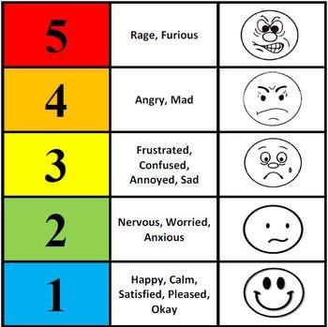
The feeling thermometer, The feeling thermometer scale visualising the given scenarios based on their feeling. The results from the thermometer range from “Disapproval’ to “Pleased”. The scale is often used as the measurement in the political science field where it needs the sensitivity of the matters to the people. The subjects can be used for a given group, individual, issues, or organisation.

The graph below will explain the relationship from the collected data from a sample of U.S college students. They were part of the population that has a high risk of infection.

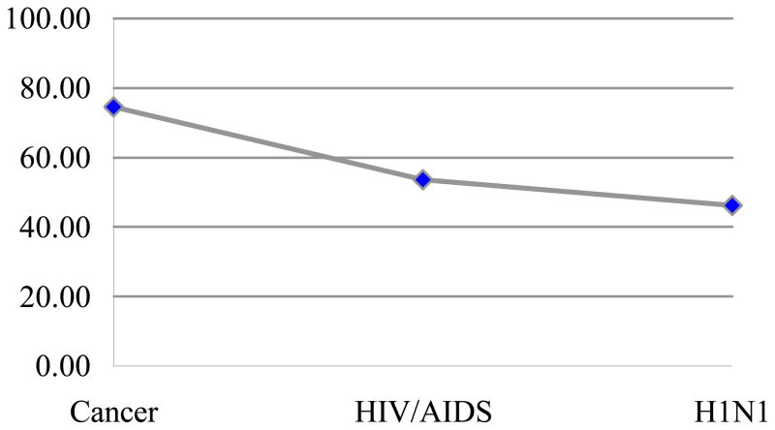

According to the graph, the test compared H1N1 to other stigmatised diseases, which are HIV/Aids and cancer. Analysing responses to the feeling thermometers by conducting repeated measures of ANOVA ( analysis of variance ), the effects towards people of 3 diseases to understand the feelings of people who're using the thermometers. As a result, H1N1 was the most stigmatised compared to others at the height of the pandemic, with colder effects on people.

Method of the study:

Siting the information from the Participants University of Connecticut conducting with a total sample from a population of 237 students includes the ages of 17 and 24. Most of the participants are female. From the study, it appears that 16 of them were infected with H1N1 and only 2 of them have cancer. Remains with 219.
Participants were asked to think about each disease and answer the questions that followed. After the participants answered they being tested by the feeling thermometer immediately

The next is to examine the perceptions of the H1N1 threat, which leads to a physical distance between people. If the threat of H1N1 reduces the effect on people will be lower. Next, when the effect on people lowering a physical distance will be lower.
To achieve the second goal, the study evaluated the effect on people's perception of whether it is threatening under the H1N1 situation.
Achieving the goals from the second objective is the perception of the reconcile relationship between the desire to be together and acknowledgment of toxicant characteristics.

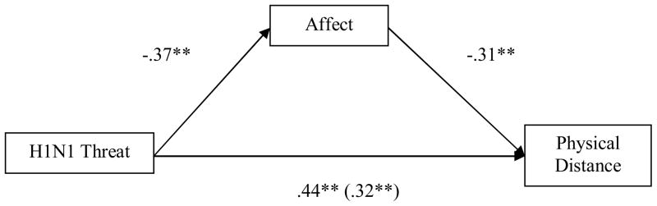

The diagram denotes the relationship between three subjects: H1N1 Threat, Affect, and physical Distance. The effect will be calculated based on the mediation of the normal distribution of the effects. H1N1 has a negative correlation to the effect since the mediation shows as negative at -3.77** which led to the positive externality to physical distance. On the contrary, the H1N1 threat is seen as a negative threat but it can also yield a positive ramification to the physical distance shown in the mediation of .44**.

Every cloud has a silver lining, the stigmatisation is arguably worsening the society condition but it can be seen as the effective strategies to decelerate the expansion of the virus where stigmatised-people tend to lower their incentive to stay in close contact with others.
Stigma implications have a relation between the human and the rest of society. The curative treatment is the threshold that divides people since the people who can afford the cost will get better implied that the cost of the vaccination dominates the society’s perspective towards that person.
The desire for physical distance in the case of H1N1 can be considered a positive externality. The positive externality explains the benefit that society gains from doing such activities which takes into account the social cost, the cost that society has to pay, and the private cost, the cost that is compensated by the individuals. The relationship of both costs is the determinant of the way externality shifted towards. The characteristic of the stigmatisation describes the mechanism of the positive externality since the effect from the stigmatisation driven the incentive of social distancing to be higher. People recognise the stigmatised-people as the ones that caused society to worse off thus keeping distance for a certain group the best possible outcome for them and the societal action has secured the virus expansion.

Media Frame

Also, information about the virus has mostly been reported by the media via many channels some of them are falsely leading to the misunderstanding of the subjects. This chapter analyses information regarding the virus and how the media shaped the perception of livelihood. Since the distribution of the news, the media started to call the virus Swine flu due to the origin of the virus from Mexico, the Latino and most of the people that live near the originated were stigmatised by As this report mentioned above, the related people that are seen as the cause of the virus were affected not just Asian in Chinatown and Latino were stigmatised as a virus carrier during the swine flu,

According to the study, there was an exploratory study of psychological processes, which purposely examined the stress level of Latinos between the one who was born in the US and the outsiders. Method of the test: convergence of many people’s thoughts, conflating the news of the H1N1 outbreak with pre-existing cognitive scripts that blamed Latino immigrants for a variety of social problems.

The result was participants born in the USA reporting more stressful responses than those who were not. Because of the pressure of the surrounding society that they live in, Stigmatisation has been common during epidemics, varied by race and ethnicity. The study has highlighted some of how flu pandemics can be significant sources of individual and social stress.

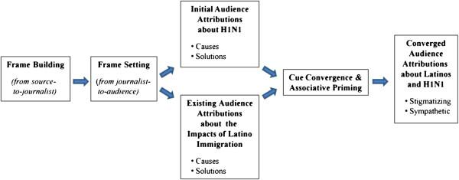

The diagram describes the process of distributing the news to the society starting from imposing the frame building including the allegations of the matters and the extensiveness of the news. Setting the framework to visualising the importance of the journalist and setting the targeted audience which leads to initialise the audience of attributions to H1N1, focus on the causes and the solution, and the audience perspectives towards the impacts of the Latino Immigration as the cause as well as its solution. As both of the issues are convergences, the audience’s contribution becomes stigmatising and sympathetic towards the negative side.

Free rider problem

The lack of social responsibility can include a problem that occurs in most of society. The free-rider problem is the conception that individuals receive the benefit from other parties without contributing to the burden which can lead to the decreasing incentive thus resulting in a worse-off situation in the market. In the United State during the pandemic, the vaccination is voluntarily not yet regulated hence when the community has the confidence that others have been vaccinated then they feel no obligation to have the vaccine and the free-rider problem occurs.
On one hand, the statistics showed that vaccination is still an essential tool to prevent the spread of the virus. During the previous, people change the behaviour towards the vaccination that is better off, the pandemic will be small compared to the non-vaccination pandemic. In the case of the H1N1, the period between the previous one and after has changed the course of human behaviour in the aspect that more people become free riders and do not get the vaccination since they do believe that another has already been vaccinated.

The bar chart below illustrates the maximum prevalence and the duration of the vaccine protection counted in years. The chart showed the increasing vaccine protection only

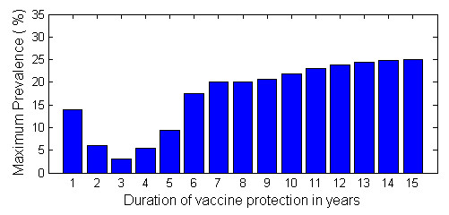
From year 3 until year 6 then the chart became consistent with the maximum percentage of the maximum prevalence which is around 25% with a margin error of 2.

To further analyse the relation of the subject, start by evaluating the vaccination and the conflict of interest. The first H1N1 influenza vaccine or swine flu vaccine was started to develop on April 21, 2009, by the Centers for Disease Control and Prevention in the United State’s laboratory. April 26th, 2009, the CDC began to release 25 percent of antivirus medicines to treat the infected people in the early period of the swine flu pandemic. The first antivirus swine flu seems to be the protection more since the CDC distributed the medicine for clinicians. The 1000 antivirus medicines have been shipped domestic 120 and shipped to 250 laboratories in 140 countries. On September 15th, 2009, the Food and Drug Administration declared its approval of four 2009 H1N1 influenza vaccines. On September 30th, 2009, the Us placed its first orders of vaccine and got the first dose on October 5th. After the fifth test by the FDA of the vaccine and the approval, it is available for anyone in late December. The vaccine turned out to work pretty well at the beginning of 2010, then WHO announced the end of the H1N1 influenza pandemic in 2010, on 11th August.

The vaccine appeared to be effective and safe giving protection and an increase in the immune system. However, older people tend to already be immune due to the previous virus before H1N1 in their older generation. This vaccine was giving more benefit to the younger age which is about 70 percent of the population. The vaccine that has been transported to many countries seems to show an effectiveness result of 95% with a confidence interval of 76%-100%. Because the process of making and developing the vaccine took several months and was produced with limited doses. There are not enough vaccines for all people in the world.
The effectiveness of the H1N1 vaccine Some people have taken other medications before the vaccine with its pre-existing medical condition. The intervention of interest is the inactive vaccine. The data did not include the Live attenuated influenza vaccine which has the pandemic strain. Some reports were using different data and LAIV which some are good to measure the reverse transcriptase PCR.

Free rider problem in swine flu and long term flu
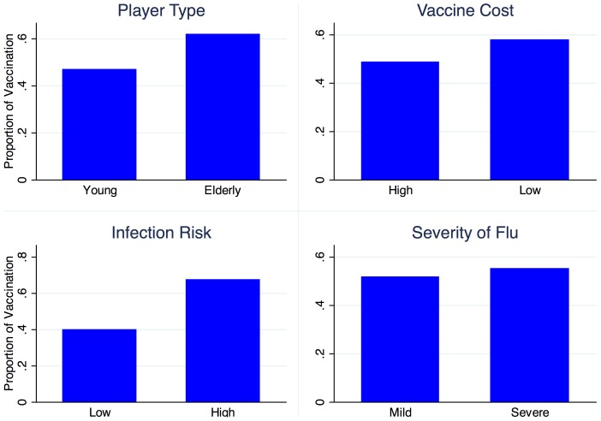
Since there are so many people infected with the H1N1 influenza pandemic virus especially at young ages. People’s decision-making differs from other decisions of vaccination. The bar chart above illustrates the effect of those decisions which have the incentive to be free riders for their benefits. The vaccines in the study are the regular vaccine for common type influenza that can be found. The study was conducted by segmenting the patients into two different groups which are young and elder. Surprisingly, They found that the numbers of vaccinated are slightly different in the size or the severity of flu.

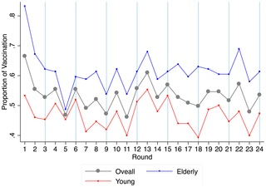
The proportion of vaccine in 24 rounds by each player types
The fluctuations suggest that The elders bought 8 times more than another group in the study due to the higher purchasing powers and their elasticity to the vaccination price. The probability of vaccination is likely to decrease compared to the previous proportion of the vaccinated. Showing the free-rider of making decisions by using other decisions to change their behaviour. In other meaning, both young and elder players respond similarly to a change in the proportion of other vaccinations.
These decisions reflect the effect of clear vision and examination. During the H1N1 influenza pandemic, after the vaccine had launched, some people were vaccinated for treatment or recovery from the virus and to protect themselves. However, some tend to change their decisions due to the vaccinations by other people leading to the free-riding behavior that people would take the vaccine counting on others regardless of the cost of the vaccine treatment and the numbers of the available vaccine.
The limitation of vaccines can be seen as an impediment to free-riding activity. Since the early available vaccination had been ordered by individual countries where financial support is the crucial role. The free-riding activity could play out when one country started to order the vaccine first then the other countries could change or decide on their proportion of vaccine dose. For the smaller scope, domestically, some people were able to effort the vaccine but some not. This could lead to unconscious regard for free riding for some who aren’t able to vaccinate.
h1n1 influenza can be contacted by person to person. With an infection of human contact, free riding can lead to the continuation of the pandemic or even worse of the next wave of the pandemic. However, luckily, the vaccine has been developed which yields the better in the protection of multi-virus including the passed virus that has been found to enhance the immune system for vaccinated people.
The coin always has two sides, we can not ignore the fact that stigmatisation is disadvantageous for society but under different circumstances, it prevails the advantages in which it benefits society in some respects. Besides, Media is playing a crucial role in distributing the information regarding the H1N1 but we have to understand its nature since the information must make the headline but it misses the point that some information may be perceived by a person that unable to find the additional information to support the claim hence the misinformation become widespread. Furthermore, vaccination from the government is not compulsory which makes the incentive to get the vaccine lessened due to the free-rider problem therefore society is worse off.

According to the research, we do believe that During the third wave without the vaccine and the large numbers of hospitalised people. People started to have the free-rider behaviour of each other in deciding on hospitalisation. Moreover, when the vaccine came out after the third wave, people were free-riding on each other in the vaccination. One reason is because of the limitation of the number of available vaccines. Another reason is the effectiveness of the vaccine that comes in the dose. Individuals in different age intervals would require different doses for vaccines. Youngers might need more doses due to the increase in their immune systems and the higher risk of the infection than the elders. The government tried to put policies and make the available vaccines in the countries more. Even though the force was made during or after the start of the first launched vaccine in the country, the outcome of the H1N1 pandemic tends to turn out good as seen by the result of the pandemic events that government and its people can help control the situation together. Therefore, the free-riding tends to decrease due to the corporate of everyone domestically or together with the whole world.

Additional factors that influence the cause of the free-riding problem are according to the social norm since the like-minded people will most likely decide according to their society. Social norm originated from the information that distributed to the members of the society in which focus on what they intended to be

The problem of the free-rider can be minimised by the government imposing the regulation that will limit their freedom to choose such as making the vaccination compulsory to the society and subsidise the cost of the vaccination to eradicate the free-rider problem.

The government can use particular policies in the pandemic to resolve the free-riding problem. They can subsidise the health care for those who were unable to effort the vaccine and who are unintended to become free riders thus the subsidisation assists the free-rider. The government aims to encourage the intended free-rider regards the severity of the virus as well as the importance of the vaccination.

Conclusion

Swine flu yields large consequences to humankind, it has an economic impact and public health, all of the regulation is indeed trying to solve the tangible aspects of the impact but the ignorance of the regulation in mental ramification will result in the divided nation. The lack of social responsibilities consists of many views; not wearing a mask and another. Our group does see the opportunity to explore the influences of the media that facilitate society’s perspectives. The media frame is one of the justifications of stigmatisation but if the society was well aware regards the current situation and informed with accurate information, the society will better off rather than fall into the situation that segregated as it is now. The path that society has chosen will dictate the outcome. Enhancing morality will allow more space for improvement within society only if the paths are suitable for each society. A free rider is considered to be a negative effect on society since the free-riders focuses on self-interest rather than society’s benefit.

Index and Preference

- 1918 Pandemic (H1N1 virus). (2019, March 20). Retrieved November 24, 2020, from https://www.cdc.gov/flu/pandemic-resources/1918-pandemic-h1n1.html

- The first, second and third wave of pandemic influenza A (H1N1)pdm09 in North Denmark Region 2009-2011: a population-based study of hospitalizations

- Low, D., & McGeer, A. (2010, November 23). Pandemic (H1N1) 2009: Assessing the response. Retrieved November 25, 2020, from https://www.ncbi.nlm.nih.gov/pmc/articles/PMC2988536/

- Vardavas, R., Breban, R., & Blower, S. (2010, April 5). A universal long-term flu vaccine may not prevent severe epidemics. Retrieved November 24, 2020, from https://www.ncbi.nlm.nih.gov/pmc/articles/PMC3003272/

- G. Pappas, I., P. Wagner-Egger, A., R. Barrett, P., M. Schoch-Spana, N., D. DeBruin, J., P. Blumenshine, A., . . . KA. Taylor-Clark, K. (1970, January 01). The H1N1 pandemic: Media frames, stigmatization, and coping. Retrieved November 25, 2020, from https://bmcpublichealth.biomedcentral.com/articles/10.1186/1471-2458-13-1116

- Earnshaw, V., & Quinn, D. (2013, June 1). Influenza Stigma during the 2009 H1N1 Pandemic. Retrieved November 25, 2020, from https://www.ncbi.nlm.nih.gov/pmc/articles/PMC3827981/?tool=pmcentrez

- (PDF) Infectious diseases and social stigma. (n.d.). Retrieved December 20, 2020, from https://www.researchgate.net/publication/236212491_Infectious_diseases_and_social_stigma

- Buttenheim, A., &amp; Asch, D. (2013, December). Making vaccine refusal less of a free ride. Retrieved December 21, 2020, from https://www.ncbi.nlm.nih.gov/pmc/articles/PMC4162060/

- The vaccine against 2009 H1N1 Influenza Virus. (n.d.). Retrieved December 21, 2020, from https://www.cdc.gov/h1n1flu/vaccination/public/vaccination_qa_pub.htm

- G. Pappas, I., P. Wagner-Egger, A., R. Barrett, P., M. Schoch-Spana, N., D. DeBruin, J., P. Blumenshine, A., . . . KA. Taylor-Clark, K. (1970, January 01). The H1N1 pandemic: Media frames, stigmatization, and coping. Retrieved December 21, 2020, from https://bmcpublichealth.biomedcentral.com/articles/10.1186/1471-2458-13-1116

- Take Action to Prevent the Spread of Flu Between Pigs and People. (2019, July 24). Retrieved December 21, 2020, from https://www.cdc.gov/flu/swineflu/prevention.html

- Ibuka Y;Li M;Vietri J;Chapman GB;Galvani AP;. (n.d.). Free-riding behavior in vaccination decisions: An experimental study. Retrieved December 21, 2020, from https://pubmed.ncbi.nlm.nih.gov/24475246/

- 2009 H1N1 Pandemic Timeline. (2019, May 08). Retrieved December 21, 2020, from https://www.cdc.gov/flu/pandemic-resources/2009-pandemic-timeline.html

- 2009 swine flu pandemic vaccine. (2020, December 09). Retrieved December 21, 2020, from https://en.m.wikipedia.org/wiki/2009_swine_flu_pandemic_vaccine

- Lansbury, L., Smith, S., Beyer, W., Karamehic, E., Pasic-Juhas, E., Sikira, H., . . . Nguyen-Van-Tam, J. (2017, March 14). Effectiveness of 2009 pandemic influenza A(H1N1) vaccines: A systematic review and meta-analysis. Retrieved December 21, 2020, from https://www.sciencedirect.com/science/article/pii/S0264410X17302724

- Social Stigma Attached to "Swine Flu"-An FAQ for U.S. Elected Leaders and Health Officials. (n.d.). Retrieved December 21, 2020, from https://www.centerforhealthsecurity.org/our-work/publications/social-stigma-attached-to-swine-flu-faq

