The Phillips curve may be broken for good
It has long been assumed that economic policymakers face a trade-off between unemployment and inflation. Since the mid-1980s, though, the relationship (known as the Phillips curve) has weakened. Some say it has now broken down. One theory ascribes this to foreign competition. Another posits that central banks have got better at fighting inflation. Yet many bankers still remain loyal to the theory.

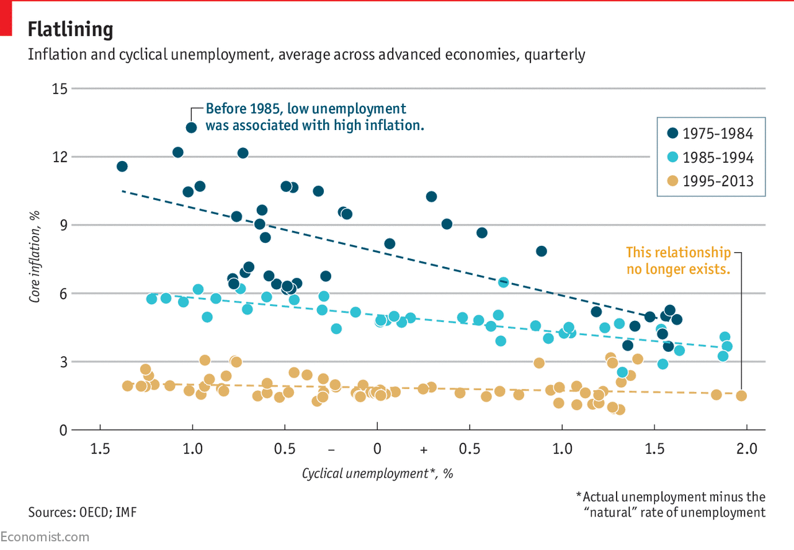

IT HAS long been assumed that economic policymakers face a trade-off between unemployment and inflation. Let unemployment fall below its “natural” rate (the level of joblessness that results merely from the normal patterns of job gains and losses at any one time) and the economy could overheat, causing inflation to spiral out of control. The Federal Reserve chair, Janet Yellen, alluded to this relationship in a speech in September when she warned that, left unchecked, America's healthy job growth could create an “inflationary problem down the road”.
But a growing number of economists now say that the trade-off, known as the Phillips curve after an economist who described it in a 1958 paper, no longer holds. Until the mid-1980s, unemployment and wage inflation in America and other advanced economies did indeed appear to be inversely correlated. Since then, however, the relationship has weakened (see chart). America’s recovery from the Great Recession has proved particularly puzzling. Since 2010, as the unemployment rate has fallen steadily from 10% to 4.4%, inflation has hovered between 1% and 2%. This has prompted observers like Larry Summers of Harvard University to argue that the Phillips curve has “broken down”.
So what happened? One theory holds that increased foreign competition has made it difficult for firms to raise prices or for workers to demand higher wages in response to changes in domestic demand. Another posits that central banks have become more credible at fighting inflation, in turn helping to anchor inflation expectations and making prices less sensitive to the business cycle. Whatever the reason, a new consensus has emerged that the Phillips curve is not a particularly useful tool for forecasting inflation. A recent paper by researchers at the Federal Reserve Bank of Philadelphia finds that inflation models that include unemployment data perform no better than those that do not.

For all its empirical flaws, many central bankers remain loyal to Phillips’s teachings. According to minutes from the meeting of the Fed’s rate-setters in July, “most participants” are unwilling to let the theory go just yet. As one of them, William Dudley of the New York Fed, recently told Bloomberg News, he is “not ready to throw the Phillips curve out the window”.

