Create forms and reports according to the pictures.
Use Rabbit.accdb and rename it to your student id.

- Form for recording top-up transactions to a card
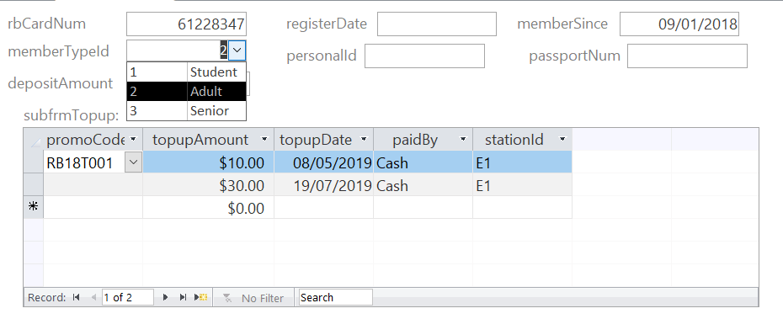
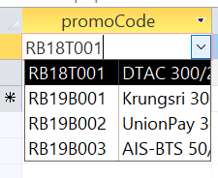
- Form for recording promotion
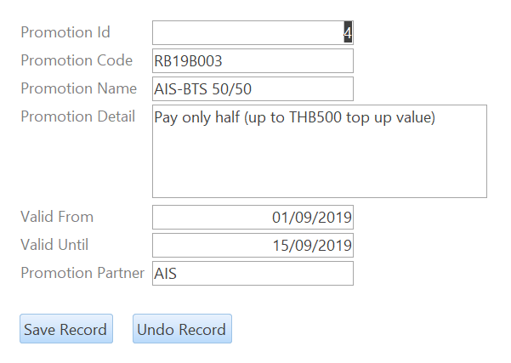

- Report: Rabbit cards by member types
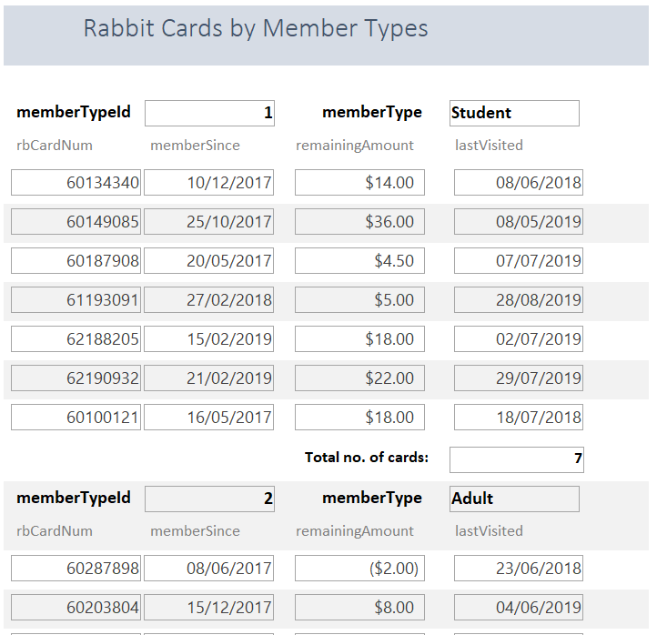

- Report: Top-up transactions of each card
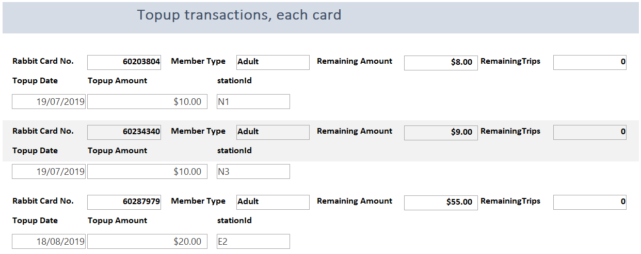

- Report: Top-up transactions by promotions


