FN 312 - Investment Challenge

Welcome to the Stock Market Challenge! Investing in stocks can be an emotional and financial roller coaster. Money is made through a series of transactions over a long period of time. There will be both wins and losses and you need the patience and intelligence to make good decisions over the long haul. Fortunately, we have about three months or so until the end of this class, so let’s see which team can make the most money before the end of the semester!

Basic Parameters of the Challenge:
- Each team will have $100,000 deposited into their Virtual Stock Exchange (VSE) account. All teams must have their accounts created by Sunday, August 28, 2016. Visit http://www.marketwatch.com/game/fn312-challenge to sign up. The password to join is fn312invest
- Spending Deadlines:
  - You must invest at least $25,000 in the market by Friday, September 23rd, 2016.
  - You must invest at least $50,000 in the market by Friday October 21st, 2016.
  - You must invest at least 95% of your money by Friday, November 18th, 2016. This percentage must stay invested until the game ends on November 25th. No “sitting on your cash” until the game ends!
- Each team must purchase stock in at least ten different stocks/funds during the course of the challenge. You need to diversify a bit! Spread the money around.
- Students may execute as many “buys” and “sells” as they deem necessary. You are allowed to sell short … we’ll learn more about what that means later. Note that the commission for each trade is $10.
- Each team is responsible for preparing an Investment Challenge progress presentation each week starting the week of Sep 7th and ending Nov 11th (10 weeks). Every team member should take turns presenting to receive credit. Each presentation should only be about 2-3 mins long and should give the class a quick and to-the-point rundown on investment strategies and the team’s portfolio performance. For example, it could include a recap of what you bought and sold and what your rationale was, or discuss events taking place in the market that may affect upcoming trades. I would also like to hear your thoughts on how you’re integrating new things into your strategy as we cover them in class. Presentations will account for 50% of your investment challenge grade.
- On the day of the final exam, you are expected to submit INDIVIDUAL write-ups that summarize your team’s investment strategy and portfolio performance, as well as a section that outlines your contribution and a discussion of what you would have done differently from the team strategy. The write-up limit is 3 pages, single space, not including any graphs or figures that you might want to include. This report accounts for 50% of your investment challenge grade.

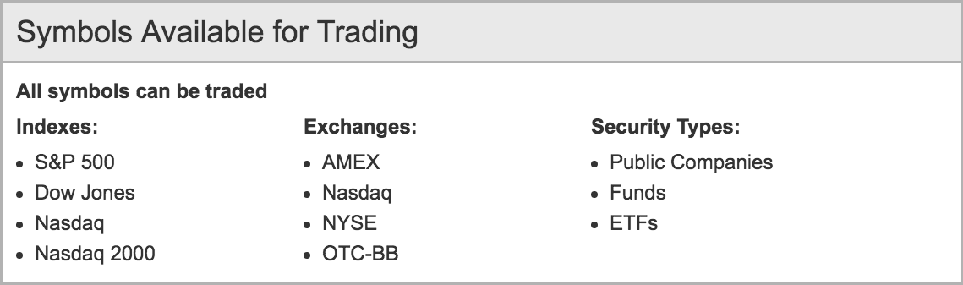
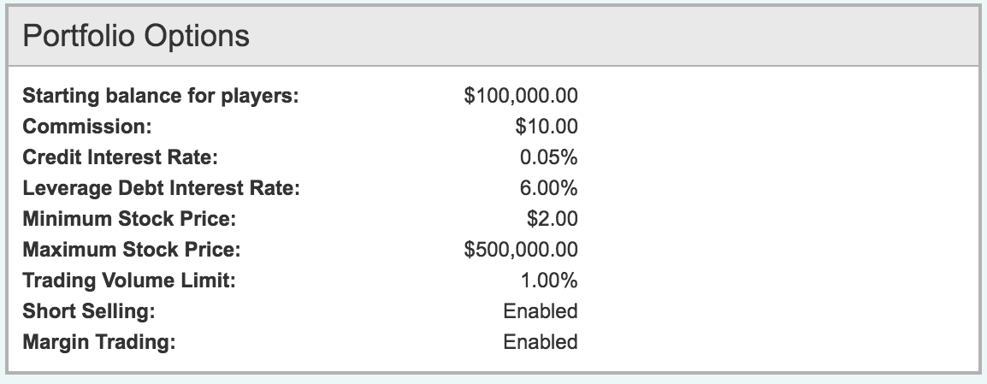

Site navigation:
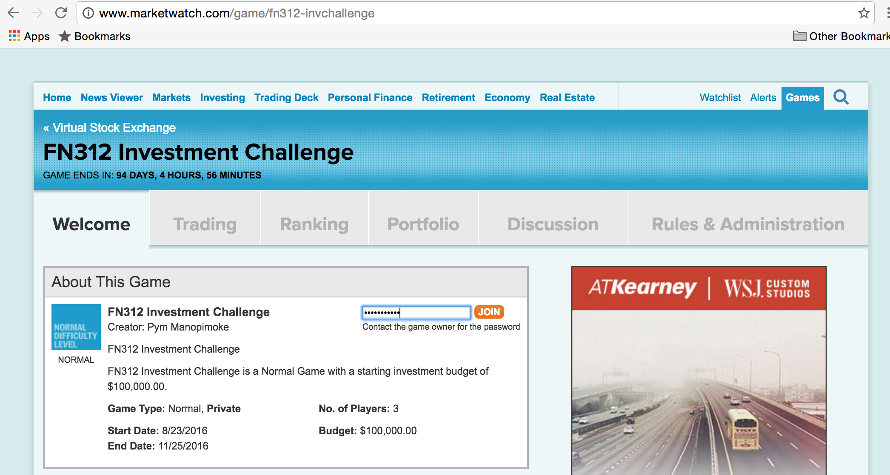
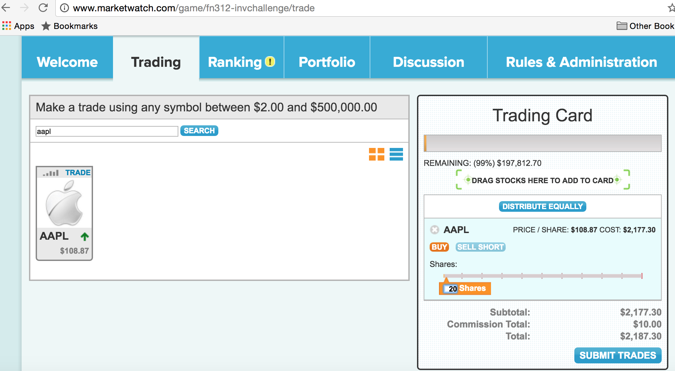
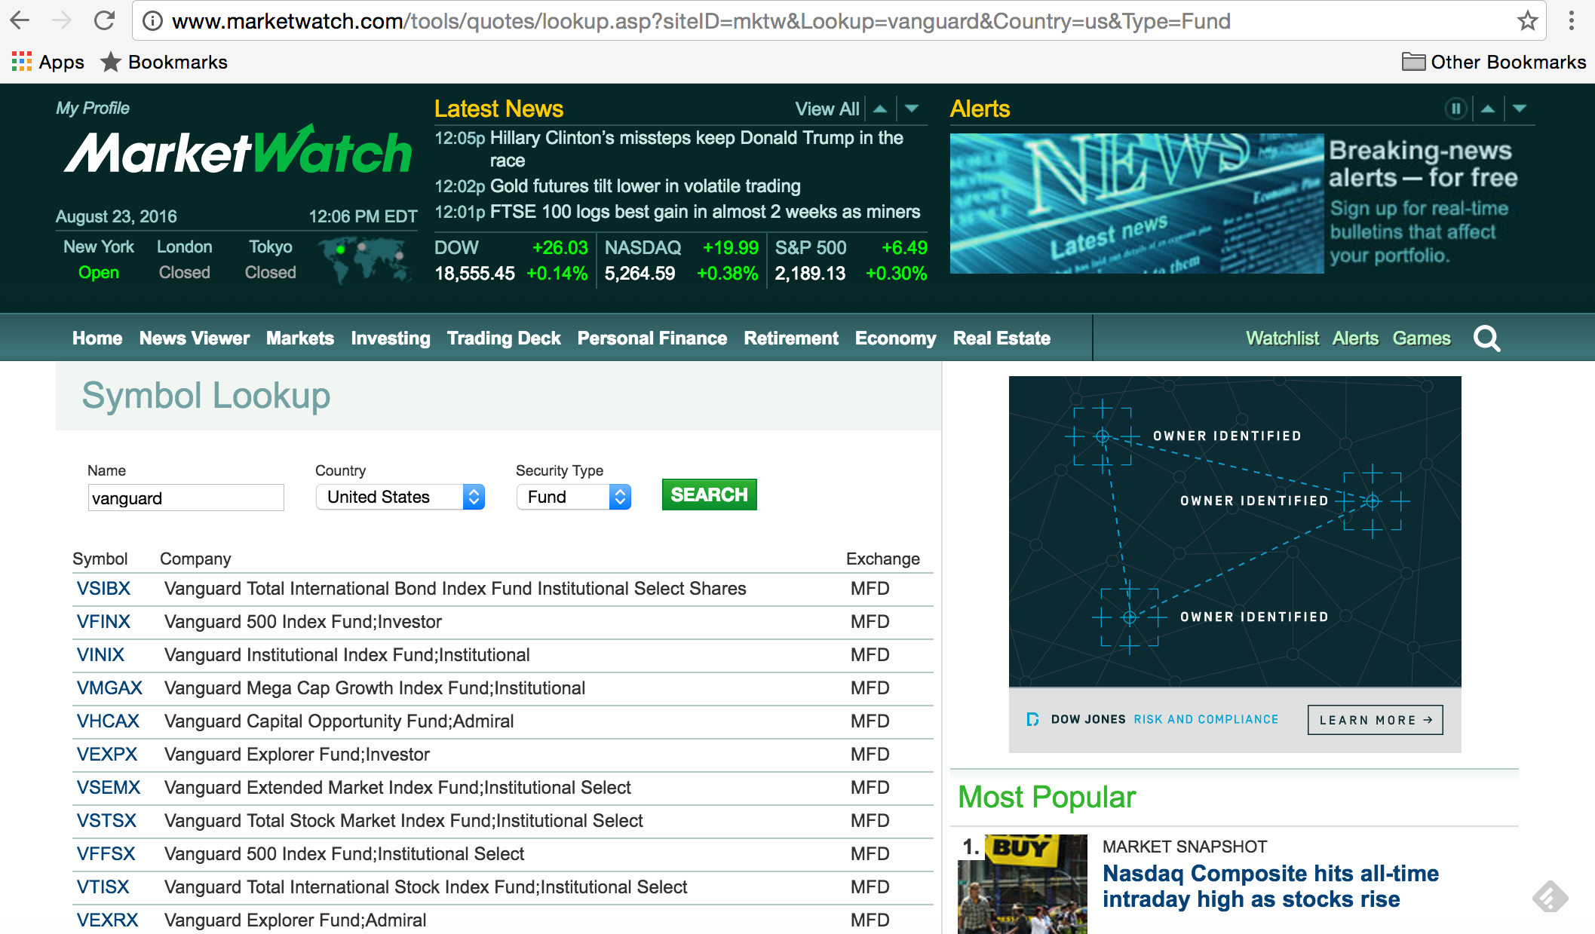

Some resources:
http://www.morningstar.com
http://seekingalpha.com/
https://finance.yahoo.com/

