Investment banking

Bonfire of the bankers

Profits down, jobs cut, strategy needed
Feb 4th 2012 | from the print edition

“IT SUCKED,” says the head of investment banking at one of Europe’s biggest banks, reviewing the fourth quarter of 2011. That succinct assessment will take few by surprise. The sale and trading of bonds and shares slowed to a trickle last year. Analysts at Credit Suisse reckon that investment-banking revenues among the big American banks slumped by a quarter in 2011. Trading bonds, currencies and commodities (activities known as FICC) is the industry’s bread and butter: FICC revenues fell by about 15% in America. Things are even worse in Europe. Credit Suisse reckons that European investment banks will post a 43% drop in revenue for 2011. On February 2nd Deutsche Bank announced a fourth-quarter loss for its investment bank.
The first few weeks of this year also look dire. Markets have recovered relative to December, but there has not been the usual January leap. Analysts at Citigroup gloomily predict a further 10% fall in FICC revenues in Europe this year.
The question dogging the industry is whether these falls are temporary or permanent. “Trading goes up, trading goes down,” Jamie Dimon, the boss of JPMorgan Chase, told journalists in January. “When things come back these numbers will boom again and we’ll be geniuses, and it won’t be because we did anything, it will be because we stayed in the game.”
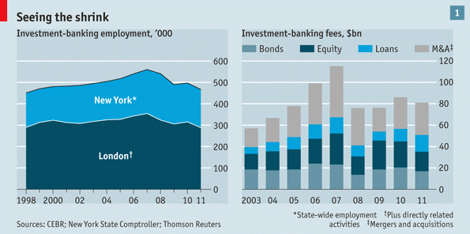
If surviving the downturn is the goal, the logical response is to cut variable costs (see chart 1). The banks have been slashing headcounts with vigour. CEBR, an economics consultancy, forecast in October that 27,000 jobs would be lost in London’s financial district in 2011, taking the number of financial employees in the City down to a level last seen in 1998. Not only the City is suffering. Financial News, a specialist newspaper, reckons that 16 of the biggest investment banks have cut 26,600 jobs globally over the past six months. That represents 8% of their total headcount.
From diets to gastric bands
Times are also grim for those bankers who have kept their jobs. In the past investment banks fired some people but still paid big bonuses to those that remained. Now costs are being cut more deeply and banks are less concerned about being outbid in pay. “Compensation is going to get crushed,” says the head of one large investment bank. “Investors are concerned about returns…[Their] bigger concern is about the split between shareholders and employees.” CEBR reckons that the bonus pool in London’s financial district will slump by some 38% this year, leaving it at about a third of the level it was before the financial crisis. On Wall Street banks including Citigroup, Morgan Stanley and Goldman Sachs are said to be cutting pay by anything from 30% to 70%.
Slimming cures are not enough for many banks, however. Some are changing their business models. Under pressure from regulators, banks everywhere are crowding into client-focused businesses which do not eat up as much capital. Britain and Switzerland in particular are pressing their banks to hold lots more capital; past disasters have also persuaded management to cut their losses. UBS, Switzerland’s biggest bank, is cutting risk-weighted assets at its investment bank by almost half over the next five years and is pulling out of several business lines. Royal Bank of Scotland (RBS), which once had ambitions to be a leading global investment bank, is now shedding assets: on February 1st RBS announced that it was selling its Hoare Govett corporate-broking unit to Jefferies, an American investment bank.
All this will lead to consolidation in two ways. The first is that as some banks pull back, they create an opportunity for rivals to gain market share. The second is that as banks crowd into capital-light “flow businesses”—trading bonds, currencies or shares—they are likely to drive down margins. That will please banks’ customers but will also lead to a concentration of market share among the biggest firms.
This process is not new. Two decades ago an investment bank could buy a telephone and earn decent margins by quoting bond or currency prices to ignorant customers. These days corporate customers trade electronically and have terminals providing a stream of prices. Although “flow businesses” do not require much regulatory capital, they do need massive investments in computer systems.
Firms with the best systems tend to attract the most liquidity and in turn are able to offer the most competitive rates. That suggests that only a few “flow monsters” can achieve sufficient volumes of trade to cover the costs of their infrastructure. In areas such as currencies, which are almost entirely traded electronically, this consolidation has already largely taken place: JPMorgan, Goldman Sachs and Deutsche Bank already have big market shares. The next frontier will be the move of bonds onto similar platforms: the same handful of banks is likely to benefit again.
Niche work if you can get it
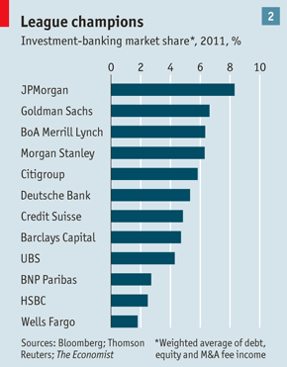
With money tight and capital a scarce resource, investment banks must also choose whether to specialise in areas where they are strongest. The very top tier of global investment banks will still hope to generate synergies across diverse businesses—lending a firm money, say, and then helping it to sell shares and to hedge currency movements on the capital it is raising. This elite bunch will probably include Barclays Capital, Deutsche Bank, Citigroup, JPMorgan and Goldman Sachs (see chart 2). Most banks, however, will slim down. “We’re seeing an additional specialisation in investment banking,” says the head of a bank. “Firms are fundamentally either debt or equity [specialists] …They have debt or equity in their DNA.”
A second area of specialisation will be geographic. All but a handful of the very biggest banks will probably be forced to give up their ambitions of being global and concentrate instead on the regions where they are strongest. The retreat is partly driven by capital and cost pressures at home, partly by the realisation that there is less room than expected for outsiders in many of the fastest-growing emerging markets.
A home bias in investment banking is not new, nor is it confined to emerging markets. Of the top five corporate feepayers in the industry last year, four gave most of their investment-banking work to firms from their country or region, according to Thomson Reuters. But the trend is likely to be reinforced as foreign banks become less willing to make cheap loans to prise open new markets and win investment-banking mandates.
As dire as the outlook is, it would be foolish to underestimate the resourcefulness of the industry. The investment banks are staffed by clever, entrepreneurial people with a knack for inventing new financial products and selling them to the world. Instead of going through a grinding decade of job cuts and restructuring, investment bankers could come up with another big, money-spinning innovation.
But even if markets simply bounce back as Mr Dimon expects, the investment-banking industry will look quite different in a few years’ time. There will be fewer big firms straddling the globe; the rest will try to dominate their own niches. And if revenues do stay flat, shareholders may still benefit as employees make do with less of the pot. For bankers that really will suck.
from the print edition | Finance and economics

