

Course Syllabus
EE 376 Economics of Climate Change
Semester 1/2020

Number of credits: 3 credits
Prerequisites: EE 210 or EE 211 or EE 213
(Credits will not be awarded to students who are taking or have completed any 400-level courses in this subfield.)
Hours: Wednesday and Friday, 14.00-15.30
Classroom: Room# Faculty of Economics,
Thammasat University Tha Prachan Campus
Instructor: Assoc. Prof. Chayun Tantivasadakarn
Email [chayunt@econ.tu.ac.th]
Office: Room# 8 the 60th Anniversary Building
Office hour: Wednesday and Friday 13:00 – 14:00

Moodle enrolment key:

Course Description:
Basic concepts of climate change relating to environmental economics, efficiency, externalities, and policy instruments. The role of economics in the formation of climate policy. Economic problems of climate change, such as intertemporal decisions, impacts of climate change, cost of mitigation, and adaptation. Thailand and international cooperation and debate in climate policy.

Lecture Schedule
Date | Topics
1-2 | 1. Introduction to Climate Change Science  - The Earth’s climate system  - Greenhouse gas (GHGs), global energy balance, and the greenhouse effect  - Important GHGs: CO₂ and carbon cycles, other GHGs  - Dissenting opinions: the great hoax?  Reading: H Ch. 1-4, T Ch. 1, Nordhaus Ch.5, 13-14, 24-25, Incropera Ch. 2-6, 9.
Aug 14-19, 2020
3-4 | 2. Anthropogenic global warming and consequences  - GHGs concentration and global temperature  - Impacts, damages and losses of CC  - GHGs data and information  - GHGs emission by countries  - Share of mitigation responsibility for climate stability  Reading: H Ch. 6-7, Incropera Ch. 5, T Ch. 2, IPCC (2013a), Stern Ch. 3-6
Aug 21-26, 2020
5-6 | 3. Climate Change and Market Failure  - Externalities and carbon pricing  - Global commons and Tragedy of Commons  - The under provisioning of Public Goods  Reading: HR Ch. 3-4, T Ch. 3
Aug 28, 2020 - Sep 2, 2020
7- 9 | 4. Carbon Taxes  - Optimum emission  - Correction market failure with carbon  - Single source  - Multiple sources  - Pros and cons of carbon taxes  - Carbon tax research  Reading: HR Ch. 16, T Ch. 4, Pearce, David (1991) pp. 938-948.
Sep 4-11, 2020
10 - 12 | 5. Carbon Market or Cap-and-Trade  - Definition and concept of Carbon market  - Demand and supply of carbon credits  - Deriving the demand and supply for carbon credits  - Factors influencing the demand and supply  - Carbon market equilibrium  - Choices of carbon credits allocation and efficiency  - Comparison of carbon market and carbon tax  - Carbon market research  Reading: HR Ch. 16, T Ch. 5
Sep 16-23, 2020
13-14 | 6. Technological Development Policy and mitigation  - Why do mitigation technology grow so slow?  - Technology-push vs. Demand-pull debate  - Policy for inducing technological change  - Costs of low carbon technology and mitigations  Reading: Grubb, M. (2004), Goulder and Schneider (1999), T Ch. 5
Sep 25, 2020
Oct 7, 2020
15-16 | 7. Global Institutions: Kyoto Protocol and Post-Kyoto  - The Intergovernmental Panel on Climate Change (IPCC)  - The United Nations Framework Convention on Climate Change (UNFCCC)  - Kyoto Protocol  - ‘Annex-I’ vs. ‘Non-Annex-I’ countries  - Emissions Trading Scheme (ETS), Joint Implementation (JI), and Clean Development Mechanism (CDM)  Cooperation failure?  - Paris Agreement  Reading: Incropera Ch. 8, T Ch. 5
Oct 9-14, 2020
17-20 | 9. International Trade and Climate Change  - Mitigation & competitiveness  - Carbon offshoring and Carbon leakages  - Concepts about GHGs responsibility  - Production-based and consumption-based responsibility  - Carbon leakages and Border-Carbon Adjustment (BCAs)  - Pros and cons of BCAs  - World Trade Organization (WTO) and Climate Change  Reading: Incropera Ch. 8, T Ch. 8-9
Oct 16-28, 2020
20-22 | 7. Economic Concepts (III): Social Costs of Climate Change  - Cost-Benefit Analysis (CBA) concept  - Social discount rates  - Economic assessment of the damages caused by global warming  - The Stern’s Review  - The Nordhaus DICE model  - Stern vs. Nordhaus debates  Reading: FF Ch.6, Stern Ch.6, 9, 12, Nordhaus Ch.15-16, 18
Oct 30, 2020 – Nov 6, 2020
22-23 | 8. Economics of Climate Change Adaptation  - Climate risks  - Climate change adaptation  - Economics of technology & adaptation  Reading: Stern Ch.5, 18-20, OECD (2015)
Nov 11-13, 2020
24 -25 | 10. Climate Change and Economic Sectors  - Fossil fuel vs. renewable energy  - Carbon sink  - Carbon offsets  - REDD+  - Demand management
Nov 18-20, 2020
26-27 | 14. Group project presentation
Nov 25-27, 2020 | 14. Group project presentation
Field trip: (tentatively)

Evaluation
Midterm Examination 35%
Final Examination 35%
Group project or reports 15%
Assignment and participation 15%

Group project (15 points):
- Design and print an A0-sized academic poster linking climate change issue with a selected topic from the following list. A poster may have a free-style title, but must be informative and comprehensive in its content, and contain some constructive arguments in the analytical part.
Topic lists:
Electrical vehicle | Agriculture | Public Transportation | Biotechnology
Solar energy | Fishery | Financial sector | Gender
Hydropower | Livestock | Biodiversity | Poverty
Bio fuel | Energy-intensive industry | Coastal adaptation | Youth
Nuclear power | Real estate | Draught management | Disaster
Wind energy | Aviation | Waste management | Arts and Culture
Risk management | Tourism related services | Disaster management | IT and AI

Evaluation will be based on the ability to arrange data and information with proper visualization and citation, presenting sharp arguments (concise and interesting leading questions and the existing conflicts of viewpoint relevant to the chosen topic) linking the topic with the economics of climate change mitigation and/or adaptation, attractive and reader-friendly poster design. The total mark will come from peer evaluation (7 marks) and instructor evaluation (8 marks)
Your oral presentation would take 15 minutes (without any note!) and 5 minutes of Q&A.
Submission date of selected topic: October 2, 2020
Presentation dates: November 2020 (to be announced)
Note: Please be strictly aware of ‘plagiarism rule’ which could bring a zero score for violators.

Reading lists
[T] Tantivasadakarn, Chayun (2019) Economics of Climate Change (in Thai), Thammasat University Press.
[FF] Field, B., & Field, M. (2017). Environmental economics: An introduction (Seventh ed.). New York, NY: McGraw-Hill Education.
Grubb, M. (2004). "Technology Innovation and Climate Change Policy: an overview of issues and options." Keio Economic Studies, 41(2): 103-132.
Goulder, L.H., and S.H. Schneider (1999) ‘Induced Technological Change and the Attractiveness of CO₂ Abatement Policies,’ Resource and Energy Economics, Vol. 21, pp. 211-53.

[HR] Harris, J. M., & Roach, B. (2017). Environmental and natural resource economics: A contemporary approach. Routledge.

[H] Houghton, John (2004) Global Warming: The Completer Briefing, 3rd edition, Cambridge University Press.
http://www.gci.org.uk/Documents/Global-Warming-the-Complete-Briefing.pdf
[Incropera] Incropera, F. P. (2016). Climate change: a wicked problem: complexity and uncertainty at the intersection of science, economics, politics, and human behavior. Cambridge University Press. (ห้องสมุดปรีดี)
IPCC (2013a) Summary for Policymakers. In: Climate Change 2013: The Physical Science Basis.Contribution of Working Group I to the Fifth Assessment Report of the Intergovernmental Panel on Climate Change [Stocker, T.F., D. Qin, G.-K. Plattner, M. Tignor, S.K. Allen, J. Boschung, A. Nauels, Y. Xia, V. Bex and P.M. Midgley (eds.)].
Milton, E.J., and Euston Quah (2021) Cost-Benefit Analysis, Routledge.
Nordhaus, W. D. (2007). A review of the Stern review on the economics of climate change. Journal of economic literature, 45(3), 686-702.
[Nordhaus] Nordhaus, W. D. (2013). The climate casino: Risk, uncertainty, and economics for a warming world. Yale University Press.
Pearce, David (1991), “The Role of Carbon Taxes in Adjusting to Global Warming,” The Economic Journal, Vol. 101, No. 407, (Jul., 1991), pp. 938-948.
[Stern] Stern, N., & Stern, N. H. (2007). The economics of climate change: the Stern review. Cambridge University press.
[TT] Tietenberg, T. H., & Lewis, L. (2016). Environmental and natural resource economics. Routledge.

Additional links:
Glossary terms: https://archive.ipcc.ch/pdf/special-reports/srex/SREX-Annex_Glossary.pdf
Gas Emissions by Countries and Sectors: https://www.wri.org/blog/2020/02/greenhouse-gas-emissions-by-country-sector
Global emission: https://www.c2es.org/content/international-emissions/
NASA: https://climate.nasa.gov/evidence/



ACADEMIC CALENDAR & HOLIDAY

Semester 1/2020

(August 10 – November 28, 2020)
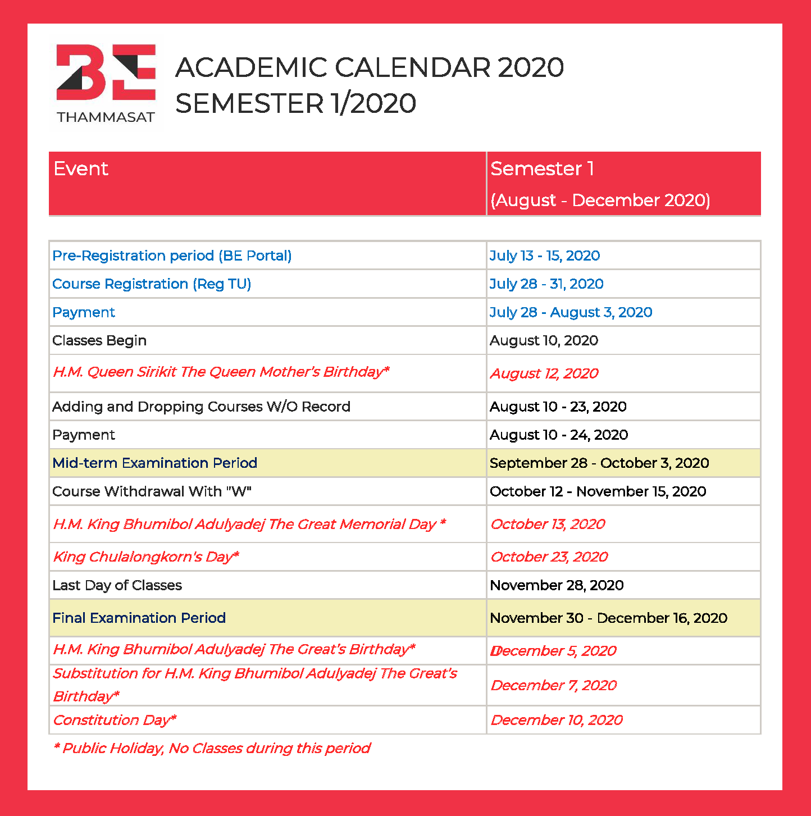
* Holiday, No classes during this period
CONTACT INFORMATION
BE International Program, Faculty of Economics, Thammasat University
Address: 2 Prachan Road, Pranakorn, Bangkok 10200 Thailand
Tel: +66 (0)2613 2437-8
Fax: +66 (0)2224 0150
Email: be@econ.tu.ac.th
Website: www.be.econ.tu.ac.th
BE-Moodle: http://bemoodle.econ.tu.ac.th/

