AC 201 Fundamental Accounting
Chapter 1 Financial Statements and Business Decisions

Financial Statements:

Order  Prepared | Financial Statement | Description of Statement
1. | Statement of comprehensive income (Income statement) | A summary of the revenue and expenses for a specific period of time, such as a month or a year.
2. | Statement of owner’s equity | A summary of the changes in the owner’s equity that have occurred during a specific period of time, such as a month or a year.
3. | Statement of financial position  (Balance sheet) | A list of the assets, liabilities, and owner’s equity as of a specific date, usually at the close of the last day of a month or a year.
4. | Statement of cash flows | A summary of the cash receipts and cash payments for a specific period of time, such as a month or a year.

Statement of Comprehensive Income (Income Statement)
The income statement reports the revenues and expenses for the period of time. The excess of the revenue over the expenses is called net income, net profit, or earnings. If the expenses exceed the revenue, the excess is a net loss. Net income for a period increases the owner’s equity (capital) for the period. A net loss decreases the owner’s equity (capital) for the period.

The order in which the expenses are listed in the income statement varies among businesses. Most businesses list expenses in order of size, beginning with the larger items. Miscellaneous expense is usually shown as the last item, regardless of the amount.

Statement of Owner’s Equity
The statement of owner’s equity reports the changes in the owner’s equity for a period of time. It is prepared after the income statement because the net income or net loss for the period must be reported in this statement. Similarly, it is prepared before the statement of financial position (balance sheet), since the amount of owner’s equity at the end of the period must be reported on the statement of financial position (balance sheet). Because of this, the statement of owner’s equity is often viewed as the connecting link between the income statement and the statement of financial position (balance sheet).

Statement of Financial Position (Balance Sheet)
The statement of financial position reports the amounts of assets, liabilities, and owner’s equity as of the end of accounting period. The owner’s equity or capital is taken from the statement of owner’s equity.

Statement of Cash Flows
The statement of cash flows consists of the following 3 sections:

Cash Flows from Operating Activities – This section reports a summary of cash receipts and cash payments from operations. The net cash flow from operating activities normally differs from the amount of net income for the period because revenues and expenses may not be recorded at the time that cash is received from customers or paid to creditors.

Cash Flows from Investing Activities – This section reports the cash transactions for the acquisition and sale of relatively permanent assets.

Cash Flows from Financing Activities – This section reports the cash transactions related to cash investments by the owner, borrowings, and withdrawals by the owner.

The four financial statements and their interrelationships are illustrated as follows.

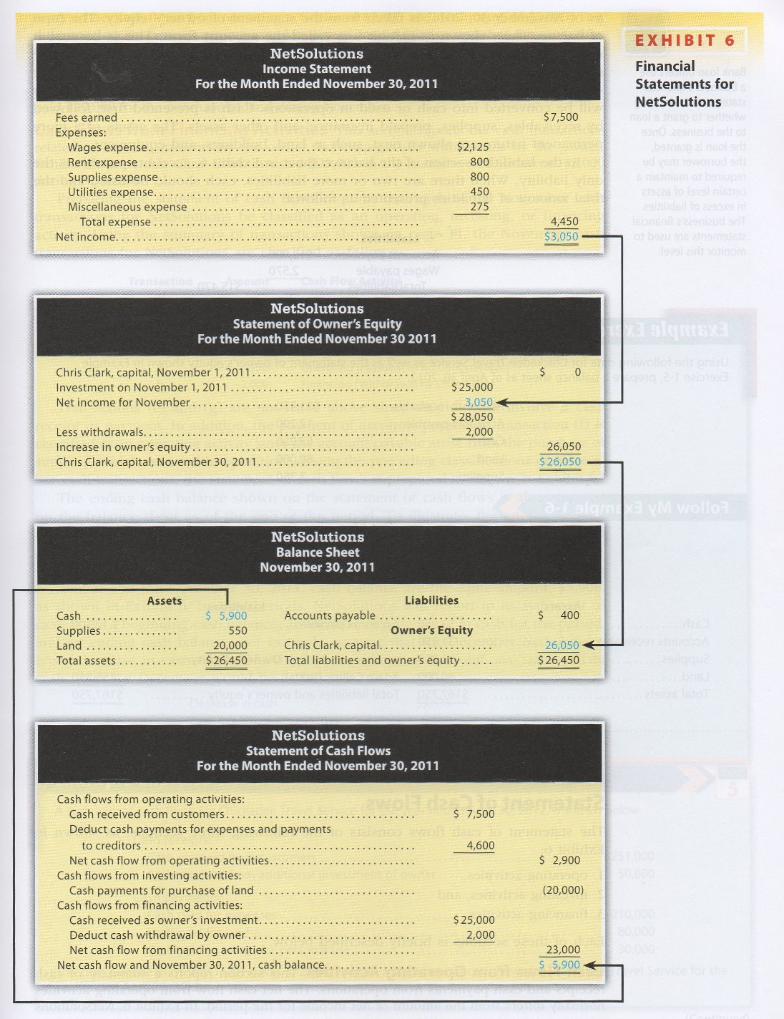
This form of the statement of financial position is called the “account form.”
This is because it resembles the basic format of the accounting equation, with assets on the left side and the liabilities and owner’s equity sections on the right side.
Withdrawals in a corporation are made
in the form of dividends.
Review Problem: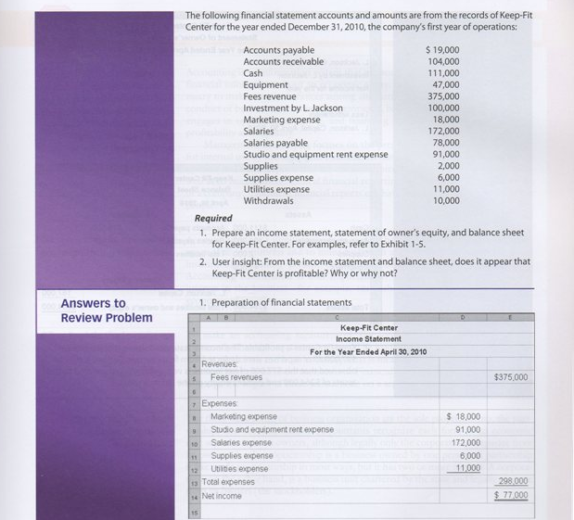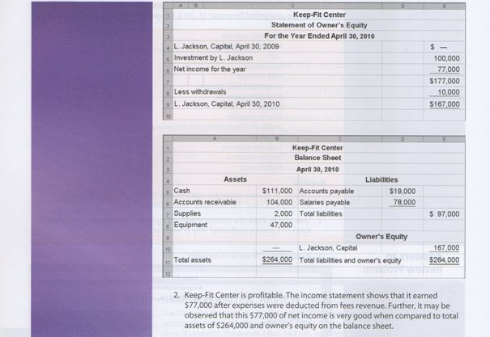
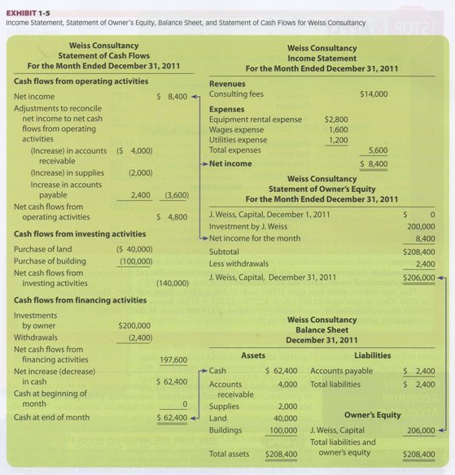

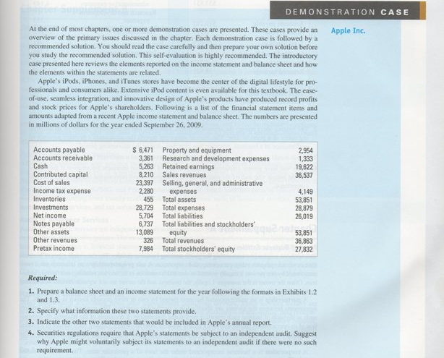
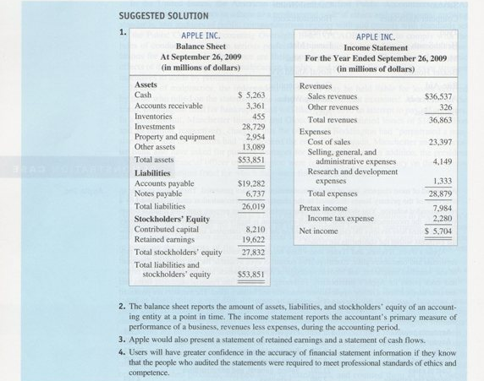
Review Problems:



