How to set up your marketwatch account for the investment challenge

1. Go to: http://www.marketwatch.com/game/invfn312
2. Click Join Game
3. Create an account (Click at the bottom where it says Not a member? Register here)
4. Follow the steps to create your profile. Only one profile is needed per group.
5. Once you are signed in, you will see the game homepage. Click Join Game and enter password: befn312
6. Follow the steps and start playing around on the website. We will discuss more about the parameters of the game and how to trade in class.

Parameters of the game

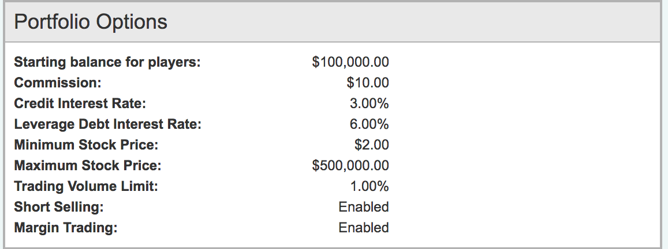

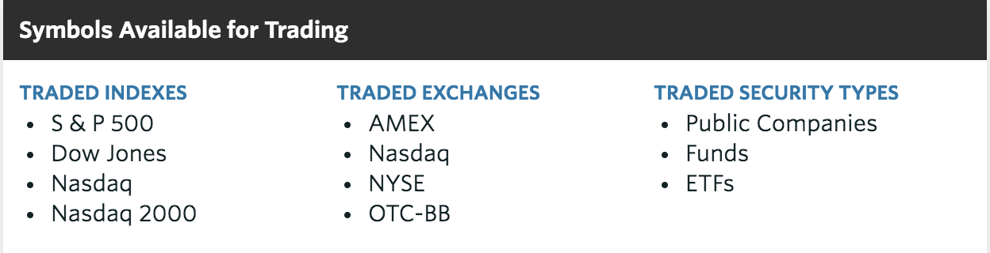
Some resources:
http://www.morningstar.com
http://seekingalpha.com/
https://finance.yahoo.com/

