Sarisa Sookchanuluk 1026
Exercise 1
Introduction to Macroeconomics
- What are the four macroeconomic agents? What are the three markets in which the agents interact?
The 4 macroeconomic agents:
Households, firms, the government, the rest of the world
the 3 markets:
Factor markets, goods and services market, financial market

- What is sticky price? Explain why price may be sticky.
Sticky price is when price move toward the equilibrium slowly due to minimum wage policy, labor union and employment contract.

- Explain the four main categories of unemployment.
- Frictional – is a normal turnover, ppl looking/switching jobs.
- Structural – is a result of changes e.g. technology, skills demand, location or labor market rigidities (like minimum wage policy, labor union, job security and employment contract).
- Cyclical – due to recession/fluctuations in business cycles.
- Seasonal – due to changing seasons e.g. hotel workers in low season.

- Classify the following events into the categories of unemployment.
- Some friends just graduated from college and have been looking for jobs. Frictional
- Christine lost her job as a biologist at a biotech-company when the whole industry went into recession. Cyclical
- Gerhard, who used to be a taxi driver, stopped looking for a job three months after he lost his job. Not Unemployed
- Dirk used to work as a wooden-doll maker. Now all kids want plastic dolls, so he is out of work. Structural
- The hotel part-timers were laid off during low season. Seasonal
- Aditi, a high-tech engineer, just decided to quit her job; she is being interviewed for a better-paid job in a multinational company. Frictional
- A man lost his job as a public reader as literacy has increased in his village. Structural

- Suppose there are 100 people in labor force and 60 people currently in employment. Find the unemployment rate. Can we find labor force participation rate? If not, what information do we need?
The unemployment rate is 40% or 0.4, we cannot find labor force participation rate because the number of populations are not given.

- What is the discouraged-worker effect? How can it affect the unemployment rate?
Occurs when people exit the labor force by giving up looking for jobs, those people will not be count as unemployed which can mislead us into thinking that the unemployment rate got better, more people must have got their jobs although it’s not true.

- On average, nations in Europe pay higher unemployment benefits for longer periods of time than the US. How would this affect the unemployment rates in these nations? Explain which type of unemployment is most directly affected.
From my point of view, the unemployment rates in European countries isn’t that high even though they are well benefited as an unemployed which could be said that the policy does not affect the unemployment rate. However, the unemployment rate can be affected depends on economic condition, Cyclical unemployment would mostly be affected if the economy is in a bad condition.

- What is inflation? It is often said that inflation reduces one’s purchasing power, and hence inflation is bad. How can inflation reduce one’s purchasing power? Is there a case where inflation may not be bad?
Inflation is an increase in the overall price level, meaning that money loses its purchasing power. For example, 5 baht is used to be enough to buy a bowl of noddle but now you need at least 40 baht for a bowl of noodle. However, if the goods become more expensive but people also get higher incomes, in this case, inflation is actually not that bad.

- Who – lender or borrower – is better off, given unanticipated deflation? Explain with examples.
The lender is better off because the purchasing power of the money become stronger when borrower give it back. For example, Mickey borrowed 5 million baht from Minny long time ago. when Mickey give Minny back the money, deflation happen. 5 million baht can buy 1 house in the past, but now 5 million baht can buy 1 house and a luxury car.

- When inflation is anticipated, what will the central bank do with the interest rate? (Hint: Fisher Equation)
When there is inflation, the central bank would increase the interest rate to encourage people into saving their money and reduce people confidence in spending it.

- The CPI is 120 in year 1 and 150 in year 2. All inflation is anticipated. If the bank charges an interest rate of 30%, what is the bank’s real interest rate?
The inflation rate is 25%. Using Fisher Equation (i=real+inflation rate):
30-25=5
Real interest rate is 5%

- Explain why inflation is necessary to a growing economy with reference to the money supply.
When the economy has unused labor or resources, inflation can helps increase the productivity. When people have more money supply, they spend more money which means more demand and, more demand means more production to meet the demand. This activity will emerge economic development, the inflation rate tends to get higher and higher.

- What are the two administrative costs of inflation? Explain.
- Menu cost- costs from changing price lists
- Shoes leather cost- the opportunity cost of holding cash outside banks is high when interest rate rise and high.

- Draw a diagram of business cycles and the trend line. Label the four phases of business cycles. Answer the following questions.
- Which phase do you expect to see inflation?
- Which phase do you expect to see high unemployment?
- Which phase should the government use expansionary policy? Give example.
- Which phase should the government use contractionary policy? Give example.
- What factors determine the trend line? 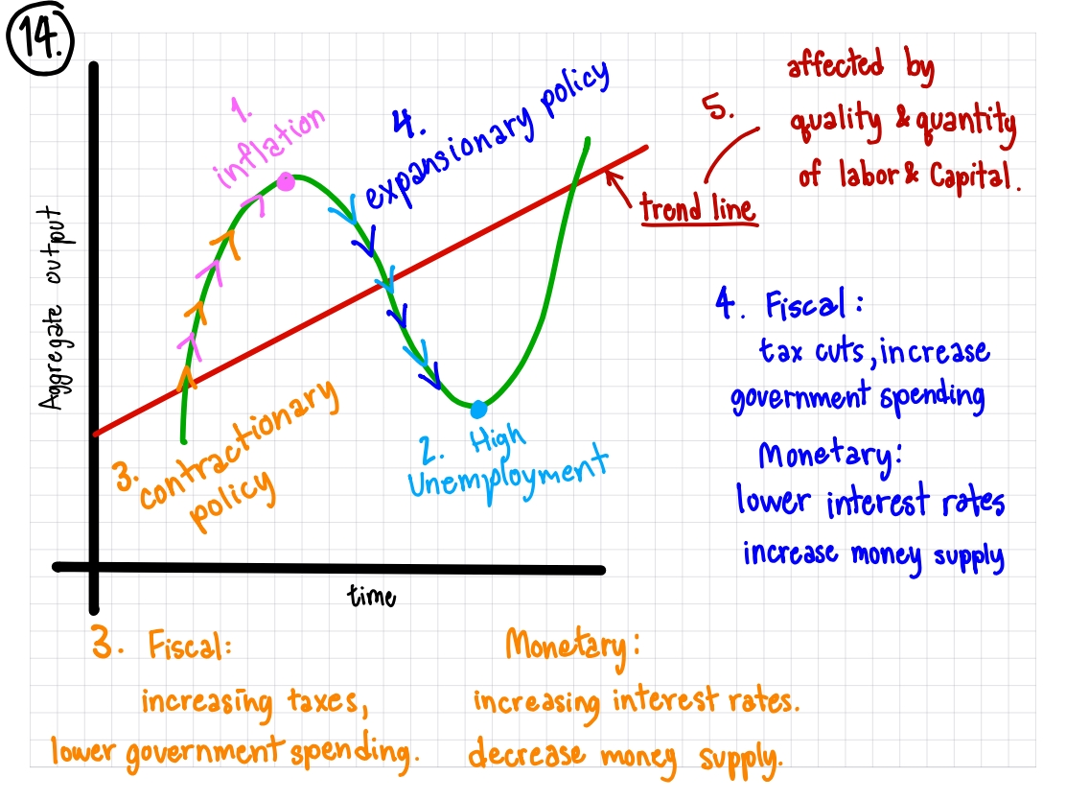

- An article states that capital stock and labor force are both increasing at an annual rate of 7%. The same article also states that real output is growing by 11%. Explain why this is possible.
The increase in quantity and quality of capital stock and labor force can increase the productivity, meaning more goods and services, more money circulating in the economy results in growing of GDP.

