บช. 201 การบัญชีชั้นต้น
แบบฝึกหัด บทที่ 13
ผศ. ดร. อรพรรณ ยลระบิล
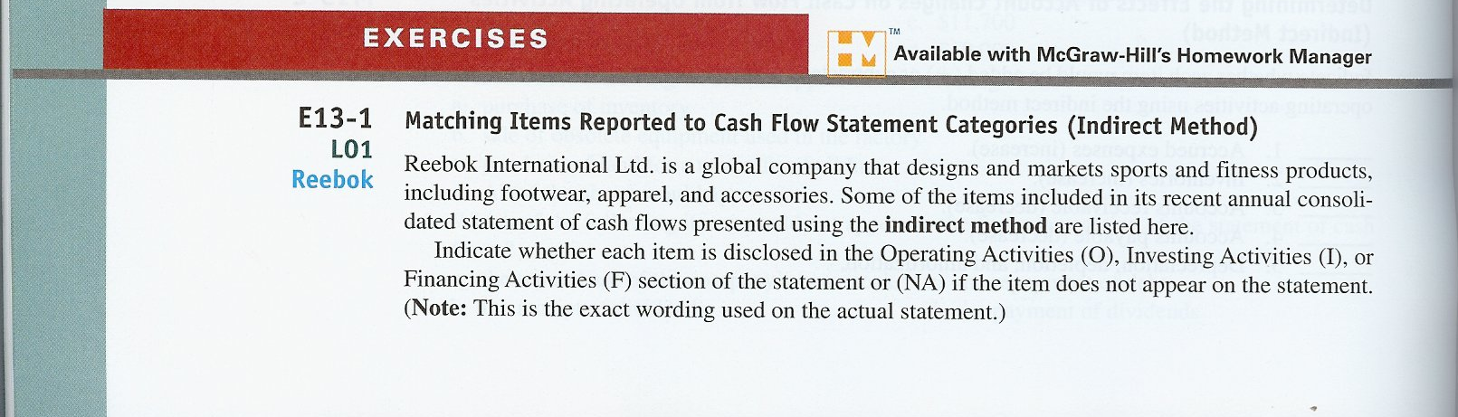
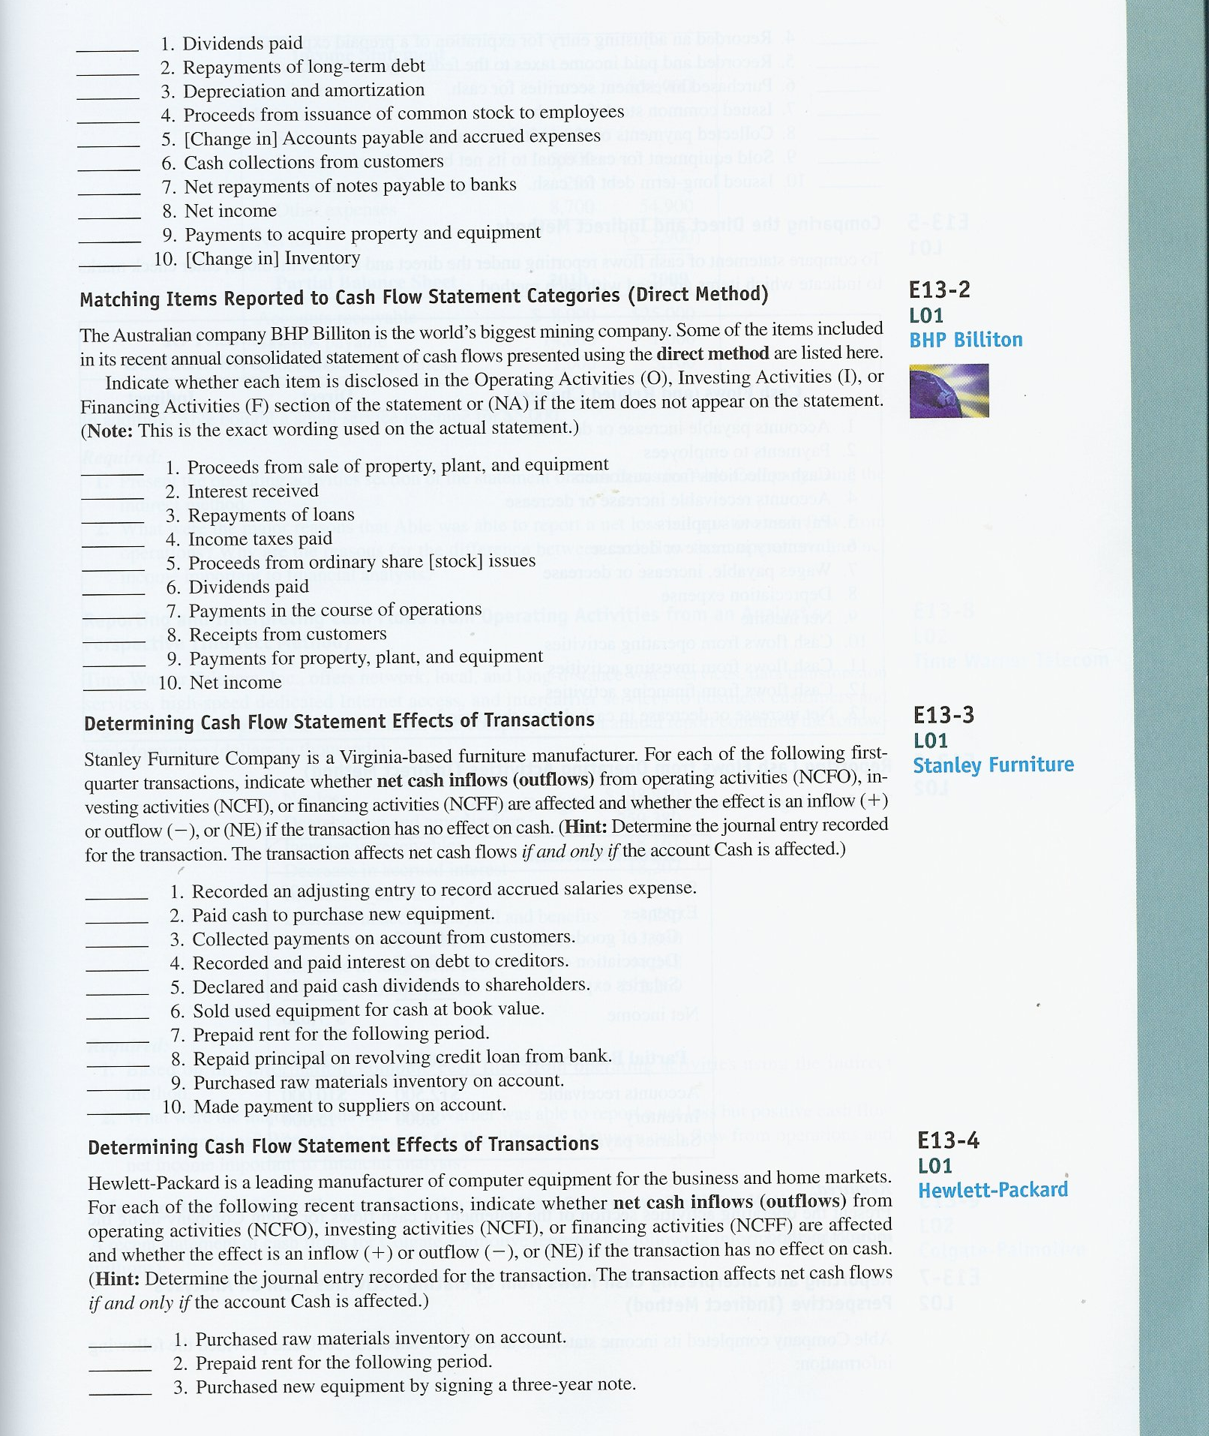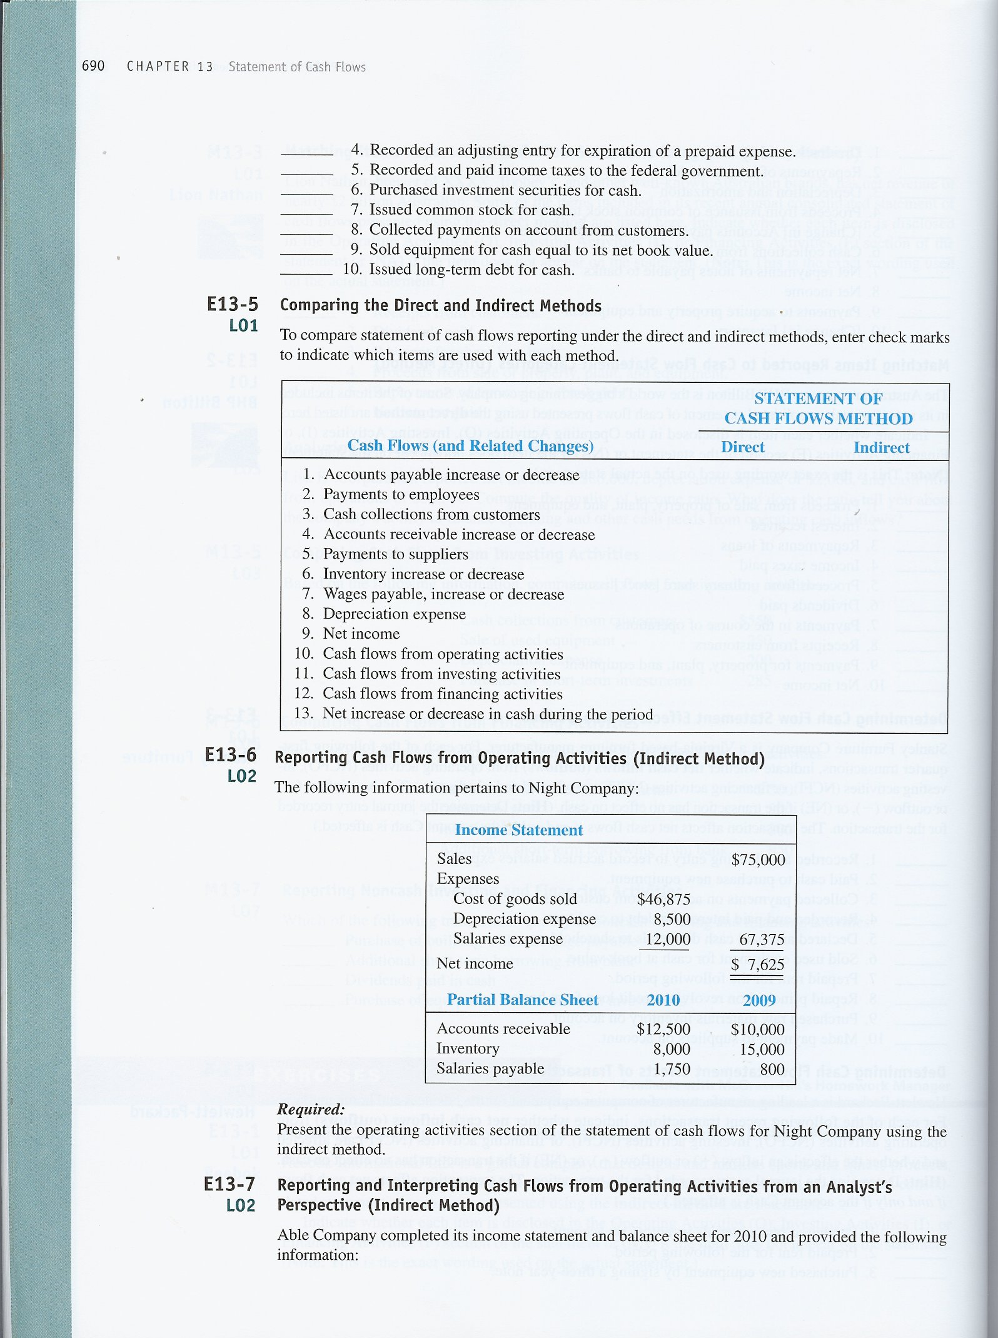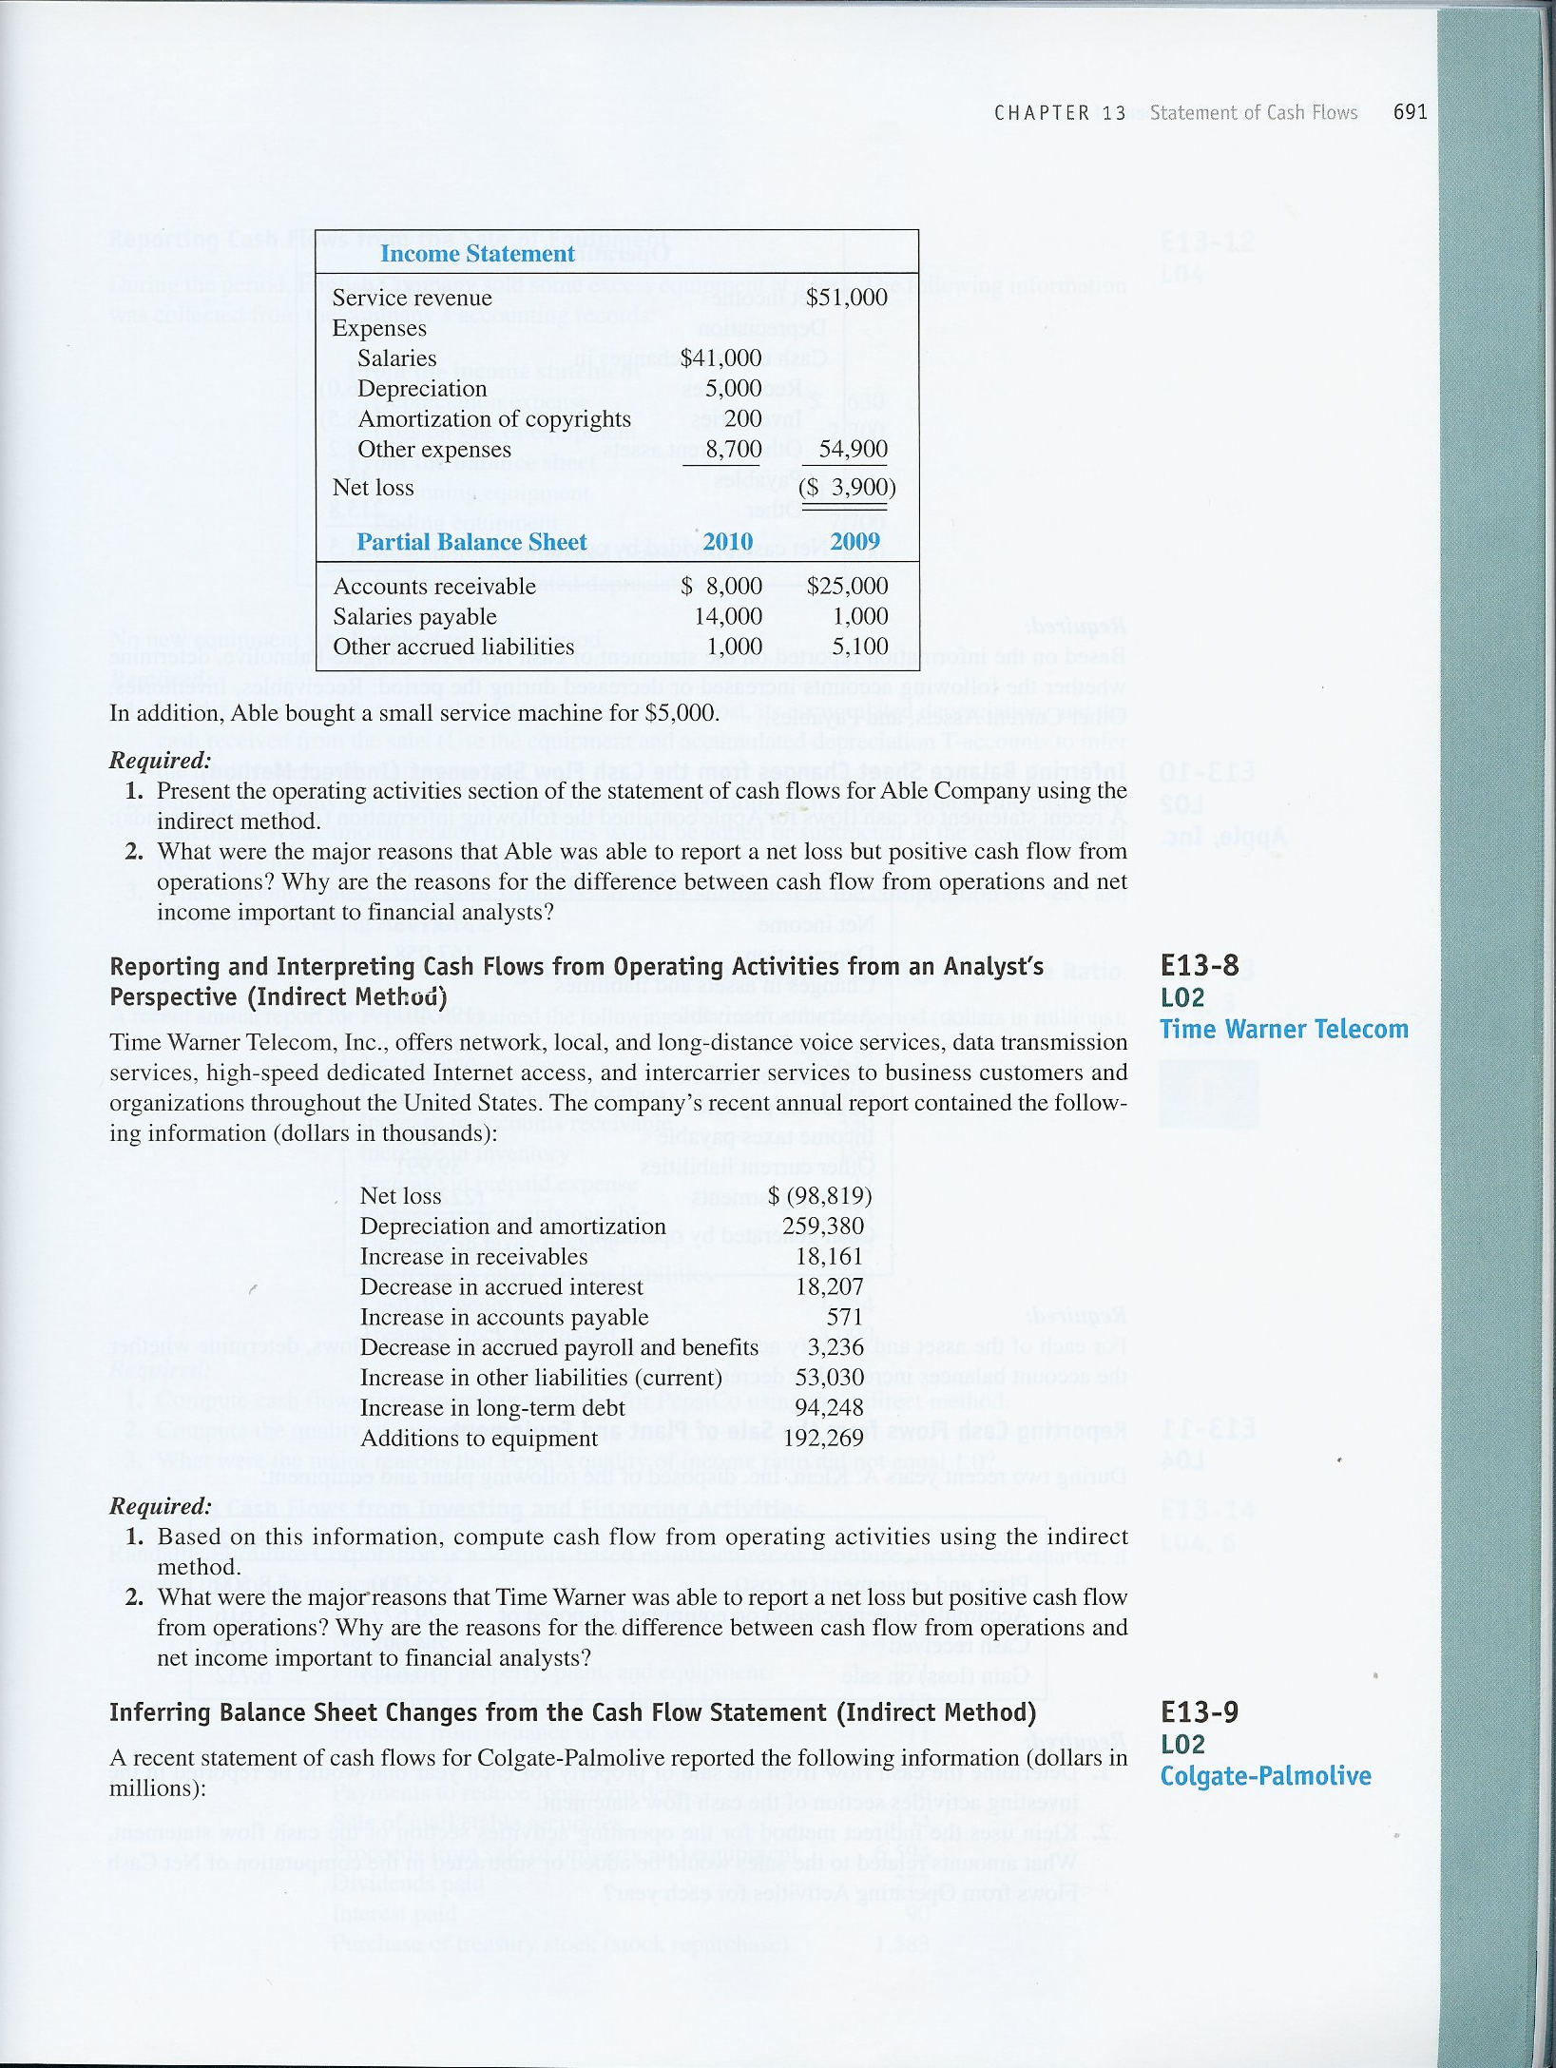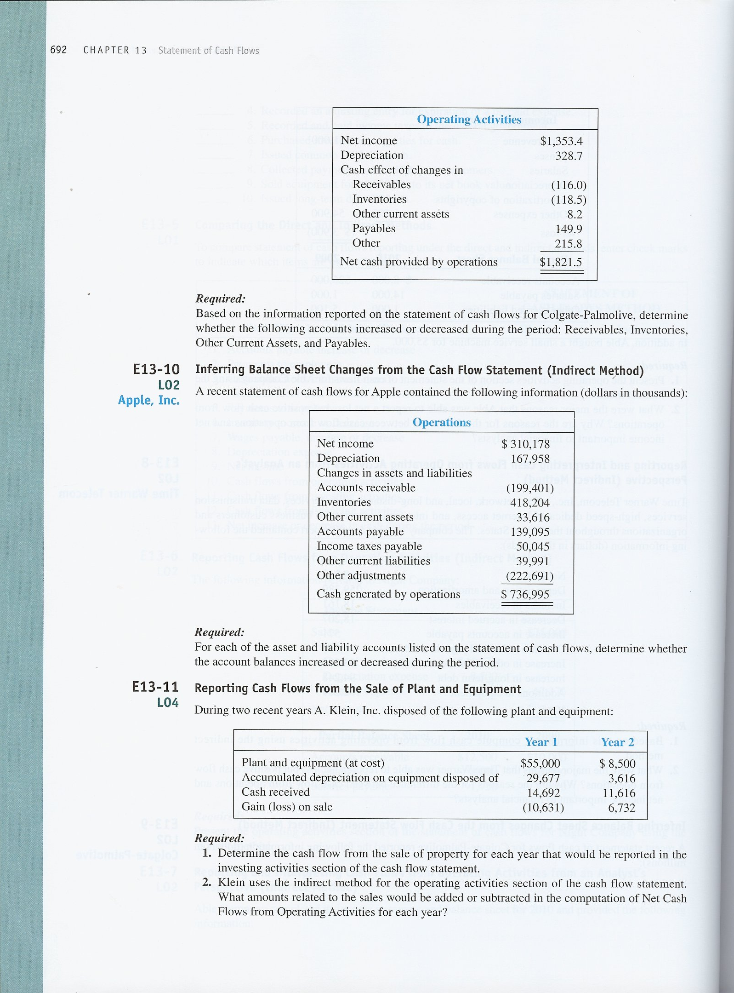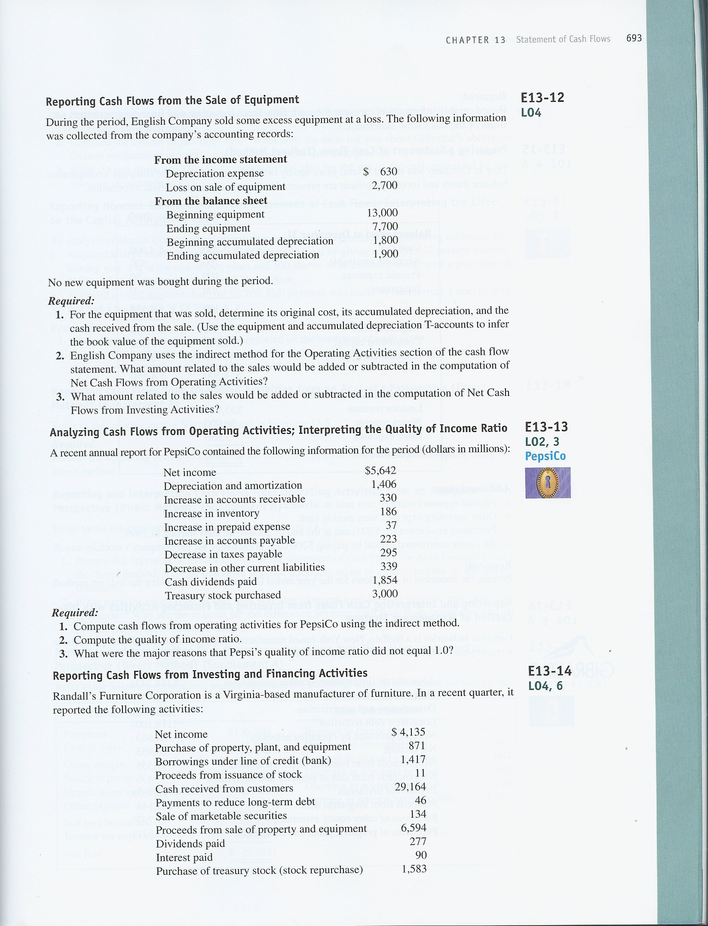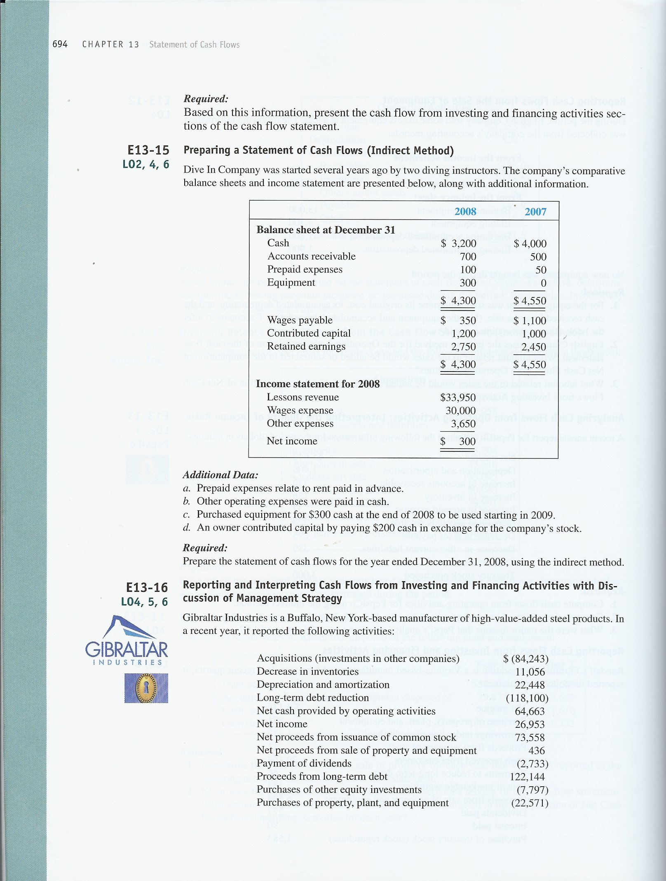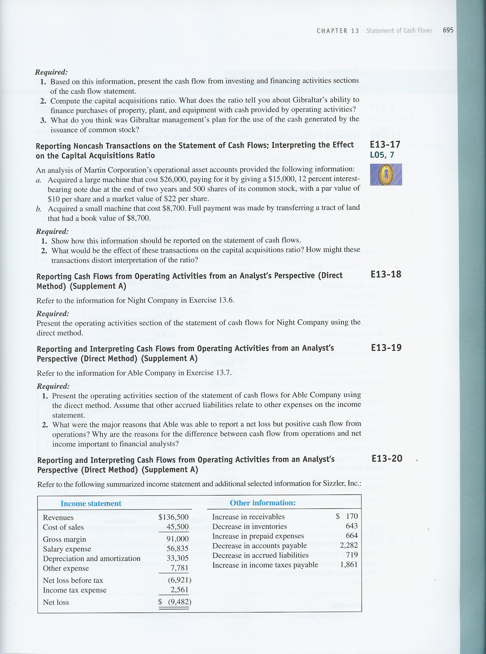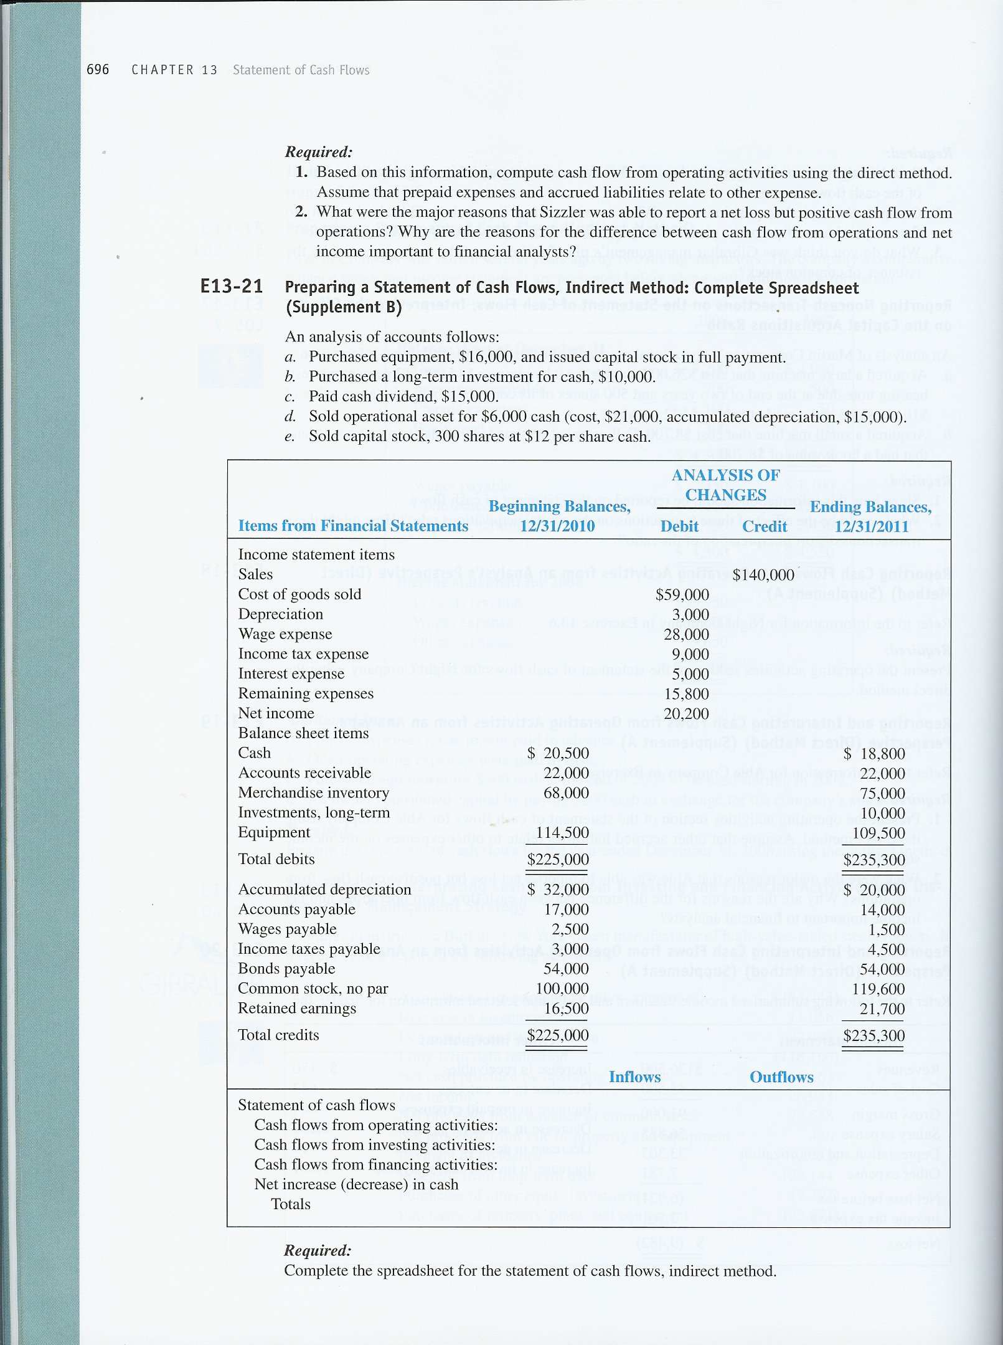

EXERCISES
E13–1.
F | - Dividends paid
F | - Repayments of long-term debt
O | - Depreciation and amortization
F | - Proceeds from issuance of common stock to employees
O | - [Change in] Accounts payable and accrued expenses
NA | - Cash collections from customers
F | - Net repayments of notes payable to banks
O | - Net income
I | - Payments to acquire property and equipment
O | - [Change in] Inventory

E13–2.
I | - Proceeds from sale of property, plant and equipment
O | - Interest received
F | - Repayments of loans
O | - Income taxes paid
F | - Proceeds from ordinary share [stock] issues
F | - Dividends paid
O | - Payments in the course of operations
O | - Receipts from customers
I | - Payments for property, plant and equipment
NA | - Net income

E13–3.
1. NE Salaries expense
Accrued salaries payable
2. – NCFI Plant and equipment
Cash
3. + NCFO Cash
Accounts receivable
4. – NCFO Interest expense
Cash
5. – NCFF Retained earnings
Cash
6. + NCFI Cash
Accumulated depreciation
Plant and equipment
7. – NCFO Prepaid expenses (rent)
Cash
8. – NCFF Short-term debt
Cash
9. NE Inventory
Accounts payable
10. – NCFO Accounts payable
Cash

E13–4.
1. NE Inventory
Accounts payable
2. – NCFO Prepaid expenses (rent)
Cash
3. NE Plant and equipment
Note payable
4. NE Expense
Prepaid expense
5. – NCFO Income tax expense
Cash
6. – NCFI Investment securities
Cash
7. + NCFF Cash
Common stock
Additional paid-in capital
8. + NCFO Cash
Accounts receivable
9. + NCFI Cash
Plant and equipment (net)
10. + NCFF Cash
Long-term Debt
E13–5.

Comparison of Statement of Cash Flows direct and indirect reporting
Cash flows |  |  |  | Statement of Cash Flows Method
(and related changes) |  |  |  | Direct | Indirect
 | 1. |  | Accounts payable increase or decrease |  | X
 | 2. |  | Payments to employees | X
 | 3. |  | Cash collections from customers | X
 | 4. |  | Accounts receivable increase or decrease |  | X
 | 5. |  | Payments to suppliers | X
 | 6. |  | Inventory increase or decrease |  | X
 | 7. |  | Wages payable, increase or decrease |  | X
 | 8. |  | Depreciation expense |  | X
 | 9. |  | Net income |  | X
 | 10. |  | Cash flows from operating activities | X | X
 | 11. |  | Cash flows from investing activities | X | X
 | 12. |  | Cash flows from financing activities | X | X
 | 13. |  | Net increase or decrease in cash during the period | X | X
The direct method reports cash flows from operating activities individually for each major revenue and expense. In contrast, the indirect method reports a reconciliation of net income to cash flow from operating activities. The two methods report the investing and financing activities in exactly the same way.

E13–6.
Cash flows from operating activities—indirect method
Net income | $7,625
Depreciation expense | 8,500
Accounts receivable increase ($12,500 – $10,000) | (2,500 | )
Inventory decrease ($8,000 – $15,000) | 7,000
Salaries payable increase ($1,750 – $800) | 950
Net cash provided by operating activities | $21,575

E13–7.
Req. 1
Cash flows from operating activities—indirect method
Net loss | ($3,900 | )
Depreciation expense | 5,000
Amortization of copyrights | 200
Accounts receivable decrease ($8,000 – $25,000) | 17,000
Salaries payable increase ($14,000 – $1,000) | 13,000
Other accrued liabilities decrease ($1,000 – $5,100) | (4,100 | )
Net cash provided by operating activities | $27,200

Req. 2
The first reason for the net loss was the depreciation expense. This is a non-cash expense. Depreciation expense, along with decreased working capital requirements (current assets - current liabilities), turned the net loss into positive operating cash flow from operations. The reasons for the difference between net income and cash flow are important because they help the financial analyst to determine if the trends are sustainable or whether they represent one-time events.
E13–8.
Req. 1
Cash flows from operating activities—indirect method
Net loss | ($98,819 | )
Depreciation and amortization | 259,380
Increase in receivables | (18,161 | )
Decrease in accrued interest | (18,207 | )
Increase in accounts payable | 571
Decrease in accrued payroll and benefits | (3,236 | )
Increase in other liabilities | 53,030
Cash flows from operating activities | $174,558
Note: The increase in long-term debt and additions to equipment do not affect cash flows from operating activities.

Req. 2
The primary reason for the net loss was the depreciation and amortization expense. These represent non-cash expenses. Large depreciation and amortization expense, offset partially by increased working capital requirements, turned Time Warner’s net loss into positive operating cash flow. The reasons for the difference between net income and cash flow from operations are important because they help the financial analyst to determine if the trends are sustainable or whether they represent one-time events.

E13–9.
Account |  | Change
Receivables |  | Increase
Inventories |  | Increase
Other current assets |  | Decrease
Payables |  | Increase

E13–10.
Account |  | Change
Accounts receivable |  | Increase
Inventories |  | Decrease
Other current assets |  | Decrease
Accounts payable |  | Increase
Income taxes payable |  | Increase
Other current liabilities |  | Increase

E13–11.
Req. 1
Cash flows from investing activities |  | Year 1 |  | Year 2
Proceeds from sale of equipment |  | $14,692 |  | $11,616
The amount reported in the cash flow from investing activities section of the statement of cash flows is the total cash proceeds from the sale of the equipment, regardless of the amount of any gain or loss.

Req. 2
Any gain on the sale of the equipment is subtracted from net income to avoid double counting of the gain. Any loss on the sale of the equipment is added to avoid double counting of the loss.
Cash flows from operating activities |  | Year 3 |  | Year 2 |  | Year 1
Loss (Gain) on sale of equipment |  | $10,631 |  | $(6,732) |  | --

Computations:
 | Year 1 | Year 2
Plant and equipment (at cost) | $55,000 | $8,500
Accumulated depreciation | 29,677 | 3,616
Net book value | 25,323 | 4,884
Cash Proceeds – Net book value = Gain (Loss) on sale | (10,631) | 6,732
E13–12.
Req. 1  Equipment |  |  |  |  |  |  | Accumulated Depreciation
Beg. Bal. | 13,000 |  |  |  |  |  |  |  |  |  | 1,800 | Beg. Bal.
 |  |  |  | 5,300* | Sold |  | Sold | 530* |  |  | 630 | Dep. Exp.
End. Bal. | 7,700 |  |  |  |  |  |  |  |  |  | 1,900 | End. Bal.
*plug figures
Cost of equipment sold = $5,300
Accumulated depreciation on sold equipment = $530
Book value of sold equipment | $4,770
Less: Loss on sale (given) | (2,700 | )
Cash received from sale | $2,070

Req. 2
Any gain on the sale of the equipment is subtracted from net income to avoid double counting of the gain. Any loss on the sale of the equipment is added to avoid double counting of the loss. The loss of $2,700 would be added.

Req. 3
The amount of cash received is added in the computation of Net Cash Flow from investing activities, regardless of whether the sale results in a gain or loss. The cash inflow if $2,070 would be added.

E13–13.
Req. 1
Cash flows from operating activities—indirect method
Net income | $5,642
Depreciation and amortization | 1,406
Increase in accounts receivable | (330 | )
Increase in inventory | (186 | )
Increase in prepaid expense | (37 | )
Increase in accounts payable | 223
Decrease in taxes payable | (295 | )
Decrease in other current liabilities | (339 | )
Cash flows from operating activities | $6,084
Note: The cash dividends paid and treasury stock purchased are not related to operating activities and do not affect cash flows from operating activities.

Req. 2
Quality of income ratio | = | Cash flow from operations | = | $6,084 | = | 1.08
 |  | Net income |  | $5,642

Req. 3
The reason the quality of income ratio was greater than one was primarily because of large non-cash depreciation charges.

E13–14.
The investing and financing sections of the statement of cash flows for Randall’s Furniture:
Cash flows from investing activities:
Purchase of property, plant & equipment | $(871)
Sale of marketable securities | 134
Proceeds from sale of property & equipment | 6,594
Net cash flows from investing activities |  | $5,857
Cash flows from financing activities:
Borrowings under line of credit | 1,417
Proceeds from issuance of stock | 11
Payments on long term debt | (46)
Payment of dividends | (277)
Purchase of treasury stock | (1,583)
Net cash flows from financing activities |  | (478)

E13–15.
DIVE IN COMPANY
Statement of Cash Flows
For the Year Ended December 31, 2008
Cash flows from operating activities:
Net income | $ 300
Adjustments to reconcile net income to net cash
provided by operating activities:
Increase in accounts receivable | (200 | )
Increase in prepaids | (50 | )
Decrease in wages payable | (750 | )
Net cash provided by (used for) operating activities | (700 | )
Cash flows from Investing activities:
Cash paid for equipment | (300 | )
Net cash provided by (used for) investing activities | (300 | )
Cash flows from financing activities:
Cash proceeds from issuing stock | 200
Net cash provided by financing activities | 200
Net increase (decrease) in cash during the year | (800 | )
Cash balance, January 1, 2008 | 4,000
Cash balance, December 31, 2008 | $3,200

E13–16.
Req. 1
The investing and financing sections of the statement of cash flows for Gibraltar Industries:
Cash flows from investing activities:
Acquisitions (investments in other companies) | (84,243)
Purchases of other equity investments | (7,797)
Purchases of property, plant and equipment | (22,571)
Net proceeds from sale of property and equipment | 436
Net cash used in investing activities |  | (114,175)
Cash flows from financing activities:
Long-term debt reduction | (118,100)
Proceeds from long-term debt | 122,144
Net proceeds from issuance of common stock | 73,558
Payment of dividends | (2,733)
Net cash provided by (used in) financing activities |  | 74,869

Req. 2
Capital acquisitions ratio | = | Cash flow from operations | = | $64,663 | = | 2.86
 |  | Cash Paid for Plant & Equipment |  | $22,571
The capital acquisitions ratio measures the company's ability to finance plant and equipment purchases from operations. Since this amount was more than 1 (2.86), the company has generated more than enough to finance plant and equipment purchases from operations.

Req. 3
Gibraltar’s management is using the cash proceeds from the stock offering, along with the excess cash generated by operations (see Req. 2) mainly to invest in other companies. Note that most of the new long-term debt issuances are being used to pay off existing long-term debt.

E13–17.
Req. 1
Both of these transactions are considered noncash investing and financing activities, and are not reported on the statement of cash flows. The transactions must be disclosed in a separate schedule or in the footnotes. The information disclosed in the separate schedule would state:
a. Equipment valued at $26,000 was acquired by giving a $15,000, 12%, two-year note, and common stock with a market value of $11,000.
b. A machine valued at $8,700 was acquired by exchanging land with a book value of $8,700.

Req. 2
The capital acquisitions ratio measures the company's ability to finance plant and equipment purchases from operations. Since neither of these transactions enters the numerator or denominator of the ratio, they would have no effect. Many analysts believe that these transactions represent important capital acquisitions, and thus should be included in the denominator of the ratio to indicate what portion of all (not just cash) acquisitions are being financed from operations.
E13–18.
Cash flows from operating activities—direct method
Cash collected from customers1 | $72,500
Cash payments to suppliers of inventory2 | (39,875 | )
Cash payments to employees 3 | (11,050 | )
Net cash provided by operating activities | $21,575
1. Cash collected from customers = Sales revenue – Increase in Accounts receivable
$75,000 – $2,500 = $72,500
2. Cash payments to suppliers of inventory = Cost of goods sold – Decrease in Inventory
$46,875 – $7,000 = $39,875
3. Cash payments to employees = Salaries expense – Increase in Salaries payable
$12,000 – $950= $11,050

E13–19.
Req. 1
Cash flows from operating activities—direct method
Cash collected from customers1 | $68,000
Cash payments to employees2 | (28,000 | )
Cash paid for other expenses3 | (12,800 | )
Net cash provided by operating activities | $27,200
1. Cash collected from customers = Sales revenue + Decrease in Accounts receivable
$51,000 + $17,000 = $68,000
2. Cash payments to employees = Salaries expense – Increase in Salaries payable
$41,000 – $13,000 = $28,000
3. Cash paid for other expenses = Other expenses + Decrease in Other accrued liabilities
$8,700 + $4,100 = $12,800

Req. 2
The first reason for the net loss was the depreciation expense. This is a non-cash expense. Depreciation expense, along with decreased working capital requirements (current assets - current liabilities), turned the net loss into positive operating cash flow. The reasons for the difference between net income and cash flow are important because they help the financial analyst to determine if the trends are sustainable or whether they represent one-time events.
E13–20.
Req. 1
Cash flows from operating activities—direct method
 | Cash collected from customers¹ | $136,330
 | Cash payments to employees | (56,835)
 | Cash payments to suppliers² | (47,139)
 | Cash payments for other expenses³ | (9,164)
 | Cash payments for income tax⁴ | (700)
 | Net cash provided by operating activities | $22,492
- Cash collected from customers:
Revenues – Increase in Accounts receivable
$136,500 – 170 = 136,330
- Cash payments to suppliers:
Cost of sales – Decrease in Inventories + Decrease in Accounts payable
$45,500 – 643 + 2,282 = 47,139
- Cash payments for other expenses:
Other expense + Increase in Prepaid expenses + Decrease in Accrued liabilities
$7,781 + 664 + 719 = 9,164
- Cash payments for income tax:
Income tax expense – Increase in income taxes payable
$2,561 – 1,861 = 700

Req. 2
The primary reason for the net loss was the depreciation and amortization expense. These represent non-cash expenses. Large depreciation and amortization expense, offset partially by increased working capital requirements, turned Sizzler’s net loss into positive operating cash flow. The reasons for the difference between net income and cash flow from operations are important because they help the financial analyst to determine if the trends are sustainable or whether they represent one-time events.

E13–21.

 | Balances |  |  | Analysis |  |  |  |  |  | Balances
Item | 12/31/2010 |  |  | Debit |  |  | Credit |  |  | 12/31/2011
Cash |  | 20,500 |  |  |  |  | l | 1,700 |  |  | 18,800
Noncash accounts:
Accounts receivable (net) |  | 22,000 |  |  |  |  |  |  |  |  | 22,000
Merchandise inventory |  | 68,000 |  | h | 7,000 |  |  |  |  |  | 75,000
Investments, long-term |  |  |  | d | 10,000 |  |  |  |  |  | 10,000
Equipment |  | 114,500 |  | b | 16,000 |  | i | 21,000 |  |  | 109,500
Total |  | 225,000 |  |  |  |  |  |  |  |  | 235,300
Accumulated depreciation |  | 32,000 |  | i | 15,000 |  | c | 3,000 |  |  | 20,000
Accounts payable |  | 17,000 |  | e | 3,000 |  |  |  |  |  | 14,000
Wages payable |  | 2,500 |  | f | 1,000 |  |  |  |  |  | 1,500
Income taxes payable |  | 3,000 |  |  |  |  | g | 1,500 |  |  | 4,500
Bonds payable |  | 54,000 |  |  |  |  |  |  |  |  | 54,000
 |  |  |  |  |  |  | j | 3,600
Common stock, no par |  | 100,000 |  |  |  |  | b | 16,000 |  |  | 119,600
Retained earnings |  | 16,500 |  | k | 15,000 |  | a | 20,200 |  |  | 21,700
Total |  | 225,000 |  |  |  |  |  |  |  |  | 235,300
Statement of Cash Flows  Conversion of net income to cash flow  from operating activities: |  |  |  | Inflows |  |  | Outflows
Net income |  |  |  | a | 20,200
Depreciation expense |  |  |  | c | 3,000
Accounts payable decrease |  |  |  |  |  |  | e | 3,000
Wages payable decrease |  |  |  |  |  |  | f | 1,000
Income taxes payable increase |  |  |  | g | 1,500
Inventory increase |  |  |  |  |  |  | h | 7,000 |  |  | 13,700
Cash flows from investing activities:
Long-term investment purchased |  |  |  |  |  |  | d | 10,000
Sale of equipment |  |  |  | i | 6,000 |  |  |  |  |  | (4,000 | )
Cash flows from financing activities:
Sale of capital stock |  |  |  | j | 3,600
Dividends paid |  |  |  |  |  |  | k | 15,000 |  |  | (11,400 | )
Net increase (decrease) in cash |  |  |  | l | 1,700
Totals |  |  |  |  | 103,000 |  |  | 103,000 |  |  | (1,700 | )

