EE 441 SHORT PAPER
Japan’s government expenditure
Japan is one of among East Asia countries that succeed in development when compare to other countries. For example, they have high and standardized technology, they have advance transportation and infrastructure, and they have good social security system and good social welfare etc. All of these things will well establish if government can control and manage government expenditure. Government expenditure or government spending is expense that government used for consumption in both goods and services such as education, social welfare, military, transportation etc. Each country has different method or strategy in expenditure management. Therefore, some countries are very successful while some are not.
We will look at how Japanese government use their expenditure by starting from government expenditure (current US$) and government expenditure (% of GDP). According to figure 1, Japan’s general government final consumption expenditure (current US$) increasing since 1990 to 2013. It measured approximately $1,012,070,000,000 at latest year 2013. And the average is approximately $414,460,000,000.
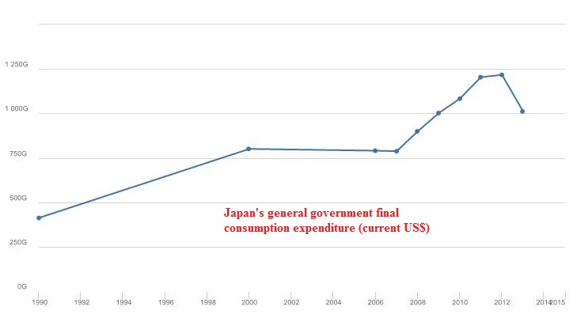
Figure 1

For figure 2, Japan’s general government final consumption expenditure (% of GDP) also increasing since 1990 to 2013. The highest percentage is 20.57% at 2013 and the average value is 14.69%. Therefore, we already know that Japan’s government expenditure has increasing trend.
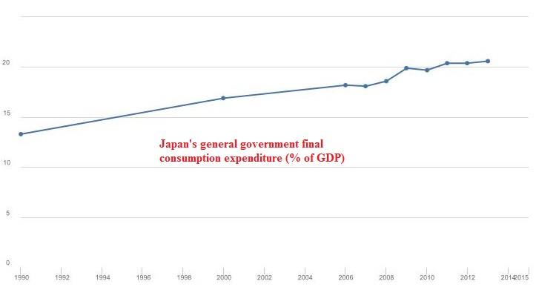
Figure 2

Moreover, we have to look at share of total government expenditure. What’s sector that Japanese government spent most money in. Because it can imply to how it’s important to the country. In 2013, Japanese government spent most of their money in social security and following by debt servicing, national tax revenue grants to local governments, other sectors, public works; education and science, and defense. The percentages of total government expenditure are approximately 31%, 24%, 18%, 10%, 6%, and 5% respectively (as shown in figure 3).
Figure 3

We can say that Japanese government pay attention to social security sector because they spent 31% of their expenditure in this sector. Furthermore, Japanese government set a budget plan for 2016 that increase amount of spending in social security sector.
According to social security’s definition, “Social security is a program of old-age, unemployment, health, disability, and survivors insurance maintained by the government through compulsory payments by specific employer and employee groups. Or the theory or practice of providing economic security and social welfare for the individual through government programs maintained by moneys from public taxation (Collins English Dictionary, 2012).” Definitely, social security consists of many parts including health care.
Health care is action that maintains good health or makes better health. Not only physical but also involve in mental or behavioral. Health care is significant for both of developed and developing countries because health is related to human capital. If people in the country (Human capital) have good health, they will work effectively and productively. Country that has effective human capital tends to develop faster than others.
In Japan, most of Japanese people are old people. Japan is in aging society now. Therefore, they spent a lot of expenditure in health care for serving their people. Moreover, nowadays it has many diseases including chronic diseases. Unsurprisingly, Japan’s total health expenditure per capita (US$) increases over time like it shows in figure 4. Total health expenditure per capita in 2000 is $2,865 but in 2013 is higher at $3,965.6.

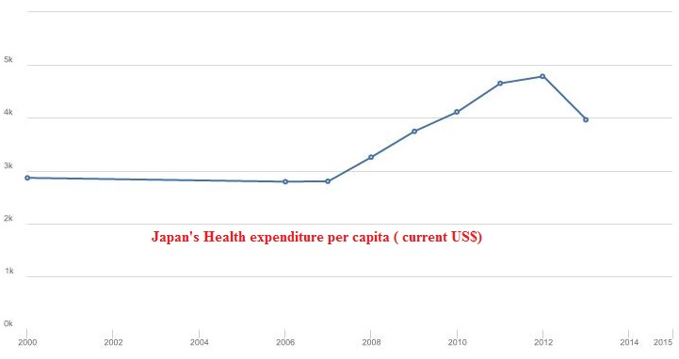
Figure 4

According to figure 5, it shows increasing trend in health expenditure (% of GDP). It increases from 7.6% in 2000 to 10.3% in 2013. Moreover, government has to pay approximately 70% of cost of health care while Japanese people are responsible for the rest 30% because they have National Health Insurance or NHI policy that everyone in the country has to join no matter what they are employed or not. This’s also one of the reasons why government health expenditure in Japan is high.

Figure 5
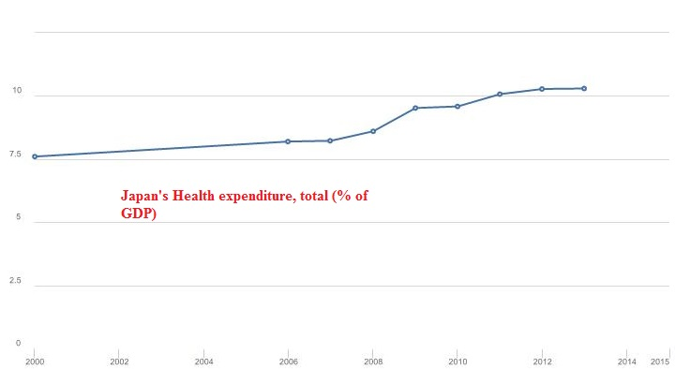

Due to high total amount of health expenditure, Japanese government has to impose the new policy. This method tries to save more money and strictly control budget. This’s also one part of social security reform.
The new policy tries to change fee-for-service-based care due to many health care services in Japan belong to private section such as private hospital, clinic’s individual doctor etc. Fee-for-service-based care has both advantage and disadvantage. The advantage is creating motivation. It motivates doctors to work more for their revenues. However, doctors may raise their revenues by ordering unnecessary medicine. In private hospital case, they will make patients stay longer in the hospital for more fees to charge. Therefore, Japanese government intervenes to control medical fee. They solve this problem by using new policy. It consists of imposing fix-rate-for-service and cost containment strategy. For cost containment strategy, government finds the optimal allocation and then reallocation of hospital beds. They also promote and control dispensation of medicine. Furthermore, they try to change from acute care service to nursing care service or personal social service.
According to acute care’s definition, “acute care is a branch of secondary health care where a patient receives active but short-term treatment for a severe injury, episode of illness, an urgent medical condition, or during recovery from surgery. In medical terms, care for acute health conditions is the opposite from chronic care, or longer term care. Acute care services are generally delivered by teams of health care professionals from a range of medical and surgical specialties. Acute care may require a stay in a hospital emergency department, ambulatory surgery center, urgent care center or other short-term stay facility, along with the assistance of diagnostic services, surgery, or follow-up outpatient care in the community (Wikipedia, 2015 March 14).” Nowadays, most of Japanese people received acute care service that has higher cost than nursing care service or personal social service.
Hence, government imposed regulation that forces acute hospital to treat patients with long term care. Nursing care service or personal social service will take responsibility in short term care instead. This method efficiently helps to cut expenditures in old people’s health care and reduce total health expenditure.
In conclusion, Japan has increasing trend of total government expenditure. The biggest proportion of total government expenditure is social security which health care participated in. To reduce and control total government expenditure, it’s significant to pay attention to total health expenditure because total health expenditure also increases over time. It comes from many reasons such as aging society, chronic diseases, or inefficient old policy. Therefore, Japanese government has to impose new policy that cut total health expenditure and reduce high cost of health care to achieve main purpose of the government that need to reduce total government expenditure and balance their budget while still provide good social welfare including good health care service.

Written by Karittha Chalermchavalit
5604640440

References

- Collins English Dictionary. (2012). Social security. (n.d.). Retrieved January 3, 2016, from http://dictionary.reference.com/browse/social-security
- NipponMarketBlog. (2013, April 25). Japan is insolvent, but “please don’t worry…”. Retrieved January 1, 2016, from https://nipponmarketblog.wordpress.com/2013/04/25/japan-is-insolvent-but-please-dont-worry/
- Wada, Y. (2015). 2015 health care outlook Japan. Retrieved January 2, 2016, from http://www2.deloitte.com/content/dam/Deloitte/global/Documents/Life-Sciences-Health-Care/gx-lshc-2015-health-care-outlook-japan.pdf
- Wikipedia. (2015, March 14). Acute care. Retrieved January 2, 2016, from https://en.wikipedia.org/wiki/Acute_care
- World Bank. General government final consumption expenditure (current US$). (n.d.). Retrieved January 2, 2016, from http://data.worldbank.org/indicator/NE.CON.GOVT.CD
- World Bank. General government final consumption expenditure (% of GDP). (n.d.). Retrieved January 1, 2016, from http://data.worldbank.org/indicator/NE.CON.GOVT.ZS
- World Bank. Health expenditure, total (% of GDP). (n.d.). Retrieved January 2, 2016, from http://data.worldbank.org/indicator/SH.XPD.TOTL.ZS
- World Bank. Health expenditure per capita (current US$). (n.d.). Retrieved January 2, 2016, from http://data.worldbank.org/indicator/SH.XPD.PCAP

See (Collins English Dictionary, 2012) in references at the end of paper
See (Wikipedia, 2015 March 14) in References at the end of paper

