Creating Reports
Creating reports is a very useful feature in Microsoft Access because the data is processed and arranged in format that is easy to view and useful for business decision.
Prior to creating and designing reports in Microsoft Access, users should know report structures as follows.

Report Structure
Reports in Microsoft Access consists of the following sections.
- Report Header and Footer is the area number 1 in the image below. Report header will appear only 1 time per 1 report at the top of the first page and Report Footer will appear 1 time per 1 report at the end of the last page of the report. Therefore, Report Header should be the area to put report name so that it appears as the header of report first page.
- Page Header and Footer is the area number 2 in the image below. Page header will appear only 1 time at the top of 1 page report and Page Footer will appear only 1 time at the bottom of 1 page report. If the report has 3 pages, any text in the page header and page footer section will appear on all 3 pages. Therefore, Header and Footer of page is the area to put what will be displayed on every page such as page number, date that the report was created.
- Group Header and Footer is the area number 3 in the image below (In the picture, it says Brand Header, which is a group created in the example report). The number of times that group header will appear on the top of group will be based on the amount of data. For example, suppose that a group is created in reports by using car brands as group. And if in the database there are 5 car brands, all text that are placed in the Group header and Footer will appear 5 times. However, Group footer is not automatically turned on in the design view, user must click to open the footer section, which will be referred to in report creation steps.
- Details is the area number 4 in the image, which is the section that displays the content that is the details of the report itself.
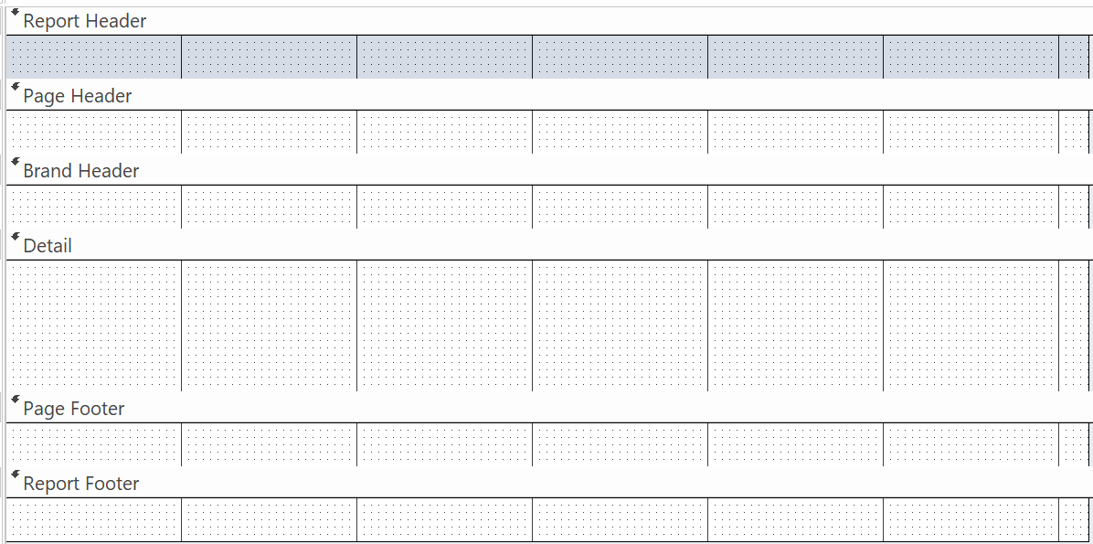
4.
3.
2.
2.
1.
1.

Creating reports in Design mode
- Click the DESIGN tab then click Report Design, Microsoft Access will open blank report in Design View, and the report structure is as described above.
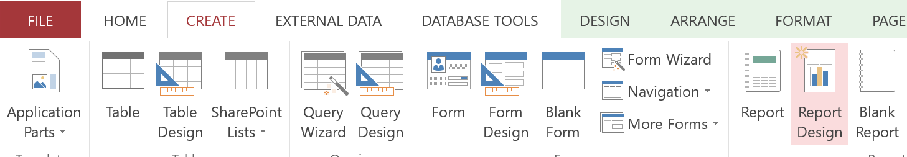

- Open property sheet of report by going to DESIGN tab and click property sheet.
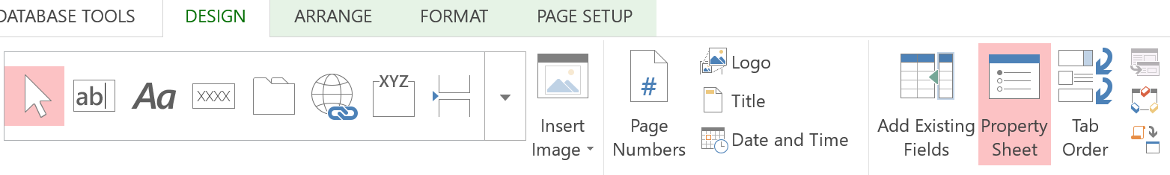
The property window will open as shown. Go ahead and set Record Source of the report by selecting table or query that you want to use as data source to display in the report as shown in the picture below. (In this example, suppose that you want to create report showing cars information and number of days the car was rented , select query named qryRentedCars.)
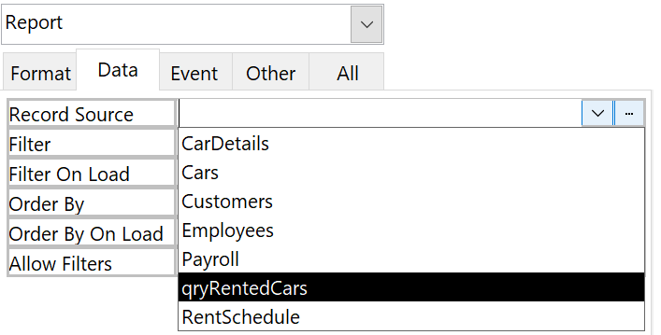

- Once the record source has been assigned to report, Click Add Existing Fields on the DESIGN tab, Microsoft Access will display all the fields that could be placed on the report. All available fields will be displayed on Field List window on the right of screen.
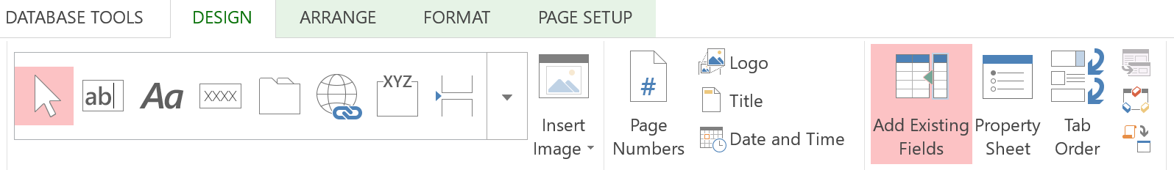
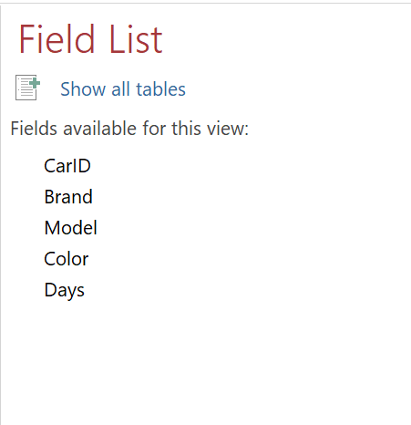
- In this example, suppose you want to show all the fields on report. You can click the field, hold and drag onto space on the report in the desired position one field at a time, or you can double click the field name one by one to allow Microsoft Access to create control that are automatically tied to that field and then move the position of the controls as needed.
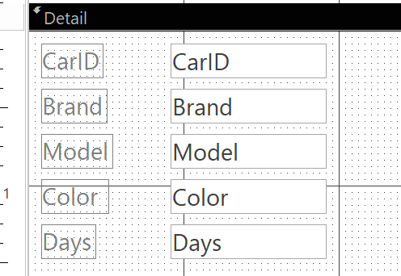

- In case you want to add group to the data displayed on the report, click DESIGN tab then click Group & Sort to open group control panel in report. Then select the data field that you want to use as a groping field.
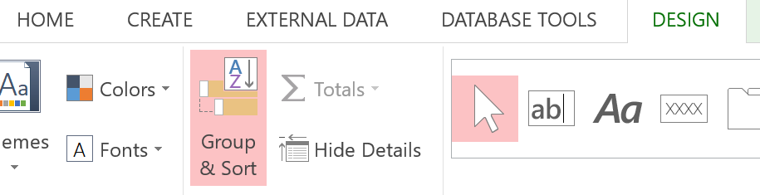

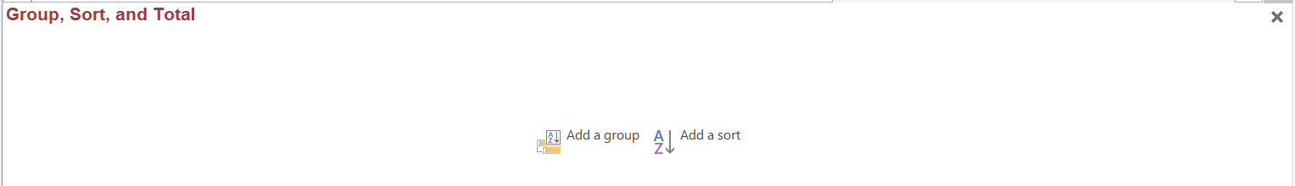
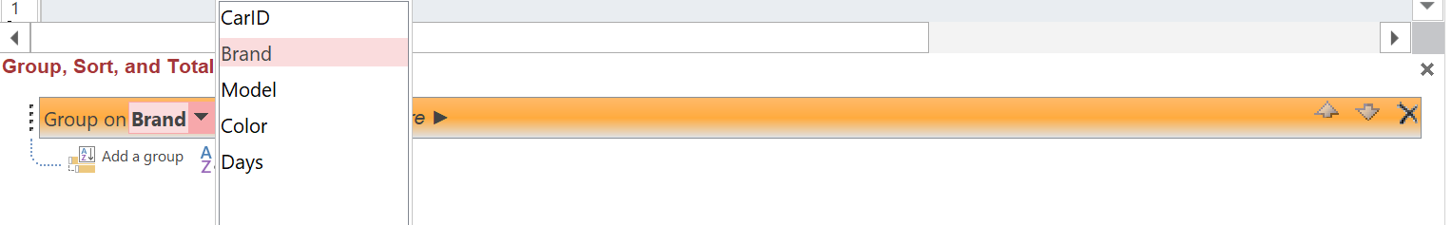
Once you have added a group (grouping by brand), Brand Header section will appear (as shown in picture below). Users can set the controls in the desired positions by dragging and dropping.
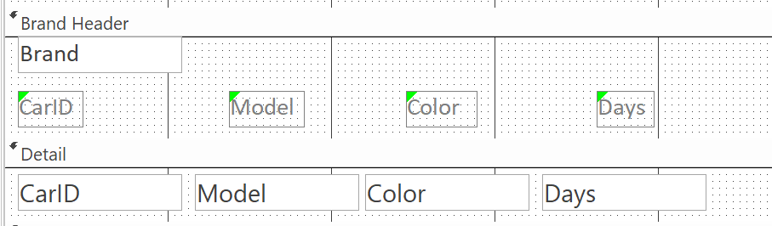
If you wish to add Group Footer section, go to the group control panel that is shown at the bottom of the report in Design View. Then click with a footer section as shown in the picture below.

- For the fields that require total value, for example suppose the user want to calculate total number of days of rental, right-click on the field that needs to be calculated, the menus will show up, select Total then select Sum to calculate total number of days that the car was rented.
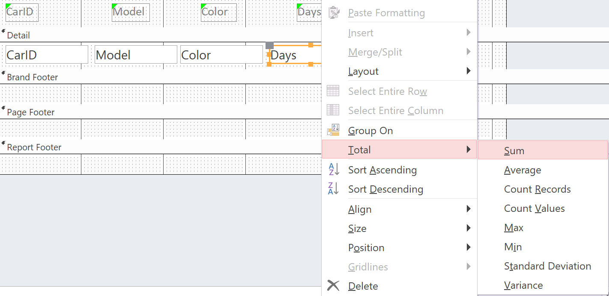
The field for displaying the total value will appear at 2 places, in Group Footer and in Report Footer which shows total number of days that all cars of the same brand were rented and the number of days that all cars in this report were rented respectively.

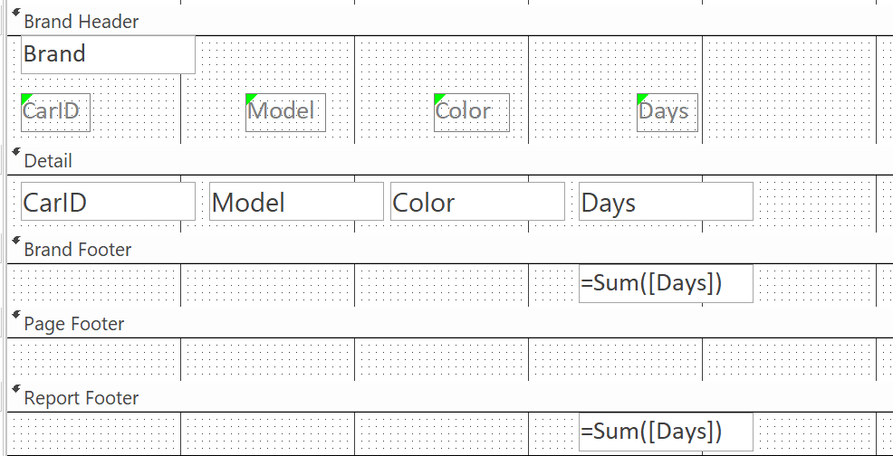

- For color and font size adjustment and other formatting, It can be done on Format tab.

Exercise: Creating Report for RentACar database
- Create pay slip for each employee.
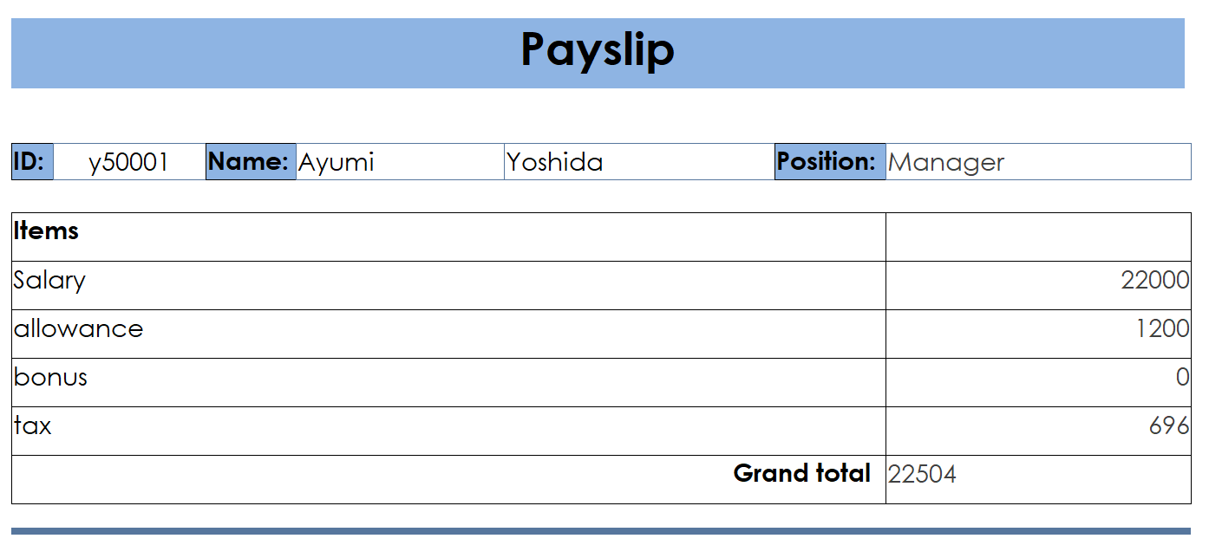
- Create a report displaying car rental items by each customer.
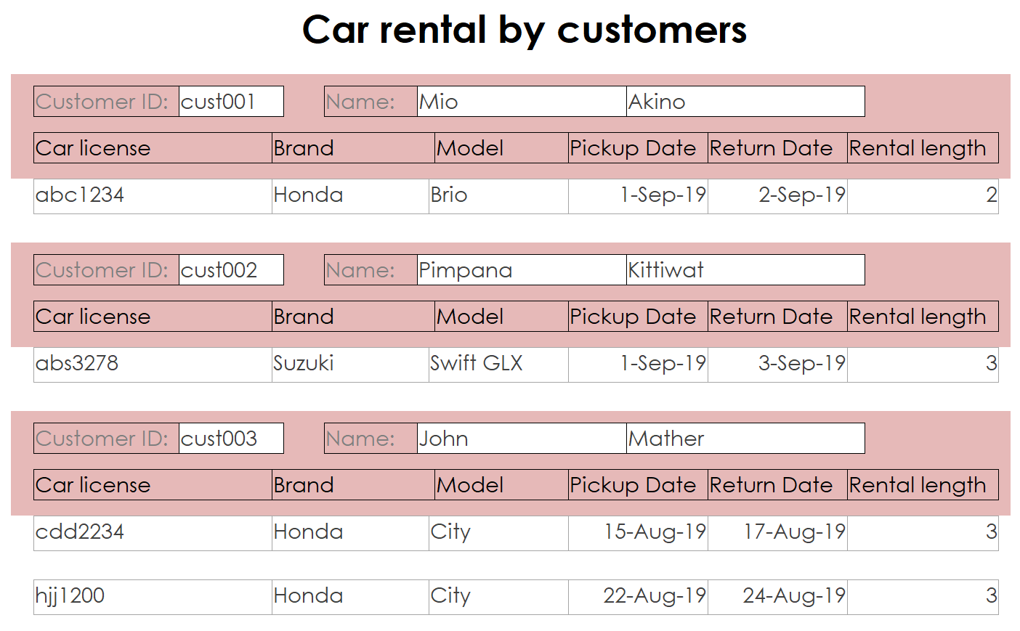

- Create a report displaying rented cars by model.


