1) Research current economic conditions (interest rates, inflation) using The Wall Street Journal, other library resources, or the World Wide Web. Based on current economic conditions, what actions would you recommend to people who are saving and borrowing money?

According to the Board Of Trade Of Thailand’s analytics, the inflation rate of Thailand in 2015 is expected to stay in the range between 1.8%-2.5%. Expected growth rate is expected to grow 4%-5%. Oil price will be pushed in the low range between50-60$/Barrel in the first 3-6 months and might be driven up to 70-80$/Barrel after that.
Bank Of Thailand intends to maintain the interest rate around 2% in year 2015, however, there is a tendency to decrease the interest rate if the economy is not as active as it predicted.

Now consider the effects of this economic criteria changes to savers and borrowers.

With low expected inflation rate, implicitly implies that borrowers will lose the benefits since they bear with the high cost of borrowing while savers will gain advantage because low expected inflation means that they can get higher real return. Low oil price will increase the productivity which drives up the real wage therefore, profit, employment and output increase. This is good for the GDP of the economy and the growth rate which is expected to expand to 4%-5% is a good sign for both of savers and borrowers since high growth rate reflects the healthy economy. Last but not least, interest rate definitely has an impact on savers and borrowers. When the interest rate has a tendency to decline, savers suffer because of gaining low return while borrowers have an advantage of bearing low cost of borrowing.

What should savers and borrowers react?

Two things to consider before making decision on saving or borrowing in the current economic situation; interest rate, inflation.
According to the current situation, BOT is considering to push down interest rate in the near future. Savers should decide not to just put their money into saving account and should find other channels that they can earn higher return given the same maturity. Those who are interested in fixed income market will gain benefits since lower interest rate means higher price. In case of mutual fund, they should invest in the general fixed income fund, which is used to invest in long-term bonds. This action allows saver to lock the current interest rate. Another way for risk-lover savers, they should take their money out from saving deposit and invest in stock market instead that might generate higher return. Inflation is another factor for savers to consider since it reflects the purchasing power in the future especially for the savers who invest in the long-term bonds. From the current situation, inflation has tendency to decrease. Thus, the real return from the general fixed income fund will increase. This is also true for money market fund and equity fund.
For borrowers, interest rate reflects the cost of borrowing. It is a benefit for them if they want to borrow. The lower interest rate, the more benefit for them. The lower interest rate encourages borrowers to borrow more. However, inflation reflects the true cost of borrowing. A decrease in inflation raise the true cost of borrowing so even borrowers gain advantage from interest rate’s fall, they lose a little bit benefit in real return.
2) Collect advertisements and promotional information from several financial institutions, or locate the Web sites of financial institutions. Create a list of factors that a person might consider when comparing costs and benefits of various savings plans.

What are major considerations when choosing the saving plan?

1. Stability of financial institution, which can be considered by 2 factors
1.1 Stability and capability of financial institution: reliability rating, management, performance, profit and loss, financial position, and external risk.
1.2 Potentiality of the managers: specialization in management, risk management, development of that financial institution.

2. Return: when people choose the financial institution, they focus on interest rate. Financial institution with high stability usually have numerous depositors so the interest rate is lower than financial institution with lower stability. Moreover, the duration of deposit is another consideration since the longer the duration, the higher interest rate. Also, each financial institution provides more than one type of saving account. For example: saving deposit account, fixed deposit account, current account, etc. Therefore, individuals will consider all information provided before choosing their saving type that suits with their desire.

3. Convenience and services: the financial institutions with many branches and have good service have higher chance to attract people to be their customers.

4. Deposit protection: it is a system that strengthen the financial institution which will pay back the depositors in the specified period if that financial institution goes bankrupt or closes down.

Financial institution | Pro | Con
Bank | 1. The operation is stable and reliable.  2. It has many choices for consumer to choose the type of saving forms.  3. The bank always introduces new interest rate promotions for saving plan.  4. There are many branches to take service. | 1. Return from saving is normally lower than other financial institutions.  2. Have to pay tax on return.
Credit cooperative | 1. Return will be higher in forms of dividend, average fund return and interest rate.  2. Get other forms of welfare provide by the cooperation. Ex. Scholarship for offspring, fund for spouse death, insurance, etc. | 1. Only arrange saving for cooperation’s members.
Business credit’s fancier | 1. Give out return higher than financial banks. | 1. No branch to provide service.  2. Has less stability than banks.  3. Have limitation on saving.  4. Have to pay tax on return.
Finance company | 1. Give out return higher than financial banks. | 1. No branch to provide service.  2. Has less stability than banks.  3. Have limitation on saving.  4. Have to pay tax on return.

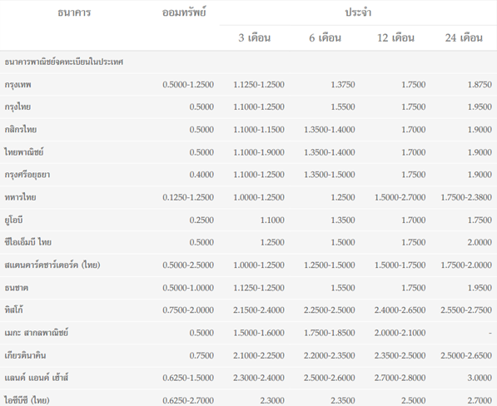

As consumers to choose a suitable bank for my saving account, we choose Land and house bank. The reason is that we consider our return from saving as the first priority. In this case we are looking for a 12 months saving account. From the table provided, LH bank generates up to 2.7-2.8% of interest rate. LH bank has only 119 branches in Thailand and mostly locate in urban area, comparing to Kbank which has 1124 branches located all over the country, making Kbank more convenient than LH bank . However, we still choose LH bank because we do not go to the bank very often, so there is no need to choose the bank with many branches. Lastly, as stated, our first priority is interest rate so what other banks may have better than LH bank have no effect in our decision. Also LH bank is reliable since it is well known at a certain level. The consumer can normally know it from housing investment, etc. Therefore, after comparison for many factors, LH bank is the best choice for me to invest in saving.

References: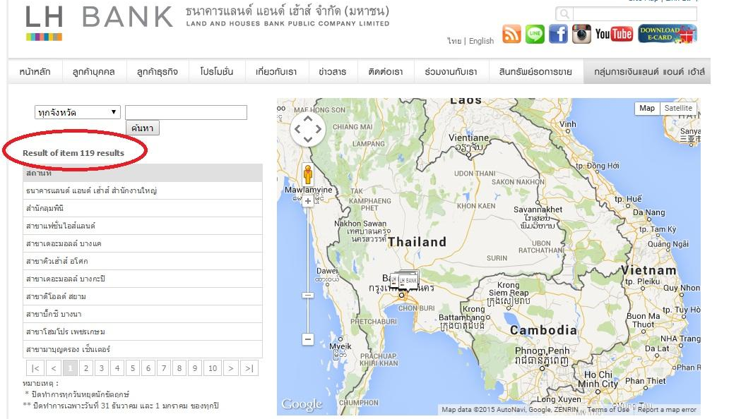

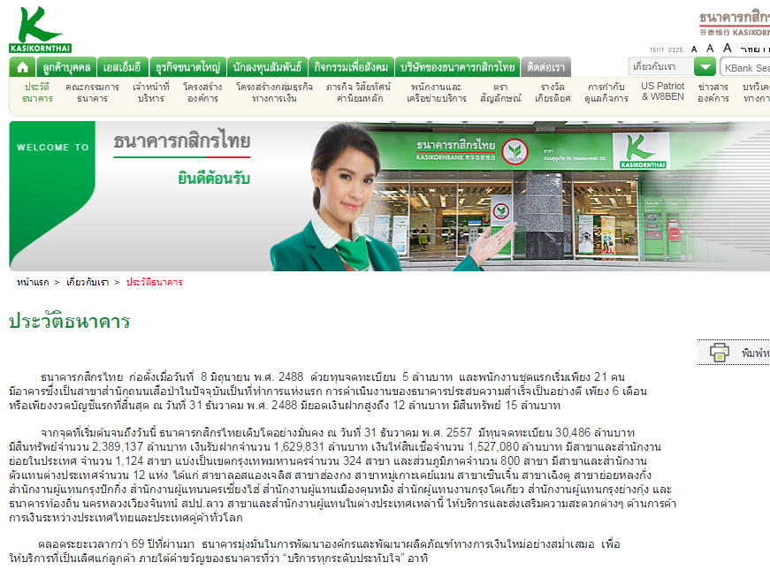

website reference:
https://www.bot.or.th/thai/statistics/_layouts/application/interest_rate/in_rate.aspx
http://www.kasikornbank.com/th/AboutUs/CompanyBackground/Pages/CompanyBackground.aspx

Kitti Tantisrisuk 5404540368
Chutimon Keowkiri 5504640243
Jitlada Sethakomut 5504640383
Tanabodee Ratanachuvongs 5504641779
Thanchon Uersukcharoenku 5504641944
Wan Thabkrajang 5604642016

