Exercise 7 AD-AS Model
- Explain why AD is downward-sloping (that is, how AD is derived), using the money market diagram and the IS-LM.
- AD curve is a downward sloping since it determines the negative relationship between the price level (PL) and output (Y). The money supply is given that MS = nominal amount(M)/price level(P). So, when price level goes up, the MS will go down. As a result, interest rate has to go up to be at equilibrium in the money market. The LM curve will then shift to the left while IS curve stays the same.
- When Price level goes up, there will be a fall in aggregate demand.
- The three reasons behind the change of price level are wealth effect, interest rate effect, and international trade effect.
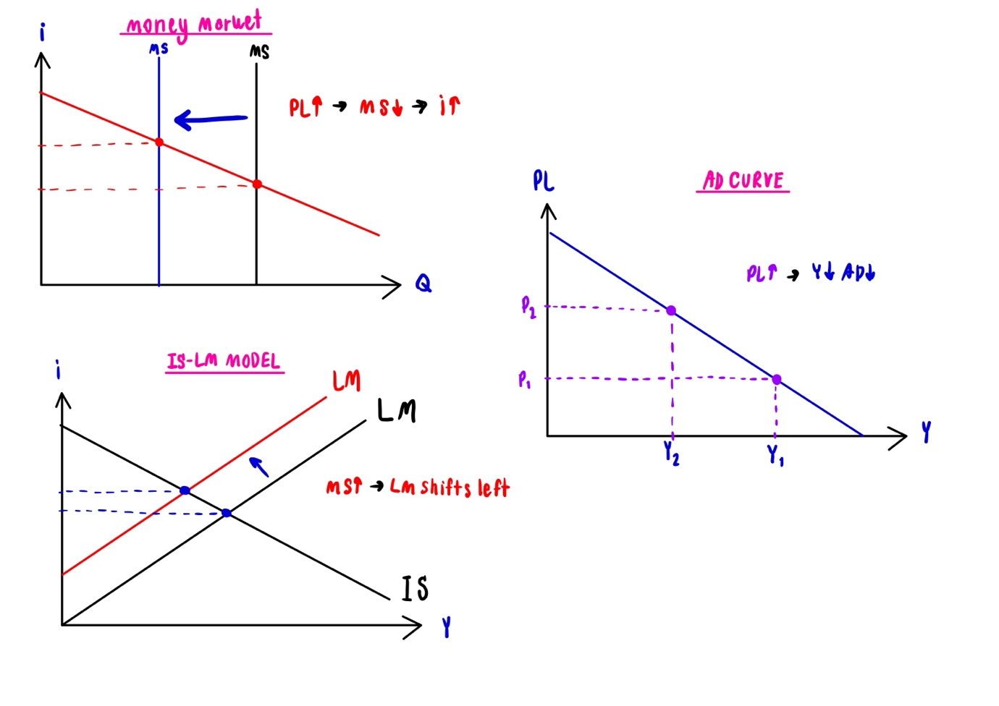

- What is Sticky Wage Theory? Explain why SRAS is upward-sloping (that is, how SRAS is derived), using the sticky wage theory, labor demand diagram, and production function.
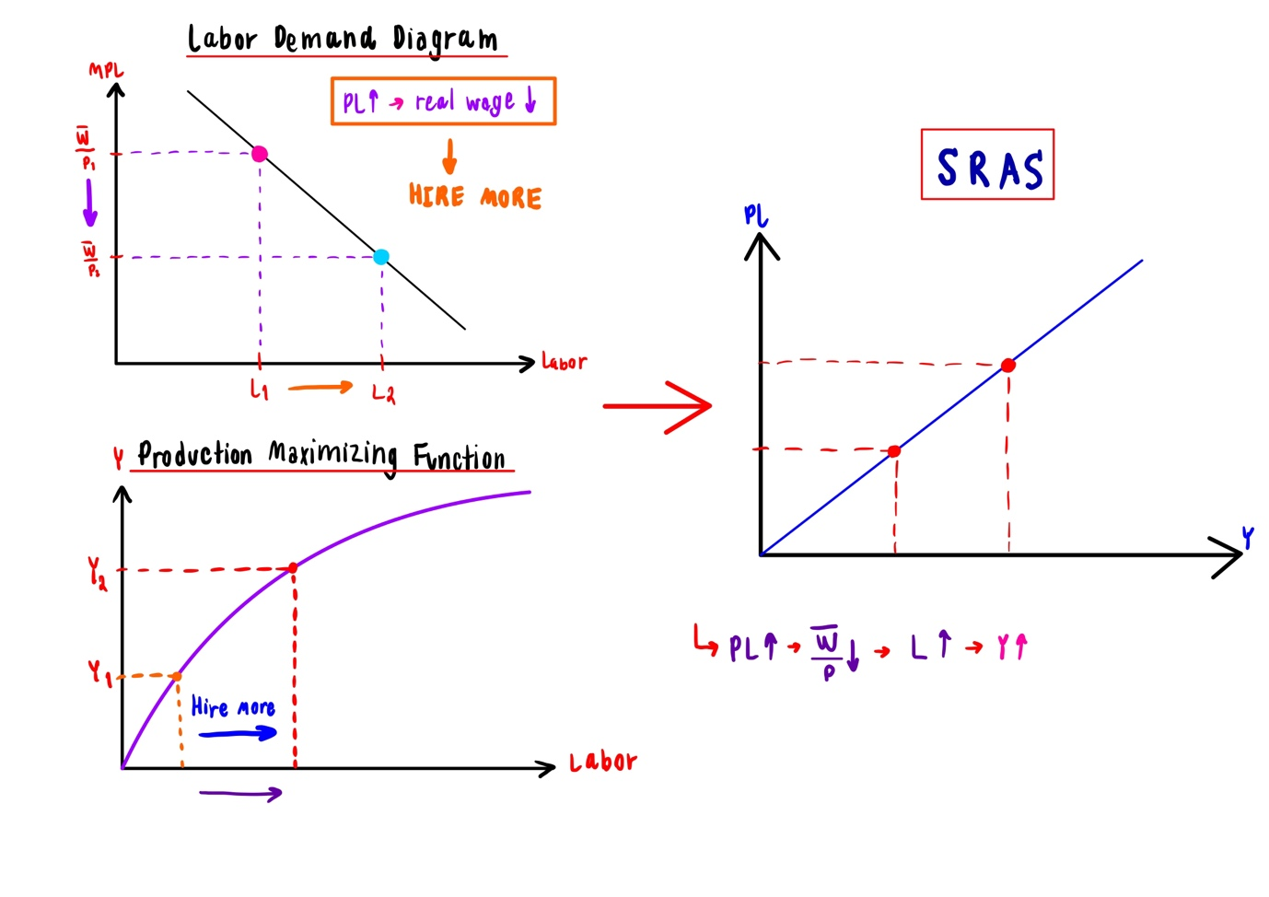
- Sticky Wage Theory is one of the three theories that can be used to derive the Short-run Aggregate Supply curve (SRAS). In short run, the wages are fixed so when PL happens to go up, the nominal wage (w⁻)will remain the same while the real wage decreases. This will result in two reactions: workers are not happy, and firms are happy since it will lower the cost of production. Labor demand will increase. Firms will produce more and the output will increase. There’s a positive relationship between price level and output.

- Explain why LRAS is vertical.
- In the long run, the output will be at the full employment level. Long run Aggregate supply (LRAS) does not depend on price, and hence it is vertical. The price level does not affect the output.
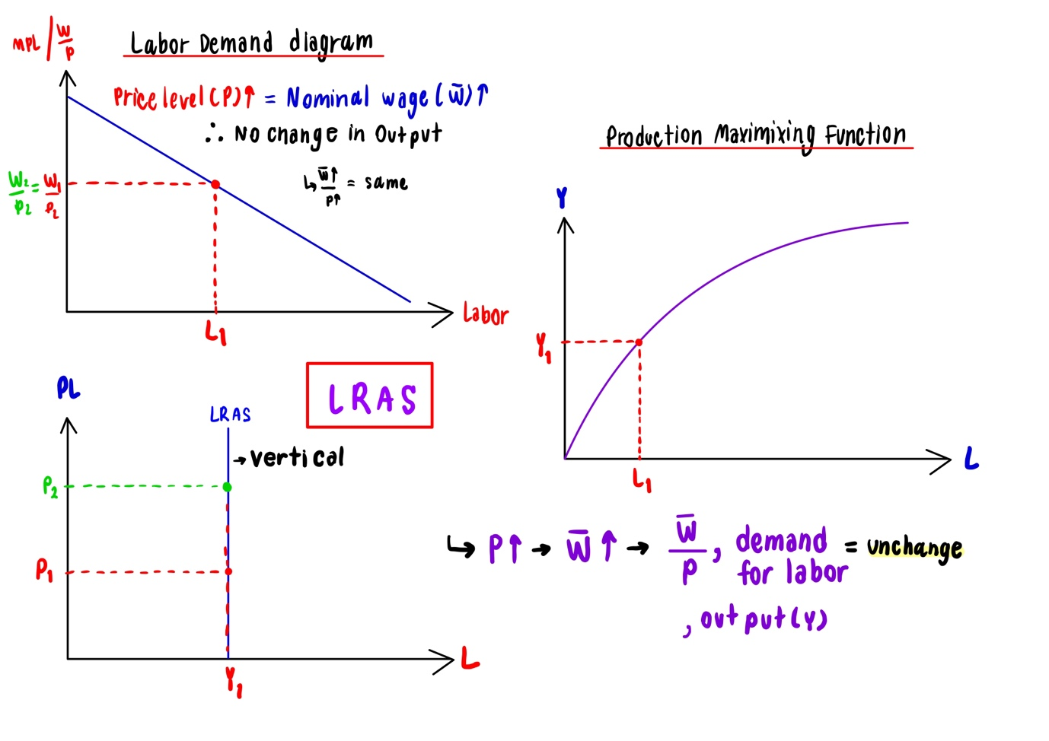
- Workers will ask for more wage as the price level goes up meaning that the wage is no longer fixed. In this case, the nominal wage(w) will increase. The real wage(w/p) will stay the same because both P, W increase.

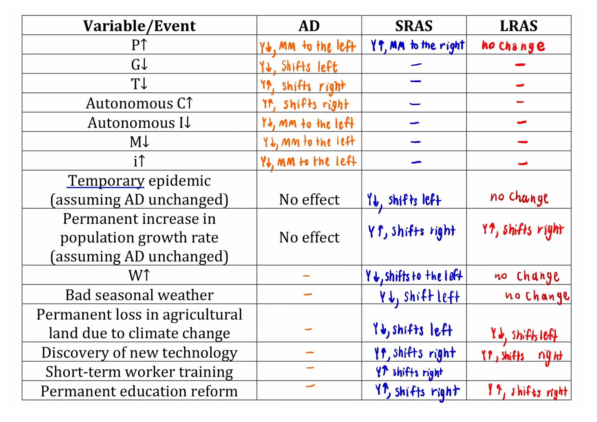
- Cetaris Paribus (other things equal), how will each variable/event affect each curve – shift (to which direction?) or movement?

5. Suppose the economy faces a negative AD shock (e.g. loss in consumers’ confidence).
- What output gap do we have? Draw the AD-AS diagram to show the output gap at the new short-run equilibrium.
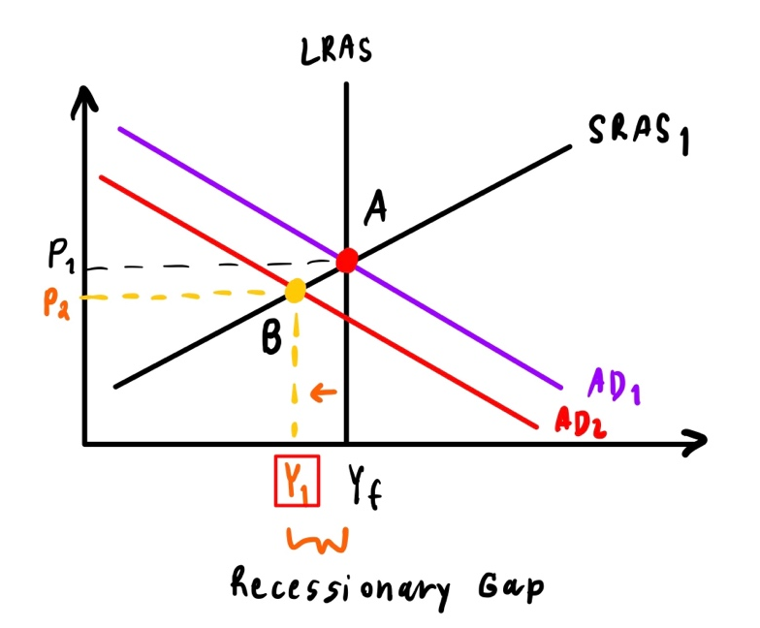
=The output gap that we have is recessionary or deflationary gap.

At point A, there is no output gap since LRAS, SRAS and AD₁ meet. But when there’s a negative AD shock, there is a fall in AD. So now, it falls from AD₁ to AD₂. Making the point A falls to point B at the new SRE instead of LRE before.

- If the government wants to correct such output gap, what policies can it implement? Give examples.
= Expansionary fiscal policy can be used to correct or close the recessionary or negative output gap. The government might decide to raise taxes or decrease spending to fix a budget deficit.
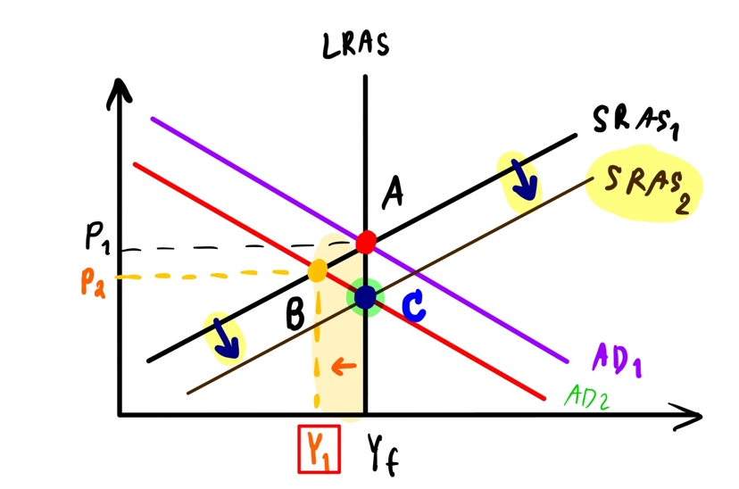
- If there is no government intervention, explain with the AD-AS diagram how the economy will return to the long-run equilibrium.
When there is a recessionary gap means that there is a lot of unemployment, PL decreases/things become cheaper, and the real wage is still expensive. With Self-correcting mechanism, the nominal wage is flexible. As a result, the cost of production decreases which makes the SRAS shifts to the right and return to the long run equilibrium at point C as mentioned in the diagram. (Solved the recessionary gap)

6. Suppose the economy faces a temporary, positive AS shock.
- Give one example of a temporary, positive AS shock.
= An example for a temporary positive AS shock would be a good weather.
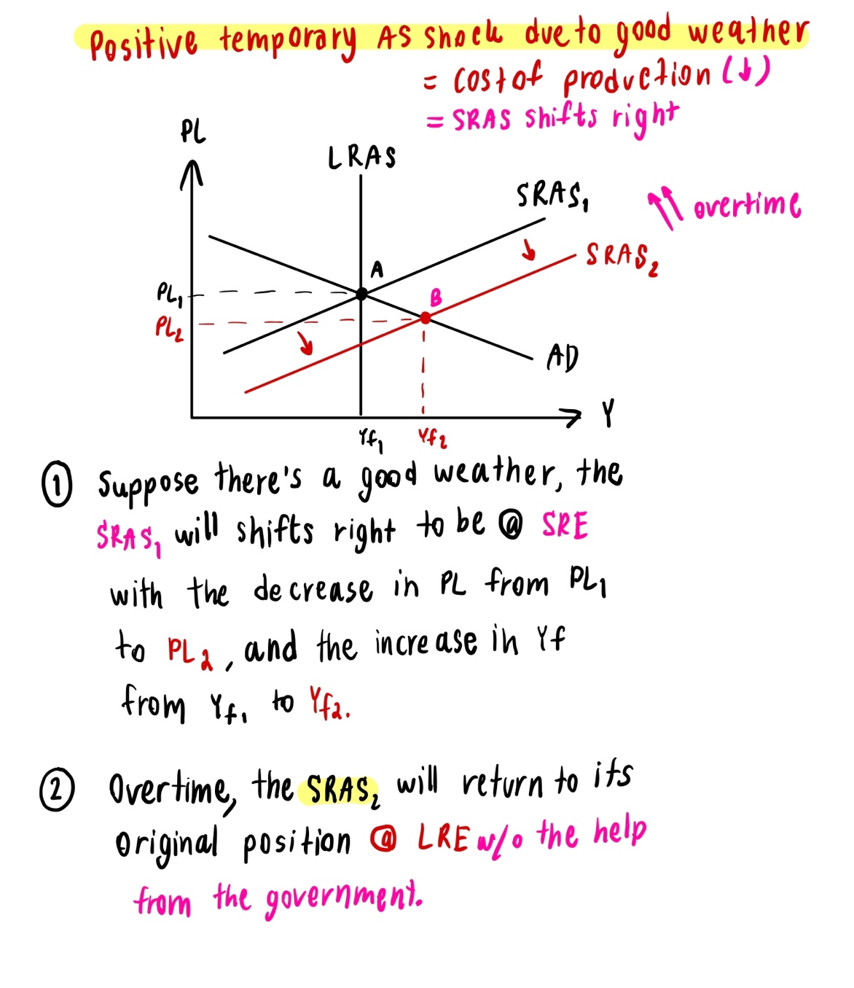
- If there is no government intervention, explain with the AD-AS diagram how the economy will return to the long-run equilibrium.

7. Suppose the economy faces a permanent, negative AS shock.
- Give one example of a permanent, negative AS shock.
= A permanent negative AS shock can be global warming.
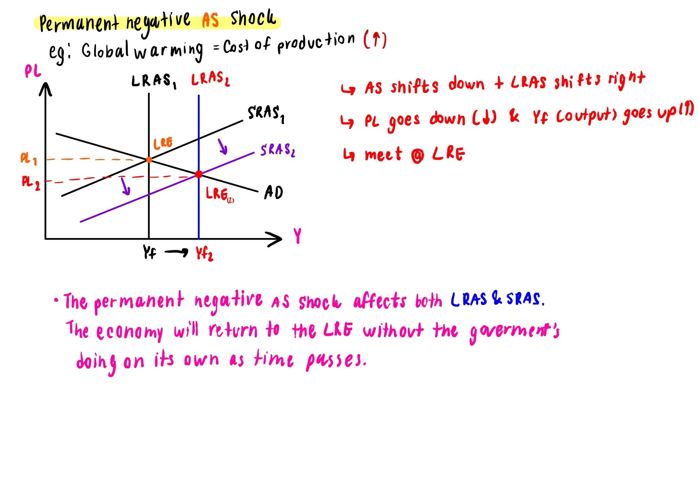
- If there is no government intervention, explain with the AD-AS diagram how the economy will return to the long-run equilibrium.

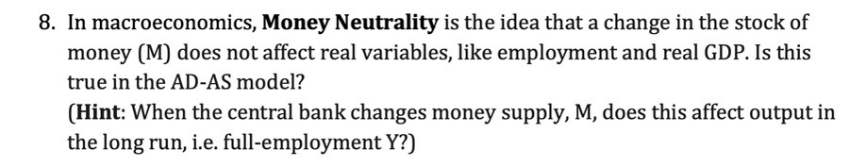
Money Neutrality is the idea that a change in the stock of money (M) does not affect real variables. It is not true in the AD-AS model. When the central bank changes the money supply in this case if the money supply goes up or increases, the LM curve will shift to the right, causing a movement in the AD curve which affects the price level to go down and output goes up which will not be at the long run.
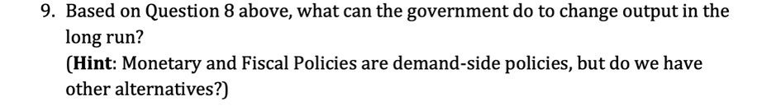
= Apart from Monetary and fiscal policies (demand-side policies), we have supply side policies which are the free-market supply side policy and interventionist supply side policies to shift the AS that the government can apply. According to the theory, supply-side policies will increase productivity and shift long-run aggregate supply (LRAS) to the right.

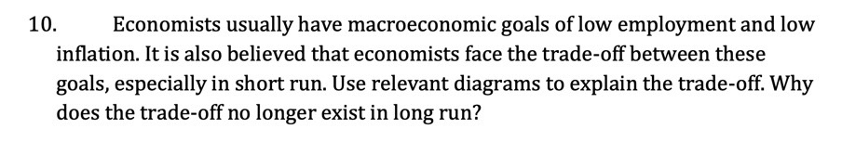
= The Long run aggregate demand is a vertical line since it does not depend on the price level. As unemployment rates increase, inflation decreases; as unemployment rates decrease, inflation increases.


