Class Activity Thinking and Problem Solving

- Use all the letter to form an actual English word. Record the response time for each word.
DNSUO = ___________________ Time: __________
RCWDO = ___________________ Time: __________
IASYD = ___________________ Time: __________
- Answer these questions
- A farmer had 17 sheep. All but 9 die. How many sheep did he have left?
___________________________________________________________

- A stranger approached a museum curator and offered him an ancient bronze coin. The coin had an authentic appearance and was marked with the date 544 BCE. The curator called the police and had the stranger arrested. Why?
________________________________________________________________________________________________________________________________________________

- How would you arrange six matches to form four equilateral triangular?

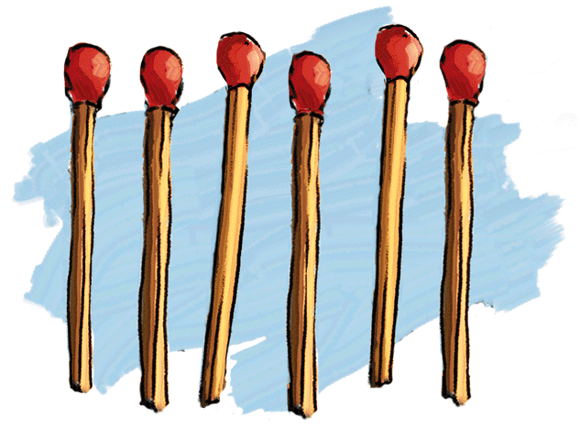

- How to fix a lit candle on a wall (a cork board) in a way so the candle wax won't drip onto the table below. To do so, you may only use the following along with the candle:
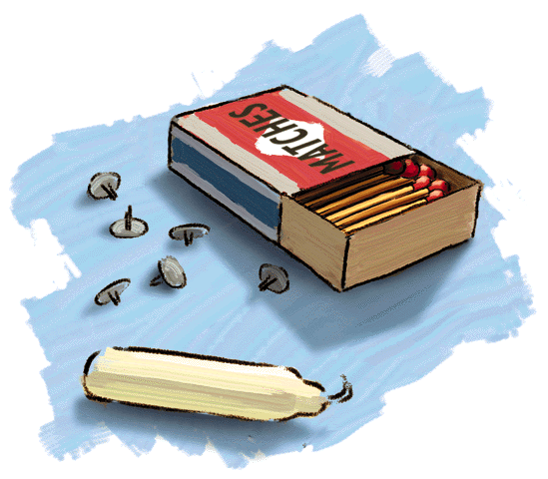
- A box of matches
- A box of thumbtacks (pegs)

- A farmer has a FOX, a GOAT, and a CABBAGE.
He wants to cross a river, but his boat will hold only one item beside himself.
He cannot leave the FOX with the GOAT, or the GOAT with the CABBAGE.
How can he get all THREE across the river?



