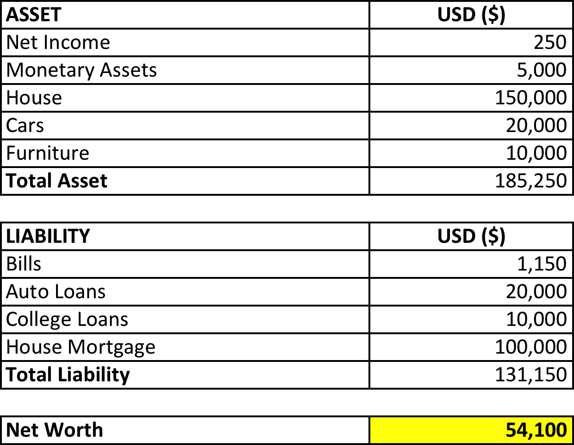
Steve and Mary Jo’s net worth, which is total assets minus total liabilities, is $54,100. This is the Jo’s net economic position. The fact that their net worth is on the positive side demonstrate that they are able to meet all of their financial obligations such as bills and house mortgage. However, their ability to meet all liabilities suggests that certain essential assets may need to be liquidated such as house, cars and furniture. The house appears to be the highest valued asset. Further analysis on their level of liquidity will be assessed further in the paper.
Investors with net worth (excluding primary residence) of at least $1 million, either alone or with their spouse, are considered as accredited investors by the Securities and Exchange Commission, for the purpose of investing in unregistered securities offerings. Although Steve and Mary do not qualify in this category, their net worth is higher than the average Americans whose net worth hovers in the range between $65,000 to $80,000.
It can be seen that majority of the Jo’s asset has low liquidity, which includes house, cars and furniture. In addition, these are not certain form of financial asset that generates return. The only financial asset that the family own is a $5,000 monetary asset. This clearly shows that the Jo’s has not considered long-term investment for their growth in financial wealth, which would contribute to a higher net worth. Liabilities such as auto loans, college loans and house mortgage sums up to a large annual expense on debt. With an annual income of $50,000 it would be a difficult task for Steve and Mary to have large savings and can contribute to financial investment.

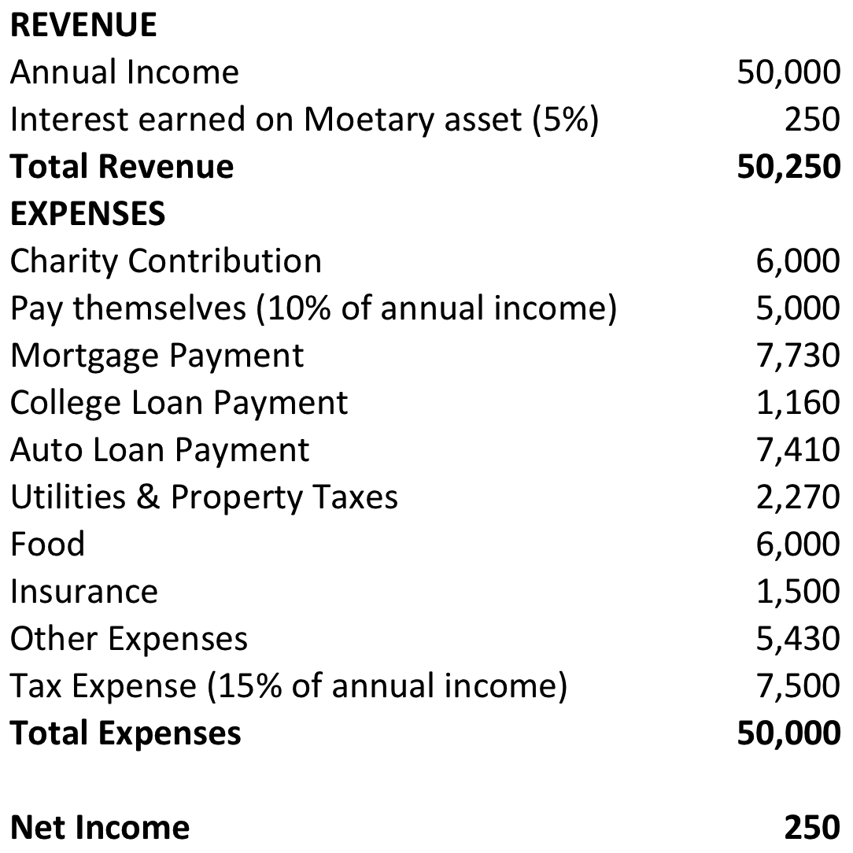

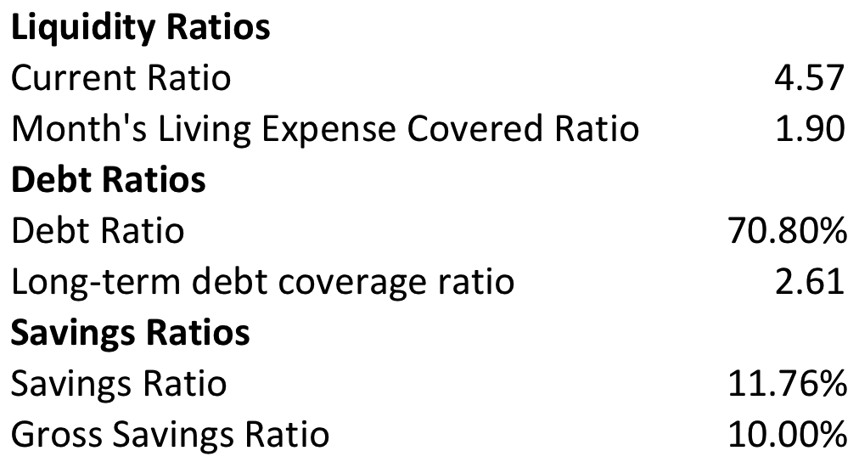

The Jo’s net income is low, but their expense is within their earning limit. They do not have enough money saved for any unexpected expenditure that may arise. Their annual income is too low to be supporting such a large amount of expenses. It is assumed that Steve and Mary earn 5% interest annually on their $5,000 monetary asset. The interest earned is the only source of revenue keeping the Jo’s net income on the positive side. Unnecessary expenses such as $6,000 to charity contribution should be terminated so that Steve and Mary have money for any emergency expenses and hopefully invest for a higher earning. In addition, depending on the level of necessity of other expenses, Steve and Mary should also be reducing expenses from there too.
The fact that Steve and Mary pay themselves 10% of their income shows that they are able to have excess income for leisure expenses totaling $5,000. Car loan expense is expiring within three years. After which point the Jo would have additional revenue of approximately $7,410 annually to spend as they wish. Depending on Steve’s and Mary’s future plan, if they plan on having children, they would need to be saving much more to financially support a child. However, if they choose to not have a child, then their earning and expenses can remain at the same fashion without any financial distress issue in the foreseeable future.
Current ratio of 4.35 suggests that the Jo’s liquidity level is not high, but they are able to meet their short-term obligations. Month’s living expense covered ratio of 1.90 suggests that Steve and Mary are able to cover their annual living expenses slightly less than two months. Reduction of expenses such as mortgages and loans would need to be reducing to increase the ratio. Living expenses is assumed to include all expenses except charity contribution, 10% payment to self and tax expense. Around 70.8% of the Jo’s assets are financed by debt. Long-term debt ratio is 2.61 times shows that the couple is able to cover their long-term debt payments. It should be noted that the inverse of long-term debt coverage ratio is known as the debt service ratio or total debt service ratio, which shows the amount of income that covers debt payment. Debt service ratio is (1/2.61) = 38.31%. The debt service ratio demonstrate that 38.31% of the Jo’s income is use for debt payment. Debt should be reducing in the future so that the couple can save money for investment for retirement or other expense purpose. Approximately 11.76% of income is use for living expenses, which is the savings ratio. Gross savings ratio is 10%, which is relatively in line with savings ratio. At the age of 35, Mary and Jo should be saving more and plan for future expenses. .
I would advise Steve and Mary to start saving more. Car loan payment will complete in three years time and college loan payment will complete in ten years. The additional revenue gained from loan payment completion in the near future should be use for investment in certain forms of financial asset. As recommended before that charity contribution of $6,000 should be terminated and saved for investment. The couple would have to plan for future expenses and retirement. At the age of 35 might be too fast for that but they have no money for emergency usage, which is highly recommended. One point to be made is that the couple’s debt payment is too much. Total debt payment of house mortgage, two car loans and student loan sums up to $16,3000 annually, which is approximately one-third of their annual income. And as mentioned earlier that 70.8% of the Jo’s assets are financed by debt. Ultimately, as mentioned earlier, Steve and Mary need to be saving more by reducing debt and unnecessary expenses such as charity contribution. Depending their level of car usage, maybe one car is enough for Steve and Mary to share.

