Solutions to recommended exercise
Chapter 09 Process costing
Exercise 9-1
a. To record issuing raw materials for use in production:
Work in Process—Molding Department 23,000
Work in Process—Firing Department 8,000
Raw Materials 31,000

b. To record direct labor costs incurred:
Work in Process—Molding Department 12,000
Work in Process—Firing Department 7,000
Wages Payable 19,000

c. To record applying manufacturing overhead:
Work in Process—Molding Department 25,000
Work in Process—Firing Department 37,000
Manufacturing Overhead 62,000

d. To record transfer of unfired, molded bricks from
the Molding Department to the Firing Department:
Work in Process—Firing Department 57,000
Work in Process—Molding Department 57,000

e. To record transfer of finished bricks from the Firing
Department to the finished bricks warehouse:
Finished Goods 103,000
Work in Process—Firing Department 103,000

f. To record cost of goods sold:
Cost of Goods Sold 101,000
Finished Goods 101,000

Exercise 9-2
Weighted-Average Method

 | Equivalent Units (EU)
 | Materials | Conversion
Units transferred out | 190,000 | 190,000
Work in process, ending:
15,000 units × 80% | 12,000
15,000 units × 40% |  | 6,000
Equivalent units of production | 202,000 | 196,000

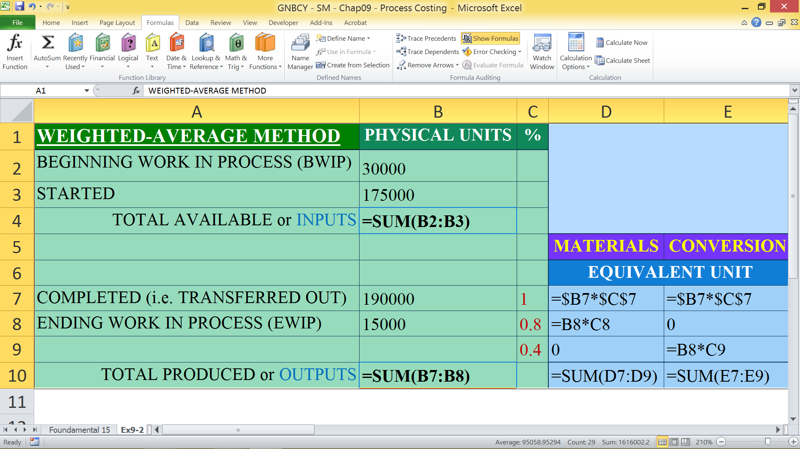
Exercise 9-3
Weighted-Average Method
1.
 | Materials | Labor | Overhead
Cost of beginning work in process inventory | $ 18,000 | $ 5,500 | $ 27,500
Cost added during the period | 238,900 | 80,300 | 401,500
Total cost (a) | $256,900 | $85,800 | $429,000
Equivalent units of production (b) | 35,000 | 33,000 | 33,000
Cost per equivalent unit (a) ÷ (b) | $7.34 | $2.60 | $13.00
2.
Cost per equivalent unit for materials | $ 7.34
Cost per equivalent unit for labor | 2.60
Cost per equivalent unit for overhead | 13.00
Total cost per equivalent unit | $22.94

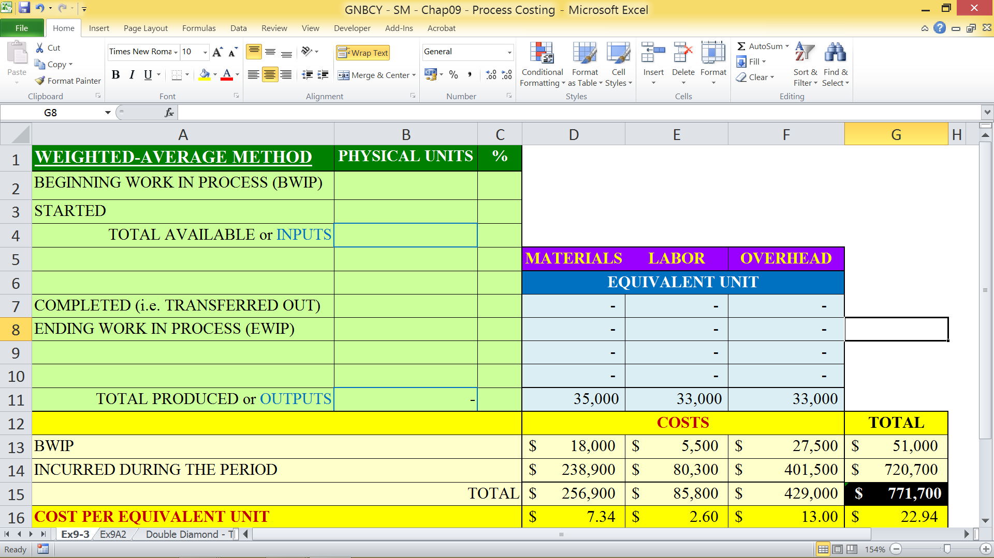

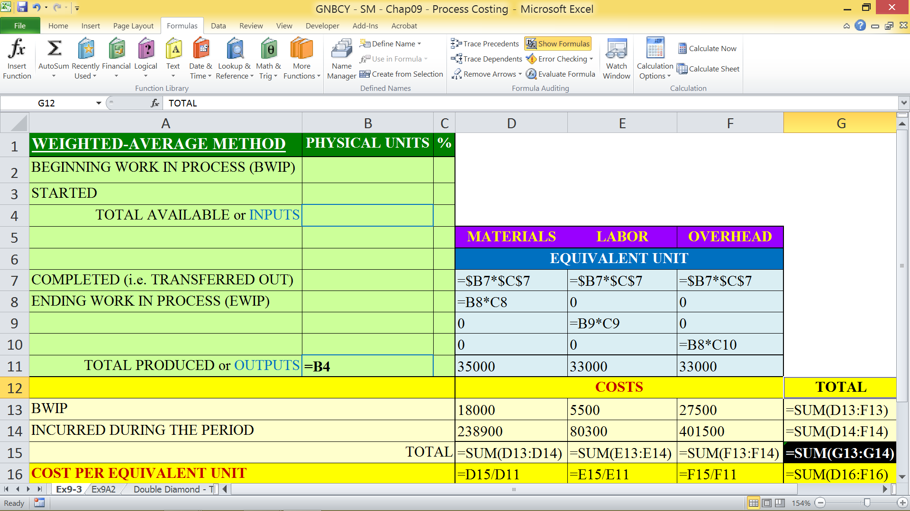
Exercise 9-4
 | Materials | Conversion | Total
Ending work in process inventory:
Equivalent units of production | 2,000 | 800
Cost per equivalent unit | $13.86 | $4.43
Cost of ending work in process inventory | $27,720 | $3,544 | $31,264
Units completed and transferred out:
Units transferred to the next department | 20,100 | 20,100
Cost per equivalent unit | $13.86 | $4.43
Cost of units transferred out | $278,586 | $89,043 | $367,629

Problem 9-14
Weighted-Average Method

1. | Equivalent units of production
 |  | Materials | Conversion
 | Transferred to next department* | 95,000 | 95,000
 | Ending work in process:
 | Materials: 15,000 units x 60% complete | 9,000
 | Conversion: 15,000 units x 20% complete |  | 3,000
 | Equivalent units of production | 104,000 | 98,000

*Units transferred to the next department = Units in beginning work in process + Units started into production − Units in ending work in process = 10,000 + 100,000 − 15,000 = 95,000

2. | Cost per equivalent unit
 |  | Materials | Conversion
 | Cost of beginning work in process | $ 1,500 | $ 7,200
 | Cost added during the period | 154,500 | 90,800
 | Total cost (a) | $156,000 | $98,000
 | Equivalent units of production (b) | 104,000 | 98,000
 | Cost per equivalent unit, (a) ÷ (b) | $1.50 | $1.00

3. | Cost of ending work in process inventory and units transferred out
 |  | Materials | Conversion | Total
 | Ending work in process inventory:
 | Equivalent units of production | 9,000 | 3,000
 | Cost per equivalent unit | $1.50 | $1.00
 | Cost of ending work in process inventory | $13,500 | $3,000 | $16,500
 | Units completed and transferred out:
 | Units transferred to the next department | 95,000 | 95,000
 | Cost per equivalent unit | $1.50 | $1.00
 | Cost of units completed and transferred out | $142,500 | $95,000 | $237,500
Problem 9-14 (continued)
4. | Cost Reconciliation
 | Costs to be accounted for:
 | Cost of beginning work in process inventory  ($1,500 + $7,200) | $ 8,700
 | Costs added to production during the period  ($154,500 + $90,800) | 245,300
 | Total cost to be accounted for | $254,000
 | Costs accounted for as follows:
 | Cost of ending work in process inventory | $ 16,500
 | Cost of units completed and transferred out | 237,500
 | Total cost accounted for | $254,000



