More Exercise for Income Statement
For self-study, no submission, you can see answer key on the next page
8. Willow Company manufactures and sells travel luggage. In their 2017 and 2018 financial years, they sold its specific type of luggage 800 units and 1200 respectively at 2,500 THB each. Cost of goods sold per unit was 350 THB in year 2017 and 400 THB in 2018. Selling, General & Administration expenses for 2017 and 2018 was 90,000 THB and 900,000 THB respectively. In both financial years, the company paid 30,000 THB interest expenses and paid their income tax at 30% of the operating income. a.) Construct a comparative Income Statement for the company for both financial years. b.) Calculate gross profit ratio and net profit ratio. Briefly interpret the results.

Answer:

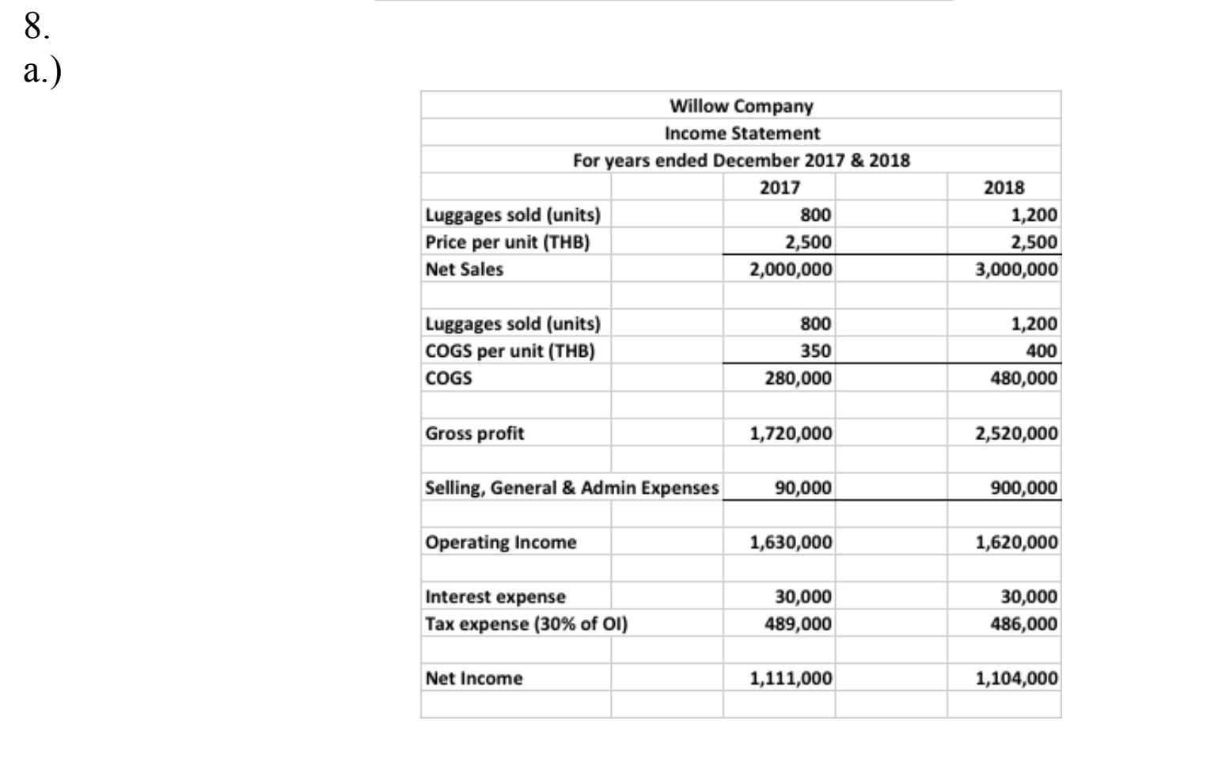
b.)
Gross profit ratio: Year 2017 0.86; Year 2018 0.84 – for every dollar of sale in years 2017
and 2018, $0.86 and $0.84 returned as gross profit respectively.
Net profit ratio: Year 2017 0.55; Year 2018 0.37 – for every dollar of sale in years 2017
and 2018, $0.55 and $0.37 returned as net profit respectively.

