The gravity of China’s great fall

Aug 25th 2015, 11:54 BY THE DATA TEAM

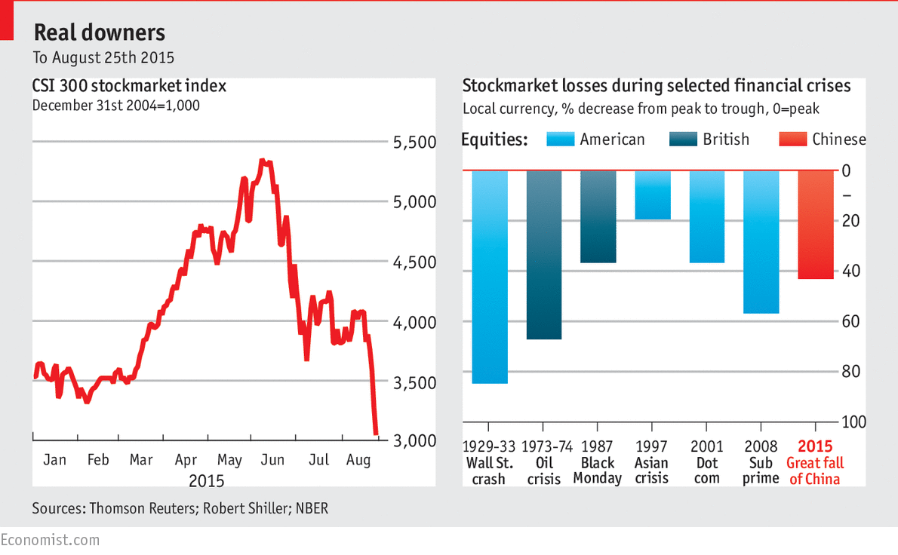
INTERACTIVE: Latest Chinese stockmarket data and exchange rates
ASIAN markets are once again driving traders batty. A mammoth 8.5% plunge in China's stockmarkets on Monday, August 24th, touched off a wild day on global markets: in which Japanese and European stocks plummeted (as did American shares, before staging a remarkable turnaround) prompting commentators to liken the situation to previous crises from the Wall Street crash of 1929 to the Asian financial crisis of 1997. A day later, the Shanghai Composite Index continued its plummet, falling a further 7.6% as the market closed on August 25th.
Asian share prices have had a brutal summer. China deserves much of the blame. Its own market has crashed (falling by over 40% from its peak, and losing all the ground gained in 2015) amid worries about the pace of China's economic slowdown. Slackening Chinese demand for goods and commodities would represent a big blow to its Asian neighbours.
The region has also been squeezed by a reversal of capital flows back toward the rich world, which has been accelerating as America's Federal Reserve moves closer to interest rate increases. The currencies of Asia's large economies have been falling as a result: Malaysia's ringgit is down by 19% since May 1st, for example, while the Indonesian rupiah has dropped 8%. Despite those declines, which boost export competitiveness in those economies, export growth has slowed dramatically. There will probably be more market wobbles ahead.


