1) Research current economic conditions (interest rates, inflation) using The Wall Street Journal, other library resources, or the World Wide Web. Based on current economic conditions, what actions would you recommend to people who are saving and borrowing money?

Global Economy

In 2015, the overall outlooks for global economic activity remained depressed. The growth in emerging market and developing economies, which account for approximately 70 percent of global growth, still declined for the fifth consecutive year. However, the emerging countries in Asia, especially India, are expected to grow vigorously, even though the China’s economic rebalancing and weak global demand may impact some relevant countries. In advanced economies, the growth is expected to rise by only 0.2 percentage point in 2016. In the Euro area, despite of the weak net export, there is a stronger private consumption supported by lower oil prices and easy financial conditions. For Japan, the growth is likely to be more stable due to the rising domestic consumption and fiscal support.
After all, in 2016, there will be three key transitions continue to influence the global outlook: (1) the slowdown and rebalancing of economic activity in China, (2) an expected tightening in monetary policy in the United States, and (3) the lower prices for energy and other commodities.
The growth in China is forecasted to grow by 6.4 percent from 6.9 percent in 2015 and, reflecting the economic weakness as a result of the falling in domestic investment and total trade. Since, Chinese government try to concentrate more on sustainable growth of the country by shifting from the boosting the government spending and investment to promoting the domestic consumption, China’s economy should remain in the balancing period for two to three years. Additionally, the devaluation of Yuan becomes lowest in the last five years, emphasizing that the capital still flows out of the country. Hence, the Chinese government is forecasted to stimulate its economy by lowering the interest rate and expect the further devaluation of the currency.
In United States, the overall activities show a good sign of recovery due to the strong labor market and housing sector, which support the domestic consumption. However, the lower oil price along with the appreciation of US dollars put a pressure on the investment and export sector. According to the inflation that has a tendency to increase, the US government expects to gradually increase its interest rate but not in the near future since it might weaken some foreign countries and eventually further restrain domestic economic activity. Therefore, we might expect that there is the limited downside for THB to depreciate because of the less possibility of increasing FED interest rates.
In mid-2014, the crude oil price was more than US$100 per barrel but, nowadays, it plunges by more than 70%, which went around US$26 per barrel in January and bounced back to around US$30 per barrel. The main reasons behind this bearish in oil price are oversupply for oil and decreasing in demand. The oversupply for oil caused because, at first, OPEC had increase the production, especially Saudi Arabia who want to maintain the largest market shares, and then US began to export their oil to the world market, so this raised the supply for oil. Afterward, Iran started to export their oil as well after the lifted of sanction and boycott on Iran’s oil export. Therefore, we can see that this created the oversupply in oil and lower the oil price to below US$30 per barrel in this year. However, the latest news is that Saudi Arabia, Qatar, Venezuela, and Russia said that they would freeze the oil production at this level, so we expect that oil price will be traded around US$28-US$32 per barrel in this year until oil producers agree to cut down the oil production, with the risk awareness that if there are some conflicts among these producers, there might be the increasing in output and the decline in the oil price to US$15-US$20 per barrel. In addition, the weak demand for oil was caused by the world economic slowdown and lead to the weak demand for oil as well. Moreover, investors also panic about the fall in oil price and likely to linked with the concern about the inflation, so this slow down the investment from investors.

Thailand Economy

The growth rate of GDP has a decreasing trend since 2012 till 2015 as there is some limitation in the economic growth which come from both internal and external factors. But later in 2015, there is a sign of recovery of the economy which driven from a significant increase in consumption both public and private. Nevertheless, the increase in private consumption come from the excise taxes that are going to rise in the next year that induce people to purchase a car now rather than purchase it next year and pay higher taxes, so we see this effect as the temporary increase in consumption and this year consumption will slow down from last 4th quarter. For, the drop in oil price result in higher purchasing power and thus increase the spending of people for short-term but, in long-term, the fall in oil price will pull down the inflation and it will be the negative signal for the economy. However, last year there was an increase in the government spending which come from the investment in telecommunication business and irrigation and, in this year, we expect that government will invest in infrastructure project as they promised. For investment in the country that last year increases due to the temporary effect of acceleration in car manufacture, we expect that this year the investment from private sector will increase with the increase in government spending. For the export of Thailand, the value of export drop by 9.1% from last year which result from the contraction in the economy of China and ASEAN countries. The value of import of Thailand also drop by 8.7% from last year which mainly come from the decrease in import of fuel that correspond with the changing in the price of oil. But the import of consumer products still expand as the higher in the numbers of tourists and the higher private consumption in the country.
In conclusion, the overall stability of the economy in Thailand is quite remain the same, compared to last year. The factor that might increase the GDP in this year is mainly from government spending but we also weigh less in this factor because of political instability, so we expect less on private investment as well. Moreover, private consumption and import are expected to slow down due to the global economic slowdown and the long-term impact from low oil price. For export, we see that the impact of depreciation in THB is not effective to increase the export volume, since the demand from foreign countries are still weak and China, which Chinese Yuan had devalue and have lower cost of labor, might be more attractive for foreign countries to import from China. Therefore, we expect that BOT will remain interest rate unchanged at 1.5% on this year with the tendency to decrease in the future. We recommend borrower to borrow money to invest because of this low cost of holding money, while saver should seek for higher return from saving rather than Thailand, for instance India that strongly grow with high interest rate, or invest in other assets that give higher return, for example stocks, bonds, or mutual funds. However, if savers didn’t concern much to receive high return or just satisfy with the return that higher than inflation, they can save within Thailand.

2) Collect advertisements and promotional information from several financial institutions, or locate the Web sites of financial institutions. Create a list of factors that a person might consider when comparing costs and benefits of various savings plans.

BBL Terms and Conditions

Saving account:

- Cash deposits and withdrawals can be made at any time for any transaction amount with an interest calculated daily and automatically transferred into your savings account every six months (June and December).
We have the convenient provided by the spending with a Be1st Debit card or Be1st Smart card and utility and bill payments using the Bualuang Direct Debit service
With a Statement Savings Account you can print out a free statement at any Bangkok Bank ATM.

Current account

- The account is non-interest bearing and it comes with a cheque book - you can just write a cheque whenever and wherever it's convenient.
- It can be opened with a THB 10,000 deposit at your home branch.
- You can purchase a cheque-book containing 20 personalized cheques.
- A statement of transaction will be sent to you twice a year so that you can see your transaction movements, moreover, you can also request that the Bank provides you with a statement every day, every week, every 15 days or every month.

Time deposit

- These accounts are stable and secure and protected under the Deposit Protection Agency Act.
- It requires a minimum deposit of only THB 2,000 in a three month, six month, one year, two year, or three year term.
- You can also use your deposit as a guarantee for a loan.
- Retail consumers are liable for a withholding tax of 15% on the interest received on a deposit account. It will be paid automatically by Bangkok Bank. You can request the bank to issue a certificate of withholding tax on interest which you can use for a tax exemption. It’s free.
Convenient
- Multiple Deposits: This gives you the advantage of not having to carry more than one passbook. If you add to your deposits over a period of time they will mature at different times. This means you have more flexibility when it comes to withdrawing your money.
- Early Withdrawals: If you withdraw your money prior to three months, you will get no interest on your deposit. If you withdraw money from your six-month or twelve-month account after three months but before it matures, you will get the same interest rate as a savings account.

KTB terms and conditions
Saving account
- A minimum of THB 500 deposit required to open an account
- Short-term savings account, convenient for deposit and withdrawal
- Automatic direct debit bills payment for utilities
- Daily interest calculation at the rate specified by the bank and payable twice a year at the end of every accounting period and paid twice a year with Krungthai Savings Account.
Convenient
- Passbook, ATM card or VISA debit card are convenient tools that can be used to make payments in leading stores and cash withdrawal at VISA-endorsed ATM machines worldwide
- Financial transaction such as fund transfer, bill payment, auto direct debit through other KTB e-banking channels including ADM, ATM, Auto Update Passbook, Internet Banking, Krungthai Telebank, Mobile Banking, and KTB Online
- Deposit and withdrawal at all branches
- VDB/ATM available for individual customers to allow convenient for deposit and withdrawal as well as product and service payments (for VDB card)

Current account
- Minimum initial amount of THB 10,000 deposit is required for both individual customers and juristic persons
- Every of your business will become much easier KTB CAC We speed, mobility, and flexibility suitable for business owners, both individuals and juristic persons. Deposits, withdrawals, and overdraft credit to smoothen your business are available at every KTB branch.
Convenient
- KTB Deposit Current Account is a cheque operated account to facilitate business’ financial transactions which makes deposit and withdrawal easy matters
- The cheque allows you to deposit and withdraw under the given credit limit specified by the bank at any branches
- ATM/VDB cards to facilitate cash withdrawal anywhere and anytime
- ATM service from your savings to your current account to facilitate check payment
- Overdraft (OD) credit to increase business’ liquidity

Time deposit

Choose your own saving period
- Fix your saving period, for example 3, 6, 12, 24, 36 months
- Fixed interest as announced by the bank at the time of deposit
- Minimum 1,000 Baht per deposit for 3, 6, and 12 months fixed deposit. Interest is payable at the end of deposit term
- Minimum 1,000 Baht per deposit for 24 and36 months fixed deposit. Interest is payable every three months by direct transfer to the principle account (saving or current account)

Fixed Deposit of 3 , 6 and 12 months | Fixed Deposit of 24 and 36 months
3 month account –  no interest for premature withdrawal | No interest for premature withdrawal within the initial 3 months
6 and 12 months account with minimum 3-month deposit duration –  withdrawal before due, interest of which shall be calculated based on saving account interest rate according to type of account at the date of withdrawal and subject to withholding tax | Deposit over 3 months  Interest shall be calculated based on actual deposit period according to type of account at the date of withdrawal and subject to withholding tax. Excess interest paid by the bank shall be deducted against the principle
In case that the deposit term is mature on the bank’s holiday and the matured sum is withdrawn on a working day after such holiday  the interest shall be calculated for such holiday in addition to the specified maturity date at the previously specified rate | At the maturity of the deposit, the sum shall be transferred to the principle account (saving or current account) as specified to the bank

Krungsri Terms and conditions
Saving account
General saving deposit
- An opening balance of only THB 500 you will be given a passbook to record your deposits and withdrawals.
- Direct debit service is available for you to settle your purchases and utility bills, such as electricity, running water and telephone, among others; and can be made monthly matching the amounts shown on your billing statements. Our staff is pleased to assist you should you wish to use this payment option.
- The interest rate payment will be made on June and December
- There will be tax exemption when the interest rate is lower than THB 20,000 per year.
Mee Tae Dai savings
- An opening balance of only THB 500 you will be given a passbook to record your deposits and withdrawals.
- Only 2 transactions are free, the third or more transaction will charge by THB 50 each time which we will deducted from the account by the next day automatically.
- An ability to earn higher interest rate compares to the general saving deposit (0.6%).
- Receiving interest rate monthly.
- Withdraw or transfer cash via branches, ATM, online anytime anywhere
Convenient
- Krungsri Online – our Internet banking service
- Krungsri ATM Card
- Krungsri VISA Electron/Krungsri Debit cards, which can be used with Krungsri ATM system
- Krungsri Mini ATM Card
- Krungsri Phone 1572

Current account
- Opening with a minimum initial amount of THB 10,000.Then, you can instantly use the Current Account, draw cheques for payments and withdraw cash from the Bank’s branches nationwide.
- A direct debit for purchases of goods, services and utility bill payments can also be made from this account.
Convenient
- Krungsri Online – our Internet banking service
- Krungsri ATM Card
- Krungsri VISA Electron/Krungsri Debit cards, which can be used with Krungsri ATM
- Krungsri Mini ATM
- Krungsri Phone Banking 1572
Time deposit
- Individuals and juristic persons can open a General Time Deposit account with an opening balance of only THB 1,000. You will be given a passbook to record your deposits and withdrawals.
- Offering higher interest return.
- We offer various tenures from 3, 6, 12, 24 to 36 months
- The withdrawals of the principal and interest can be made upon the agreed maturity. You can also choose to roll over just the principal or both the principal and interest return for another term, thus contributing to an efficient accumulation of your money.
- Holders earn not only interest, but they can also use the account as collateral when applying for a loan from us.

K-bank Terms and conditions
Saving account
- Required minimum deposit of account opening is THB 500.
- Deposit and withdrawal can be conducted every day at any K-Bank branch nationwide, without daily limits on the number of transactions or amount.
- Increase interest in your account every day! Interest will be calculated and credited to your account at the end of every accounting period (in June and December).
- Your account can be used as collateral for loan application.

Convenient
- You can use a K-Bank ATM Card, K-Debit Card or K-Credit Card linked to your savings account.
- Financial transactions including deposit, withdrawal, funds transfer, and bill payment can be conducted at any K-Bank branch throughout the country or via K-Bank electronic channels, i.e., K-ATM, K-CDM, K-Contact Center at tel. 0 2888 8888, or K-Cyber Banking.
- Provide direct debit service for utility bills including water, electricity, telephone or mobile phone.
- Passbook renewal can be conducted at any K-Bank branch nationwide.
- Maximum daily withdrawal at K-Bank branches is up to 2,000,000 Baht with presentation of your savings deposit passbook and national ID card.
- Maximum daily withdrawal at an ATM is 200,000 Baht.

Current account

- Deposit a minimum of THB 10,000 for individuals, or 30,000 Baht for associations
- If the balance in a Current Account falls below 1,000 Baht, customers will be charged a small custodial fee

Convenient
- Can be used in conjunction with ATM Card, KBANK Credit Cards, Debit Cards, and KBANK e-Phone Banking Services.
- Can be used with KBANK Direct Debit Services to pay for a variety of products and services.

Time deposit

- Required minimum deposit of account opening is THB 1,000.
- Ensure greater convenience! Deposit and withdrawal can be conducted at any K-Bank branch across the country.
- Get more attractive and stable interest than that of a standard savings account.
- Your account can be used as collateral for loan application.
- Issuance of certification of withholding tax on interest on fixed deposit, free of charge.
- Passbook update and renewal can be conducted at any K-Bank branch across the country.

Convenient
- Fixed deposit terms are available, i.e., 3-, 6-, 12-, 24-, 36-month periods, or others as stipulated by the Bank.
- If money is withdrawn from the account prior to the agreed deposit period, interest will be paid at a Bank-specified rate

SCB Terms and conditions
Saving account
- Minimum deposit required for open the account is THB 500 with the next deposit minimum of only THB 10.
- You can deposit or withdraw in anytime with unlimited numbers of transactions.
- The interest will be paid semiannually on 25th of June and 25th of December in each year
- 15% tax on the interest received on a deposit account.
- If the overall interest income from your deposit accounts in every financial institution are less than or equal to THB 20,000 per year, you will be exempted 15% of tax (only for individual)
- This deposit will be protected by Deposit Protection Agency within amount stated in the law which will not be higher than THB 25 million up until August, 10th 2016 and not more than THB 1 million after August, 11th 2016.
- This account will be able to deposit, withdraw, or transfer with unlimited times of transaction.
- The convenient provided by this account will make your life becomes easier as we will update the statement of the account by E-statement which will be send to your Email address directly. Moreover, you can recheck the account by your own from Easy net system and ATM in any place and anywhere easily.

Current account

- This account is the one providing the ability to deposit or withdraw the money in anytime with unlimited transactions.
- The cheque will be available for easier spending method which letting you don’t have to carry the passbook around.
- A minimum deposit required to open the account is THB 10,000 with the next deposit at least only THB 10.
- This deposit will be protected by Deposit Protection Agency within amount stated in the law which will not be higher than THB 25 million up until August, 10th 2016 and not more than THB 1 million after August, 11th 2016.
- The convenient provided by this account will make your life becomes easier as we will update the statement of the account by E-statement which will be send to your Email address directly. Moreover, you can recheck the account by your own from Easy net system and ATM in any place and anywhere easily.

Time deposit
- Open with a minimum initial deposit of only THB 1,000.
- Plan your short-term or long-term savings with a choice of 3 month, 6 month, 12 month, 24 month, or 36 month deposits.
- Convenient cash deposit or withdrawal at any SCB branch nationwide.
- Enjoy low risk while benefiting from a fixed interest rate and loan guarantee acceptance.
- No more fluctuating interest rate worries.

TMB Terms and conditions
Saving account
- A minimum of 500 Baht is required for account opening.
- Deposit can be made at every TMB branch nationwide without limit.
- Withdrawal can be made at any TMB branch nationwide without limit.
Current account
- Deposit a minimum of THB 10,000
Time deposit
- Both individuals and juristic persons can open fixed deposit accounts.
- For fixed deposit accounts with passbooks, the minimum initial deposit to open an account amounts to THB 1,000 baht.
- The minimum initial deposit to open an account amounts to THB 10,000.
- Withdrawals can be made at any branch. [However, in case of withdrawals at other branches than the one where the account is opened, the maximum cash amount that can be withdrawn (using the depositor's passbook) is 1,000,000 baht per day.]
- Except the fixed deposit accounts which pay interest periodically, depositors can partially withdraw their fixed deposits.
- If the customer closes the account within 3 months after opening it, the Bank will pay no interest.
- If the customer does not withdraw the deposit upon maturity, the aggregated principal and interest will be automatically redeposit for the same term.
- For accounts with a deposit period of 6, 12, 24, to 36 months, if the depositors maintain their deposit for over 3 months but close their accounts before maturity, the Bank will pay interest for the actual deposit period at a rate of 0.50% per annum, except for depositors who are financial institutions or non-residents (to whom the Bank will pay no interest).
- For 3, 6, 12 months’ type, principal withdrawal, can withdraw for some amount of money.
- For 24, 36 months’ type, principal withdrawal, must withdraw the whole amount of deposit in each list.
Convenient
- The Bank will pay interest when the deposit reaches maturity, with the interest being added to the principal right away.
- The Bank will pay interest periodically in accordance with the conditions set out for the periodic interest payments and in line with the notifications issued by the Bank.
- The interest income earned by individuals is subject to 15% tax.
- The interest income earned by juristic persons may be subject to tax.

Kiatnakin Terms and conditions
Saving account (KK Saving plus)
- Can be opened for individual or juristic person.
- Required minimum initial deposit is 1,000 Baht and account can be opened at all branches.
- The Bank shall calculate interests on a daily basis based on the remaining balance and the interests shall be paid semiannually on 30 June and 31 December (after withholding tax).
- The Bank reserves the right to take a withholding tax from the interest payment and deposit according to the condition of the Revenue Department, unless the tax is exempted.
- The Bank reserves the right to change interest rate and other conditions as deemed suitable.
Convenient
- More than your deposit, you will get the higher interest rate.
- Get interest according to the deposit amount.
- Make deposit or withdraw every day, no limit on frequency.
- Convenient and flexible when using ATM.
- Deposit amount can be increased any time for higher interest.
- Interest be calculated daily, based on the outstanding balance at the end of each day.
- KK Smart SMS service gives account balance on the next day after completion of transaction.

Current account
- Can be opened as individual or juristic person account.
- Only 10,000 Baht required initial deposit.
- Can be used with Sweep In /Sweep Out.
- Cheque book costs only 300 Baht (20 checks at 15 Baht per check)
- The bank reserves the right to make any change to the interest rate and other conditions as deemed suitable.
Convenient
- Convenient cheque service.
- Can be used with sweep in / sweep out.
- Transaction can be checked through KK e-Banking.
- Using cheque to withdraw fund.
- No need to carry cash with you.
Time deposit
- Can be opened as individual or juristic person account.
- Only 5,000 Baht required initial deposit and 5,000 Baht in the subsequent deposit.
- Interest shall be calculated at a rate, prescribed by the bank.
- Holders of fixed deposit account with the term of 12 months or more may choose to receive interest payment every 6 months. However, the holders must have saving or current accounts to take the transfer of interest payment.
- Interest earning is subject to withholding tax, based on the type of the depositor.
- The withdrawal of fixed deposit cannot be done partially. The withdrawal must be made in the whole amount.
- In a case of premature withdrawal:
  - No interest payment if the period of deposit is less than 3 months.
  - If deposit period is 3 months or more, interest shall be paid at the same rate as that of the saving account.
- The bank reserves the right to make any change to the interest rate and other conditions as deemed suitable.
Convenient
- Periodical deposit and get return benefit at the maturity date.
- Receive certain interest rate.
- You can choose to receive interest payment either at every 6 months or at the maturity date.

Thanachart’s terms and conditions

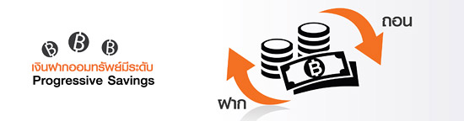
Saving account (Progressive Savings)
- A minimum opening deposit of 500 baht is required.
- Different interest rates apply to different ranges of deposit amounts. Calculation of interest will be based on the outstanding balance of the account at the end of each day with the interest being paid semiannually at the end of June and December.
- In case the owner of the account does not notify the Bank of his or her tax ID number, interest income above 10,000 baht per annum (per person) will be subject to 15% tax.
- In case the owner of the account notifies the Bank of his or her tax ID number, interest income above 20,000 baht per annum (per person) will be subject to 15% tax.


Current account

- A minimum initial deposit of 10,000 baht.
- The current account pays no interest and has no passbook.
Convenient
- The account holder can check transactions and movements on the account from bank statements.
- The account holder can issue cheques for payments or withdrawals from the account.
- The account holder can make use of an overdraft facility in accordance with the terms and conditions laid down by the Bank.
- To enhance the flexibility in withdrawing cash, the account can be jointly used with an ATM card and Debit card.

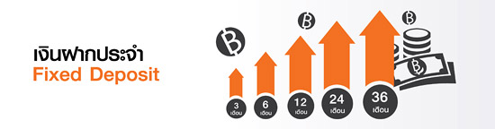
Time deposit
- Both individuals and juristic persons can open fixed deposit accounts.
- For fixed deposit accounts with passbooks, the minimum initial deposit to open an account amounts to 1,000 baht.
- For fixed deposit accounts with deposit receipt certificates, the minimum initial deposit to open an account amounts to 10,000 baht.
- Withdrawals can be made at any branch. [However, in case of withdrawals at other branches than the one where the account is opened, the maximum cash amount that can be withdrawn (using the depositor's passbook) is 1,000,000 baht per day.]
- Except the fixed deposit accounts which pay interest periodically, depositors can partially withdraw their fixed deposits.
- If the customer closes the account within 3 months after opening it, the Bank will pay no interest.
- If the customer does not withdraw the deposit upon maturity, the aggregated principal and interest will be automatically redeposited for the same term.
- For accounts with a deposit period of 6, 12, 24, to 36 months, if the depositors maintain their deposit for over 3 months but close their accounts before maturity, the Bank will pay interest for the actual deposit period at a rate of 0.50% per annum, except for depositors who are financial institutions or non-residents (to whom the Bank will pay no interest).

LH’s terms and conditions

Saving account
- Minimum initial deposit of only Baht 500.
- Convenience through anytime unlimited deposits and withdrawals.
- Interest paid twice a year (every end of June and December)
- Eligible collateral for credit and letter of guarantee applications.
- Eligible evidence for certified bank letter issuances.

Current account
- Deposit a minimum of THB 10,000.
- Using cheque for withdrawal.

Time deposit
- Only Baht 1,000 minimum opening balance.
- Higher and non-floating interest rates.
- Deposit principals available for planned usage upon maturity.
- Multiple deposit tenors available for your selection.
- Premature withdrawal subject to interest rate stipulated by the Bank, withdrawal within first 3 months of account opening subject to no interest income.
- Eligible collateral for credit and letter of guarantee applications.
- Eligible evidence for certified bank letter issuances.

TISCO’s terms and conditions

Saving account
- Can be opened for individual or juristic person.
- Required minimum initial deposit is 1,000 Baht
- In case that the deposit is less than 1,000 Baht, bank will collect fee.

Current account
- Can be opened for individual or juristic person.
- A minimum initial deposit of 20,000 baht.
- In case that the deposit is less than 20,000 baht per month, bank will collect fee.
- Using cheque for withdrawal.
- In case that the account does not move in the period of 24 months consecutively, bank will restrain the account until the customer comes contact.

Time deposit
- A minimum initial deposit of 20,000 baht.

Deposit interest rate of commercial bank on February,23 2016
Bank | Saving |  | Time deposit
Bank |  |  | 3 months | 6 months | 12 months | 24 months | 36 months
Commercial Bank registered in Thailand
BBL |  | 0.5000 - 0.6250 | 1.0000 | 1.2500 | 1.5000 | 1.7500 | 1.7500
KTB |  | 0.5000 | 0.9000 | 1.3500 | 1.5000 | 1.7000 | 1.7000
K Bank |  | 0.5000 | 0.9000 | 1.1500 | 1.3000 | 1.4500 | 1.6000
SCB |  | 0.5000 | 0.9000 - 1.6000 | 1.1500 - 1.2500 | 1.3000 - 1.4000 | 1.4500 - 1.5500 | 1.7000
Bank of Ayudhya |  | 0.3000 | 0.9000 - 1.0000 | 1.1500 - 1.2000 | 1.3500 | 1.5000 | 1.7000
TMB |  | 0.1250 - 0.7500 | 0.7500 - 1.0000 | 1.0000 | 1.1500 - 1.8000 | 1.4000 - 2.0000 | 1.6500
TNC |  | 0.4000 | 0.9500 - 1.0000 | 1.1500 - 1.2000 | 1.5000 | 1.7000 | 1.7500
Tisco |  | 0.5500 - 1.5500 | 1.5000 - 1.7000 | 1.6000 - 1.7500 | 1.7000 - 1.8500 | 1.8000 - 1.9000 | 1.9000
KK |  | 0.5000 | 1.4000 - 1.5500 | 1.5000 - 1.6500 | 1.5500 - 1.7000 | 1.6000 - 1.7500 | 1.8500
LH |  | 0.6250 - 1.2500 | 1.6500 | 1.7000 | 1.8000 | 1.8000 | 2.0000

Comparing Terms and Conditions

Saving account
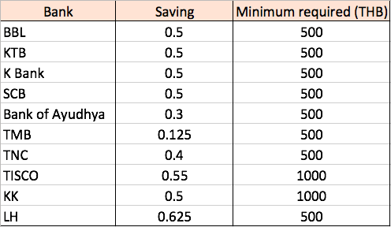

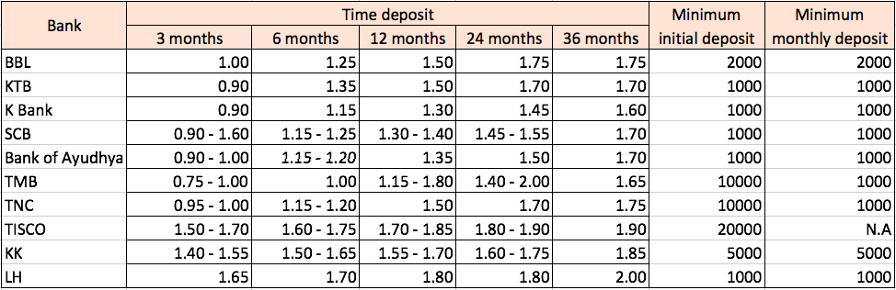
Fixed deposit

LH Flexible RMF (LHFLRMF)

Fund has the plan for invest in mixed fund between debt securities and equity instruments. The fund will invest in or hold equity instruments, hybrid instruments, debt securities and deposits including securities and other assets or generate benefits by other things according to the SEC announced its approval from 0 percent to 100 percent of the net asset value of the fund by adjusting the ratio of investment appropriately due to the circumstances. The fund may invest in or hold derivatives. The objective is to prevent the risk (Hedging). The fund will not invest in or hold securities that are characteristic of hidden derivatives (Structured Note), equity instruments of companies that are not listed on the SET (Unlisted Securities), debt securities with the very low credit ratings (Non-investment grade) and debt instruments that have not been rated reliability (Unrated Securities).

Growth of 1,000 THB
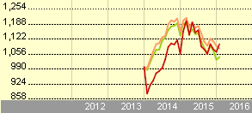
• | Fund: LH Flexible RMF
• | Category: Aggressive Allocation
• | Index: Cat 75%SET PR&25%ThaiBMA Gvt Bond TR

Annual Returns |  |  |  |  |  |  | 31/01/2559
 |  |  |  |  | 2013 | 2014 |  | 2015 | 2016
Total Return |  |  |  |  | -11.19 | 18.93 |  | 0.74 | 3.17
+/- Category |  |  |  |  | -8.55 | 5.17 |  | 6.76 | 4.23
+/- Index |  |  |  |  | - | 5.01 |  | 10.17 | 2.08
% Rank (Rel to Cat) |  |  |  |  | 93 | 20 |  | 17 | 1

Quarterly Returns |  |  |  |  | 31/01/2559
 | Quarter 1 | Quarter 2 | Quarter 3 | Quarter 4
2015 | 7.77 | 1.84 | -8.98 | 0.83
2014 | 5.62 | 5.88 | 10.87 | -4.08
2013 | 0.35 | -0.54 | -0.64 | -10.44

บัวหลวงเฟล็กซิเบิ้ลเพื่อการเลี้ยงชีพ (BFLRMF)

Fund has objective for diversification in equity hybrid instruments, debt instruments and deposits including the securities and other resource assets. Or generate benefits by other methods from 0 percent to 100 percent of the net asset value of the fund.

Growth of 1,000 THB
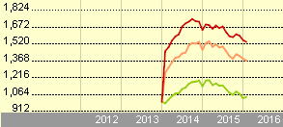

• | Fund: บัวหลวงเฟล็กซิเบิ้ลเพื่อการเลี้ยงชีพ
• | Category: Aggressive Allocation
• | Index: Cat 75%SET PR&25%ThaiBMA Gvt Bond TR

Annual Returns |  |  |  |  |  | 31/01/2559
 | 2009 | 2010 | 2011 | 2012 | 2013 | 2014 | 2015 | 2016
Total Return | 36.09 | 29.72 | 14.43 | 53.61 | -2.44 | 9.82 | -5.52 | -1.07
+/- Category | -14.63 | -5.56 | 15.56 | 20.40 | 0.21 | -3.93 | 0.50 | -0.02
+/- Index | - | - | - | - | - | -4.10 | 3.92 | -2.17
% Rank (Rel to Cat) | 86 | 76 | 1 | 5 | 48 | 79 | 42 | 54

Quarterly Returns |  |  |  | 31/01/2559
 | Quarter 1 | Quarter 2 | Quarter 3 | Quarter 4
2015 | 0.64 | 1.30 | -5.73 | -1.70
2014 | 3.52 | 8.13 | 4.03 | -5.69
2013 | 13.74 | -8.84 | -5.16 | -0.79
2012 | 18.97 | 2.67 | 12.35 | 11.94
2011 | 4.02 | 4.16 | -5.34 | 11.59

Phatra Balance RMF (PHATRA BLRMF)

Fund has objective to invest in deposits, debt instruments, hybrid instruments, equity instruments and other assets from the announcement in the ratio from 0-100 percent of the net asset value. By making the appropriate investments due to the economics situation while investors hold the instruments. So that the holders will receive a good return properly. This fund will not invest in derivatives and instruments with characteristics of hidden derivatives (Structured Note).

Growth of 1,000 THB
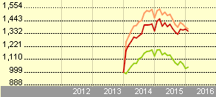

• | Fund: Phatra Balance RMF
• | Category: Aggressive Allocation
• | Index: Cat 75%SET PR&25%ThaiBMA Gvt Bond TR

Annual Returns |  |  |  |  |  | 31/01/2559
 | 2009 | 2010 | 2011 | 2012 | 2013 | 2014 | 2015 | 2016
Total Return | 44.38 | 29.41 | 4.78 | 31.45 | -8.85 | 13.05 | 1.20 | -1.28
+/- Category | -6.34 | -5.87 | 5.90 | -1.76 | -6.20 | -0.70 | 7.23 | -0.22
+/- Index | - | - | - | - | - | -0.87 | 10.64 | -2.37
% Rank (Rel to Cat) | 65 | 81 | 13 | 70 | 91 | 52 | 14 | 68

Quarterly Returns |  |  |  | 31/01/2559
 | Quarter 1 | Quarter 2 | Quarter 3 | Quarter 4
2015 | 3.05 | 1.18 | -6.05 | 3.32
2014 | 5.64 | 3.75 | 7.08 | -3.67
2013 | 7.04 | -4.92 | -1.56 | -9.02
2012 | 20.43 | -2.47 | 6.84 | 4.75
2011 | 3.14 | -1.84 | -7.96 | 12.43

Krungsri Flexible 2 RMF (KFFLEX2RMF)

Fund has objective to invest in equity instruments, debt instruments, and deposits or other instruments that are not contrary to the rules of SEC especially investing in equities with strong basis and adjust an appropriate ratio of investment to the circumstances in each period.

Growth of 1,000 THB
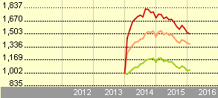

• | Fund: Krungsri Flexible 2 RMF
• | Category: Aggressive Allocation
• | Index: Cat 75%SET PR&25%ThaiBMA Gvt Bond TR

Annual Returns |  |  |  |  |  | 31/01/2559
 | 2009 | 2010 | 2011 | 2012 | 2013 | 2014 | 2015 | 2016
Total Return | 50.58 | 30.17 | 0.26 | 41.33 | 6.96 | 12.97 | -10.97 | -1.04
+/- Category | -0.14 | -5.11 | 1.39 | 8.12 | 9.61 | -0.79 | -4.94 | 0.02
+/- Index | - | - | - | - | - | -0.95 | -1.53 | -2.13
% Rank (Rel to Cat) | 49 | 66 | 35 | 21 | 1 | 56 | 79 | 50

Quarterly Returns |  |  |  | 31/01/2559
 | Quarter 1 | Quarter 2 | Quarter 3 | Quarter 4
2015 | -0.40 | -0.62 | -7.47 | -2.79
2014 | 9.58 | 5.25 | 4.26 | -6.05
2013 | 28.53 | -7.07 | -4.92 | -5.82
2012 | 11.62 | -1.24 | 11.42 | 15.05
2011 | 3.05 | 1.01 | -8.50 | 5.28

CIMB-PRINCIPAL FAM Retirement Sol RMF (CIMB-PRINCIPAL (FAM) RSRM)

Fund has objective to invest in or hold debt, equity, hybrid instruments or the units of the Mutual Fund within the country, including the Fund in gold, commodity funds and ETF's fund, which is trading on the Stock Exchange of Thailand. And may invest in overseas fund, real estate fund. The fund may invest in or hold derivatives with goods or variable according to the SEC’s regulation. By the objective to reduce risks and to enter to hold the derivatives to avoid the risk from the exchange rates.

Growth of 1,000 THB
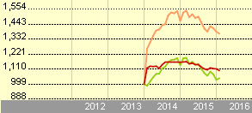

• | Fund: CIMB-PRINCIPAL FAM Retirement Sol RMF
• | Category: Aggressive Allocation
• | Index: Cat 75%SET PR&25%ThaiBMA Gvt Bond TR

Annual Returns |  |  |  |  |  | 31/01/2559
 |  |  |  | 2012 | 2013 | 2014 | 2015 | 2016
Total Return |  |  |  | 5.58 | 5.69 | 4.08 | -4.21 | -1.18
+/- Category |  |  |  | -27.63 | 8.34 | -9.68 | 1.81 | -0.13
+/- Index |  |  |  | - | - | -9.84 | 5.23 | -2.28
% Rank (Rel to Cat) |  |  |  | 97 | 3 | 94 | 36 | 61

Quarterly Returns |  |  |  | 31/01/2559
 | Quarter 1 | Quarter 2 | Quarter 3 | Quarter 4
2015 | -0.40 | -0.62 | -7.47 | -2.79
2014 | 9.58 | 5.25 | 4.26 | -6.05
2013 | 28.53 | -7.07 | -4.92 | -5.82
2012 | 11.62 | -1.24 | 11.42 | 15.05
2011 | 3.05 | 1.01 | -8.50 | 5.28

Comparing
PHATRA BLRMF
KFFLEX2RMF
CIMB-PRINCIPAL (FAM) RSRM
LHFLRMF
BFLRMF

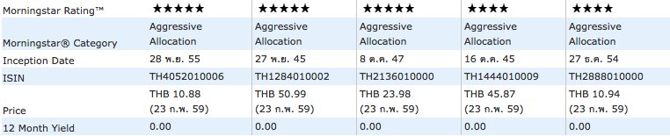

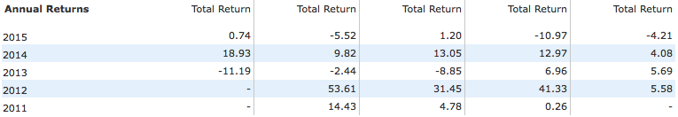

Volatility

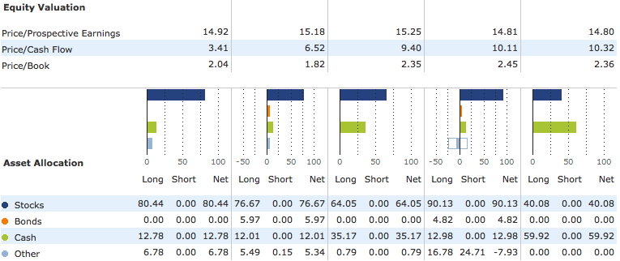

PHATRA BLRMF
KFFLEX2RMF
CIMB-PRINCIPAL (FAM) RSRM
LHFLRMF
BFLRMF

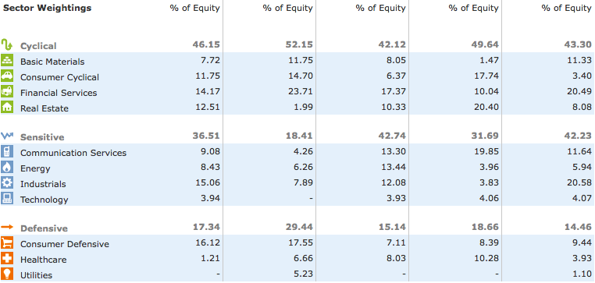

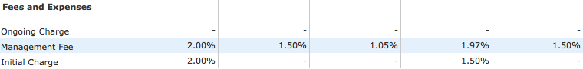

• | Fund: LH Flexible RMF
• | Fund: บัวหลวงเฟล็กซิเบิ้ลเพื่อการเลี้ยงชีพ

• | Fund: Phatra Balance RMF
• | Fund: Krungsri Flexible 2 RMF

• | Fund: Phatra Balance RMF
Fund: Krungsri Flexible 2 RMF

• | Fund: CIMB-PRINCIPAL FAM Retirement Sol RMF

• | Category: Aggressive Allocation
• | Index: Cat 75%SET PR&25%ThaiBMA Gvt Bond TR

First type of mutual fund we focused is RMFmix, which we consider on the top-5 rank of this kind of mutual fund; LH Flexible RMF, Bualuang Flexible RMF, Phatra Balance RMF, Krungsri Flexible 2 RMF, and CIMB-Principal FAM Retirement Sol RMF. According to the graph, the red line is the fund we interested in, comparing to the benchmark. The benchmark we use to compare is the orange line, which is Cat 75%SET PR&25%ThaiBMA Gvt Bond TR. The trend of the return of the funds are very similar to each other, but the results from the graph have only 2 outstanding funds; Bualuang Flexible RMF and Krungsri Flexible 2 RMF because the return from these funds are outstandingly higher than the benchmark.
Due to the fees and expenses of these 2 funds, for Krungsri Flexible 2 RMF, there are management fee of 1.97% and the initial charge of 1.50% while Bualuang Flexible RMF has only management fee of 1.50%, which is lower than Krungsri Flexible 2 RMF. And it does not have the initial charge for this fund. So, in our group point of view based on these data, we suggest Bualuang Flexible RMF be the best choice for investing in RMFmix.
However, the decision for investing in RMFmix depends on each investor’s point of view. Because each fund invests in the different ratio in each sector. Some investors prefer the fund investing on sensitive sector than cyclical and defensive sector. And the return on mutual fund cannot predict and decide that which one is the best because it’s long term investing. Therefore, the decision of investing in mutual fund is depending on each investor’s point of view.

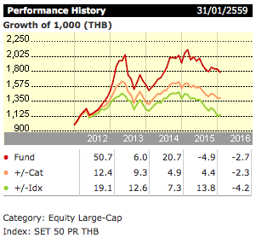
CG-LTF
Investment objective: Invest in the SET listed companies that have good corporate governance.

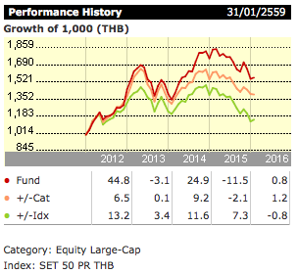

P-LTF
Investment objective: Invest in SET listed companies that are growth stock by investing more than 65% of NAV and the left portion of the fund will invest in other assets that SEC allows this type of fund to invest and may invest in derivatives for hedging and in bonds that return is underlying with structural notes.

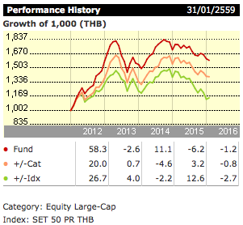
B-LTF
Investment objective: Invest in SET listed companies that are growth stock by investing more than 65% of NAV and the left portion of the fund will invest in other assets that SEC allows this type of fund to invest but this fund will not invest in derivatives and bonds that return is underlying with some assets.

BLTF75
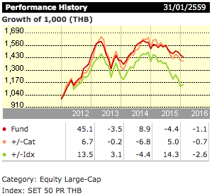
Investment objective: Investment objective: Invest in SET listed companies that are growth stock by investing more than 65% but not more than 75% of NAV and the left portion of the fund will invest in other assets that SEC allows this type of fund to invest but this fund will not invest in derivatives and bonds that return is underlying with some assets.

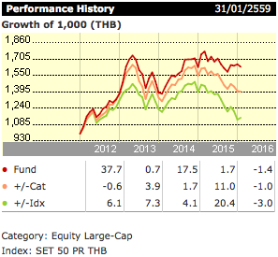
PHATRA LFTD
Investment objective: Investment objective: Invest in SET listed companies that are growth stock by investing more than 65% of NAV and the left portion of the fund will invest in other assets that SEC allows this type of fund to invest but this fund will not invest in derivatives and bonds that return is underlying with some assets.

Insurance

Insurance plan is one form of saving plan. It used to reduce risk that we might face in the future. However, to select which insurance plan is suit with each individual, the individual needs to study the details of every insurance plan and choose the one that best suit with him/her. Therefore, in this section, we compile top 5 life insurance companies in Thailand and provide the overview details of each plan.

1.AIA

For saving insurance, there are 3 types

AIA15 Pay30 (Par)
Age of insurer: 1month - 69 years old
Term of insurance: 30 years
Term of premium payment: 15 years
Cash back in case the insured passes away: total benefit the contract of 100% of insured
Cash back in case the insured alive: total benefit throughout the contract of 178% of insured
Health check: require
Dividend payment: obtain at the end of policy year of 15 and 30
Tax deduction: -

AIA8 Pay20Special (Par)
Age of insurer: 1month - 70 years old
Term of insurance: 20 years
Term of premium payment: 8 years
Cash back in case the insured passes away: total benefit the contract of 100% of insured
Cash back in case the insured alive: total benefit throughout the contract of 188% of insured
Health check: require
Dividend payment: obtain at the end of policy year according to the contract
Tax deduction: -

AIA15 Pay25Special (Par)
Age of insurer: 1month - 70 years old
Term of insurance: 25 years
Term of premium payment: 15 years
Cash back in case the insured passes away: total benefit the contract of 100% of insured
Cash back in case the insured alive: total benefit throughout the contract of 144% of insured
Health check: require
Dividend payment: obtain at the end of policy year of 5, 10, 15, 20, and 25
Tax deduction: -

For retirement insurance, there are 5 types

Long life pay insured 20 years
Age of insurer: 1month – 65 years old
Premium payment period: 20 years
Term of coverage: until age of 99 years old
Life coverage: total benefit the contract of 100% of insured
Health check: require
Dividend payment: obtain every year start at policy year 2
Tax deduction: -

Senior OK
Age of insurer: 50 – 70 years old
Term of coverage: until age of 99 years old
Life coverage: 50,000 – 200,000 baht
Health check: not require
Dividend payment: -
Tax deduction: -

Insurance 50 up
Age of insurer: 50 – 70 years old
Term of coverage: until age of 99 years old
Life coverage: maximum benefit the contract of 150% of insured
Health check: not require
Dividend payment: -
Tax deduction: -

AIA Long life pay insured 15 years
Age of insurer: 1month – 70 years old
Term of coverage: until age of 99 years old
Life coverage: total benefit throughout the contract of 150% of insured
Health check: not require
Dividend payment: -
Tax deduction: -

AIA Universal life protection
Age of insurer: 1month – 60 years old
Term of coverage: until age of 99 years old
Life coverage: in case the insured passes away: obtain insured and value of policy money,
in case the insured alive: obtain the value of policy money
Health check: not require
Dividend payment: -
Tax deduction: -

For personal accident, there are 3 types

AI/RCC
Age of insurer: 16 – 60 years old
Term of insurance: 1 year
Life coverage: medical expense for accident maximum of 20 weeks, in case of accident from public car, elevator, fire, give a double protection for insurer if insurer died or disability
Health check: require

ADB/RCC
Age of insurer: 1month – 60 years old
Term of insurance: 1 year
Life coverage: in case of accident from public car, elevator, fire, gives a protection for insurer if insurer died
Health check: not require

ADD/RCC
Age of insurer: 1month – 64 years old
Term of insurance: 1 year
Life coverage: in case of accident from public car, elevator, fire, gives a protection for insurer if insurer died or disability
Health check: not require

2. Thai Life Insurance

For saving insurance, there are 3 types

Smart Gain 10/5
Age of insurer: 15 - 60 years old
Term of insurance: 10 years
Term of premium payment: 5 years
Cash back in case the insured passes away: maximum benefit of 300% of insured
Cash back in case the insured alive: total benefit throughout the contract of 310% of insured
Health check: require
Dividend payment: -
Tax deduction: maximum of 100,000 baht per year

Smart Gain 14/7
Age of insurer: 15 - 60 years old
Term of insurance: 14 years
Term of premium payment: 7 years
Cash back in case the insured passes away: maximum benefit of 300% of insured
Cash back in case the insured alive: total benefit throughout the contract of 305% of insured
Health check: require
Dividend payment: -
Tax deduction: maximum of 100,000 baht per year

Suk-Thavee 15/10
Age of insurer: 15 - 60 years old
Term of insurance: 15 years
Term of premium payment: 10 years
Cash back in case the insured passes away: maximum benefit of 300% of insured
Cash back in case the insured alive: total benefit throughout the contract of 200% of insured + benefit of 5% of the contract for 15 period of policy year (total of 275%)
Health check: require
Dividend payment: -
Tax deduction: maximum of 100,000 baht per year

Special benefits: Thai Life Insurance hotline, iService

For retirement insurance

Thai Life retirement
Age of insurer: 20 – 60 years old
Term of coverage: until age of 90 years old
Life coverage: total benefit the contract of 105% of insured. If in case the insured passes away, insurer still obtain 15% for 15 years
Health check: just answering the question
Dividend payment: -
Tax deduction: maximum of 300,000 baht

For personal accident

For Thai Life, they divided insurer to 3 groups which is 1.working in office 2.working with activity 3.working hard outdoors

Thai Life PA refund
Age of insurer: 6 – 65 years old
Term of insurance: until the age of 65
Life coverage: if no claim for every 3 years, receive premium of year 3 back. Additional protect for rebellion or riot. Have a reserving medical payment.
Health check: just answering the question

Special benefits: 190 network hospital, helping on the road, Thai Life care center, Easy pay of 10 ways, iService for customers

3.Muangthai Insurance

For saving insurance, there are compose of many choice where the different for each choice are term of insurance and term of premium payment.

Muangthai Happy Benefit 15/10
Age of insurer: 1month - 60 years old
Term of insurance: 15 years
Term of premium payment: 10 years
Minimum summation insured: 120,000 baht
Cash back in case the insured passes away: total benefit the contract of 150% of insured
Cash back in case the insured alive:
- at the end of policy year 1-14, receive annual cash back at 2% of insured
Health check: require
- at the end of policy year 15, receive maturity benefit at 150% of insured
Health check: subject to the company’s regulations
Dividend payment: -
Tax deduction: eligible for tax reduction

For retirement insurance, there are 5 types

Muang Thai 8560 G15
Age of insurer: 20 – 55 years old
Premium payment period: age until 60 years old
Term of coverage: age until 85 years old
Life coverage: up to 250% before retirement
Health check: not require
Dividend payment: -
Tax deduction: tax deduct annuity

Muang Thai 8501, 9901
Age of insurer: 55 – 70 years old
Premium payment period: single premium payment without future burden
Term of coverage: age until 85 years old
Life coverage: receive annual annuity of 12% after retirement
Health check: not require
Dividend payment: -
Tax deduction: tax deduct annuity

Muang Thai 8501 D55 D60
Age of insurer: 30 – 58 years old
Premium payment period: age until 60 years old
Term of coverage: depends on insurance plan
Life coverage: 140%
Health check: not require
Dividend payment: -
Tax deduction: tax deduct annuity

Smile retirement online campaign
Age of insurer: 60 – 85 years old
Premium payment period: age until 60 years old
Term of coverage: age until 85 years old
Life coverage: before retirement, receive up to 250% and
after retirement, receive annual annuity at 12%
Health check: not require
Dividend payment: -
Tax deduction: benefit entitled for tax reduction

Muang Thai retirement plus 60
Premium payment period: age until 60 years old
Term of coverage: age until 90 years old
Life coverage: long-term coverage up to 400%
Health check: not require
Dividend payment: -
Tax deduction: tax deduct annuity
For personal accident, there are 5 types

Easy PA plus
Age of insurer: 1month – 75 years old
Term of premium payment: one time premium payment
Term of insurance: 1 year
Life coverage: up to 4,000,000 baht
Health check: subject to the company regulations

Tessakal Suk Jai PA
Age of insurer: 20 – 60 years old
Term of premium payment: pay 100 baht per year
Life coverage: in case of accident death from accident receives 100,000 baht, from murdered receive 50,000 baht
Health check: not require

PA Extreme
Age of insurer: 16 – 60 years old
Term of premium payment: 1 year, via credit card is applicable
Life coverage: in case of death or disability due to extreme sport up to 1,000,000 baht, get medical expense benefit in case of accident 50,000 baht per time, general accident 100,000 baht
Health check: not require

PA return cash
Age of insurer: 6 – 65 years old
Life coverage: if no claim for every 3 years, receive premium of year 3 back. Daily compensation during hospitalization 1,000 baht per day, no need for advance payment, just present a card at network hospital
Health check: not require

PA Sabai Jai Online
Age of insurer: 1month – 70 years old
Term of premium payment: pay premium by credit card only, purchase for yourself and minor child only
Life coverage: in case of death, get 2,000,000 baht, medical expense for accident up to 30,000 baht, no need for advance payment, just present a card at network hospital, daily compensation up to 3,000 baht per day
Health check: not require

4.Krungthai-AXA Life

For saving insurance, there are 3 types

10EC 10/6
Age of insurer: 1month - 70 years old
Term of insurance: 10 years
Term of premium payment: 6 years
Cash back in case the insured passes away: total benefit the contract of 200% of insured
Cash back in case the insured alive:
- at the end of policy year 1-9, receive annual cash back at 2% of insured
Health check: require
- at the end of policy year 10, receive maturity benefit at 182% of insured
Health check: subject to the company’s regulations
Dividend payment: obtain at the end of policy year of 7 – 10, maximum of 25.2%
Tax deduction: eligible for tax reduction

20SS 20
Age of insurer: 1month - 70 years old
Term of insurance: 20 years
Term of premium payment: 20 years
Cash back in case the insured passes away: total benefit the contract of 200% of insured
Cash back in case the insured alive:
- at the end of policy year 5 and after that, receive per 3 year benefit at 10, 15, 20, 25, 30, and 200% of insured
Health check: subject to the company’s regulations
Dividend payment: obtain a special right of getting dividend
Tax deduction: eligible for tax reduction

25PG
Age of insurer: 1month - 70 years old
Term of insurance: 25 years
Term of premium payment: 25 years
Cash back in case the insured passes away: total benefit the contract of 200% of insured
Cash back in case the insured alive:
- at the end of each 5 policy year, receive a higher benefit of 10% of insured
Health check: subject to the company’s regulations
Dividend payment: obtain a special right of getting dividend, maximum of 27% of insured
Tax deduction: eligible for tax reduction
Special benefits: have the right of borrowing money in the emergency case

For retirement insurance, there are 2 types

iWish
Term of coverage: until the age of 90 years old
Life coverage: death benefit 100% of sum assured or cash value or 110% of total premium paid
Health check: require
Dividend payment: -
Tax deduction: maximum up to 300,000 baht
Special benefit: stepped-up annuities to match with rising inflation

PR60
Life coverage: obtain after retiring at the age of 60
Health check: require
Dividend payment: have a additional right maximum of 18% of insured
Tax deduction: -

For personal accident, there are 3 types

iChild
Age of insurer: 1month – 15 years old
Term of insurance: until the age of 22
Life coverage: includes vaccination, health screen, routine optical and dental care, hospital output care such as X-ray, ultrasound diagnosis and prescription charges, worldwide coverage allows access to world class medical exports anywhere, anytime
Health check: require

iBegin
Term of premium payment: short payment while still having income stream
Life coverage: Lump sum and hospital income benefits due to cancer, protection and hospital income benefits due to accidents
Health check: not require

iCare
Term of premium payment: no more premium payment for the whole policy upon diagnosis of severe critical illnesses
Life coverage: coverage of up to 100 illnesses from early to severe stage, additional 10 juvenile illnesses, family discount benefit upon purchasing 2 policies or more at the same time, death benefit from any cause of 100,000 baht
Health check: require

5.Ayudhaya Alliance

For saving insurance, there are 5 types

My Bhum-narn Five A90/5
Age of insurer: 60 - 90 years old
Term of premium payment: 5 years
Cash back: 10% of insured every year
Health check: not require
Dividend payment: -
Tax deduction: maximum of 300,000 baht

My Super Return 11/6
Term of insurance: 11 years
Term of premium payment: 6 years
Cash back: 5% of insured every year
Health check: require
Dividend payment: -
Tax deduction: maximum of 100,000 baht

My Saving 10/6
Term of insurance: 10 years
Term of premium payment: 6 years
Cash back: 6% of insured every year
Health check: require
Dividend payment: -
Tax deduction: -

My Plan
Term of insurance: you must choose for 10 – 25 years
Term of premium payment: you must choose for 5 – 25 years
Health check: require
Dividend payment: depends on your decision
Tax deduction: -

My Smart Plan 15/10
Term of insurance: 15 years
Term of premium payment: 10 years
Cash back in case the insured passes away: total benefit the contract of 100% of insured
Cash back in case the insured alive: total benefit throughout the contract of 131% of insured
Health check: require
Dividend payment: -
Tax deduction: maximum of 100,000 baht

For retirement insurance, there are 5 types

Ayudhaya retirement A55/A55
Age of insurer: 16 – 45 years old
Premium payment period: until age of 55
Term of coverage: until age of 99
Life coverage: total benefit the contract of 100% of insured
Health check: require
Dividend payment: -
Tax deduction: maximum 100,000 baht

Ayudhaya retirement A60/A60
Age of insurer: 16 – 45 years old
Premium payment period: until age of 60
Term of coverage: until age of 99
Life coverage: total benefit the contract of 100% of insured
Health check: require
Dividend payment: -
Tax deduction: maximum 100,000 baht

Ayudhaya retirement A65/A65
Age of insurer: 16 – 45 years old
Premium payment period: until age of 65
Term of coverage: until age of 99
Life coverage: total benefit the contract of 100% of insured
Health check: require
Dividend payment: -
Tax deduction: maximum 100,000 baht
Special benefits: insurer can select the type of payment

My pension plus
Age of insurer: 25 – 50 years old
Premium payment period: until age of 55
Term of coverage: until age of 85
Life coverage: obtain the pension of 10% per year
Health check: require
Dividend payment: -
Tax deduction: maximum of 300,000 baht

My pension five A90/5
Age of insurer: 60 – 90 years old
Term of coverage: until age of 90
Life coverage: obtain the pension of 10% per year
Health check: require
Dividend payment: -
Tax deduction: maximum of 300,000 baht

For personal accident, there are 2 types

Fully dressed Insurance
Term of insurance: along the contract
Life coverage: medical fee maximum 30 times per year, ultrasound, X-ray, compensate 500 baht per day if injury, cover a cancer and 48 illnesses
Health check: require

Accident Insurance
Age of insurer: 7 – 74 years old
Life coverage: coverage maximum of 1,000,000 baht for an accident, double for death, compensate 1,500 per day, everywhere
Health check: require

For the insurance selection, there are many factors that affect the result such as life style of insurer, amount of income, health benefits, exclusions and limitations, costs, deductibles, copayments, coinsurance, out-of-pocket maximum, health savings accounts, special benefits, etc. Insurer has to study for the insurance that they interested in, evaluating for every factors, comparing to other, and then selected the insurance that proper for insurer.

RMFmix

Therefore, the following list shows factors that a person might consider when comparing costs and benefits of various saving plans.

· Investment objective
- The financial product should suit the objective of saving plan
· Rate of return
- The higher rate of return, the more desirable it is
· Liquidity
- The higher liquidity, the easier to convert into cash
· Degree of Risk
- The lower the degree of risk, the less uncertainty investor would face
· Convenience
- A product that provides convenience to customer is more preferable
· Safety
- Savers should weight more on the product that offer safety transaction system
· Credibility of the company
- Company with good credibility that has good historical performance and return is preferable
· Fees, charges, premium, and penalties
- The higher the fees, charges, premium and penalties, the more undesirable it is.
· Balance requirement
- The lower the minimum balance requirement, the better it is
- The higher the premium, the
· Coverage
- The more and wider the coverage, the more desirable the insurance
· Payment period
- The longer the payment period, the better it is

Group members

Thana-ek Laohapongchana 5504641878
Piyapat Inchayanunth 5604641265
Pusit Vittayanugool 5604641364
Swiss Pongpipattnakul 5604641729
Thiti Setthachinda 5604641919
Supitcha Cheablam 5704642197

