Thammasat University
Bachelor of Economics (BE)

MERS and public health responding

Contemporary Economic Issues
EE406
Ajarn Thanasak Jenmana
Final paper

Sahaphon Chernviriyakul 6204640327
Pitchakorn Chitpiboonsuk 6204640632
Wanrada Kliebphipat 6204641200
Hyeseong Yoo 6204641606

Abstract

Various unanswered questions still puzzled the public to propose a solution to solve infrequent virus cases that were difficult to explain since MERS appeared. The more fear of the virus outbreak, the more fear of new events arise. The Middle East Respiratory Syndrome (MERS), one of the most severe epidemics in the middle east region, which appeared in 2012, leads many institutions to study camel-to-person transmissions to prevent, control, and follow up on the remaining challenges for MERs outbursts in profoundly concerning. This disease led to a high case-fatality ratio caused by a severe viral lung infection that has been globally threatening to public health care. As far as we know, even if public health or any medical institution tries further to create or find an effective policy, it still cannot be a hundred-percent prevented.

Introduction

There is no prevention of effective measures in order to cope with a virus, this can be the worst. Public health did not affect only the cleanliness of people but also affect socioeconomic-structure interaction. It also has an enormous influence on society due to the economy and physical risk represented as figures will be shown. At a global level, the cases that appeared from human transmission have spread from dromedaries: Egypt, Quarter, Oman, and Saudi Arabia. First confirmed cases were found in Saudi Arabia since 2012. Coronavirus becomes more applied when people make such a movement, referred to as globalization, from the domestic and international levels. Some cases could be used as an example to determine effective solutions as a country: the Republic of Korea. The Republic of Korea gets to manage MER-CoV even though its land has been one of the most countries that have increased significantly in identified cases. Besides, its country found the right solution to manage with MERS. So, how can South Korea successfully handle the outbreak among the others? Plus, if there is an epidemic tomorrow, what should we do as a country? So how does South Korea well-managed with the illness according to public health? Even though MERS-CoV identified cases have been exposed a lot, and infected patients also receive treatments immediately, MERS-CoV seems to decrease patients' number. That means it is good news that a few of them get recovered and, in the end, the disease has been eradicated.

Furthermore, MER-CoV has a substantial spread and is developing itself to be a more significant epidemic, which means this virus can be a reoccurring event in the future. If this is happening in our country, how could we handle it to avoid such severe illness? The causes of a severe disease might be from people's movement, usually telling how people usually globalized. Plus, it could refer to that particular country's government that is not giving the exact or useful information to the public that should be announced soon, which was dangerously identified. Since then, public health plays a vital role in reducing the outbreak because many people have been planning to quit from these torture diseases in that period due to insufficient medical supply by this prompt dissemination.

The Middle East respiratory syndrome- coronavirus (MERS-CoV) has occurred globally, making people seriously concerned about these events due to low awareness. When studying the global picture, how do CDC (Centers for Disease Control and Prevention) and medical partner WHO are doing about MERS since it is no longer spreading anymore until now compared to other coronavirus cases? The report also indicated that the CDC continues to monitor the MERS situation closely, so they collaborated with its partner to better understand the outbreak (CDC, 2019). This is referred to as a lesson that from the previous illness appeared with a severe epidemic which made people suffer, so the public health did not want to repeat the same mistake that they did not seem pleased with it. So this makes it more interesting how general health can reduce an illness. For instance, the Republic of Korea cannot handle the situation due to government dialogic competency that has low reliability of concerning risk at the beginning. That is also another factor why South Korea has been one of the most concerning-risk MERS identified cases similar to Saudia Arabia cases. However, at the end, when its country changes the way to manage the problem by informing all possible levels of infectious virus rule and regulation that occurred everywhere in the region with step-by-step stages to solve this torturing disease from the public health. This report can tell us that sometimes people fail to control MERS because people could not access health care devices, insufficient information from the officials, and the government's slow management due to some reason. Still, the report illustrates that South Korea has been prosperous in dealing with MER-CoV infection as a lesson. Anyway, this report would like to exemplify and find the possible solution by using one big question: what are the MERS implications regarding public health? How do we do when the epidemics happen tomorrow? Will we be ready and prepare all things at that time?

Each following report will emphasize the background, economic implications, and public health concerning MERS. It is significant to perceive this disease's character to facilitate sanitation for all individuals to not replicate the same error in the future by looking at the previous examples from international degree to domestic degree.

Background

Before getting started with society's policy decision, this paragraph will get through to MERS' background information. The Middle East Respiratory Syndrome referred to as MER-CoV, is the infection in the respiratory system caused by one of the coronavirus strains. MERS-CoV was the first human virus in betacoronavirus lineage C. MERS-CoV is an unfamiliar disease originally unique where the patient was from Saudi Arabia in 2012. The virus was similar to the SARS Coronavirus, and the science dealing with the transmission of the disease and clinical demonstration of infection with the two viruses have been compared. The rise of the Middle East Respiratory Syndrome Coronavirus diseases has become a worldwide issue. The first patient infected was a 60 years old Saudi Arabian male who has fatal acute pneumonia and kidney failure in Jeddah, Kingdom of Saudi Arabia, in September 2012. The reflective research illustrated that this virus was also culpable for an outbreak in Zarqa, Jordan, in April 2012. Many patients and the number of death toll- 1728 patients (12 May 2016) with 624 related passings- perceived MERS contamination, which caused them to suffer to death. The virus globally connected the Middle East cases, and circumstances outside of the Middle East included explorers from this district.

Transmission

The preceding section said the MERs-CoV is related to the Egyptian tomb bats and dromedary camels. Therefore, MERS-CoV is a zoonotic infection, and dromedary camels are a supply. Bats are an original supply. Coronavirus like MERS-CoV is recognized in bats, yet epidemiologic proof of their transmission function is inadequate. The disease of other animal species with MERS-CoV is conceivable because endeavors to immunize goats, sheep, and horses with live MERS did not deliver viral shedding. No epidemiologic proof has involved any species other than dromedary camels in transmission.

Occasional zoonotic transmission from dromedary camels has resulted in circumscribed human to human, regularly in healthcare and household sections. MERS-CoV in human cases can separate into two segments of communication; primary and secondary. Direct transmission is sorted as a transmission that does not contact directly from a real human point.

Hence, the first transmission is contact from livestock or unknown sources. Besides, the secondary spread has resulted from contact with human MERS-CoV patients. The typical characteristics are healthcare and household-related. On the contrary, many cases have no expressed exposure to previous patients or healthcare or camels, representing the source is unexplored. Lastly, summarize the available evidence respecting camel-to-camel, camel-to-human, and human-to-human transmission of MERS, including direct epidemiologic evidence and supporting biologically possible transmission routes.

Symptoms

The clinical range of MERs-Cov disease ranges from no side effects or gentle respiratory indications to serious, intense respiratory illness and passing. An ordinary introduction of MERs-COV illness is fever, cough, and shortness of breath. Pneumonia could be a common finding but not a continuous show. Serious illness can cause the respiratory system to fail, which requires mechanical ventilation and support in an intensive care unit. Even though the first case was identified in 2012, they have no vaccine or specific treatment yet. (From CDC,2019)
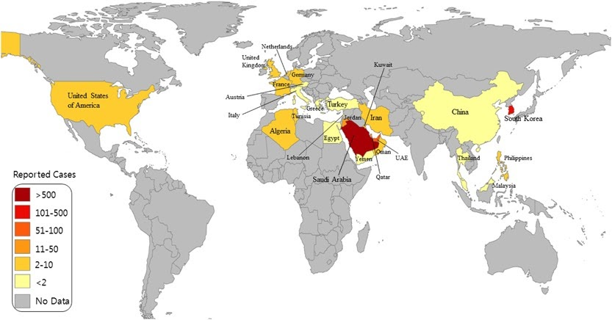

On a global level, there are more than 2,500 people with MER-CoV issues that have been identified in 27 nations, including 935 deaths since the infection was recognized in Saudi Arabia. (From WHO,2020) There have been infections on the domestic level since September 2012 in European countries for 15 laboratory-confirmed cases, including seven dead patients. Countries with the infected are France, Austria, Germany, Greece, Italy, the Netherlands, Turkey, and the United Kingdom. Moreover, in Asian countries, they also have infected. There have been nine confirmed cases in Thailand, China, the Philippines, and Malaysia, with one death. And in America and Africa have confirmed cases for seven patients. These all countries with a small number of infected can show us even the MERS is a globalization disease. But people have a slow movement, that is why these countries have a short number of patients.

On the other hand, the other country with the sizeable MERS-CoV outbreak was South Korea, which resulted in 186 confirmed cases with 38 fatalities. (From WHO,2015) In the first, the number of patients haven't been announced yet and haven't been declared about where the location is at a high-risk level. On the day when the list of medical institutions that patients had gone by or gone to for treatment was unveiled, the number of cases was expanded. On the contrary, a descending direction was watched from thereon. This inferred that unveiling the medical institutions' list was exceptionally viable in preventing individuals from encouraging contamination of MERS through the arrangement of data.

For this reason, the Korean health authorities should pay more attention to not closing the information before the disease outbreak incontinent. This can confirm the chance communication guideline arrangement of data in adapting with an outbreak is so crucial. Other than, to control this outbreak, the Korean Ministry of health needs to quarantine over 16,000 people and provide the law with up to 2 years of condemnation in the calaboose for contravening the quarantine. The Korean government has to temporarily close schools and universities, including moreover 2,400 schools and 22 universities. Despite this action, they have to cancel crowded events to avoid any possibility of the spreading outside of healthcare institutions. The sharing of essential knowledge about this disease from a trustworthy specialist is also essential. To summarize, this outbreak showed a weakened point of the medical service system, the lack of knowledge and experience. Otherwise, this crisis has provoked the government to reorganize the healthcare institutions sector and develop the infection disease sector henceforward.

Economic Impact

The MERS epidemic encouraged researchers to examine different types of implications, such as social, economic, and medical. However, the economic studies on MERS focused on the macroeconomic indices such as GDP and changes in consumer behavior in microeconomics, where MERS' economic impact challenged public health.

Since 2012, there have been more than 1000 MERS (Middle East Respiratory Syndrome) cases, mainly in Saudi Arabia. However, the MERS had entered South Korea in May 2015, which affected Korea's domestic economy. Two main factors substantially impact the economy across the nation, which are the non-citizens and citizens. Firstly, the MERS outbreak was initiated by international travelers, where tourism-related industries were the most affected by the epidemic—corresponding with a reduction in 2.1 million non-citizen arrivals alone. This case is similar to covid-19 in Thailand; as the number of travelers reduces, both freelance and official employees in the tourist industries lose their jobs. By all means, consumer spending reduces as people will spend only on necessary goods where it will impact the whole economy. During the MERS outbreak, Korea was associated with a $2.6 billion loss in the tourism-related industry, which is 0.2% of GDP in 2015. This loss was not temporary as most of the travelers canceled their trip, which is not just postponing it. It can conclude that public health emergencies compensated for by the tourist-related outbreak of MERS can cause substantial losses to the country's economies. Furthermore, influence in resource allocation decisions in readiness to mitigate the infectious diseases related to international travelers.

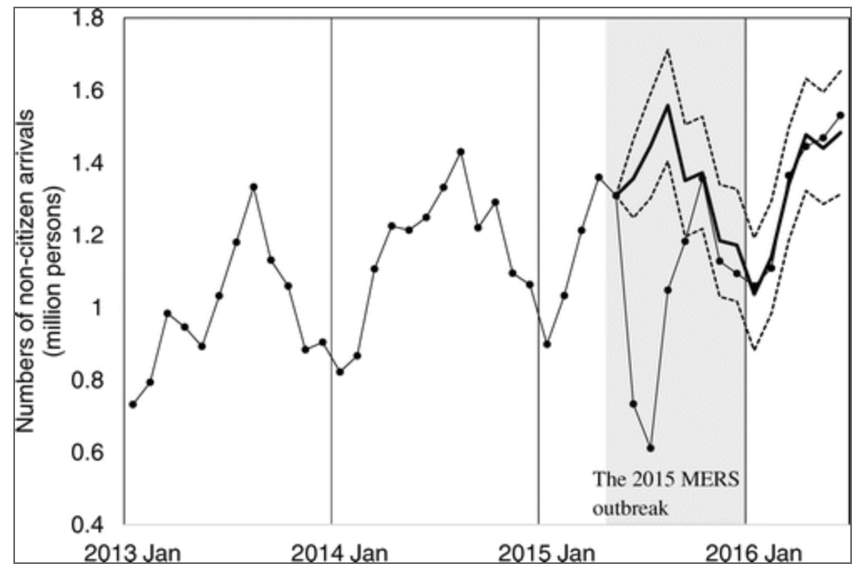
Figure 2.1
Joo, H., Maskery, B. A., Berro, A. D., Rotz, L. D., Lee, Y., & Brown, C. M. (2019). Economic Impact of the 2015 MERS Outbreak on the Republic of Koreas Tourism-Related Industries. Health Security, 17(2), 100-108. doi:10.1089/hs.2018.0115

Figure 2.1 is the graph of non-citizen arrival in Korea, which explains that there is a significant decline during mid 2015. Yet, the bold line represents the expected number of foreigner arrival, which is the total opposite of the actual result. However, MERS did not last long where Korea could overcome the epidemic and recover back to the natural order.

Infectious diseases where it is more challenging and convolute to overcome. Implementing the control of the disease, disastrous effects follow after the epidemic. Restriction in the traveling of goods and people lead to severe disruption in outputs and exports. Furthermore, investors lose their confidence in future investments. Apart from the epidemic influence on production and investment, there's a negative shock on consumer expenditure as people lose their jobs from the decline in the economy. Due to the negative impact on the economy, firms lowering their expenditures and financial budget lead to hiring fewer employees that increase the unemployment rate. Government concerning the public health which emphasize on social distancing that draws to the limitation of work and employment, which is similar to covid-19.

This infectious disease made people concerned about outdoor activities, which is a possibility of infection. As a result, there's a change in consumer behavior and a clear signal of economic decline in the country, where demand for tourism, entertainment, leisure, and dining is reduced. Significant changes in an individual's behavior or financial habits have been proved by the research from using debit and credit transaction data of Koreans. (Hongik University,2016) The transaction volume depreciation due to disruption of consumption from the fear of the disease. At the same time, transactions related to e-commerce or online shopping had ongoing transactions where people would still spend without any risk of infection. This verifies that the people limit transactions through channels that are risky to use: economic decline and changes due to the disease epidemic resulting from the public's health condition.

Despite this, in the first week of July 2015, there were no cases found in South Korea. South Korea was under the control of MERS after all the intensified public health measures, isolation of all physical contacts, and quarantine. Studies have suggested that Korea overcame the epidemic in such a short time due to trustful management by the government. This is the answer behind 'why was Korea more successful in surviving the MERS-CoV than the others?', where trust was the unexpected key component that mitigates the citizens' fear toward the diseases. In Korea, the government centralized effective communication with the public to gain the citizens' trust.

Moreover, the government ensures that the information shared with transparency about the diseases is legitimate, and knowledge management is under control to ensure public health. Public health that is related to the economy; when citizens are healthy without any severe infectious disease, they will work as usual without any constraint and fear or risk of getting infected. The healthier the workforce, the more productive they are. (Public health and economy from Harvard, 2012)

To end with an implication after the experience of Mers-CoV, with the question of "if there's an epidemic tomorrow, how should it be overcome?" Firstly, a strict and accurate traveler tracking system (via ICT) should take place. From Mers, Korea's leading telecom company KT invented the system that tracks travelers' routes from mobile phones. When this system is all settled, the government no need to rely on travelers' false retrospective memories, where the airport and medical facilities can obtain direct information on the spreading of the virus. Moreover, in the future pandemic, the government should strengthen the health care delivery system. Most of the Mers cases were from nosocomial infection means that patients were infected in the hospital or happened with the hospital-to-hospital transmission. It occurred since the medical facilities were packed and crowded with people. To ensure the optimal and most appropriate care for the patient at the correct timing is by sharing patients' prescription and medical data across hospitals for the doctors to provide a proper diagnosis that can be effective according to hospitals. However, this could only affect when there's an improvement in the referral management system, from primary hospitals transferred to other tertiary hospitals. To overcome any epidemic, transparency from the government is a crucial factor that should be maintained throughout the pandemic. At the same time, government intervention should establish privacy protection for related people. After all, the affected country should be following the world health organization (WHO) 's guidelines. Essential factors of WHO's procedure are prioritizing public health risks, planning, and mapping done before resource allocation, a system for deploying health personnel, and risk communication should be established. From lessons learned from the MERS, these are the steps that are expected to prevent and control future epidemics.

Public Health

Public health uses science to improve and protect the community's health by improving lifestyle, researching the disease, detecting, preventing, and responding to infectious disease, and trying to control the disease, not recurring. There are various organizations responsible for public health, and each organization has different charges. Mers' spreading began with the spreading from ill people to others by close contacts, such as living with the infected person. Moreover, the infected person spread the virus in public areas such as the hospital, shopping mall, or restaurants. Furthermore, the MERS-CoV virus cases have been linked to countries in and near the Arabian Peninsula, where most of the people who were infected lived in the Arabian Peninsula or recently traveled from the Arabian became ill. Some of the infected people got the virus from others that had traveled from the Arabian Peninsula. The country that has been known for the largest outbreak of MERS outside the Arabian Peninsula is Korea in 2015, with an association in tourism. The responsibility of the Mers, several countries, helped each other in the term of public health or health care with the most massive outbreaks seen in Saudi Arabia, the United Arab Emirates, and the Republic of Korea.

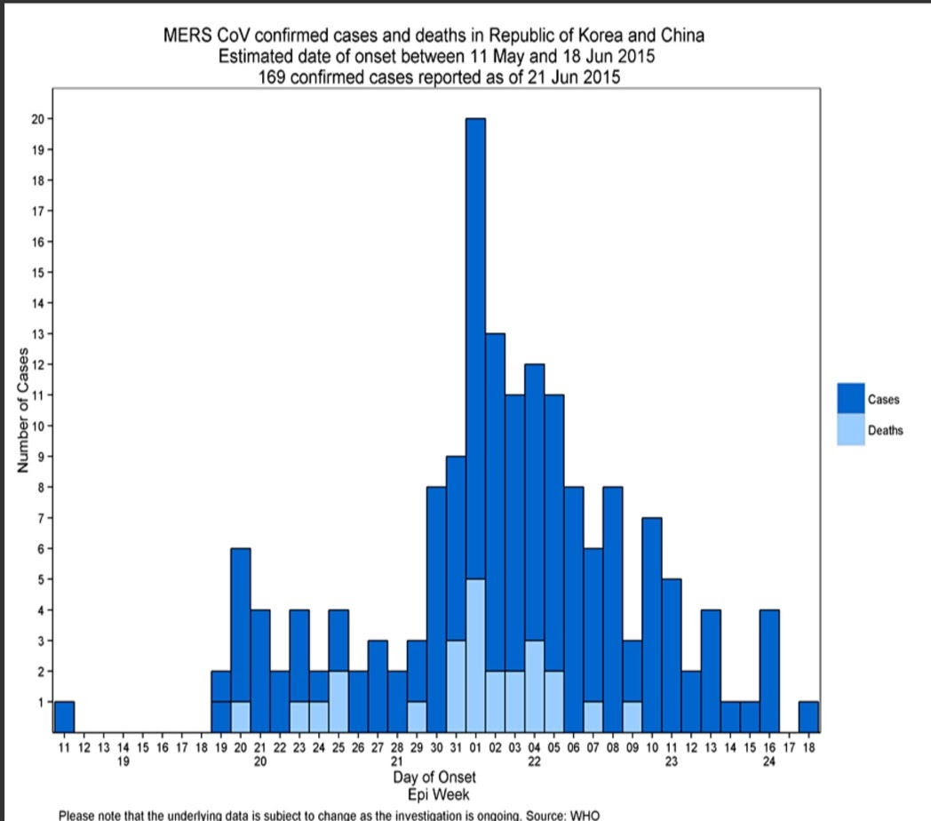
For world-class responsibility, the World Health Organization-WHO is responsible for international public health. Its main goal is the accomplishment by all people of the highest attainable standard of fitness. In general, the WHO has suggested that any traveler, trader, or arrival to the country must be restrained. Responding to the Mers, WHO is working with scientists and clinicians in affected countries to gather, share, and update the virus's information and understand the virus better. Moreover, WHO determines treatment strategies and clinical treatment and develops public health prevention strategies. For example, announcing laboratory testing of cases and infection presentation and controlling and clinical management. In December 2012, the first recommended document was published to inform that Mers caused humans and animals. In June 2014, WHO hosted an international meeting in Lyon, France, to present Mers laboratory testing and review the interim recommendations. The critical points of WHO want to remember are all healthcare workers must wear appropriate personal protective equipment (PPE). All those involved in collecting and transporting specimens should be trained in safe handling practices and spill decontamination procedures.

Inside the country and between countries, to prevent the spread of Mers, the country's public health is trying to prevent the spread of Mers by avoiding travel to other countries. Before taking a flight to the Middle East, entry screening at the airport is essential. The screening includes checking the temperature and answering health questionnaires. There are conditions for the passengers: passengers may travel during the given period or not conceal their previous travel history. During a flight or onboard, if passengers have symptoms suggestive of Mers, the pilot should follow the International Air Transport Association(IATA) or the International Civil Authority Procedures for Air Navigation Services- air traffic management (ICAO PANS-ATM) guidelines for the control and announce public health authorities at the destination airport via air traffic control. Those who travel to the Middle East countries should avoid having contact with the person who visited the farm, market barn, or other places where camels are present. Plus, a traveler should follow the measure all the time, including should not have contact or see animals that are sick and washing hands often. The precaution hygiene for travelers during Mers epidemic, they should hand hygiene and respiratory hygiene by covering nose and mouth all the time or when coughing or sneezing, washing hands before or after having contact with other people or animals, keeping social distance with is more or equal one meter away from others. Besides, they should stick to safe food and consider more about the food, such as avoiding consuming undercooked meat or food prepared under unsanitary conditions, preventing camels from drinking milk or the camel's product. Last, wash vegetables, fruits, or eat equipment before eating them. Also, WHO encouraged countries to provide more information about Mers, including transportation information, travel advice, ground staff, and medical information such as where the hospitals are in that specific area, where they can seek the medicines. After you come back from the Middle East, if you become ill with a fever or shortness of breath after traveling to the Middle East, inform the health care professional of your systems and your recent travel history, and inform the person who you recently contacted. On top of that, the International Health Regulations (IHR) recommended countries: should guarantee that there must be safe transportation for symptomatic passage to travel to the hospitals, clinics, or designated facilities for the treatment, there should be medical types of equipment ready for responding event that may occur in an emergency of international cancers.

The Community health care, the hygiene of the employees and everyone who works or at the facilities should be trained and educated such as training for the employees in health care facilities of proper donning(put on) and doffing (take off) the personal protective equivalent and prevention of contamination of clothing, skin, and environment in the course of the procedure. For hygiene in facilities, health care facilities should guarantee that facilities and equipment for performing are readily available to all personnel and should perform hand hygiene before and after contact with a patient, potentially infectious material. Additionally, hand hygiene in health care is paramount; everyone should wash hands with soap and water for at least 20 seconds or use alcohol spray. On top of hygiene, workers were trained on and demonstrated an understanding of when to use PPE (Personal Protective Equipment); why PPE is necessary, how to correctly put on PPE, use, take off; and the limitations of PPE. Moreover, how to do with PPE between and after using it; must be adequately cleaned, decontaminated, and maintained. The personal Protective Equipment(PPE) consists of 4mains parts. For the sequence of wearing PPE; first gown; second respiratory; then faces shields; last groves. Each region has different functions and instructions.

First, gloves. The workers should put on clean gloves upon entry into the patient room or care area, and change gloves if it becomes torn or heavily contaminated. The used groves must remove immediately after leaving the patient's room. Second, gowns. Workers must put on a clean, grown before and during into the patient room or area and change if the shifts become soiled. After leaving the patient's room or space, we should immediately remove and discard the gown. Third, respiratory protection. The last part of PPE that should be removed is the respirator. Its use must be in the term of a complete respiratory protection program associated with the Occupational Safety and Health Administration (OSHA) Respiratory Protection standard. The workers should wear it tightly and fit with the face pieces. Last, eye protection. Workers should wear eye protection upon entry to the patient room and remove it immediately after leaving the patient room or area. Besides, PPE has more than one kind. The different types of PPE can be used together to prevent multiple routes of transmission. Moreover, before and after putting PPE, the workers should hygiene their hands.

The facilities for patients might infect Mers. For example, an Airborne Infection Isolation Room(AIIR) has been constructed and kept up with the guidelines. The patient room air should be exhausted directly to the outside or be filtered through a high-efficiency particulate air (HEPA) filter before recirculation. If the AIIR is not available, the patent should be transferred as soon as possible to other facilities that AIIR is working. However, in an AIIR, the patient can not wear a face mask. When outside AIIR, the patient should wear a face mask to contain secretions. The door should be closed except when entering or leaving the patient's room.

The visitor should follow the rule and the facilities' measures for the patients' family or friends in the health care facilities. For instance, all visitors should follow respiratory hygiene. In the facilities' common area, limiting the surface touched between the patient and the visitor always wears PPE during the patient's room. The facilities could consider the visiting fur to the patient's emotional well-being and care in each case. After visiting the patient or during hospitalization, the visitors are a possible source of Mers-CoV.
Moreover, the visitor should report any system or signs to their health care provider for a period- at least 14 days after seeing the patient in the health care facilities. Several strategists should be improved in the whole health Picard system then find the most effective strategies to prevent an infectious disease outbreak in the future. For example, improve the public hospital facilities for the critical care of several infections and be ready for the unknown disease that might occur in the future.

Conclusion

Viruses may seem far from our daily life; however, it affects us in various ways. MERS affect multiple ways in human life: economically, physically, and psychologically. The question that the public continues to request for the possible solution and the effective policy to help in this situation in that particular period as a permanent solution for the next generation with the beneficial result is mostly determined by the case confirmed with many cure approaches and the prominent role of the international public health care.
The society has reacted to the public health as a consequence of the economy; it means that low credibility of concerning risk by recovering it and the people's incentive that is affected by the frequent cases such as medical system factors and socioeconomic status. At the first stage, we can see that MERS' weak point still spreads even though it is a temporary shock, and the disease always reoccurs caused by the medical service system. To explain, from South Korea, we could see the before and after situation that the government reveals the truth of MERS position and has been better to manage the risk of lacking knowledge and experiences. It could be said that the increasing number of coronavirus patients, which before gave the exact information, South Korea cannot control compared to the after-situation in which its country changed the structure of managing risk. Public health plays a significant role in intervening in this situation, making the illness less spread.

In the economic aspects, public health does relate to the economy's productivity. When people receive illness, they become slow and unhealthy, which causes people to become less active and thus less productive to work. Moreover, those effects induce the economy to be declined and so on GDP reduces. Some workers need to quit the job inevitably then this action causes the unemployment rate higher. In South Korea, the public medical system hits the change in consumer expenditure because people need to save more for future usage and lower expenses. Therefore, these are the economic implications for South Korea. The more people get healthier, the more productive people can work more. This will benefit the economy in terms of public medicals.

Many countries get infected frequently traveling across the globe, which means the more movement people will make the virus more spread. Next, public health has a range of focusing on global levels to domestic levels. First, world-class responsibility will most focus on international public health WHO, which manages the epidemic by announcing information for more understanding of coronavirus prevention and treatment strategies. WHO determines treatment strategies and clinical treatment then develops public health prevention strategies. In responsibility inside the country and between countries, another factor that public health tries to avoid is to stop traveling between broader globalization. If people necessarily need to globalize, public health has measures before the flight. For example, public health will regulate the airport to screen infectious persons at the entry and check their temperatures. Continually, public health will allow airport staff to follow the suggestion if passengers have a symptom of MERS. Therefore, medical officials encourage countries to provide more information, travel advice, and medical information. In the community's responsibility, the hygiene of the employees and everyone working at facilities should be trained and educated, such as introducing them to understand the essential role of wearing PPE property.

What if there is an epidemic tomorrow, what should we do as a country? Using another country's perspective, the possible solutions are public health needs to immediately intervene like using technology devices that can track traveler systems via mobile phone to update information and all hospitals need to share the information with each other to update unknown events people need to confront. The government should give all medical devices for free then provide compensation to everyone, especially to infected individuals who suffer from the disease. Moreover, everyone should follow WHO guidelines to help decrease the number of cases. All in all, in the future, the virus can repeatedly spread, so public health plays a central role in the world's healthiness.

References:

Lee, A., & Cho, J. (2016, December 01). The impact of epidemics on labor market: Identifying victims of the Middle East Respiratory Syndrome in the Korean labor market. Retrieved from https://www.ncbi.nlm.nih.gov/pmc/articles/PMC5134239/

MERS Frequently Asked Questions and Answers. (2019, August 2). Retrieved from https://www.cdc.gov/coronavirus/mers/faq.html

Wan, W. (2020, March 11). How is the coronavirus outbreak going to end? Here's how similar epidemics played out. Retrieved from https://www.washingtonpost.com/health/2020/03/02/how-is-coronavirus-outbreak-going-end-heres-how-similar-epidemics-played-out/

McGill, N. (2015, August 01). Public health looks to lessons from past in MERS outbreak: Experience with SARS offers insights. Retrieved from https://www.thenationshealth.org/content/45/6/1.4

Sandra G Gompf, M. (2020, March 22). Middle East Respiratory Syndrome (MERS). Retrieved from https://emedicine.medscape.com/article/2218969-overview

Al-Osail, A. M., & Al-Wazzah, M. J. (2017, August 07). The history and epidemiology of Middle East respiratory syndrome coronavirus. Retrieved from https://www.ncbi.nlm.nih.gov/pmc/articles/PMC5545842/

Rettner, R. (2013, August 21). Origin of MERS Virus Found in Bats. Retrieved from https://www.livescience.com/39056-origin-of-mers-virus-found-in-bats.html

MERS-CoV. (n.d.). Retrieved from https://pandemic.internationalsos.com/overview/mers-overview

Killerby, M. E., Biggs, H. M., Watson, J. T. (2020, February). Middle East Respiratory Syndrome Coronavirus Transmission - Volume 26, Number 2-February 2020 - Emerging Infectious Diseases journal - CDC. Retrieved from https://wwwnc.cdc.gov/eid/article/26/2/19-0697_article

Adlhoch, Cornelia & Baka, Agoritsa & Mollet, Thomas & Plachouras, Diamantis & Brusin, Sergio & Penttinen, Pasi & Briet, Olivier. (2018). RAPID RISK ASSESSMENT Severe respiratory disease associated with Middle East respiratory syndrome coronavirus (MERS-CoV).

Park, C. (2019, December 30). MERS-CoV infection in South Korea and strategies for possible future outbreak: Narrative review: Published in Journal of Global Health Reports. Retrieved from https://www.joghr.org/article/12122-mers-cov-infection-in-south-korea-and-strategies-for-possible-future-outbreak-narrative-review

Noh, J., Yoo, K., Kwon, Y., Hong, J., Lee, Y., Park, K. (2020, January 01). Effect of Information Disclosure Policy on Control of Infectious Disease: MERS-CoV Outbreak in South Korea. Retrieved from https://www.mdpi.com/1660-4601/17/1/305/htm

Park, C. (2019, December 30). MERS-CoV infection in South Korea and strategies for possible future outbreak: Narrative review: Published in Journal of Global Health Reports. Retrieved from https://www.joghr.org/article/12122-mers-cov-infection-in-south-korea-and-strategies-for-possible-future-outbreak-narrative-review

Stephanie Soucheray | News Reporter | CIDRAP News | Jul 09, 2. (2019, July 09). Data show MERS cases, deaths on decline since 2016. Retrieved from https://www.cidrap.umn.edu/news-perspective/2019/07/data-show-mers-cases-deaths-decline-2016

Jung, H., Park, M., Hong, K., & Hyun, E. (2016, May 06). The Impact of an Epidemic Outbreak on Consumer Expenditures:An Empirical Assessment for MERS Korea. Retrieved from https://www.mdpi.com/2071-1050/8/5/454/htm

Joo, H., Joo, A. C., & Maskery, B. A. (2019, April 19). Economic Impact of the 2015 MERS Outbreak on the Republic of Korea's Tourism-Related Industries. Retrieved from https://www.liebertpub.com/doi/10.1089/hs.2018.0115

Public health and the U.S. economy. (2014, February 19). Retrieved from https://www.hsph.harvard.edu/news/magazine/public-health-economy-election/

McGill, N. (2015, August 01). Public health looks to lessons from past in MERS outbreak: Experience with SARS offers insights. Retrieved from https://www.thenationshealth.org/content/45/6/1.4

WHO advice for international travel and trade in relation to MERS-CoV. (2018, September 18). Retrieved from https://www.who.int/ihr/travel/MERS-advice-travel-trade-9-2018/en/

M. Manal, M. M., C. Drosten, D. M., & MT. Hansen, N. N. (2019, March 21). The perceived effectiveness of MERS-CoV educational programs and knowledge transfer among primary healthcare workers: A cross-sectional survey. Retrieved from https://bmcinfectdis.biomedcentral.com/articles/10.1186/s12879-019-3898-2

Organization, P. A. (2020, February 06). Requirements and technical specifications of personal protective equipment (PPE) for the novel coronavirus (2019-ncov) in healthcare settings. Retrieved from https://iris.paho.org/handle/10665.2/51906

MERS Healthcare Facility Preparedness Checklist. (2019, August 02). Retrieved from https://www.cdc.gov/coronavirus/mers/preparedness/checklist-facility-preparedness.html

Bleibtreu, A., Bertine, M., Bertin, C., & Houhou-Fidouh, N. (2020, May). Focus on Middle East respiratory syndrome coronavirus (MERS-CoV). Retrieved from https://www.ncbi.nlm.nih.gov/pmc/articles/PMC7125975/

Oraby, T., Tyshenko, M. G., Balkhy, H. H., & Tasnif, Y. (2020, April 23). Analysis of the Healthcare MERS-CoV Outbreak in King Abdulaziz Medical Center, Riyadh, Saudi Arabia, June-August 2015 Using a SEIR Ward Transmission Model. Retrieved from https://www.ncbi.nlm.nih.gov/pmc/articles/PMC7215950/

MERS: Preventing Spreading in Homes & Communities. (2019, August 2). Retrieved from https://www.cdc.gov/coronavirus/mers/hcp/home-care-patient.html

