Individual Assignment#1

- Discuss one Insurance product and comment on its benefits
I choose ธนทวี 15/10 (มีเงินปันผล)” which is the one of the package of life insurance from Thai life Insurance Company.
The reason I choose this insurance package is because nowadays we always have to face with unexpected things. We are all taking risk of being infected in all diseases or having an accident in everyday life. And we have to plan your own financial plan for your future. If you are a leader of the family, it is sure that you want your family to be happy and have a great lifestyle.
This package is the solution for the people who want a life protection and saving, thus increasing value for each savings for your future plans. It also secures your stability of your life or your family.
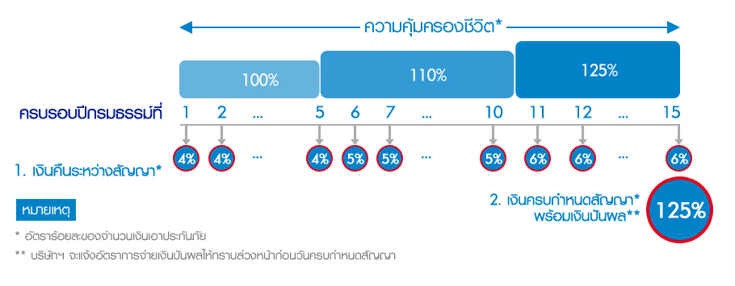
The benefit of this package is:
1.you will receive a refund every year
4% during year 1-5
5% during year 6-10
6% during year 11-15
2.you will receive a refund 125% of your money at the maturity date.
3.if you die during the contact you will receive a money
if you die during year1-5 you will receive 100% of your money
if you die during year 6-10 you will receive 110% of your money
if you die during year 11-15 you will receive 125% of your money
4.if you want more protection you can buy additional package and use it together with this package.

After i have know the benefit of this package, I think this package will benefit with the customer in term of saving money with life insurance because there are a refund every year and if you die during the contact you will receive at least 100% of your money, and by buying this package will help the customer know that how much they will receive each year so they will plan for the future financial plan, it also benefit by estate planning since if the owner of package die, the heir will get money and forced saving since the owner of the package need to pay the money for 10 years (but depend on the choice of paying such as annually, semi-annually, 3 months and per months) so this money can be use for the retirement, emergency case or for the future of the family.

- Which mortgage would result in higher total payments? Mortgage A: $970 a month for 30 years Mortgage B: $760 a month for 5 years and $1005 for 25 years

Answer:

Total payment for Mortgage A:
= ($970*30 years)*12 months
= $349,200

Total payment for Mortgage B:
= [($760*5years)*12 months] + [($1005*25 years)*12 months]
= $347,100

So, the total payment for Mortgage A is higher than Mortgage B

- What are the two main types of consumer credit?

- 1. Closed-End Credit is used for specific purpose and involves a specified amount such as Mortgage loans and Automobile loans. It also involves in written agreement, a down payment or trade­in may be required. It is with the balance repaid in equal amount over a period of time.
Most common type of closed-end credit: Installment sales credit, installment cash credit and Single lump-sum credit.

- 2. Open-End Credit is used in small purchases in different store and mostly found in credit cards. You may have to pay interest or other finance charges and once charges are paid, the amount is available for additional purchases or you have the credit line back. The maximum amount of credit depends on the lender making it available for you. The examples of open-end credit are credit card, smart card, gift card, car for cash and etc.

- What are the general rules of measuring credit capacity?
- Debt payments to income ratio should not exceed 20%
- Debt to equity ratio should not exceed by 0.5

- A few years ago, Michael Tucker purchased a home for $100,000. Today, the home is worth $150,000. His remaining mortgage balance is $50,000. Assuming that Michael can borrow up to 80 percent of the market value, what is the maximum amount he can borrow?

-Book value = $100,000
-Market value = $150,000
-Remaining mortgage (owe) = $50,000
-Amount of money that Michael can borrow up to 80% of the market value: (150,000*80%) = $120,000

To find the maximum amount he can borrow:
=(150,000*80%)-50,000
=$70,000

