Greece and the euro

An economy crumbles

Uncertainty about whether Greece will stay in the euro is crippling its prospects
Jan 28th 2012 | ATHENS | from the print edition

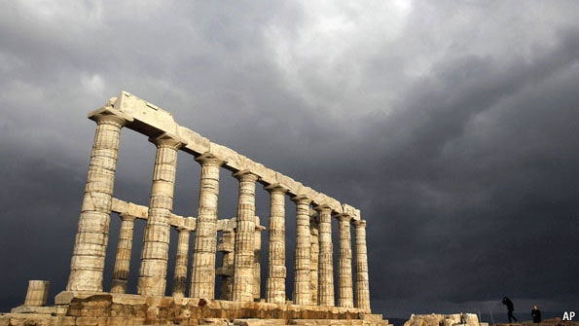
THE banners at the entrance to the Bank of Greece museum in Athens promise a “fascinating journey through Greece’s modern economic and monetary history”. How could any passer-by resist? Inside the museum ranks of glass cases enclose an array of coins and old bank notes, as well as the paraphernalia used to make them. The bills range from 5 drachma up to 100m drachma, a reminder that Greece has had problems with inflation in the past. The end of history, at least for this exhibition, is 2001 when Greece adopted the euro. But the country’s present troubles suggest an important chapter to the story of Greek money is still to be written. Some reckon the drachma may roll off the presses again.
This is no longer just a fantasy of diehard sceptics about the euro in Britain and Germany. Even Greeks concede that the big problem afflicting the economy, now in its fifth year of recession, is the uncertainty about whether Greece can stay in the euro and get its act together. Savers are anxious that their cash might be forcibly converted to a new Greek currency. By November the Greek banking system had lost a quarter of the deposits it had two years earlier. To fill the gap, the banks have borrowed €43 billion ($56 billion) of emergency funds from the Greek central bank on top of €73 billion of secured loans from the European Central Bank (ECB). Credit remains in short supply because banks have had to cut loans and raise borrowing costs. Informal credit arrangements between firms are breaking down. Foreign suppliers now demand cash payment upfront, making liquidity even scarcer.

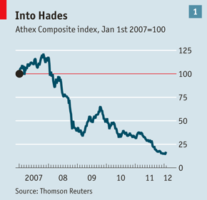
Few investors or businesses are brave enough to make long-term bets on the Greek economy in these conditions. The stockmarket has fallen steeply (see chart 1). “You can buy good companies for pocket money,” says one business chief. Assets are cheap but they would become cheaper still were Greece forced out of the euro. Capital spending is down by almost half from four years ago; house building has fallen by two-thirds. The one bright spot is tourism: visitors to Greece were up by 10% last year, in part because tourists steered clear of the unrest in north Africa.
There are hopes that the economy might recover next year if Greece’s place in the euro is confirmed. Agreement on a big new support package from the euro zone and the IMF would put some minds at rest. But a deal on new money cannot be thrashed out until the IMF in particular is sure that Greece’s public finances are on a sustainable path.
That depends, among other things, on private-sector creditors signing up to a bond-exchange deal that will see half of the face value of their Greek paper written off. A deal is proving elusive. Bondholders think Greece’s European rescuers should share in the pain. The ECB has purchased around €40 billion of Greek government bonds, at a discount to their face value, as part of its programme to stabilise bond markets. It stands to make a profit on them, which riles private bondholders. They also want a higher interest rate on the new bonds than officials are willing to sanction. Until a deal is done, Greece is stuck.
From bad to worse
The ever-gloomier diagnoses of Greece’s economy and public finances further complicate negotiations. An IMF report published at the end of last year said that a 50% write-down on private-sector bonds, a target set at an EU summit in October, together with €130 billion of extra official financing at low interest rates would give Greece a decent chance of getting its public debts down to 120% of GDP by 2020.
But that assessment already looks too sanguine. The headwinds facing the economy are proving much stronger than had been forecast. Greece’s GDP probably fell by 6% last year, far more than expected. A weaker economy has made it harder for Greece to meet its fiscal targets. Softer growth in the rest of the euro-zone economy has not helped. But the depth of last year’s slump owes much to a shortage of liquidity, an influence which most economic models ignore, says Yannis Stournaras of IOBE, an Athens think-tank.
The Greek central bank’s figures show that bank credit to households and private firms fell by 2.4% in the year to November. Banks suffering a drain of deposits have had to husband their liquidity. Official lending figures do not reflect the drying up of other sorts of credit. An informal system by which firms used postdated cheques to pay for supplies has broken down, in part because banks are warier of taking them as collateral for short-term loans. Firms complain that the government is slow to pay value-added-tax (VAT) rebates, making the liquidity shortage worse. Few foreigners will supply Greek customers on the basis of a credit guarantee from a Greek bank. So Greek importers, however solid, usually have to pay cash upfront.
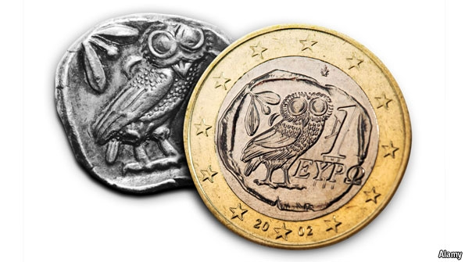
Some firms are finding ways round the stigma of being a Greek enterprise and the credit troubles that brings. The headquarters of Aquis, a firm that runs hotels and resorts in Greece, was recently moved to London by its founder, Ioannis Kent. It is now a UK holding company with a British bank account into which the firm’s revenues are paid. Other firms have delayed payments to suppliers and employees.
A necessary fiscal squeeze is adding to the downward spiral and risks becoming self-defeating. The sorts of public spending that are likeliest to induce other economic activity, such as roadbuilding, have been cut, says Mr Stournaras. Big tax increases are not a sure-fire way of raising revenue in a country where taxes are routinely avoided. The rate on restaurant meals was raised from 11% to 23%; such a sharp jump seems almost an invitation to cheat for cash-strapped small businesses. The IMF says a shortfall in VAT receipts suggests some firms are not complying. A hike in car taxes prompted many drivers to hand in their licence plates.
With so many uncertainties, the Greek economy cannot hope to attract the investment it needs to spur recovery. Until a deal on private-sector losses is finalised and implemented, investors cannot rely on a second bail-out package that will keep Greece in the euro. Even if a deal on losses is agreed in principle, a substantial number of holdout creditors could force the Greek government to implement a coercive restructuring. That might further unsettle bond markets and depositors. Banks will also have to be recapitalised after taking losses on their Greek bonds; no one is sure whether they will remain in private hands.
Goodwill hunted
Slow progress on freeing up the economy and cutting the deficit has cast doubt on the ability of Greece’s leaders to implement reforms. Last year the country moved up one place (to 100th) in the World Bank’s rankings of 183 countries for ease of doing business. Businessfolk call for something more radical to demonstrate the country’s commitment to reform.
One suggestion is immediately to shut down lossmaking or underutilised public entities. Another is to tackle the corruption and inefficiency of the tax system by outsourcing the job to foreign tax officials or to a private-sector tax consultancy. That would speed up much-needed use of centralised computer records and stop the face-to-face contact between tax collectors and taxpayers that begets bribery. A signal that banks would operate at arm’s length to the state would also reassure potential investors. So would a high-profile assault on a closed industry.
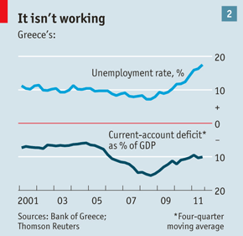
But Greece’s economic problems are too big to be fixed quickly. Despite a jobless rate that has risen to 18%, Greece still has a current-account deficit of 10% of GDP (see chart 2). For an economy to have so much slack and yet consume more than it produces is a sign of chronic uncompetitiveness. The IMF has said it will take more than a decade for Greece to become competitive. Some reckon it would be easier for Greece to regain its edge by going back to the drachma and devaluing than by keeping the euro and suffering grinding wage deflation. The short-term disruptions would be outweighed by long-term gains.
Most businesspeople see little merit in devaluation. “The empirical evidence is against it,” says Efthymios Vidalis of SEV, Greece’s main business federation. “Greece had two devaluations after joining the European Union and the benefits were short-lived before inflation eroded them. It didn’t work.”
There is another way. When the crisis struck, Apostolos Vakakis, the founder of Jumbo, a Greek retailer, faced a choice: cut costs by 20% or raise productivity by that amount. He chose to improve productivity. In return for a pledge not to cut jobs or wages, Jumbo’s employees agreed to work harder. Each store is now staffed with fewer workers, allowing the firm to open outlets at a faster rate.
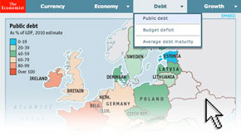Explore our interactive guide to Europe's troubled economies
Many stress the importance of greater competition in bringing business costs down. In contrast to devaluation, the benefits from opening up professions and industries to competition are permanent, says Mr Stournaras of IOBE. “It is the ‘doing business’ sort of competitiveness that matters,” he says. Greek executives point to the lack of competition in trucking, where no new licences have been issued since 1971, as an example of an industry that raises costs for other Greek firms.
Public opinion also still favours the euro: more than 70% of Greeks say they want to stay in the single currency. But if Greece is to have the breathing-space it needs to right its economy, it has to convince its rescuers that they are not throwing good money after bad. A deal on private-sector losses is only a first step; it seems likely that the euro zone will also have to stump up more money than expected to keep Greece going. It will be a while before the drachma printing plates on display in Athens can truly be confined to history.

In covers: The euro crisis
- 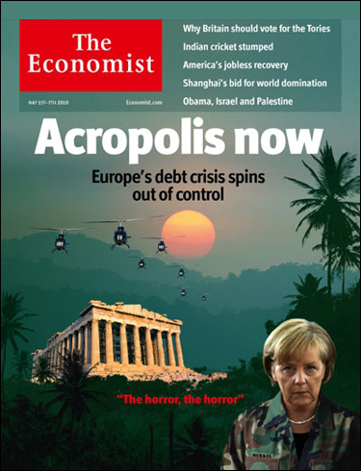
May 1st 2010 The Greek debt crisis is spreading. Europe needs a bolder, broader solution—and quickly

Related stories
Europe's sovereign-debt crisis: Acropolis now
- 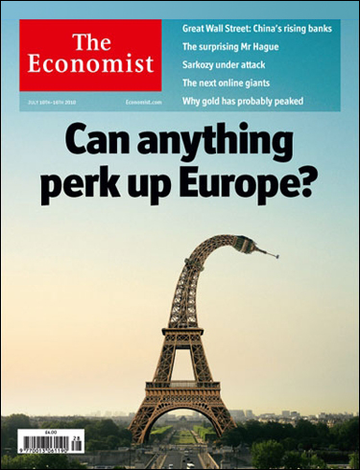
July 10th 2010 Yes: the European Union will thrive if its leaders seize the moment in the same way they did 20 years ago

Related stories
Europe's future: Can anything perk up Europe?
- 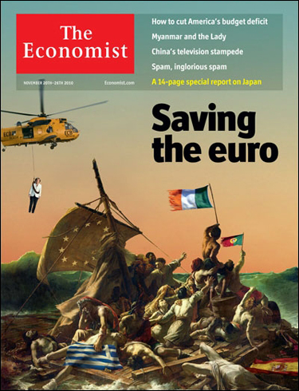
November 20th 2010 Ireland’s woes are largely of its own making but German bungling has made matters worse

Related stories
The euro-zone crisis:
Saving the euro
- 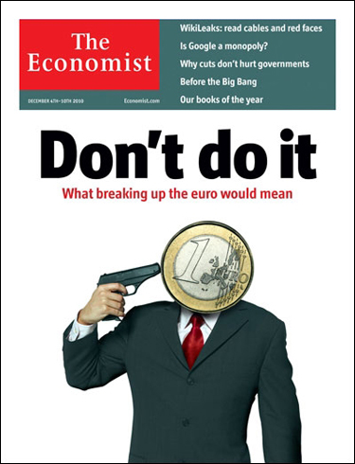
December 4th 2010 The euro is proving horribly costly for some. A break-up would be even worse

Related stories
The future of the euro:
Don't do it
- 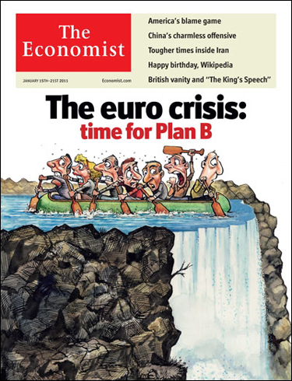
January 15th 2011 The euro area’s bail-out strategy is not working. It is time for insolvent countries to restructure their debts

Related stories
The euro area:
Time for Plan B
- 
March 12th 2011 This may be remembered as the week Europe began to split apart. One woman could stop that

Related stories
The euro and the European Union: Can Angela Merkel hold Europe together?
- 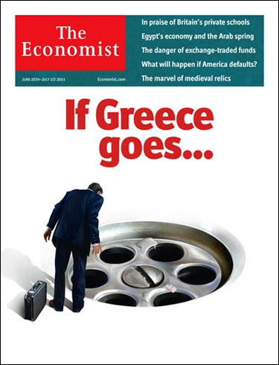
June 25th 2011 The opportunity for Europe’s leaders to avoid disaster is shrinking fast

Related stories
The euro crisis:
If Greece goes…
- 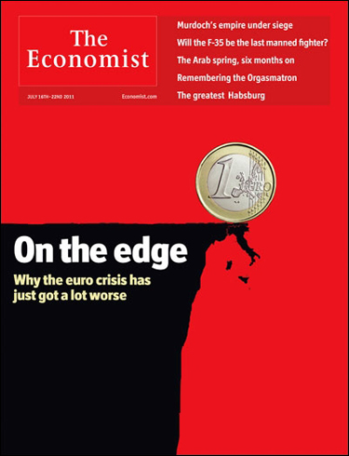
July 16th 2011 By engulfing Italy, the euro crisis has entered a perilous new phase—with the single currency itself now at risk

Related stories
Italy and the euro:
On the edge
- 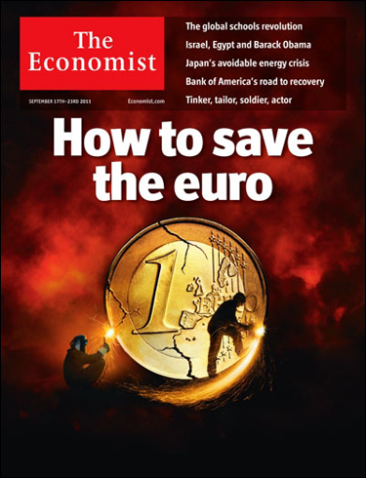
September 17th 2011 It requires urgent action on a huge scale. Unless Germany rises to the challenge, disaster looms

Related stories
Europe's currency crisis:
How to save the euro
- 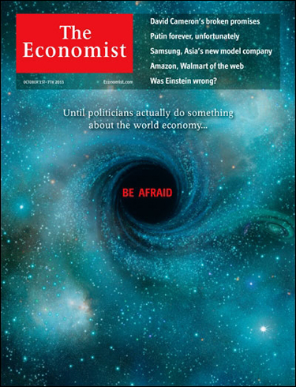
October 1st 2011 Unless politicians act more boldly, the world economy will keep heading towards a black hole

Related stories
The world economy:
Be afraid
- 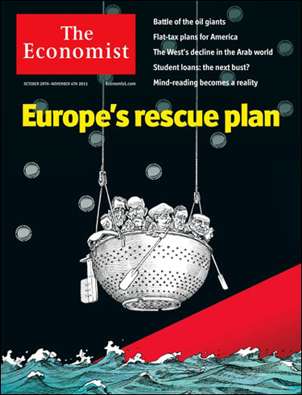
October 29th 2011 This week’s summit was supposed to put an end to the euro crisis. It hasn’t

Related stories
Economic crisis:
Europe’s rescue plan
- 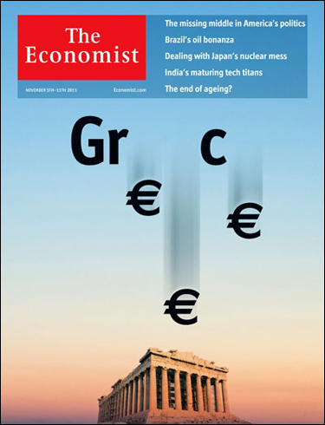
November 5th 2011 The markets are not the euro’s only threat. Voters may be too

Related stories
A euro referendum:
Greece’s woes
- 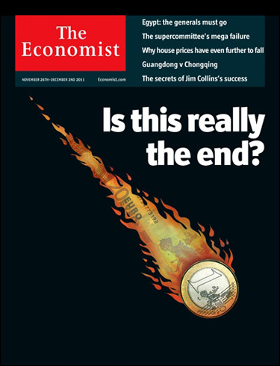
November 26th 2011 Unless Germany and the ECB move quickly, the single currency’s collapse is looming

Related stories
The euro zone:
Is this really the end?
1 / 13
from the print edition | Finance and economics

